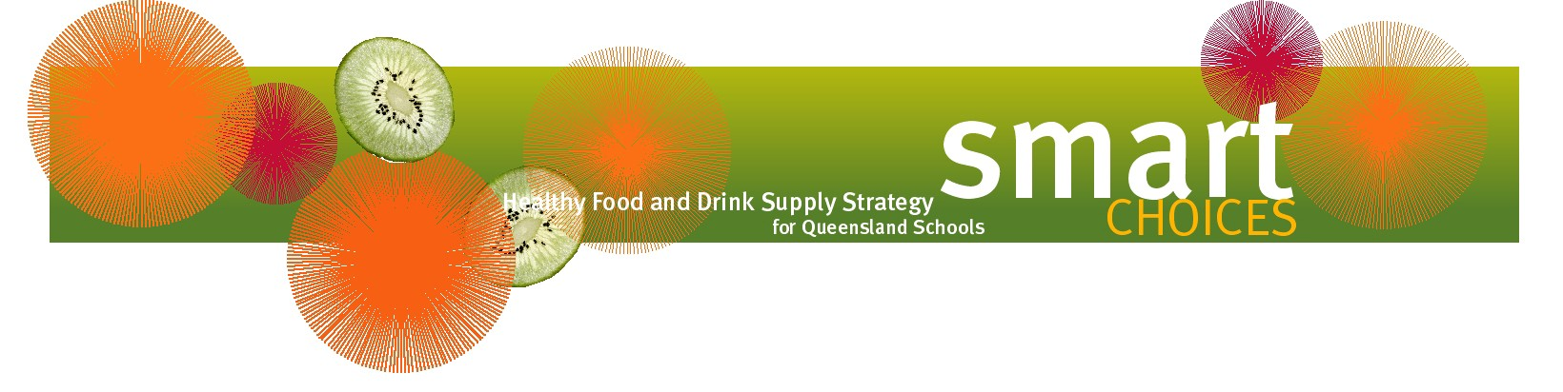
Healthier fetes and festivals

The annual fete or festival is a time of great excitement at many schools, and also a major fundraiser. With some extra creativity, a school fete can be as healthy as possible, or even a Smart Choices event!

Remember that entertainment and other stalls are just as important as tasty food stalls.

Healthier food stall ideas include:
- corn on the cob
- curries with rice
- tacos or pita bread nachos
- noodle boxes
- healthy muffins, slices and scones
- jacket potatoes
- gourmet yoghurt
- sushi
- healthy barbecues.

Consider inviting multicultural groups within the school to have a food stall.

Alternatively, invite local healthy food vendors to the fete, with a proportion of profits coming back to the school.

Soft drinks are RED products and can be the most difficult item to replace when planning an event that complies with Smart Choices. Possible alternatives include:
- fruit juice
- fruit juice slushies
- low fat flavoured milk
- low fat smoothies
- selling reusable water bottles with the school logo that can be filled at water fountains.

Don’t forget about the other stalls to entertain visitors to the fete. Popular ideas include:
- bric-a-brac or white elephant
- craft
- plants
- hair spray colouring or face painting
- baby animal farm or pony rides
- raffles
- lucky dips
- games such as dunk-a-teacher, basketball shots and ring toss.

