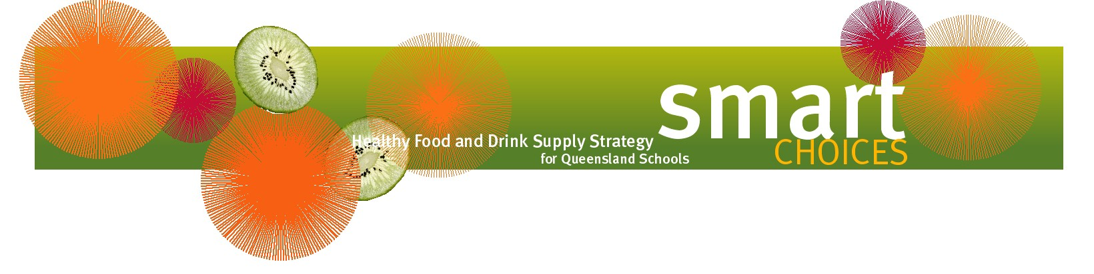
Ideas for non-food rewards for students

- Announcement on parade
- Positive attention, praise or thanks
- Certificates
- Computer time
- Discount vouchers for skating, ten pin bowling, movies
- Hair accessories
- Listening to music
- Pencils, pens, erasers
- Phone call, email, text or letter sent to parents
- Playing games or doing puzzles
- Ribbons
- Sports equipment e.g. ball, hula hoop, jumping rope
- Stencils, stamps
- Stickers
- Water bottles
- Yo-yos

Further information on Smart Choices can be found on the Department of Education’s website at https://education.qld.gov.au/students/student-health-safety-wellbeing/student-health/smart-choices.

