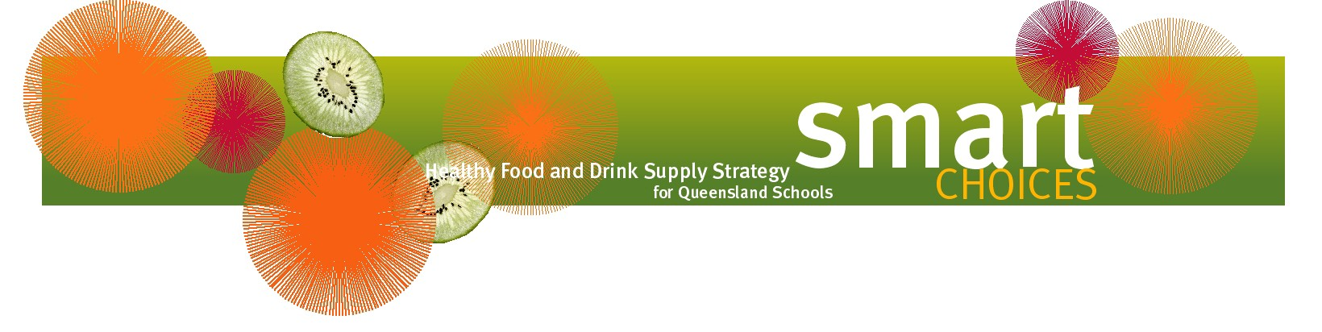

Healthier sausage sizzles and alternatives

There are a number of ways to make the common sausage sizzle consistent with Smart Choices. The table below lists healthier options for foods commonly used at sausage sizzles.

Bread and buns | - wholemeal  - multigrain  - high fibre white  - do not pre-butter bread and buns
Salad | - use plenty of fresh vegetables  - avoid creamy or oily dressings
Meat | - choose kebabs, lean steaks, lean burgers and skinless chicken breasts  - source reduced-fat and reduced-salt sausages from a local butcher or commercial distributor
Vegetarian | - vegie burgers  - vegie sausages  - barbequed vegetables
Vegetables | - barbecued mushrooms, zucchini, capsicum, eggplant and onion – marinated for extra flavour  - barbecued corn on the cob  - jacket potatoes stuffed with low-fat coleslaw, tuna and mayonnaise, baked beans and reduced-fat cheese, and salad
Fruit | - whole fruit or fruit salad  - frozen fruit for extra variety
Drinks | - cold water  - small bottles of fruit juice  - low-fat flavoured milk

