Regional Health, Safety and Wellbeing Committee

Purpose
To act as a forum for improving the health, safety and wellbeing (HSW) performance within the region and an integral part of the department’s HSW governance framework. The Committee supports the department’s legislative consultation requirements by promoting employee engagement and also assists the department in fulfilling its corporate governance responsibilities. This is achieved through the provision of oversight and direction for the implemented continual improvement of the HSW Management System consistently across departmental regions. Consultation through HSW Committees promotes employee engagement in health, safety and wellbeing.

Guiding principles
Performance-based outcomes
Monitor and review the implementation of HSW risk management strategies at all workplaces (including schools) to ensure the department meets legislative and policy requirements.
Evidence-based
Use evidence-based decision-making and HSW risk analysis to drive and shape operational priorities, strategies and objectives relevant to HSW.
Fit-for-purpose
Be responsive to emerging drivers, hazards, trends and issues that may impact HSW.
Trust and transparency
Make impartial and ethical decisions that uphold human rights, promote confidence, demonstrate accountability and prioritise HSW.
Risk-based
Make decisions that balance opportunity and risk to achieve operational priorities and objectives in relation to HSW.

Responsibilities
The Regional HSW Committee will:
- Oversee the application of HSW risk management systems within the region to ensure that reasonably foreseeable HSW risks are identified, assessed, controlled and monitored.
- Oversee contingency planning processes and ensure that appropriate plans are in place to address all high and/or extreme safety risks.
- Oversee and ensure the effectiveness of HSW reporting systems throughout the region.
- Oversee and ensure the effective management of significant HSW risks and incidents through receipt and review of reports on significant incidents and trends.
- Oversee the operation and effectiveness of HSW assurance programs.
- Review regional HSW performance, identifying the factors contributing to performance and direct reinforcing or corrective action plans.
- Recognise exceptional individual and collective HSW behaviours.
- Escalate HSW information and issues to the Department of Education’s HSW Executive Committee as required.

Membership
The composition of the Committee will reflect the scale, scope and risk profile of region’s operations and includes incumbents in the following positions:
[Add/delete cells as required]
Role | Position | Division
Chair | Regional Director
Member | Director, Human Resource Business Partnering
Member | School Representative(s)
Member | Regional Supervisor(s)
Member | Regional Infrastructure Manager
Member | Senior Internal Auditor
Member | Senior Health and Safety Consultant
Member | Senior Injury Management Consultant
Member | Other business unit representatives
Secretariat | To be determined by Chair

Committee operations
- The Regional HSW Committee is a decision-making body.
- The Regional HSW Committee’s decisions are underpinned by the Work Health and Safety Act 2011 (Qld).
- The Regional HSW Committee will meet, as a minimum, once each term (weeks 7 – 9) or as determined by the Chair.
- Committee relationships and pathways for escalation and decisions are illustrated through the department’s HSW Committee Governance Framework in the below diagram.
- See Appendix 1 for further information about the Committee’s operating model.
- See Appendix 2 for further information about Annual Forward Work Plan.
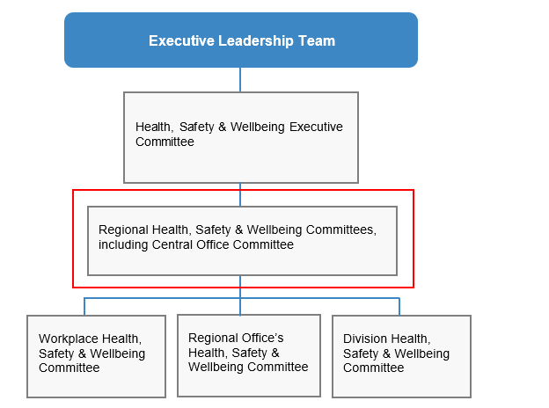

Reporting and referral relationships
The Committee, through the Chair, prepares the following reports for the parent entity, the Department of Education’s HSW Executive Committee:
- minutes of meetings;
- items for escalation; and
- progress against regional HSW priorities.
Regular reports to the Committee include:
- items raised by workplace (including school) HSW Committees.

Appendix 1 – Operating model
Quorum | The Chair (or Acting Chair) plus 50% of members.
Agenda, papers & minutes | Agenda  - Committee members may sponsor items for the agenda.  - Agenda items should be forwarded to the Secretariat at least one week before the scheduled meeting.  - The Chair will approve agendas no less than three working days before the meeting date.  Record keeping  - Minutes of meetings will be taken by the Secretariat using the department’s HSW Committee minutes template.  - Once endorsed, the minutes will be distributed to members and will be available for administrative release under the Right to Information legislation.  - The minutes and the status of associated actions must be reviewed at the next meeting.  Reporting  - As required, the Committee escalates issues to the department’s HSW Committee for endorsement or a decision.  - Escalation of issues to the Department of Education’s HSW Executive Committee shall be through the Chair or other invited members as appropriate.  - Will address compliance issues and performance of the HSW Management System.  - Communication of meeting outcomes is through the distribution of minutes to members. Members are responsible for the communication of issues within their areas as appropriate.  Resolution of issues ‘out-of-session’  - The Chair may schedule out-of-session meetings of the Committee or part thereof as deemed necessary.  - The Chair may issue papers to members for consultation and decision outside scheduled meeting. This may include papers or issues unable to be included in scheduled meetings due to time constraints.
Roles | Chair  - Approves the agenda no less than three days before the meeting date.  - Ensures the Committee operates effectively and according to agreed protocols.  - Facilitates the flow of information during meetings.  - Approves the draft minutes no more than three weeks after each meeting for circulation to members.  - Escalates issues and risks and reports on achievements to the Department of Education’s HSW Executive Committee as appropriate and no later than four weeks after each meeting  - Delegates the above responsibilities to the next most senior executive present as required.  Secretariat  - Compiles and distributes the agenda and any supporting papers at least three working days prior to each meeting.  - Circulates minutes (approved by Chair) to members for endorsement within five business days of draft approval.  - Keeps records in accordance with the department’s policies and practices (i.e. minutes).  - Monitors and tracks actions and decisions recorded in the Outcome Register.  - Maintains distribution lists and Terms of Reference.  Members  - Acquire and maintain knowledge of:  - WHS duties and obligations that affect the department; and  - safety hazards and risks inherent in the operations of the department.  - Represent the interests of, and make decisions on behalf of, their respective regions, branches and divisions, and have authority in relation to the HSW of students and employees in their areas.  - Prepare and present sponsored items for the agenda.  - Provide feedback or endorse minutes of each meeting within one week of their circulation by the Secretariat.
Review | The Committee is to review these Terms of Reference, membership and operations annually through a self-assessment process, with a focus on continuous improvement.

Appendix 2 – Annual Forward Work Plan
This work plan is directed by the Regional HSW Committee’s purpose. It guides the Committee’s focus and outcome for each meeting, assists with scheduling and supports performance assessment in annual reviews.
Meeting date | Key area of focus |  | Outcome the Committee is seeking… | Sponsoring member/s
January - June
 | Review school ‘HSW Scorecard’ | Improved performance measures
 | Subordinate HSW Committee meeting assurance | Improved performance measures
 | Determine HSW priorities for this year | Focus areas for the year
July to December
 | Safe Work Month activities (October) | Endorsement of activities
 | Implement HSW related policy and procedures | Identify key messages
 | Determine HSW priorities for next year | Preparedness and endorsement
 | Review Terms of Reference | Review and update of ToR

Version: CM reference:
Approved: Date:

Part 5 of the Work Health and Safety Act 2011 outlines requirements which must be considered by the workplace when determining consultation, representation and participation in the WHS Committee. Workers directly affected by a matter relating to work health or safety must be consulted.

