Department of Education

This document provides detailed information about the physical and psychological job demands of Cleaners in Queensland state special schools.

This report indicates the average time spent across a working week on each work activity and also on each physical demand of work. In order to make this
information meaningful to the various users of this report, in some instances the time spent is expressed as a single word, as a percentage of total time or as an
actual amount of time (i.e. hours and minutes). The timeframes used are based on the benchmark descriptions (from the referenced publications) for expressing
performance frequency of work tasks.

Descriptor | Percentage of Time | Amount of Time based on 38 hours per week
Not present | 0% | 0 mins
Rare | 1%-7% | 23 mins - 2 hrs 40 mins
Occasional | 8%-33% | 3 hrs 2 mins - 12 hrs 33 mins
Frequent | 34%-66% | 12 hrs 55 mins - 25 hrs 5 mins
Constant | 67%-100% | 25 hrs 28 mins - 38 hours

Description of the Role of School Cleaner:

Cleaners within Queensland state special schools work in a variety of educational environments and perform a range of cleaning tasks to ensure a clean,
hygienic and safe environment for Teachers and students. Cleaners generally work split shifts, before and after official school hours. They directly report to
the School Business Manager, however, work relatively independently and are allocated specific areas to clean. The allocation of these areas can vary,
but commonly Cleaners will have an allocation of classrooms and indoor areas as well as some outdoor areas. Cleaners are often allocated classrooms
and areas that are geographically close together, and classrooms are often organised into similar year groups. Due to the difference in school size, room
setups, furniture heights and equipment, the physical demands of the position may vary slightly depending upon the rooms they are allocated.

Hours of Work and Scheduled Breaks:

Hours of Work: The maximum ordinary hours of work for full time Cleaners is 38 hours per week, part time Cleaners’ hours of work vary e.g. 30 hours per
week. The ordinary spread of hours of work exclusive of meal times is between 6.00am and 6.00pm Monday to Sunday and shall not exceed 10 hours per
day. (Hours of work on Saturday and Sunday are subject to penalty rates). In certain circumstances it may be operationally sound for Cleaners to commence
work earlier than 6.00am, but no earlier than 5.00am. This is providing the following conditions are met: (a) Cleaners and Principals/worksite managers must
be in agreement to the altered arrangements and this must be recorded in writing at the local level (b) productive work is to be performed during the earlier
work hours. Where a school local consultative committee has agreed to change/extend the school hours, School Cleaners at these schools may be required
to clean after 6 pm but not later than 9 pm.

Meal Breaks: All employees (including part-time and casual employees) whether day workers or shift workers who work for more than 5 continuous ordinary
hours on any day shall be allowed a minimum of 30 minutes for a meal break to be taken between the third and sixth hour from commencement of duty. The
hours of duty of shift workers shall be inclusive of meal times, to be taken so as not to interfere with operational requirements and no deduction
shall be made from the employee's wages.

Rest Pauses: Where practicable, all employees (including part-time and casual) who work at least 6 continuous ordinary hours shall be entitled to a
pause(s) totalling 20 minutes per day to be taken at times to suit operational requirements as determined by the employer, where at least 4 continuous
ordinary hours are worked the entitlement shall be 10 minutes.

ADO: School Cleaners must accumulate sufficient hours to enable Accumulated Days Off (ADO) time to be taken during designated vacations on the
following basis: April vacation period - 2 days, June vacation period - 5 days, September vacation period - 5 days. Cleaners can also choose to accrue
up to an additional 3 ADO days per year. They will then consult with the principal 2 months in advance, to confirm their decisions on the number of ADO
hours they will accrue and the days they wish to use these on. The additional 3 days will be applied as follows: two days at Easter and an additional day over
the Summer vacation. All School Cleaners will complete an ADO Agreement at the beginning of each school year.

The Activity Frequencies below have been calculated based on a 38 hour week. Seldom = 23 mins - 2 hrs 40 mins per week, Occasional = 3 hrs 2 mins - 12 hrs 34 mins per week, Frequent = 12 hrs 55 mins - 25 hrs 5 mins per week, Constant = 25 hrs 28 mins - 38 hours (times are exclusive of scheduled break)

 | Job Activity | Average Frequency/  Time per week | Critical Job  Demand
1 | Vacuuming indoor environments: involving such activities as accessing vacuum cleaner from storage, setting up equipment (e.g. untangling cord, plugging into power source), placing vacuum on back/ positioning appropriately on floor and pushing and pulling the vacuum  cleaner across a range of floor surfaces.  Also involves emptying dust collector when full and returning equipment to usual storage. | Occasional  ≤ 12 hrs 34 mins/week | Yes
2 | Maintenance of other indoor floor surfaces: involves activities such as mopping, buffing or polishing to clean a range other surfaces.  Cleaners will access and use hand held equipment such as buckets, mops and squeegees, or operate machinery to complete these tasks. | Frequent  ≤ 25 hrs 5 mins/week | Yes
3 | Sweeping of indoor areas (including vinyl floors, carpets and mats): involves use of a dry static or micro-fibre broom and provides an alternative to vacuuming. Cleaners are required to access appropriate equipment from storage, push and pull broom across floor, collect debris and  return equipment. | Frequent  ≤ 25 hrs 5 mins /week | Yes
4 | Cleaning of external areas: involves use of a broom, manual push sweeper, high pressure hose or leaf blower to clean and clear outside paths of debris. Cleaners are required to access appropriate equipment from storage, operate equipment (usually by pushing and pulling motions), to collect debris and then return equipment to appropriate storage facility. | Seldom  ≤ 2 hrs 34 mins/week | Yes
5 | Cleaning amenities: involves activities of mopping floor surfaces and wiping the surfaces of sinks, basins, toilets, pedestals, urinals, mirrors, showers and baths. Cleaners will access a range of tools and cleaning products to complete this task e.g. toilet brushes, cloths, mops etc and may be required to replenish bathroom materials as necessary e.g. toilet paper and soap. Cleaners are also required to clean drinking troughs and fountains. This activity involves wiping of trough and fountain surfaces, as well as removal of any debris located within them. | Occasional  ≤ 12 hrs 34 mins/ week | Yes
6 | Waste removal: involving emptying small classroom waste bins and replacing the liners, accessing rubbish bins placed around the school and transporting their contents to a larger bin/skip to be emptied by an external contractor. In some schools this activity is completed with the assistance of a hydraulic bin lifter. Cleaners may also be required to clean and sanitise bins following emptying. | Frequent  ≤ 25 hrs 5 mins/week | Yes
7 | Cleaning windows: involves use of window scrapers, buckets, sponges and squeegees to clean all accessible indoor and outdoor windows. Whilst cleaning windows, Cleaners will also assess surrounding internal and external surfaces for cobwebs, mildew, dust and marks. | Frequent  ≤ 25 hrs 5 mins/week | Yes
8 | General security tasks: before, during and after performance of cleaning duties Cleaners may be responsible for opening and closing various gates, roller doors, buildings, classrooms and other areas. This may also involve arming and disarming security systems and accessing keys to lock and unlock padlocks or doors. | Seldom  ≤ 2 hrs 40 mins/week | Dependent on school
9 | Cleaning of all accessible classroom and office equipment, furniture surfaces and fittings: involving repetitive movement of the upper limbs to use cloths, dusters, polishers and chemicals to maintain a range of fittings such as keyboards, telephone headsets, heaters, fans, desks, cupboards and chairs. Regular visual inspection of the area is also undertaken to determine further tasks that need to be completed, e.g. carpet stain removal, removal of graffiti, spot cleaning etc… | Frequent  ≤ 25 hrs 5 mins /week | Yes
10 | Moving furniture/heavy items around school: assisting other staff members to move furniture and classroom supplies to different locations within school. May also involve marking and recording of equipment for auditing, security and purchasing requirements. | Seldom  ≤ 2 hrs 40 mins /week | Dependent on school

Frequency of Physical Job Demands (Average % of Shift)
Demands | Not  Present | Rare  (0-7%) | Occasional  (8-33%) | Frequent  (34-66%) | Constant  (67-100%) | Demands | Not  Present | Rare  (0-7%) | Occasional  (8-33%) | Frequent  (34-66%) | Constant  (67-100%)
Sitting |  | √ |  |  |  | Reaching |  |  |  |  | √
Standing - Static |  |  |  |  | √ | Gripping/Grasping |  |  |  |  | √
Standing - Dynamic |  |  |  |  | √ | Pushing |  |  | √
Walking - Flat Terrain |  |  |  | √ |  | Pulling |  |  | √
Walking - Slippery/ Gravel Terrain |  |  |  | √ |  | Lifting |  |  | √
Climbing -  Step Stools/Ladders |  | √ |  |  |  | Carrying |  |  |  | √
Climbing - Stairs |  | √ |  |  |  | Balancing - Above Ground |  | √
Stooping |  |  |  | √ |  | Fine Motor control |  |  | √
Kneeling |  | √ |  |  |  | Control Operation |  |  |  |  | √
Squatting |  | √ |  |  |  | Upper limb – gross motor control |  |  |  |  | √
Crawling |  | √ |  |  |  | Driving |  | √
Auditory Function |  |  |  | √ |  | Visual Function |  |  |  |  | √
Lifting / Carrying
 | Not  Present | Rare  (0-7%) | Occasional  (8-33%) | Frequent  (34-66%) | Constant  (67-100%)
0-10 kg |  |  |  | √ e.g. General cleaning equipment
11-20 kg |  |  |  | √ e.g. Vacuum cleaner
21-30 kg |  | √  e.g. Furniture
31-40 kg |  | √  e.g. Furniture
41-50kg | √

Tools/Equipment Used
Vacuum cleaners – floor units and back packs
Mops, brooms, mop buckets, microfiber mops
Manual push sweepers, floor polishers, water blasters, concrete scrubbers
Leaf blowers, hoses, gurneys
Window cleaning equipment
General cleaning equipment e.g. microfiber cloths, dustpans, doodlebugs
Small waste bins, wheelie bins, skip bin/compactor, bin lifter
Ladders, step stands, trolleys
Personal Protective Equipment – gloves, ear muffs, face masks

Risk Based Physical Environmental Considerations:

- There may be clutter in the work area, increasing the risk of trip hazards, awkward bending and lifting, and poor storage practices

- Items, furniture and fixtures may be poorly positioned or designed, requiring the adoption of awkward postures

- There may be limited space for movement during performance of some activities

- The degree of squatting, kneeling, reaching, forward bending and stooping may vary throughout special schools with respect to a range of furniture heights and
equipment specific for wheelchair and disability access (e.g. furniture heights range from 640mm, 700mm, 710mm, 720mm, 850mm, 870mm and 900mm)

- The requirement for repetitive gripping, grasping and reaching to wipe down surfaces in a special school may be to the end range of ‘Occasional’ (e.g. there is
greater need to sanitise surfaces that are frequently touched by students such as door handles)

- There may be constant low-level ambient noise (from students, traffic, machinery, etc)

- Work may be performed outdoors or in an area exposed to the elements – including uneven and sloped terrain, as well as wet and slippery surfaces

- Work may be performed in temperatures above 24 degrees (e.g. in summer)

- Requirements may exist for transport of awkward loads (such as floor polishers) up and down stairs

Psychosocial Risks to be Considered
Time pressure- while deadlines exist for many tasks, the level of demand is dependent upon school environment, cleaning needs identified and staffing level.
Poor worker/team leader relationships- may exist in some environments.
Lack of control or autonomy– may have lack of control over when and/ or how task will be performed
Environmental Stress / Temperatures: work is often done outdoors which may be hot in summer and cold in winter. Noise: there may be constant low level ambient noise from students, traffic and machinery. Odour: may be an issue with general cleaning and maintenance tasks.
Insufficient work breaks- shortened breaks may be taken on a voluntary basis due to high workload and time constraints.
Monotonous work– may exist at times.
Social / Interpersonal Demands
Communicating with supervisors, peers and subordinates.

Coordinating or Leading Others– other staff members
Establishing and Maintaining Interpersonal Relationships with staff and persons outside of
the organisation
Providing consultation and advice to others– e.g. regarding maintenance projects
Working alone– may work in a solitary manner for long periods

Photographs of selected work activities, work environments and use of equipment.

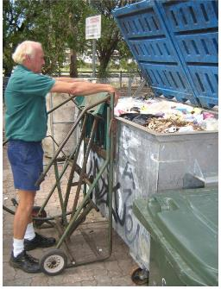 | 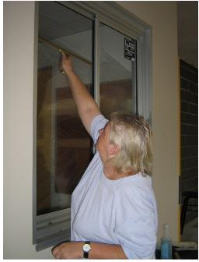
Manual bin lifter. | Wiping glass windows. | Cleaning external glass louvers. | Carrying equipment up/down stair cases. | Security tasks – locking doors.
 |  | 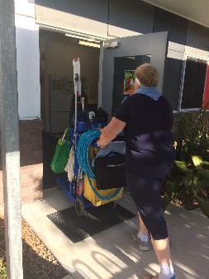 |  | 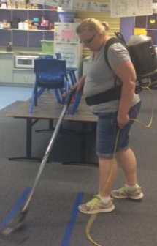
Wiping skirtings with long handed aide. | Mopping internal floors. | Pushing cleaning equipment trolley. | Emptying small waste bins. | Vacuuming internal floors.

Photographs of selected work activities, work environments and use of equipment.

 | 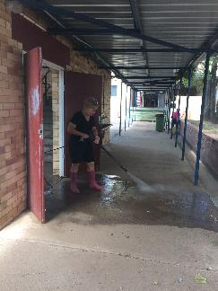 | 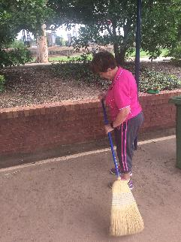 | 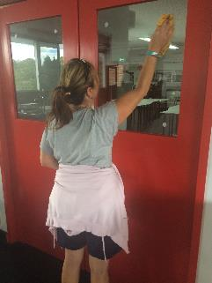 | 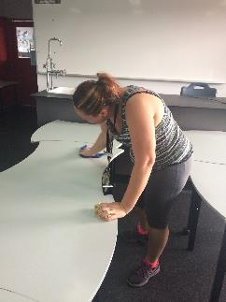
Pushing wheelie bin. | Hosing outdoor area. | Sweeping outdoor pathways. | Cleaning internal windows. | Wiping down desks.
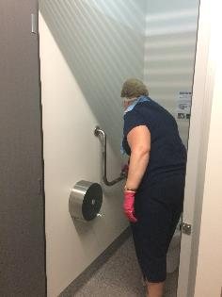 | 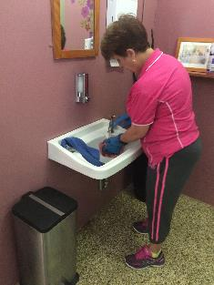 | 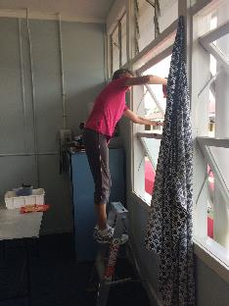 | 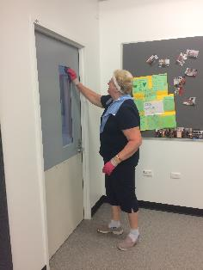 | 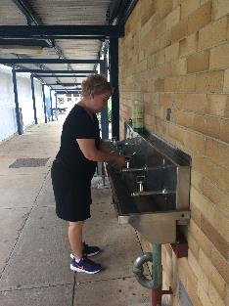
Cleaning toilet grab rails. | Cleaning sinks. | Cleaning windows. | Sanitising doors and door handles. | Cleaning drink fountains.

Considerations for Functional Assessments to determine Physical Job Fitness:

• Sustained standing capacity, including balance reactions

• Dynamic balance to negotiate varying terrains and surfaces when walking and carrying items (weighing up to 15 kg).

• Grip strength and endurance (within norms for age and gender)

• Lifting from varying heights (including below knee and overhead height (up to 15 kg)), including awkward loads, repetitive and sustained lifting

• Repetitive and sustained crouching, kneeling, and stooping postures and return to standing

• Ability to perform repetitive and sustained reaching (overhead, forwards and down)

• Ability to push/pull equipment over variable slopes for sustained periods of time, or trolley loaded with chairs or equipment (up to 20kg).

• Degrees of active range of motion and any associated symptoms of the neck, upper limbs, spine, hips, and lower limbs

• Absence of positive signs for brachial plexus neural compromise

Other Considerations:

• History of neck/shoulder symptoms associated with sustained and/or repetitive neck postures or with overhead activities, lifting or carrying

• History of upper limb, lower limb or spinal symptoms associated with repetitive or sustained tasks, or with lifting or walking

• History of lower back symptoms associated with sustained sitting, standing, walking, stooping, crouching, and kneeling

• History of lower limb injuries that may adversely affect balance / proprioception (e.g. severe ankle or knee sprains or surgery)

• Knowledge of optimal manual handling techniques

- Understanding of labels and SDS on Safe Chemical use

• Knowledge of required Personal Protective Equipment (PPE) to be worn during activity and correct us
Functional Job Requirements
For the Position of School Cleaner – Special School
Department of Education

This report identifies those activities which are essential to successful performance in this role.

In determining whether a work activity is a “critical activity” the following questions are considered:

    - Does the worker spend greater than 33% of designated work time per week performing this activity? and/or
    - Is specialised training/experience required to complete this activity? Has this been completed by only a small proportion of staff in this geographical region? and/or
    - Is this activity performed in an environment where no other workers are readily available to assist with its completion? and/or
    - Does this activity occur without prior notice and require immediate attention leaving no time to seek assistance to complete it? and/or
    - Is this activity core to the development of stakeholder relationships, which are essential to achieving successful outcomes? and/or
    - Would an inability to perform this activity result in an increased health and safety risk to co-workers, students and/or members of the public?

The development of this report included: site observation of work environments, staff interviews, staff feedback on draft documents and consideration of benchmark publications for the analysis and description of work activities and job demands specific to particular positions (the Revised Handbook for Analysing Jobs, the Occupational Information Network and the Australian Job Guide, 2006).

An audit of this document to ensure currency and validity of data was completed by Strive Occupational Rehabilitation in 2017, through school worksite visits, staff interviews and staff feedback.

