First aid contacts

This may be displayed in your first aid areas.
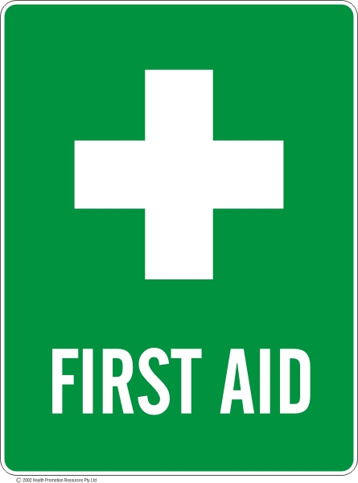
Instruction: In an emergency…
Attend to the injured and have someone nearest to the patient call an ambulance.
- Call 000 (free call)
- Ask for "Ambulance"
- You will be transferred to a QAS Communication Centre
- The QAS Emergency Medical Dispatcher will ask you some important questions and provide you with advice to assist the patient
- Do not hang up until the operator tells you to
- You may have to hold the line while an ambulance is dispatched. (add other relevant information)

Your Nearest First Aid Officer | Contact | Location
e.g. Mr John Doe  Training expiry date: / / | Phone: xxxx / Mobile: xxxxx | Administration

Where to find…
Nearest First Aid Kit
Adrenalin Auto-Injector
Asthma Reliever
Automated External Defibrillator (AED)
if needed
Important Numbers…
Emergency | 000 | Queensland Health |  | 13 HEALTH / 13 432584
Hospital (local) |  | School Office
Medical Centre |  | Security
Poisons Information | 131126 | Other xxx
Local Public Health Unit

