FOOT OPERATED WHEELIE BIN LIFTER

Caution. This tasks requires the movement of heavy objects
and the use of repetitive actions.
DO NOT use the bin lifter unless appropriate instruction has been given and you are fully conversant in its safe use and operation.

POTENTIAL HAZARDS
Repetition of movement Awkward posture Slip/trip/fall Pinch/crush in
Sprains/strains Falling waste and dust Heavy objects moving parts

PRE-OPERATIONAL SAFETY CHECKS
- Bin lifter must only be used when secured to a skip or similar bin.
- Keep loads manageable. Do not exceed your strength capacity to comfortably move bins around. Ensure bins are not overfull or exceed the safe work load limits of the lifter.
- Ensure wheelie bins are in good condition, particularly where lifter grips the bin.
- The cradle lock must engage when returning to down position.
- Never stand in front of unit, always stand to the side. Ensure others stay clear of the lift zone.
- Inspect the unit for worn parts, broken welds etc. before using it. Do not use if damaged.
- Wear covered footwear. Secure loose clothing or jewellery that could become entangled in the lifter. Wear safety glasses to protect eyes from falling or wind-blown debris.

OPERATIONAL SAFETY CHECKS
- Secure bin lifter to industrial bin with brackets (U bolts) provided.
- Place the rubbish flap over edge of industrial bin.
- Place lower edge of wheelie bin onto lower foot of bin lifter.
- Push bin forward and secure top under ledge.
- Stand to side of bin lifter.
- Release/remove padlock from lifting frame.
- Release safety catch.
- Place foot on foot activator and push foot down, steadying bin with large hoop as it rises. Ensure you are well-balanced when using foot activator to prevent slips and falls.
- To return wheelie bin to ground, bring down lifting frame using large hoop.
- When finished using bin lifter, always secure lifting frame with padlock.
- Do not continue to use the lifter if you become fatigued. Alternate with other activities tasks to prevent fatigue or share the task with another staff member if multiple bins require emptying to avoid muscle fatigue and strain.

HOUSEKEEPING
Do not leave the bin lifter attached to industrial bin when not in use. Immobilise it in a secure area.
Never leave the bin lifter in traffic lanes or pedestrian walkways.
NEVER leave lifting frame unlocked while moving bin lifter, when not attended or when not in use.
Always wash your hands when you have finished handling rubbish.
Date of last review | ______________ | Signature __________________________

Notes: For further information, refer to the Waste Management Factsheet
Operation of foot activated bin lifter
(produced by Lawn Runner)

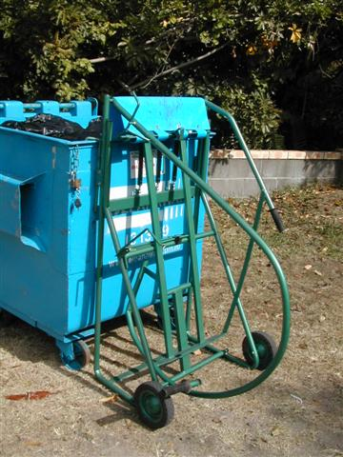
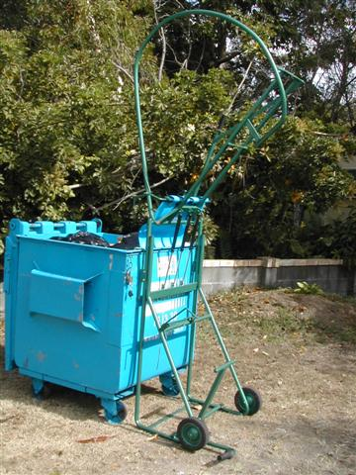
Gas Struts
Extra handle for assistant
Hoop Handle
Cradle Lip
J Hook
Foot lever
J Hook
Hoop Handle
Bin Catch
Apron
Cradle Lock
Cradle Lip
Cradle
Gas struts

1. Place the bin lifter against the skip (with wheels away from the skip). Fasten the bin lifter to skip by both J hooks and put apron over and into the skip.

- Remove padlock from cradle lock handle.

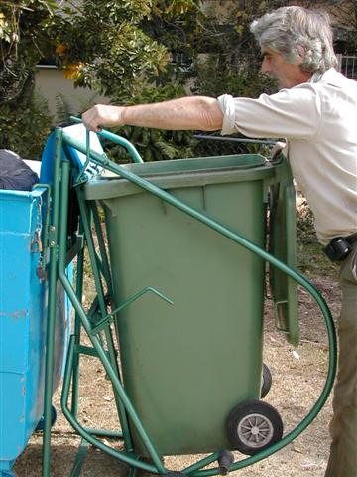
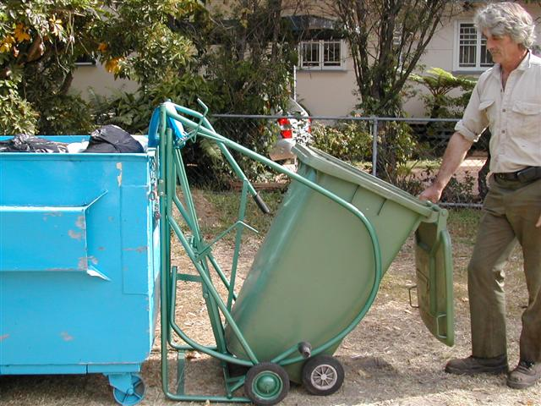
4. Push top of wheelie bin up into cradle and lift the bin handle so that the bin catch secures the bin wholly within the cradle. Use bin catch handle to do this.
3. Open the wheelie bin lid and place wheelie bin with leading bottom edge securely on cradle lip.

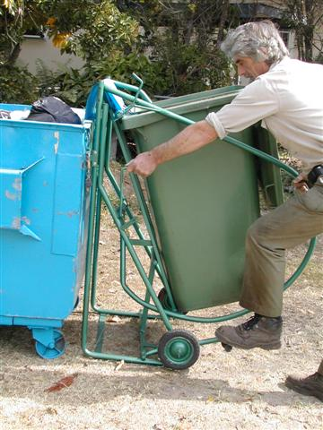
5. Standing to the left of the bin lifter and with right hand on the cradle hoop handle, release cradle lock with left hand and press down on the foot lever to start the movement.

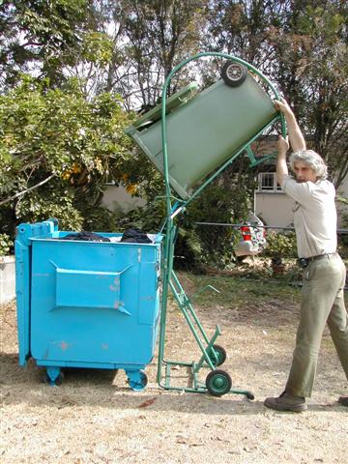
6. Wheelie bin is lifted by the operator with the assistance of the gas struts. Do not over-extend the struts by letting it crash at the end of the movement.

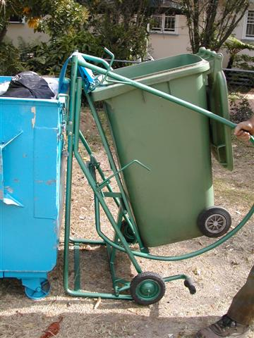
7. When bin is empty, pull cradle down firmly and make sure cradle lock engages. This is important to prevent losing control of the cradle when bin is removed.

8. Lift bin catch and remove wheelie bin.

- When bin lifter is not in use, be sure to replace the padlock on cradle lock handle. Unexpected release of cradle without wheelie bin in place could cause injury.

Important Points:
  - Bin lifter must only be used when secured to a skip or similar bin.
  - Cradle lock must engage when returning to down position.
  - Use caution when operating the bin lifter as pinch and crush injuries are common.
  - Replace bin lifter if structurally unsound (e.g. cracked/broken welds, bent cradle, missing pieces, corrosion, broken skip hooks).
  - When due for replacement, consider options that reduce the operator’s manual task load (e.g. foot pumping, hand cranking). Refer to the Waste management factsheet for further information about replacement options.

