
Partnership Initiative
Governance through shared accountability
- Formal partnerships between the community, Aboriginal and Torres Strait Islander community leaders, the school, the department, government agencies (including local government), service providers, to respond to community needs and expectations aligned to whole- of-government priorities will provide the authorising environment to design, implement and monitor local response plans, sharing accountability for their success.
,
Monitoring and evaluation
- Dedicated monitoring and evaluative approach that recognises unique contexts
- Evaluated for impact over the longer term with learnings informing how we work with other schools
- Specialised School Reviews for schools in the Partnership Initiative
A system response to improving learning and life outcomes for children and students living in in our most socio-educationally disadvantaged communities drawing on strengthened whole-of-government partnerships.
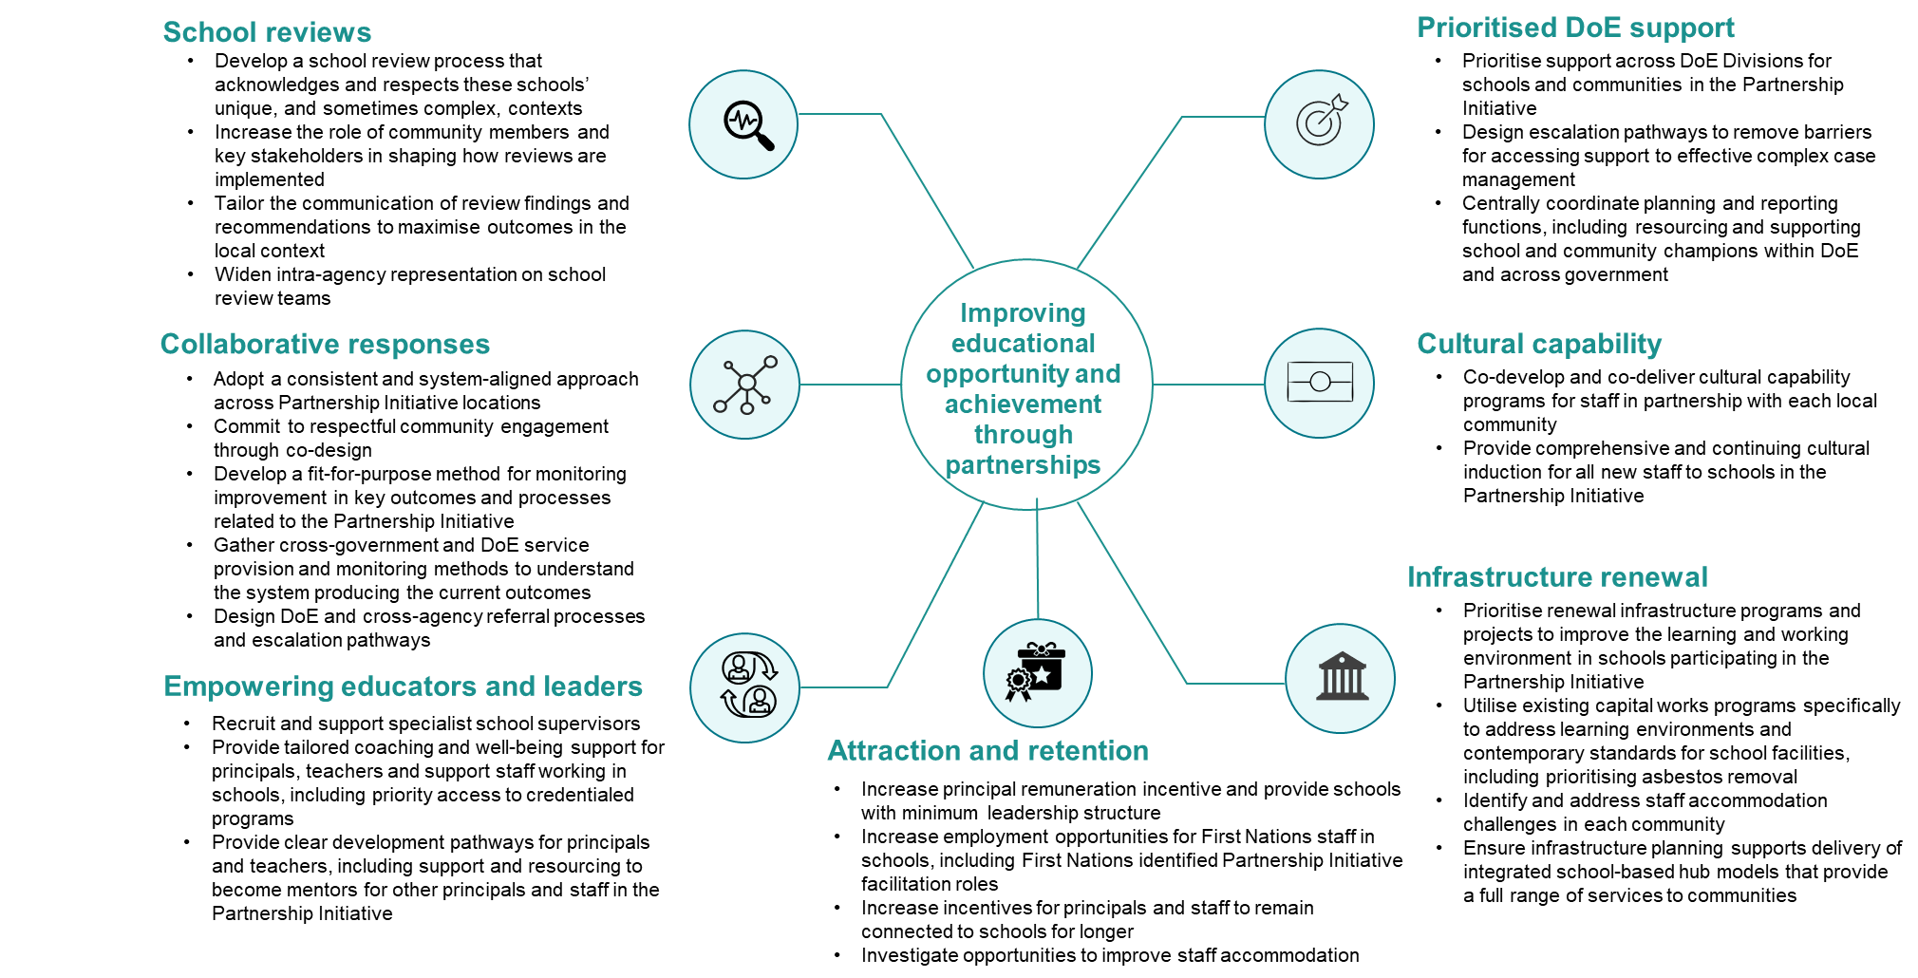

What is the Partnership Initiative?
A small number of Queensland schools are in communities that have a high degree of complexity and vulnerability. These schools require higher levels of co-ordinated intra- and inter-agency support to deliver effective local responses to community challenges and opportunities.
Schools participating in the Partnership Initiative will receive prioritised support and resourcing and act as champions for the communities they serve. Through holistic whole-of-government partnerships and collaborative community approaches, these schools will be supported to make sure that children and students in these communities have strong foundations and clear pathways for future success.
Schools participating in the Partnership Initiative will strengthen relationships between the school, early childhood education and care, the community, different parts of the government, local businesses and any not-for-profit organisations delivering services to the local area.
The Partnership Initiative approach will provide locally responsive, flexible, integrated and tailored strategies co-designed with the community. Co-designing local actions means that community benefits are understood, owned and, where possible, implemented by the community.

Identifying schools in the Partnership Initiative
Schools participating in the Partnership Initiative are identified through:
- criteria using the Index of Community Socio-educational Advantage (ICSEA); and
- inclusion of all schools serving discrete Aboriginal and Torres Strait Islander communities; and
- a small number of identified secondary school transitions settings.

Whole-of-Government alignment
The Partnership Initiative will leverage locally off a range of existing and future collaborative inter-agency work, and may include:

- Local Thriving Communities (DTATSIPCA)
- Ministerial and Government Champions (DTATSIPCA)
- Making Tracks Together (QH)
- Integrated school-based hubs (DoE)
- Connect 4 Children (DoE)
- Local community engagement through co-design (DoE)
- Family Wellbeing Services (DCSSDS)

- Community Hubs and Partnerships (DSDILGP)

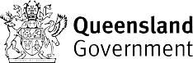
Evidence informed



achievement
 |  |  | Principles | - Student and | - Collaborative | - Cross government | - Culturally
Educational | Wellbeing and | Culture and |  | community | and co-designed | responses | respectful

engagement
inclusion

centred

Page 1 of 2

Schools participating in the Partnership Initiative
Forty-two (42) schools require higher levels of co-ordinated intra- and inter-agency support to deliver effective local responses to community challenges and opportunities
1 | Cherbourg State School (Cherbourg community) | K-6
2 | Bwgcolman Community School (Palm Island community) | K-12
3 | Doomadgee State School (Doomadgee community) | K-10
4 | Woorabinda State School (Woorabinda community) | K-6
5 | Dajarra State School | K-6
6 | Bloomfield River State School (Wujul Wujul community) | P-6
7 | Kowanyama State School (Kowanyama community) | K-10
8 | Mornington Island State School (Mornington Island community) | K-10
9 | Normanton State School | P-10
10 | Yarrabah State School (Yarrabah community) | K-10
11 | Lockhart State School (Lockhart River community) | K-12
12 | Pormpuraaw State School (Pormpuraaw community) | K-6
13 | Camooweal State School | K-6
14 | Northern Peninsula Area State College (Northern Peninsula community) | K-12
15 | Cape York Aboriginal Australian Academy (Coen community and Hopevale community) | P-6
16 | Aurukun State School (Aurukun community) | K-12
17 | Cunnamulla State School | P-12
18 | Ayr State School | P-6
19 | Tagai State College (Torres Strait community) | K-12
20 | Garbutt State School | P-6
21 | Vincent State School | P-6
22 | Innisfail State School | P-6
23 | Mount Garnet State School | K-6
24 | Cairns West State School | P-6
25 | Townview State School | P-6
26 | Urandangi State School | K-6
27 | Burketown State School | K-6
28 | Kennedy State School | P-6
29 | St George State School | P-6
30 | Boulia State School | K-6
31 | Sunset State School | P-6
32 | Rasmussen State School | P-6
33 | Balaclava State School | P-6
34 | Quilpie State College | P-10
35 | Cloncurry State School | P-12
36 | Murgon State High School (Cherbourg community) | 7-12
37 | Murgon State School (Cherbourg community) | P-6
38 | Eidsvold State School | K-12
39 | Western Cape College (Mapoon community and Napranum community) | K-12
40 | St George State High School | 7-12
41 | Mossman State School (Mossman Gorge community) | P-6
42 | Mossman State High School (Mossman Gorge community) | 7-12

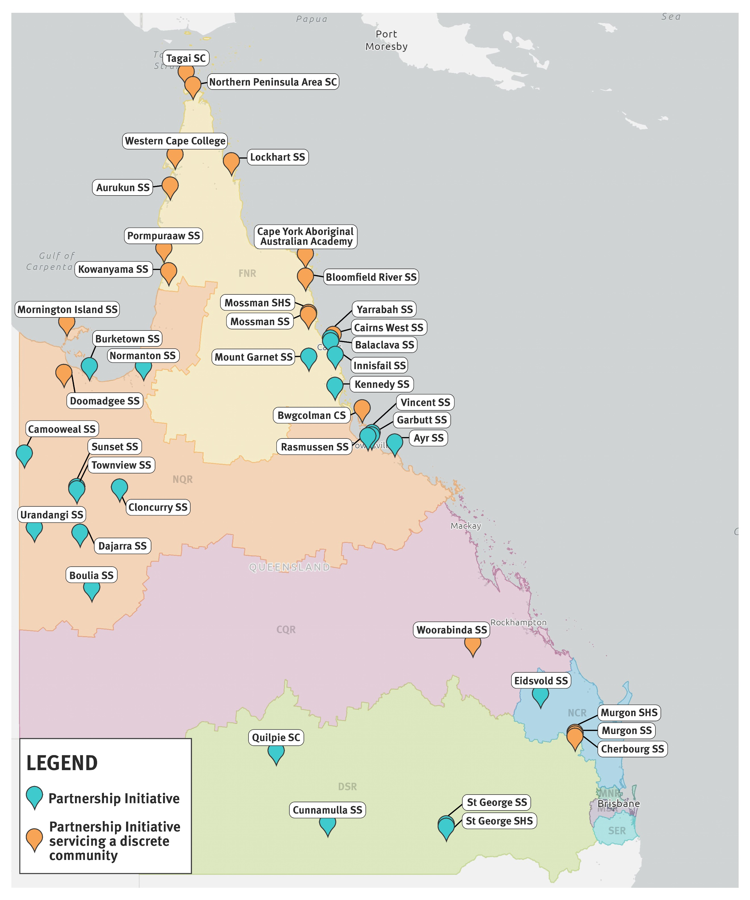

By region

NCR | 1
CQR | 1
DDSW | 7
FNQ | 17
NQR | 16

By school level

Level 1 | 2
Level 2 | 6
Level 3 | 8
Level 4 | 13
Level 5 | 6
Level 6 | 4
Level 7 | 1
Level 8 | 1
Level 10 | 1

By school type

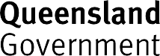
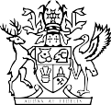
Primary school | 24
Primary/Secondary school | 15
Secondary school | 3
State Delivered Kindergarten | 20
Version: 2 December 2024

Page 2 of 2

