Health, Safety and Wellbeing Contacts | 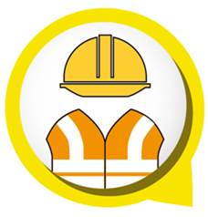 | Work Safe, Learn Safe, Be Safe  - Learn and model safe and healthy behaviour  - Take action to identify, control and report hazards  - Take responsibility for safety and wellbeing

Regional HSW network
Contacts for principals, managers and HSW roles
Senior Health and Safety Consultant:  Regional officer who provides support and assistance to principals, managers, HSAs and HSRs with the management of workplace health and safety. | name:
 | telephone:
 | email:
Claims Management Officer:  First point of contact for RRTWCs, principals and managers who have questions regarding injury management and/or rehabilitation and return to work. | name:
 | telephone:
 | email:
Senior Injury Management Consultant:  Regional officer who provides consultancy support and assistance for complex claims management. | name:
 | telephone:
 | email:
Organisational Wellbeing Consultant:  Consultancy, support, advice and training to workplaces in health and wellbeing. Not offered in all school regions. Contact the regional Human Resources area for details to complete this section.  Visit Department’s Staff Wellbeing Page on OnePortal for information and resources. | name:
 | telephone:
 | email:
Regional Health, Safety and Wellbeing (HSW) Committee:  Contact person for the regional HSW committee.  Principals, directors, senior managers and senior consultants to contact this person. | name:
 | telephone:
 | email:
Employee Assistance Program:
- Visit the department’s Employee Assistance Program web page on OnePortal
LifeWorks – Employee Assistance Program – 1800 604 640
Web Pages:
- Creating Healthier Workplaces –
https://education.qld.gov.au/initiatives-and-strategies/health-and-wellbeing/workplaces
- Health, Safety and Wellbeing – search on OnePortal
https://intranet.qed.qld.gov.au/Services/HumanResources/payrollhr/healthwellbeing/Pages/default.aspx

