School Attendance Strategies:
Results of a survey of 157 Queensland state school leaders
September 2015

APPENDICES 2-5

Appendix 2: Queensland Audit Office (2012)
Source: Queensland Audit Office (2012) ‘Improving student attendance’, Auditor-General Report to Parliament, May 2012:
http://www.parliament.qld.gov.au/documents/tableOffice/TabledPapers/2012/5412T21.pdf
Summary
Audit overview
A key objective of the Education (General Provisions) Act 2006 (the Act) is to provide high quality education to every Queensland child or young person, and help maximise their educational potential. The Act places responsibilities on parents/caregivers and on the State in relation to the education of children and young people.
Students can be absent for many reasons such as illness, truancy, family holidays or suspension. Parents and caregivers are responsible under the Act for making sure their children attend school and are required to provide reasons explaining every absence. These explanations allow schools to determine how best to support students to attend school regularly and reduce the effects of missed learning. A child with a serious illness will need different help to a child who is disengaged and refusing to attend school.
There is a direct correlation between higher levels of attendance and better academic performance. Increasing student attendance was a key strategy of the Department of Education and Training’s (DET) strategic plans in 2009 and 2010.
The Every Day Counts initiative launched in October 2008 is designed to increase awareness among parents and students of the importance of attending school all day, every day.
In 2009, the Closing the Gap Education Strategy was released. The strategy focuses on improving outcomes for Indigenous students, including attendance.
This audit assessed whether the strategies and initiatives to increase attendance have been effective. It examined:
- the department’s approach, policy, guidance and support to schools
- monitoring and reporting of student attendance by state schools and the department.
Conclusions
Strategies and initiatives to improve student attendance state-wide have not been effective. Attendance rates have remained stable, at around 91 per cent, in the four years since Every Day Counts was launched. While individual schools have improved, this has not been replicated and sustained more widely at all schools, or for all students. The same applies to Indigenous attendance rates. The gap has not closed and it is not evident it will be closed.
In addressing this challenging area, where it is primarily the parents and caregivers responsibility, the department’s performance reports focus attention on schools with below average attendance rates. However, in schools with average or above average attendance rates, there remain a significant proportion of students with unsatisfactory attendance patterns.
Current policies and reports encourage schools to focus on students who are absent three days in a row or whose absences are unexplained. While following up consecutive and unexplained absences is important, this alone does not identify all patterns of unsatisfactory attendance. Not all students with chronic absenteeism, truancy or school refusal are being identified and managed.
The focus now needs to shift to ways of better identifying and managing those students whose attendance is unsatisfactory or persistently unexplained. This requires clearer central direction and guidance, including defining what is a minimum acceptable standard of attendance.
Key findings
Attendance rates
In Queensland, attendance rates are relatively stable, at approximately 92 per cent, during the Primary Years, but start to decline in Years 8 and 9, falling to 87 per cent by Year 10. The department has not achieved its target to improve student attendance rates by 1 per cent each year.
Attendance rates for Indigenous students are on average 7 per cent less than non-Indigenous students. This gap has not reduced and the interim targets toward closing the gap by 2013 have not been achieved.
The department advises schools that chronic absenteeism is ‘variously defined’ as a student missing more than 10 per cent of the school year, but reports to schools the number of students missing 15 per cent. The year level attendance rates for Semester one are provided once a year and the extent of chronic absenteeism, truancy and school refusal is not monitored or reported.
Departmental regional offices focus their attention on schools with attendance rates that are below the state average. However, this performance data does not identify chronic absenteeism of individual students.
- In semester one 2011, around 115 000 students (31 per cent) in Years 1 to 10 missed the equivalent of at least one day or more of school a fortnight (or more than 10 per cent). Of these, more than half were at schools with average or above average attendance rates.
- The lowest attendance rates are for students in Year 10. For this cohort, 16 970 (47 per cent) missed the equivalent of one day or more a fortnight.
- At one of the schools audited, the school attendance rate was 94 per cent, but 22 per cent of students had missed more than 10 per cent of the year.
The department has policies, procedures and resources to guide schools in how to record student attendance and manage absences and there is a state-wide strategy to improve attendance of Indigenous students. There is however, no clear state-wide strategy to improve overall student attendance. The department is therefore not able to demonstrate how it will achieve its strategic objectives, or the target it set itself in its operational plans, to improve attendance rates by 1 per cent.
Managing students with unsatisfactory attendance
The schools audited are inconsistent in how well they are managing attendance, including how they:
- follow up unexplained absences
- record communication with parents
- produce and use attendance reports
- analyse, monitor and track student absences.
Schools are required to follow up all unexplained absences within three days; however, 33 per cent of the 3 million absences remained unexplained in the student absence database at the end of semester one for Years 1 to 10. When absences are not explained, it is difficult for schools to determine the underlying causes of the absence and distinguish a child who may be genuinely ill from one disengaging from school due to chronic absenteeism, school refusal or truancy.
Of the eight schools audited, four had not identified all students with chronic absenteeism. Some schools focused on students with three consecutive absences rather than total absences. One student identified by the audit had missed 45 per cent of the year. This student had not been identified by the school and therefore was not being case-managed.
Of the eight schools, three had set their own thresholds for ‘good’ attendance. These schools ran regular reports from the school attendance database identifying students whose attendance was below the school’s threshold or minimum standard. These students and their families were then contacted and management strategies put in place.
However, the other five schools relied on the judgment and vigilance of school staff marking and processing attendance rolls, to identify and report to the principal individual students with consecutive or unexplained absences. These schools had not set a minimum attendance standard and were not running reports from the database on cumulative absences or ‘unsatisfactory’ attendance.
Three of the schools had difficulty generating reports from their school databases showing the number of absences per student for the year.
The department is currently developing a broader range of reports to help schools and regions identity irregular attendance.
Addressing unsatisfactory attendance
While it is the parents’ and/or caregivers’ responsibility to make sure children attend school regularly, monitoring individual attendance by the school can identify chronic absenteeism, truancy and school refusal, and trigger actions and support from:
- the school
- parents and/or caregivers
- regional office
- counselling services
- police.
The department has developed guidance, procedures and templates for schools to help enforce the compulsory attendance requirements under the Education (General Provisions) Act 2006. The policies link to guidance on how to develop local strategies to improve student attendance.
The current procedure and guidance does not set a minimum standard for attendance that can be used consistently by schools to identify students with unsatisfactory attendance. The evaluation by the Commonwealth Department of Education, Employment and Workplace Relations of the School Enrolment and Attendance Management program in the Northern Territory and Queensland, released in February 2012, identified that having a clear definition of unsatisfactory attendance was a key factor in ensuring students are identified and referred for support.
Determining whether a student’s attendance is unsatisfactory, or unexplained absences are persistent, is left to the discretion of the principal. Schools need further advice on how to run reports to identify these students, so that all students who may be at educational risk due to their attendance are identified consistently.
Apart from the awareness raising materials issued in 2008, and some case studies, on the Every Day Counts website there are no evidence-based, state-wide programs for schools to adopt or adapt to address the underlying causes of chronic absenteeism. Three of the eight schools examined had developed their own attendance strategies and policies with supporting material, templates and forms that clearly defined unsatisfactory attendance and the issues to be addressed in improving it. These schools were able to consistently identify the students with attendance issues and had agreed approaches on how they were supporting them to improve.
Parents who do not have a reasonable excuse for a student’s absence can be prosecuted under the Education (General Provision) Act 2006. In 2006, the Act was changed to double the penalty for parents failing to send their children to school. The department prosecutes parents as a last resort. It is the only legal avenue available to principals to enforce the Act: on-the-spot fines, compulsory attendance orders or other less punitive options are not available.
In 2010, only four persons were charged under the Act for failing to meet their parental obligations to ensure their children attended school. Only 27 per cent of principals surveyed agreed this process is effective in increasing attendance.
The department does not collect all the data needed to monitor and assess how effective the process to enforce the Act is in increasing student attendance.
Recommendations
It is recommended that the Department of Education, Training and Employment:
- revise its guidance, procedures and systems to include:
- a clear definition of unsatisfactory attendance
- a consistent approach for schools to manage and track actions to follow up unexplained absences
- a consistent approach to manage and track interventions of unsatisfactory attendance.
- increase the range of OneSchool reports to help schools identify and monitor students with attendance below a state-wide minimum standard of attendance.
- provide schools with access to a range of materials and evidence-based strategies to increase attendance and case manage chronically absent students.
- assess how effective the process to enforce the Act is in increasing attendance.
- revise performance measures to include a focus on chronically absent students and publicly report progress against all student attendance performance measures.
- improve the quality of the student attendance data by:
- updating the data dictionary to cover all performance measures relating to attendance
- logging changes made to the student attendance data at the database level
- verifying changes made to the student attendance data outside of the source system (e.g. in the Collections System) are also made to the source system data.
QAO (2012) audit survey results
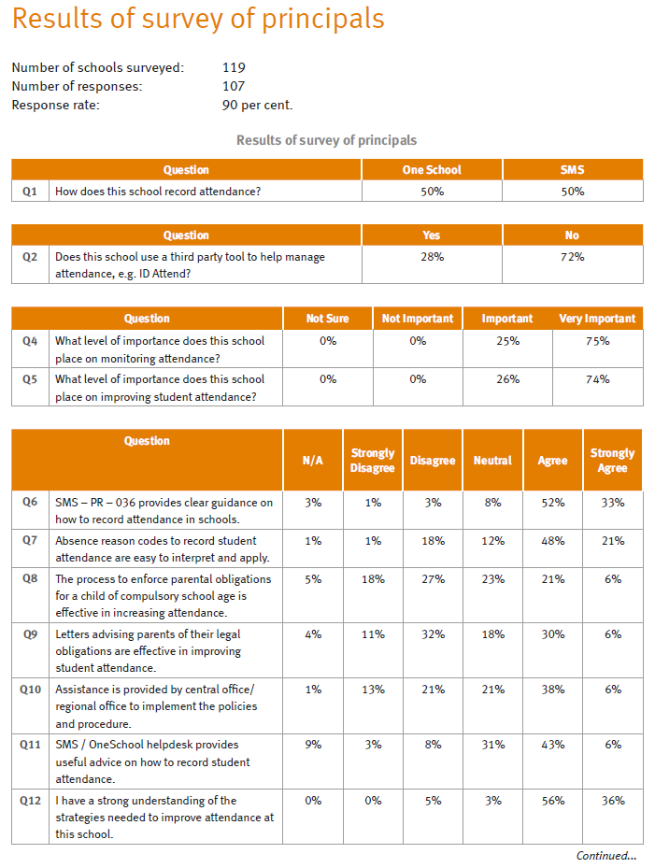
QAO (2012) audit survey results (cont.)
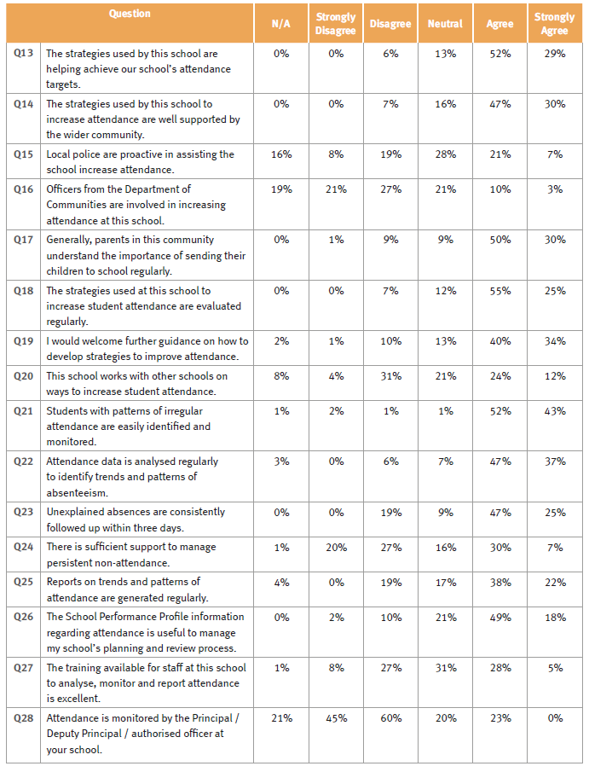
QAO (2012) audit survey results (cont.)
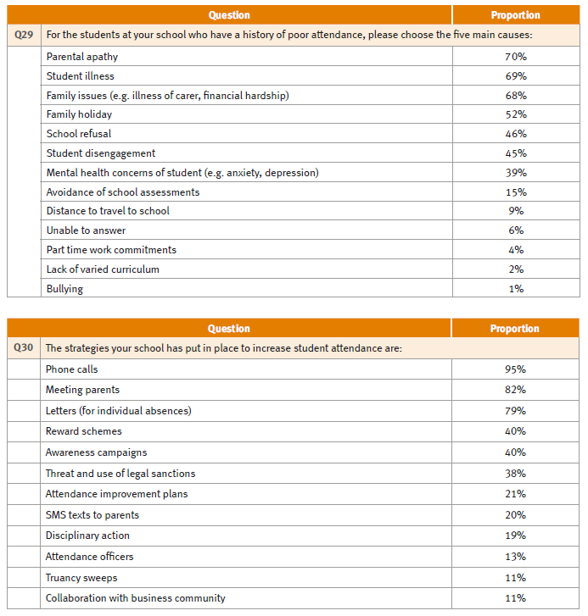

Appendix 3: Verbatim comments – Strategies used with chronic non-attenders
Respondents were asked to provide any comments about strategies for use with chronic non-attenders. Verbatim results as entered online by respondents are tabulated below (with minor data cleaning and in no particular order).
Figure 19: Other interventions and support provided by the school, and the perceived impact of these - Primary schools
Attendance type | Strategies used with chronic non-attenders
Lower | We have just implemented a strategy that targets our chronic non-attenders in the way of small rewards for (1) getting to school on time (2) attending school everyday unless parent notification for being ill.
Lower | This is an area with the indigenous families in my school that has failed. We cannot contact them and the more we contact them the more non attendance occurred. Punishment did not work.
Lower | The strategy that made the biggest difference with chronic non-attenders was going to their door and picking them up. They actually wanted to come to school but their parents wouldn't get them out of bed on time and they would miss the bus. The issue in primary school is totally with the parents. All our students want to come to school everyday and express regret and distress when they are kept at home or when their parents schedule holidays. We used to reward good attendance every term with certificates and celebrations but parents complained that it wasn't fair because it was their decision and not the students that led to substandard attendance.
Lower | The Families Responsibilities Commission is used as a partner in the attendance issue for the Cape York. This has moderate success. We have more success through positive relationships with families through teacher home visits instead of instigating welfare reform through the FRC.
Lower | Teachers driving the attendance in classrooms has made a big difference to our student attendance. Students take over the ownership of their class attendance. Chronic non- attenders, in some instances, feel obligated to attend. Teachers wearing the '100% attendance hat' is coveted by students and staff. The employment of a dedicated attendance officer has made the biggest difference. The regular monitoring and checking on attendance has been very beneficial. Ensuring those non-attenders reconnect after a period of absence, and once again become a part of the 'history, of the class, is vital. Strategies are in place to enact this reconnection phase.
Lower | Regular e-mails or phone calls has garnered the best return at my school.
Lower | Often these students come from families with significant social/drug/mental problems and are very difficult to deal with.
Lower | Off-site meetings with families at parks, cafes, etc where incentives to attend are discussed. This has proven to be very successful.
Lower | no longer have any.
Lower | Meetings are held with parents to outline our concerns and reflect on ways the school can assist.
Lower | Making children feel welcome at school and that they are important. Educating the students about the importance so they relay the message to parents.
Lower | Regular contact with families and support agencies
Lower | Home visits have been effective but only to guide parents to improve strategies or procedures at home, never to pick up students as this enables parents to avoid responsibility
Lower | Highlighting the prosecution process has a slight effect
Lower | Enlist local Police to visit families and explain legal obligations regarding attendance. Prior to 2015, implement Student Protection process.
Lower | Engagement of school 'Adopt a cop' and local Police beat
Lower | Continued contact with carer to identify validity of absence.
Lower | Complex remote indigenous schools have staff to assist with and focus on attendance whereas large complex urban primary schools have very limited staffing options. This creates a huge workload on administrative teams (school leaders and admin staff) who are already overloaded.
Lower | Chronic attendance families require significant support re school resources and partnerships to enhance attendance.
Lower | Breakfast program (toast) and tuckshop as provider of lunch (sandwich) plus afternoon fruit means students come to school to get fed. School feeds at least 30% of all students breakfast every day.
Lower | As per failure to attend procedures. Referral to support agencies.
Lower | *regular phone calls by school staff *parents often won't answer the phone calls/Text message *attendance enforcement letters sent *liaison with Child Safety
Lower | * Connection to outside agencies as well as regional engagement teams
Higher | We do not have any.
Higher | Very rare. Personal calls, followed by standardised letters of compulsory attendance.
Higher | Very difficult to make a difference without parent support. Some parents aid and abet their students to stay at home. Some are not prepared to make school attendance and punctuality a priority.
Higher | This school does not have any chronic non-attenders.
Higher | Specific meetings and follow up meetings with parents. Consistent reports and research based information being discussed at P and C meetings, in the newsletter and in parent teacher evenings.
Higher | phone calls, letters, meetings, support on re-entry, guidance catch ups, teacher involvement with parents has the most significant impact - teachers will often say most impact is when the office call but my feedback as principal from parents indicates their child's teacher is the most effective.
Higher | Parental contact is very important for chronic non-attenders.
Higher | Parent/Teacher meetings followed by Admin meeting supported by wellbeing teacher and guidance officer, followed by issuing of letters if school avoidance continues
Higher | nil
Higher | Make sure school is valued at all levels of the community and have regular conferences with the students regarding the links between their achievement and goals and their attendance. Whole class meetings utilising data books has been powerful as they record their own attendance for each term inside.
Higher | A lengthy process that allows for some students to attend occasionally only to get the authorities off their back.
Higher | Keep ringing them.
Higher | Involvement of GO and regular meetings with parents, working cooperatively with parents
Higher | Identified Case Manager to work with Guidance Officer and family (and other agencies where appropriate) to address barriers to attendance and set up attendance plan.
Higher | I am very fortunate to have to take only a handful of students. I find direct contact with the parents either face to face, phone call or email very effective.
Higher | Have tried home visits from both Guidance Officer and Police Liaison Officer.
Higher | Face to face meetings with plans set in place to ensure absentee rate improves.
Higher | Each case is unique and requires an individual approach. Our strategies target individuals and their circumstances. The one thing they all have in common is effective communication.
Higher | Direct phone contact has worked best. Parents often don't realise how many days children have been absent until data is provided to them.
Higher | Develop rapport with parent who has had bad experiences at school. Parent with large amount of children unable to get student to school; arranged for student to be accompanied to school by other parent of staff member.
Higher | Close monitoring of attendance and regular meetings with Student Support Team
Higher | Being a small community, we normally know what students are doing - mostly it is not the students but parents are disorganised, lack motivation to send student to school (not getting out of bed before 11am because of the night before etc...) In the past we have offered to get students to school by picking them up - this has worked. But under the National partnership program we had the money to do this - this. We have used our chaplain to talk to students, we have contact parents - what we have found it is not the student but the attitude and priorities of the parents
Higher | As per additional strategies and phone calls each day after 3 days to check on student well-being.

Figure 20: Other interventions and support provided by the school, and the perceived impact of these – Secondary schools
Attendance type | Strategies used with chronic non-attenders
Lower | We maintain high levels of contact with families for chronic non-attenders. Many have mental health issues or are "carers" for invalid or disabled parents. We try to organise alternative schooling for a number of these students or part time schooling when possible. These strategies often have a temporary impact but parents do not always prioritise school and do not persevere. We also run an internal alternative program for disengaged students. This program has a very positive impact on attendance for these students. However numbers are very limited due to the student-teacher ratio required.
Lower | We have used enforcement of attendance correspondence and prosecutions but they have little effect. The employment of a full time attendance officer has had the greatest effect. The school has had to fund this from GRG funds
Lower | Visits from the school support staff including Guidance Officer, CEC, School Based Police Officer sometimes achieve greater engagement.
Lower | There needs to be follow through for prosecution.
Lower | There is an attendance team that looks very closely at the attendance data every 5 weeks. The CEC and YSC are tasked with home visits for the extreme school refusers >50% attendance, ie, present and explained, to make home visits and to develop an Attendance Support Plan in partnership with the carer, student and school. In the next level of poor attendance, the SBYHN and Chaplain make contact with the student and/or family to determine how the school can support the student to attend school more regularly.
Lower | The formal process is not a quick process and difficult if parents refuse/don't have the capacity to have their child re-engage.
Lower | School staff undertake home visits. I have excluded a year 9 student due to chronic non-attendance (over year 8 and 9) in an effort to get the parent (after enforcement letters had nil effect) to engage with Senior Guidance Officers and enrol the student in a school. SGO could not contact parent successfully due to vicious dog on site. I believe student remains as a non-attender.
Lower | Referral to YSC or GO/SGO and police community liaison officer Modifications to timetable Referral to CHYMS or other mental health services
Lower | Negotiation of graduated return to school or flexible arrangements; links to external agencies; engaging with external alt programs; transition support and programs; work placements; internal student support programs/initiatives; home visits
Lower | hold the parents responsible for the attendance of their children by making it easier to lose government entitlements
Lower | Early home contact; Letter to parents advising of importance to re-engage; Compulsory attendance letters sent; Use of Canc of Enrolment
Lower | Compulsory School attendance letters often still do not result in students attending school. Often concerns with mobility, change of address / contacts. Would be good if OneSchool could include confirmation that they are enrolled at another school whether it be State, Private or Interstate. Many post-compulsory students eventually are cancelled at many schools.
Lower | 2 years ago I employed a parent liaison officer to work with the youth worker to address chronic and serious attendance, the majority of parents said all the right things however they never followed through, in the end after engaging for sometime with the support structures these 2 people provided they went to great lengths to avoid the support we put in place for them and refused to engage and encourage their children to attend
Higher | Targeted intervention and home support. Getting to the root cause of the problem and wrapping support around to encourage engagement and attendance.
Higher | Strategies that involve students, carers and school staff are the most effective for students who are absent due to refusal and mental health issues. Strategies that increase students feeling of belonging are the most effective for overall improvement in attendance.
Higher | Standard Department procedures followed closely
Higher | Interventions with tailored solutions including agency referrals, pathways to alternative providers, use of flexible or alternative arrangements
Higher | Individual tracking, adjustment of programs, involvement of additional agencies (where available).
Higher | For persistent school refusers it is extremely difficult when there are underlying Mental health issues. Parents often enable their child as they " can deal with the fighting anymore"- they will often say it is easier to give in.
Higher | Developing a supportive relationship with family and school that identifies the potential blockers for the individual. Utilising the range of support mechanisms , internal and external to the school, to build the level of personal resources of the individual to face their issues.
Higher | Case management via relevant subschool committee - Senior, Year 10, Junior. This includes DP, GO, Year cos and HODS.
Higher | As indicated on this survey's previous pages
Higher | Targeted intervention and home support. Getting to the root cause of the problem and wrapping support around to encourage engagement and attendance.

Figure 21: Other interventions and support provided by the school, and the perceived impact of these – Combined schools
Attendance type | Strategies used with chronic non-attenders
Lower | We do a lot of home visits. We use a range of support for the student and parents. Some are school programs, including the Chaplain, Guidance Officer and teachers. We make referrals to the many agencies that we have in town to support students and families.
Lower | Attendance contracts with students and their family members have had a significant impact on student attendance rates. Involving other community members in this process has also seen positive change.
Lower | Followed up by RSAS staff. Weekly report of reasons given, visits made and attendance is generated.
Lower | HOME VISITS (EARLY) ELDER INVOLVEMENT WITH PARENTS ENCOURGAING THEM TO SCHOOL STRONG RSAS TEAM - LED WELL SIMPLE CLEAR AGENDA AROUND ATTENDANCE - EARLY INTERVENTION ON A DAILY BASIS REGULAR AND 'POSITIVE' COMMUNICATION WITH FAMILIES ABOUT THE 'GOOD THINGS' THAT ARE HAPPENING (MAKE THEIR DAY APPROACH/ FISH)
Lower | Regular contact with families and support agencies
Higher | Home visits, reduced timetables.
Higher | Attendance needs to remain on the agenda every day.
higher | Some improvement as a result of letters but some parents do not seem to care

Appendix 4: Verbatim comments – How the department could support schools
Respondents were asked to provide any comments about what the department could do to support schools in increasing attendance. Verbatim results as entered online by respondents are tabulated below separately for primary and secondary schools (with minor data cleaning and in no particular order).
Figure 22: What the department could do to support schools in increasing attendance – primary schools
Attendance  ranking | What the department could do to support schools
Lower | Ensuring that our school is a part of the "catchment area" for students with chronic non-attendance parents to have Centrelink payments monitored.
Lower | Provide a liaison person who can deal with the students that are truant. This person could have the back- up of the police. This liaison person can find out what the child needs to get them back to school.
Lower | Dedicated PR campaign on taking holidays during school term. Much tougher public message on school attendance. Current every day counts campaign is too subtle and parents still don't think it's a big deal. Message intensity needs to be increased (ie same intensity level as second hand smoke, obesity and immunisation). There also needs to be tougher penalties for not sending children to school - ideally, an incentive like the recent commonwealth initiative with immunisation and family benefits, however, I'm not sure if it would work with a chronic and habitual behaviour like attendance as opposed to a few very infrequent events like immunisation.
Lower | Make the official legal process far less complicated and ensure it has 'teeth' and actually sees a prosecution. This has not been our experience.
Lower | We have just enrolled a student who has previously had chronic non-attendance. At previous schools support and official notices have been ignored until they decide to move schools, how do we as a system address the same pattern of behaviours that keep repeating? (Year 6 student, last year attended 64% of the school year at their previous school).
Lower | Dedicated person who deals with extreme problems.
Lower | Make consequences for not attending ( chronic more severe with less red tape)
Lower | Educating parents using media about the importance of school and ensuring that those who do not follow rules of attendance are responsible for their actions.
Lower | Truancy officers that support clusters of schools- funded by Region or DET- full time with a social work background Supply footballers or media starts to visit schools to spread the word that they have to be here at school. More powers for prep students attendance- creating a behaviour about attending and not legal
Lower | As our school has a high percentage of parents who are apathetic towards education and have very low socio-economic levels, a dedicated attendance officer would be put to great use.
Lower | Government to cut welfare payments
Lower | Providing extra funding to support the employment of an attendance and engagement officer for schools with high absence rates
Lower | Have an absence team in place whose sole objective is to pursue carers in relation to high level, continued, absence - especially to support small schools, where limited staff, are concerned. This team would be fully versed in the current legislation, policies and consequences, that can legitimately be applied.
Lower | Provide specialised attendance officers and/or increase Primary administration staffing so that it is physically possible to follow up the way we need to in order to improve attendance.
Lower | Allocate funding for breakfast program to schools like [SCHOOL NAME] with very low ICSEA value as part of the funding formula. Allocate funding for a Connectedness (mobility officer plus data gathering) for schools like [SCHOOL NAME] with very low ICSEA value as part of the funding formula. Costs a lot for small schools like [SCHOOL NAME] with a dysfunctional community.
Lower | More government support/consequence for families with poor attendance without reason. Advertising in media and in the community. Police support for truancy.
Lower | For [SCHOOL NAME] - we need a dedicated officer (EQ)and the principal (me) to knock on doors and escort our non attending students to school -(wouldn't do this in this community without some security- not comfortable doing this on my own or with school staff as it would put us at risk of harm); EQ could offer small workshops for parents around attendance, but for our parents to come along - you'd have to provide a shopping voucher for every parent who attends -otherwise they won't come; a targeted marketing campaign by EQ with news/radio/advertorials identifying the benefits of students attending school and the consequences if they don't attend.
Lower | * The need for a permanent engagement district team to support schools.
Lower | I think the government should review centre-link payments based on attendance to school.
Lower | Truancy officer at each school or school cluster to specifically find non-attendees and bring them to school.
Lower | Support through attendance officers visiting homes.
Lower | some extra assistance in follow up of students not responding would be of benefit
Lower | Negotiate with other agencies such as police and DChS so that there is a triangulated approach to absenteeism. All agencies should be involved
Lower | Link attendance to Centerlink payments. Ultimately, the parent is in control of attendance and needs to be motivation to maintain consistency for the betterment of their children. Regular non-attendance generally has been due the parent being unable/unwilling to get the children to school on time or at all due to lack of organisation or commitment the education of their child. There are no real consequences. If formal letters are issued, the staff then have to deal with escalated abuse and blame from the parent, or the family moves to another school. This cycle then continues. The child is then left to cope with the gaps in learning and the social/emotional associated with moving schools/systems.
Lower | Automated messaging service integrated into OneSchool so that parents would be notified as soon as the roll is marked each day.
Lower | Attendance Officers shared in a cluster arrangement
Lower | Allow schools to take legal action more quickly so parents take it more seriously.
Higher | The engagement of students is the key. Providing based curriculum and extra curricula activities eg Stephanie Alexander Kitchen Garden Program, an extensive leadership structure for students, the valuing of student voice, clear and varied parent communication, a curriculum based on real life issues and global reach. The employment of a CLO has been one of our most effective strategies.
Higher | Whilst not applicable to this school, regionally based, mobile attendance officers working with police as needed.
Higher | Attendance officers and buses to collect students. We do this in our own cars currently meaning that we place ourselves and our own personal vehicle at risk. Please provide shared resources across primary schools to make a difference.
Higher | Negotiate with the Politicians about restrictions on parenting payments for families who keep children home regularly. Negotiate with Australian companies about breakfast programs and hot lunch programs (how to eat at a table and communicate around meals), would provide additional benefits.
Higher | The prosecution letters are not worth pursuing. Chronic non-attendance is very tough for schools and some sort of additional family liaison officers would be worthwhile. In indigenous communities where I worked we had support with liaison officers and you would visit the families but working in metro the expectation is very different and I would not take this approach here. I think some other agency would be helpful. I have sent the letters but often they are not opened and returned via mail even when registered mail. it is one pathway but never an effective one - it decreases the trust and positive partnership and does little to improve attendance of child.
Higher | Some support around the reports that can be run to identify attendance trends would be appreciated.
Higher | Fund programs that are innovative, engage and inspire students to be part of a community of learners
Higher | provide better transport options in rural areas
Higher | I already feel supported through my PAES
Higher | Tell families that they are depriving their child of life opportunities. Link their Centrelink payments with satisfactory school attendance.
Higher | Issues with non-attendance not being a Student Protection issue - surely non-attendance of Year 1 student (compulsory education) and low attendance of prep (non-compulsory education) is a life barrier and hence a Student Protection issue?
Higher | I felt supported when I have called on Regional Office or the Legal for help.
Higher | Follow up chronic non-attenders from a Regional level - when Principals do [and send those Form 4 and 5 letters] we are seen as uncaring and after them - and has dire consequences for the school/home relationship. Putting a name on it from a Regional Attendance person takes away from the level of personalisation that comes from the Principal they know - we can say the attendance data is analysed by the Region and prosecution comes from them. It is step removed from the school then.
Higher | Provide free SMS messaging service linked with Oneschool for all schools. When unexplained absence is recorded, SMS is generated.
Higher | Actively assist in following up students who do not attend - eg. providing a truancy officer for primary schools.
Higher | If the Department could supply a 'Truancy officer' schools in an area could access (one day a fortnight on flexible a timetable)- this would solve any absenteeism (I know there is no money... but if the Central Office is serious then this would be the way to go.
Higher | The letters to parents regarding legal responsibilities and possibility of legal action are not taken seriously by parents and the process has too much 'red tape'. In many cases it is the actions and inactions by parents, who do not respect education or educational authority that result in high absenteeism and students not being discouraged to stay home or encouraged to attend. Certainly at my previous school where I battled with high absenteeism by some students. I implemented a pick up support structure to collect students for parents, provided clothing, breakfasts, lunches, conducted support meetings etc. Legal responsibility letters were ignored, had no effect and prosecution processes were difficult. Even Child Support and SCAN teams did not, or could not effect changes or support in these circumstances. Multi-agency support was not effective for chronic non-attendees either. You need family support!
Higher | Social Worker options (as a cluster).
Higher | Provision of Home School Liaison Officers to do initial and follow up visits and support families who have poor attendance records
Higher | Provide a School Friendly parent attendance pack that schools can be issued with to send home to parents and caregivers.
Higher | How to convince the P&C committee that a reward program that recognises improved or good attendance is a positive step. Some P&C members feel it is unfair if students miss out on receiving an award.
Higher | Feel that the letters we send to parents don't have any legal teeth. Parents say their children are sick but often they are not.

Figure 23: What the department could do to support schools in increasing attendance – secondary schools
Attendance  ranking | What the department could do to support schools
Lower | Increased and improved support for student mental health issues
Lower | In schools with low attendance because of community socio economic factors the department could look at providing a funded attendance officer. Our school uses a range of strategies to improve attendance, including the department letters leading to prosecution. At this point Regional or higher intervention/support of these students needs to be provided.
Lower | 1. The Every Day Counts materials are useful and make an impact with parents. A regular change to the presentation of this material and the inclusion of new videos and brochures would mean that it remains fresh. 2. Fund an Attendance Officer. Currently we use 0.5 FTE of teacher time to release a staff member to follow up on attendance/truancy. This is particularly important in a high school setting. 3. Ensure sufficient funding for multiple support staff remains available. Schools need a range of staff (GO, CEC, Nurse, Police, Attendance Officer, Social Worker etc) to address the many different issues that hinder student attendance.
Lower | Prosecute parents and simplify the paperwork involved in reaching this step.
Lower | Fund truancy officers for schools that have low attendance statistics. Ensure that the prosecution letters and follow up with families once prosecution is imminent.
Lower | Access to locations e.g., flexi-schools for students is incredibly difficult to negotiate.
Lower | Senior Guidance or Department engagement officers could undertake home visits with school refusal, long term non-attendance
Lower | Speed up the process for prosecution and make the process more user friendly Provide additional TA/GO or YSC time to follow up with students poor attendance
Lower | Additional resources to support schools (particularly in low SES areas) in tracking and improving attendance; regional support for schools in targeting and re-engaging chronic non-attenders; provision of an alternative educational facility for at-risk students (particularly for compulsory schooling)
Lower | Put teeth into legislative process, so that complacent families have real pressure to convince students attend.
Lower | Better system of 'flagging' students on OneSchool who have consecutive absences / poor attendance. Interesting to have some set benchmarks and procedures for students below those benchmarks. Sharing of best practices.
Lower | The legal process much simpler, having followed the whole process to court in Tully and having it fall over was extremely disheartening and didn't help change the family ideas
Lower | Funding for dedicated Participation Officers to build relationships with students and families and support staff with strategies to re-engage students. Dedicated funding to support families in need who avoid school for financial reasons – e.g. Uniforms, lunches, text fees.
Lower | Additional support once the T letter process has been followed and there has been no change in absences.
Lower | Further support to provide alternate pathways/education options for students that have disengaged with mainstream schooling.
Higher | School Based Police Officer. Link attendance to welfare payments (schools given the ability to notify Centrelink of chronic non-attendance)
Higher | Further AO hours for parent liaison of students with <85% attendance .co-ordinate State and Federal agencies to provide interventions and parental accountability for chronic absenteeism

Attendance  ranking | What the department could do to support schools
Higher | 1) Parents know that the letter of threat will never be followed through - why bother. 2) We have funding for a Senior Pathways Officer (clustered). This is great for aligning the disengaged with some positive future training/employment options. More funding for these types of positions. 3) The GO is the best positioned officer to deal with the chronic refusers/disengaged - yet we have had an effective cut in our allocation (due to year 7s) - with more and more mental health issues surfacing this reduced allocation is reducing their impact on attendance/ engagement. 4) Improve funding for CECs as they are at the frontline to close the gap - you need Aboriginal people to work with Aboriginal families at the coalface to improve attendance. 5) Secure more funding for Youth Support Workers - we have a wonderful person in the position but only one day a week for 1500 students.
Higher | Successful attendance strategies rely heavily on the use of human resources, schools can make decisions about the use of resources but this has a limit. The capacity to access additional resources to support school strategies would assist significantly to address this issue
Higher | More outside agencies available to work effectively with schools. More funding for schools to employ more staff or to be used specifically to improve student attendance.
Higher | I have significant experience in leading attendance improvement in two schools. At [SCHOOL NAME] we improved attendance from 77% to over 90% consistently. At [DIFFERENT SCHOOL NAME] we have moved from high 80's into the 90%'s.I have developed some firm views on what is required. I also believe that the vast amount of non-attendance is parent sanctioned. Our work has been recognised within and outside the system as being effective. The link between improved learning results and attendance is irrefutable. We seem as a system and society to accept that on average around 90% is good enough. That means that on average every student in Queensland misses a day per fortnight. If system leaders and politicians don't get serious about attendance the slack approach from families will get worse and attendance will continue to slide. This is not a school issue. This is a societal issue and should be tackled by state leaders (not school leaders) with firm, non-negotiable consequences for parents who do not ensure that their children attend school everyday. This should include fines. Student non-attendance is parent neglect. The department should be advocating for politicians to enact legislation that gives us real power to not approve student absences and then refer families to legal processes that actually work.
Higher | Continued sharing of successful strategies of improvement. Funding for dedicated attendance support staff.

Figure 24: What the department could do to support schools in increasing attendance – Combined schools
Attendance Type | What the department could do to support schools
Lower | DEDICATED ATTENDANCE OFFICERS, WELL TRAINED
Lower | Attendance Officers employed by the school under the RSAS program have been successful when working with families and students to get them to school. Although funded by the Federal Government, this program could also be extended to other schools.
Lower | Until parents who are legally liable for non-attendance are actually brought to account by the government certain families will never have children who attend.
Higher | Strengthen the departmental truancy process to include real consequences for parents.
Higher | A designated attendance officer at a regional level.
Higher | Additional resources to monitor and work with non-compliant parents
Higher | Advertising campaign 2 weeks prior to school recommencing each year about getting ready to return to school - like each sporting code does prior to signing up for the season. Consideration in the budget for petrol and vehicle costs for staff to undertake home visits - or provision of department vehicles for use on set days to complete these tasks.
Higher | Truancy officer for home visits

Appendix 5: Verbatim comments – Final comments
Respondents were asked to provide any additional comments about student attendance or feedback on this survey. Verbatim results as entered online by respondents are tabulated below (with minor data cleaning and in no particular order).
Figure 25: Additional comments about student attendance or feedback on this survey – Primary schools
Attendance type | Final comments
Lower | A very timely survey. Thank you.
Lower | Improving attendance is an essential part of our school culture, but it continues to be the most challenging part of our improvement agenda.
Lower | In my location parents often take their students to specialist appointments/doctors appointments because they cannot arrange them in the weekend and it is too far for them to make it back in time for school pick up.
Lower | As a Principal I feel that all the responsibility is left up to us and the department does very little to provide material support apart from telling us that we need to improve our attendance.
Lower | More actual brochures- not downloads that have to be printed- more postcards and posters sent to school to save time and money
Lower | The legal registered post letters do not work, and have never worked, and lead nowhere. Most of our students with poor attendance move around a lot and camp with different family members so the letters normally don't reach them anyway. They are painful to prepare and we don't have time or staff to be consistent with them. This whole process needs to be revised.
Lower | Daily parades in the morning ensure students know they must be at school in time for the daily behaviour challenge parade. The daily [SCHOOL NAME]Voucher rewards are based on the behaviour target. Example: this week is Be a Learner Week and today's behaviour target is 'first time, every time.'
Lower | We are trying everything and more and are open to suggestions for support with this issue; *the general apathy of the parents/carers in the community for valuing education, teachers, schools and attendance is widespread; *the issue is not a simple one at NSS-many of our indigenous students have been at Cherbourg last term on Sorry business - even though this is non-school attendance - culturally this is an important activity for these students to participate in-maybe some of the attendance categories could be changed to reflect this; *we have one family who is regularly visited by police, child safety and I'm again up to recommending prosecution for the parents - but they take no notice. They simply say their children are being bullied at school and they won't send them to school. These children haven't attended school for most of term 1 and are not here today. What should I do? In my experience, recommendations to prosecute are often overturned because proceeding would not be in the best interests of the wellbeing of the family and so we start again - doesn't seem to be enough of a deterrent to get these children to school.
Lower | OneSchool option to generate individual class attendance data, daily, weekly, termly, year to date and option to compare this data.
Lower | The biggest barrier for children is the parent's attitude and value of education.

Figure 26: Additional comments about student attendance or feedback on this survey – Secondary schools
Attendance  Type | Final comments
Lower | The school spends a large amount of its resources on improving student attendance and this is a HR and financial drain that is consequently not available for student learning.
Lower | When a school is implementing many strategies, it is impossible to accurately identify which of these strategies is having an impact.
Lower | As with all things in schools, every school and context is different. If support is provided by the department it needs to be differentiated to support the schools and communities that have the most difficulty in ensuring children and youth do attend school. The research tells us that students who do not attend regularly in primary school are most of risk of failing to develop their literacy skills. By the time these students get to high school they do not have good attendance habits, they are disengaged because they are not able to read effectively thus hindering their life chances of being successful at school or as a decent citizen of the future. It is my perception based on my current context that if parents are held to account in primary to ensure student attendance that the problem is so much harder to combat in the secondary years.
Lower | Truancy officers (as many schools employed under National partnerships could be employed by the department (in conjunction with Department of Communities) given a title such as School Engagement officer, car and phone and actually visit chronic non-attenders and encourage them to return to school.
Lower | Student mental health is becoming more and more of an issue with attendance. It takes significant time for GOs, HODs (Welfare), DPs and Principals to assist students and their attempts to engage in schooling. Students that are admitted to metal health facilities often turn up back at school within a few days and sometimes the following day. Schools are not adequately equipped for this. Parents work and can't afford to stay off work to care for their child and the pressure is put on schools to work it out. Not to mention the impact on students witnessing the breakdowns in the school.
Lower | Strategies from survey feedback should be shared, with link to responsible school(s).
Lower | There are a small group of families who for a whole range of reasons do not send their child to school and do not value education, in many cases we have found these families to be in significant crisis with mental health issues of both parents and students and parents having very little control over their teenager, we have thrown every support mechanism we can think of at them and they are just not ready to engage of change the very worst attenders repeat for every child in the family
Lower | As a small mining community with limited services a large proportion of our absences is related to families accessing these services (Medical, Gov't, etc.), and the mine shift pattern (days on/off) impacts on absences in a number of families. The transient nature also contributes.
Higher | Our school has raised attendance from 92 to 95% by paying greater attention to tailored intervention where required, acknowledging the 66% of our students with 100% attendance, having incentives for all and quality relationships with families that necessarily value learning and who understand learning continuity can only be achieved through regular and consistent school attendance.
Higher | Some of our most significant issues are to do with students verified as ASD who experience high levels of anxiety. As they get older they say " I can't take it anymore"
Higher | Our implementation of ASOT with an emphasis on improving student engagement in all classes also had had a major impact (couldn't fit in on previous page)
Higher | A complex issue we will continue to work hard to improve.

Figure 27: Additional comments about student attendance or feedback on this survey – Combined schools
Attendance Type | Final comments
Lower | The emphasis should be on early years (Pre-Prep). Fund full-time programs for all pre-prep aged children in low socio-economic areas. This sets up a pattern of schooling which can then follow through into the later years. It also aligns with the AEDI data that stresses the main learning time is 0-6 years of age.
Lower | We use the letter system but find this very frustrating and not effective.
Higher | Unless there is parent support for ensuring that students are attending school and arriving on time, it is virtually impossible to improve student attendance. Students who have parents who value education will ensure their children attend and these students value knowing what their attendance is and being recognised when they consistently attend. Families who exist in a cycle of unemployment provide no role modelling or encouragement for breaking the cycle.
Higher | When it comes to the crunch, it is too difficult to enforce any serious penalty.

