INSTRUCTIONS – each SOP must reflect your site, equipment and activities
1. Read:
Review: Read and review the SOP contents against local operating practice
Manufacturer’s Instructions: Align the SOP with the equipment’s instruction manual for technical safety
2. Consult:
Feedback: Consult with users to ensure the SOP reflects practical site usage
PPE and RPE Assessment: Evaluate the specific materials being used, the equipment features and local ventilation options. Determine the exact Personal Protective Equipment PPE and Respiratory Protective Equipment RPE required
3. Update:
Customisation: Edit the SOP content to reflect instruction manual feedback and specific site-based risks. Adjust PPE & RPE requirements to reflect assessed needs
4. Footer Details
Date of Review: Record the date the school review was completed
Reviewed By: Who completed the school review
Next Review: SOP must be reviewed annually or with any change to process or equipment
Version: Retain for tracking template control
5. Approve and Print:
Finalise: Ensure the reviewed SOP is signed and dated
Visibility: Provide the colour printed SOP where it is easily accessible to all operators/users
6. Schedule Review:
Maintenance: Review and update this SOP annually, or immediately if equipment, work processes, or legislation changes

Personal Protective Equipment (PPE) Signage
Add or remove icons from the SOP template as appropriate for your specific piece of equipment
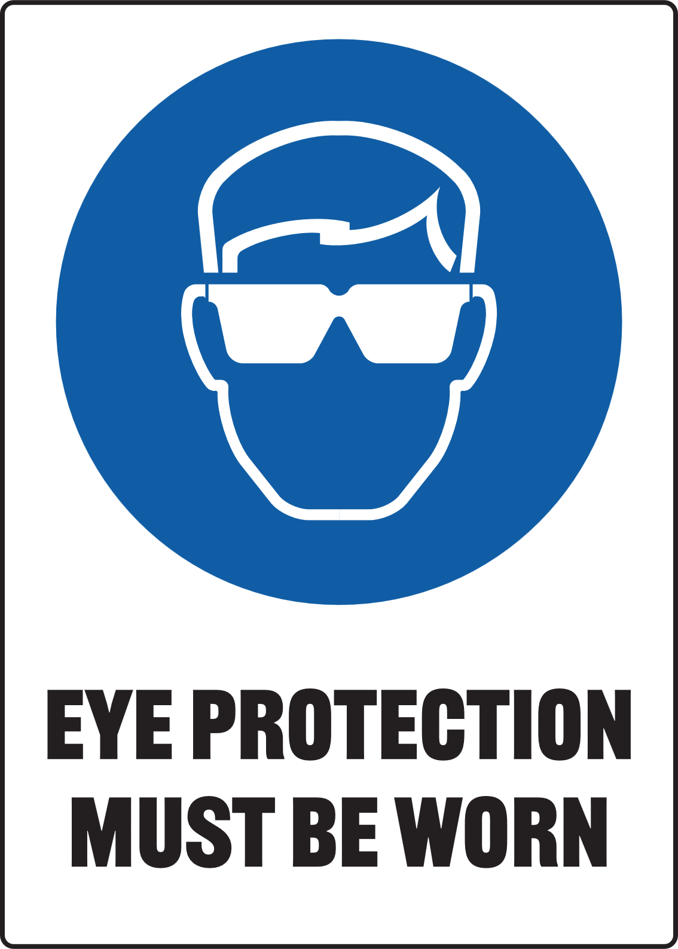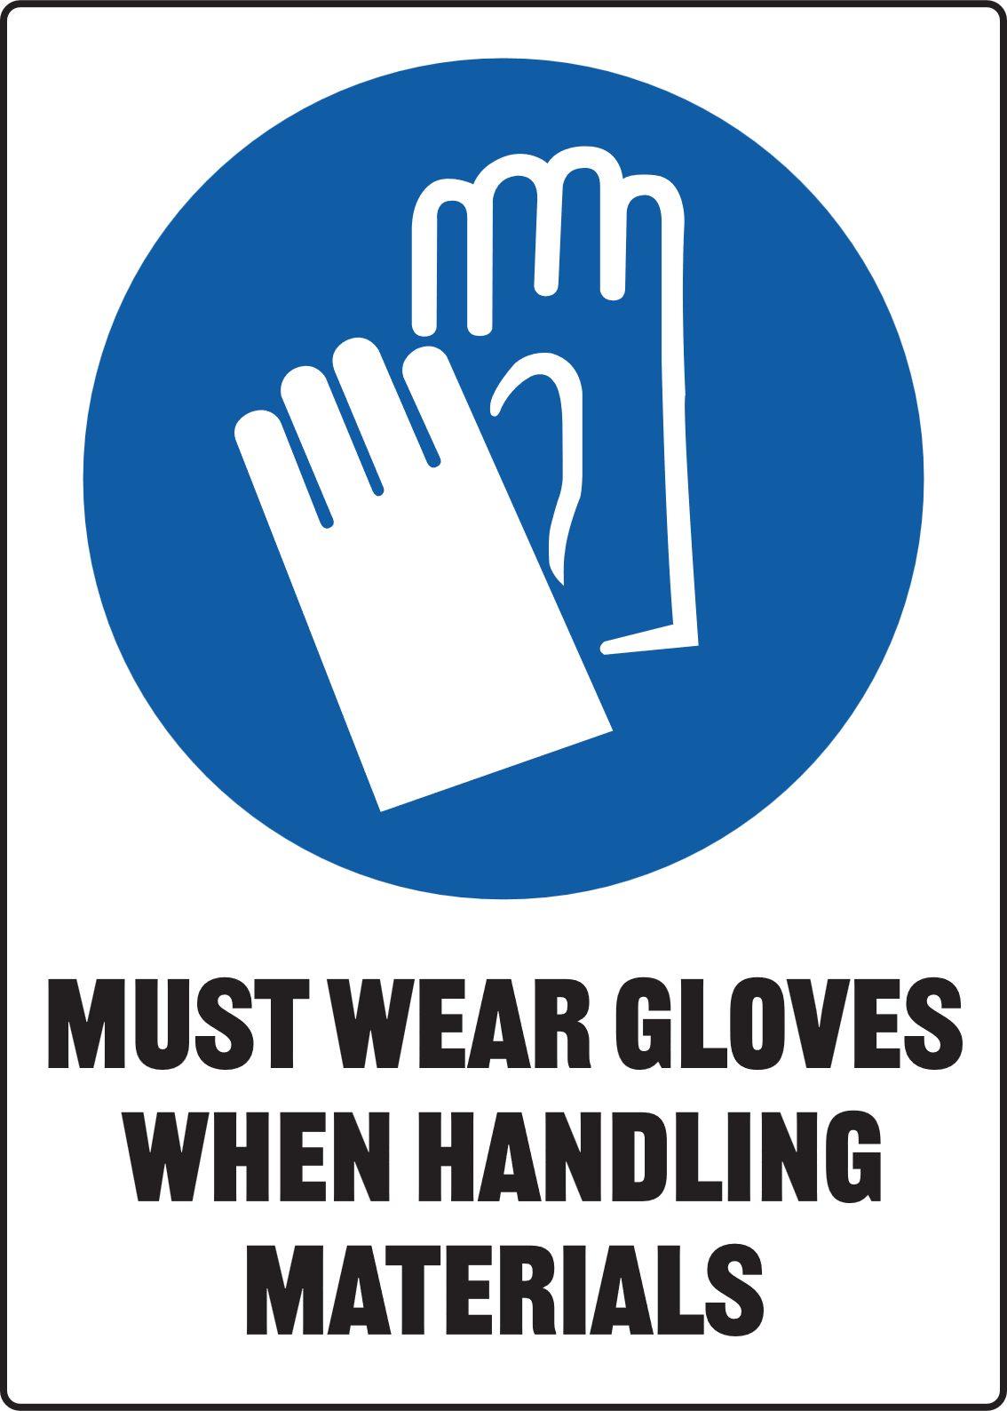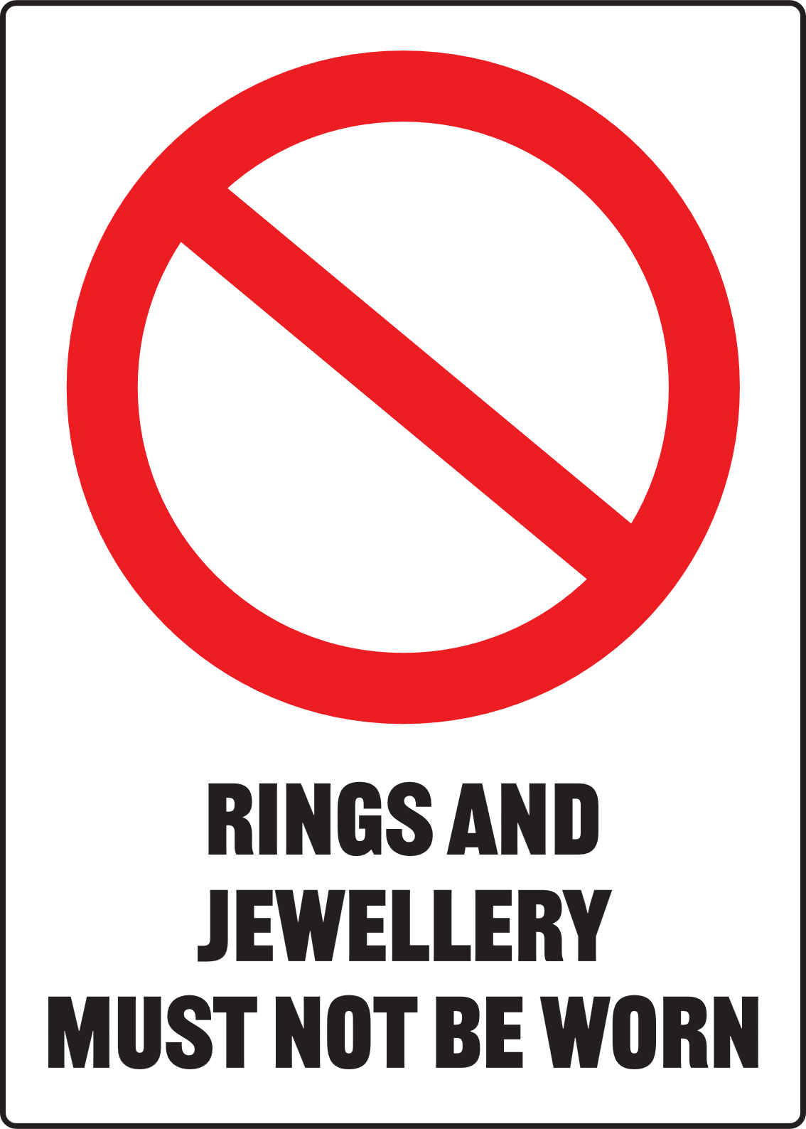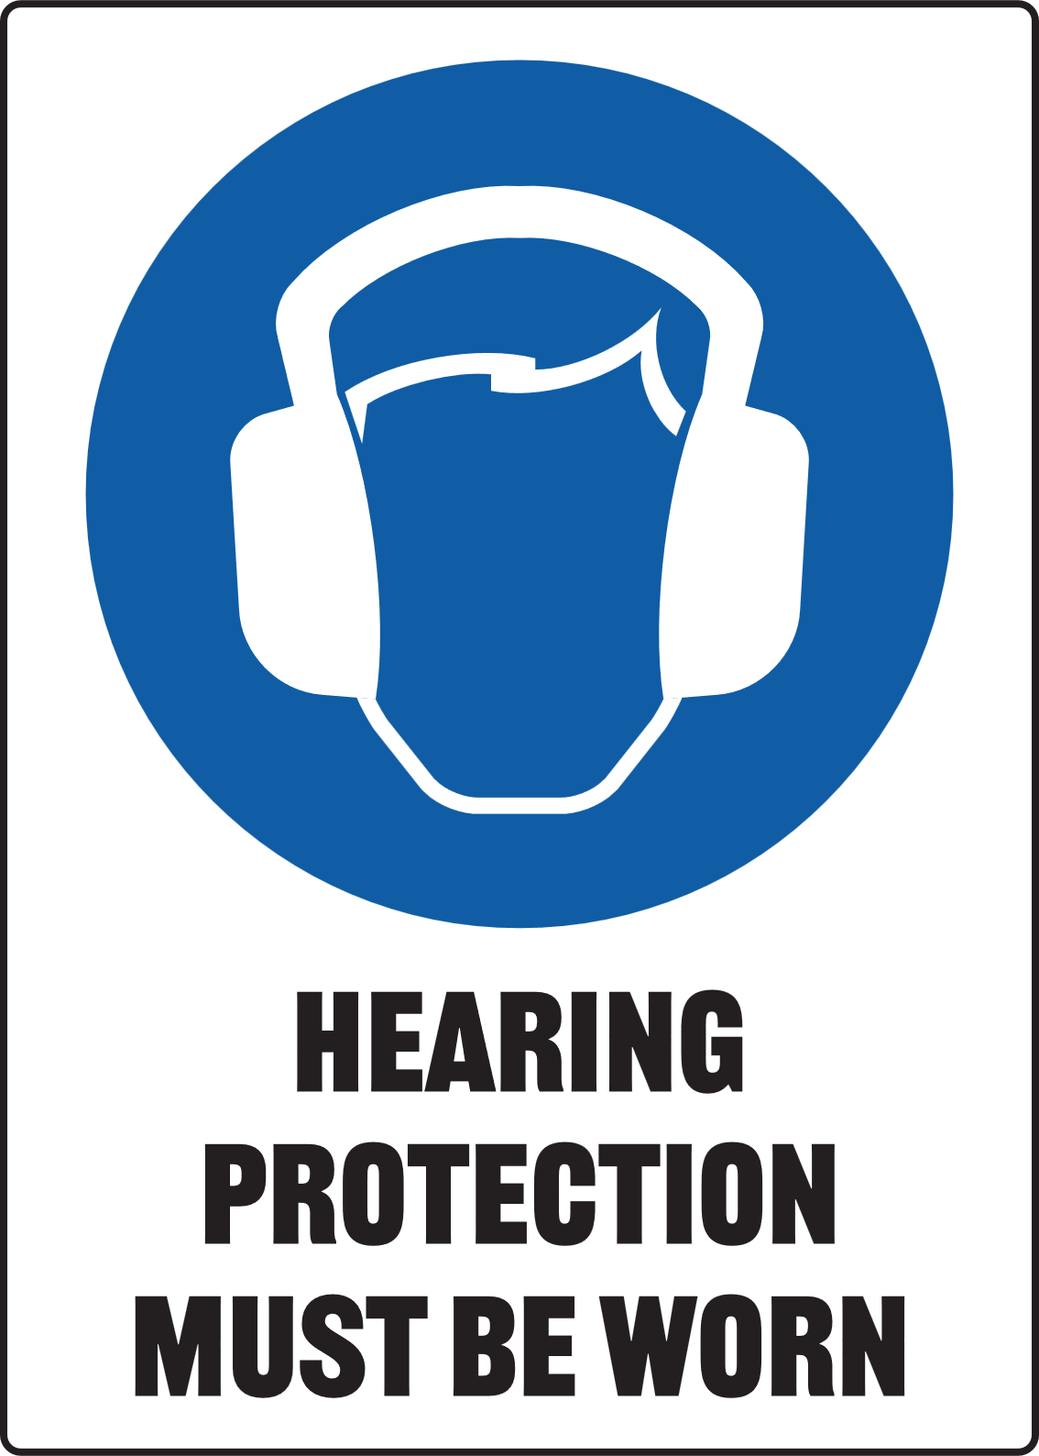
PROTECTIVE CLOTHING MUST BE WORN

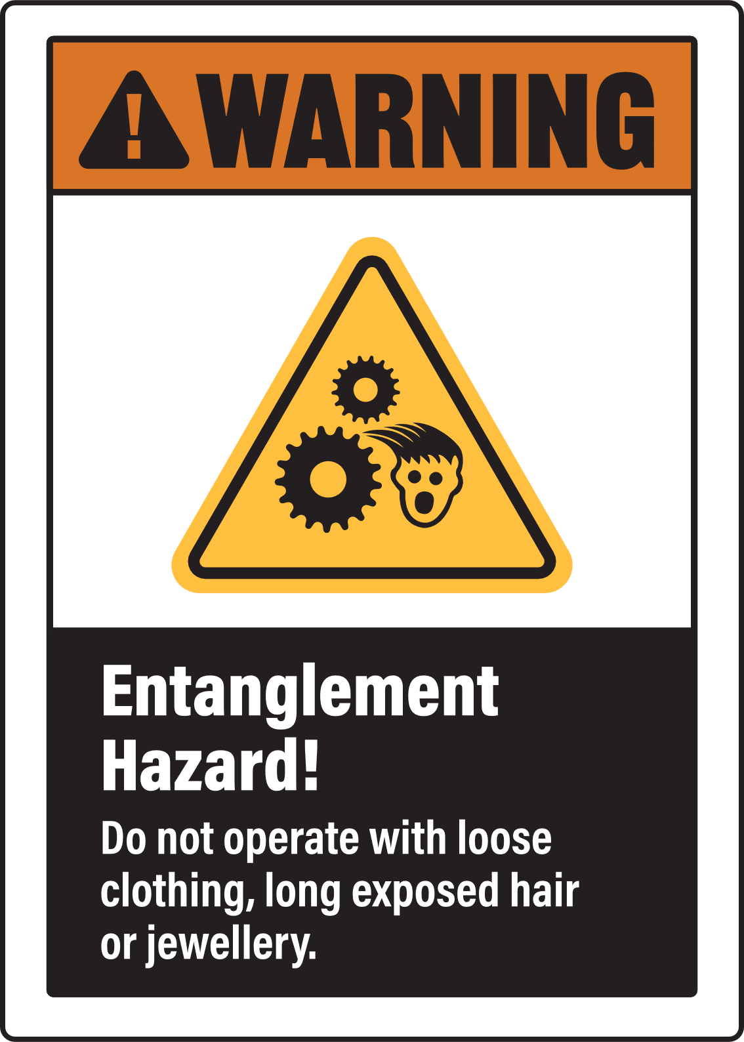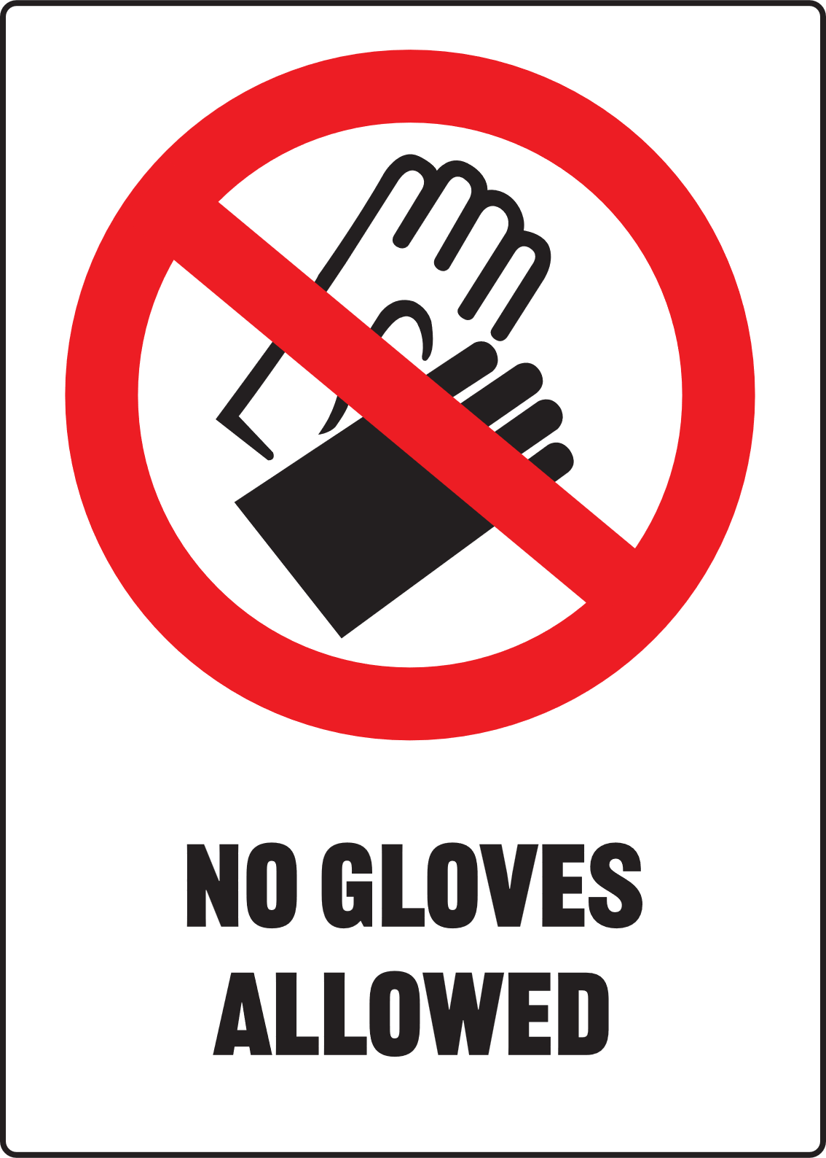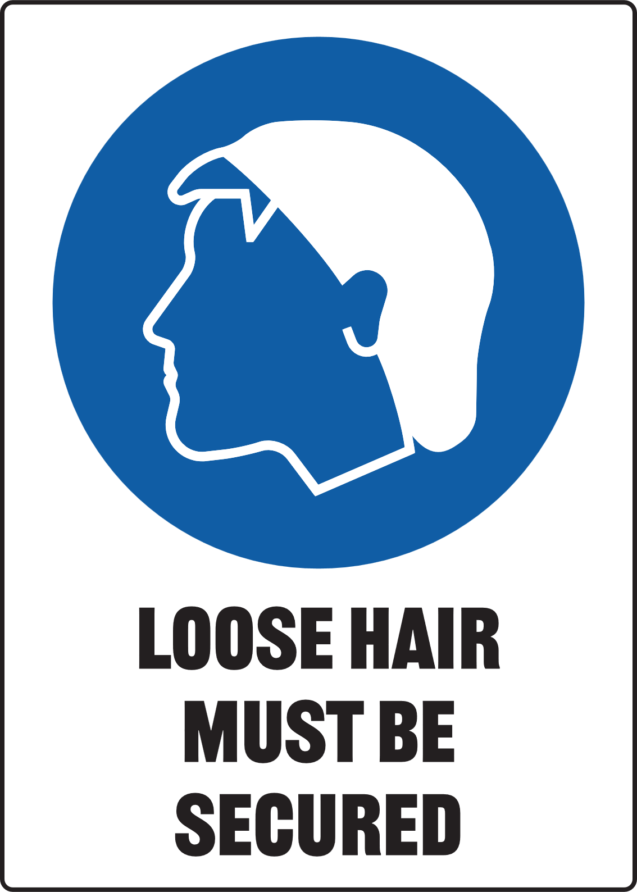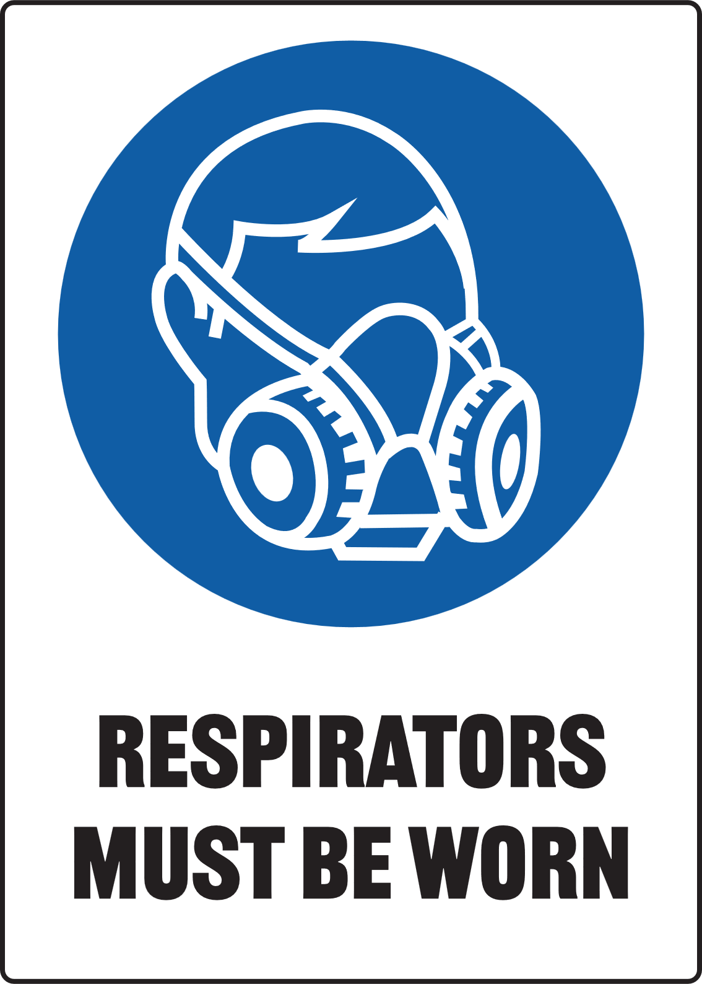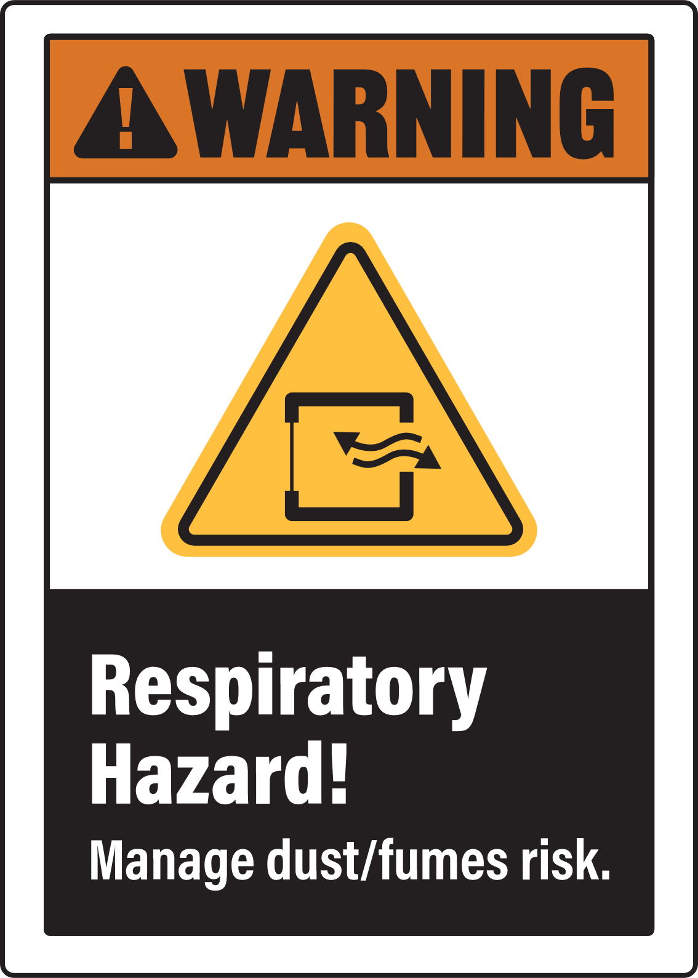

ONLY PAGE 2 REQUIRES PRINTING FOR ON-SITE DISPLAY

ART KILN - Electric

Only authorised staff and service providers are allowed to load, unload or clean the interior of art kilns
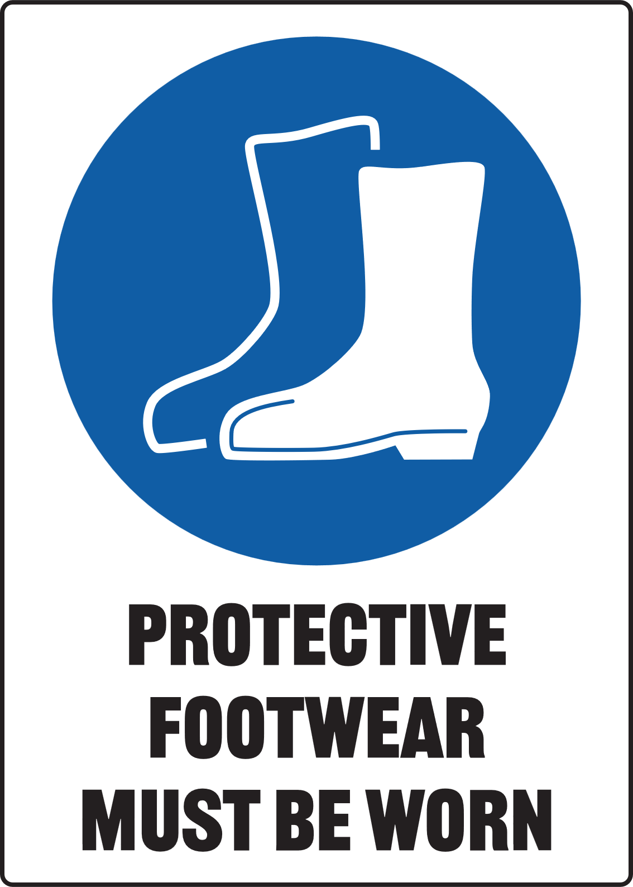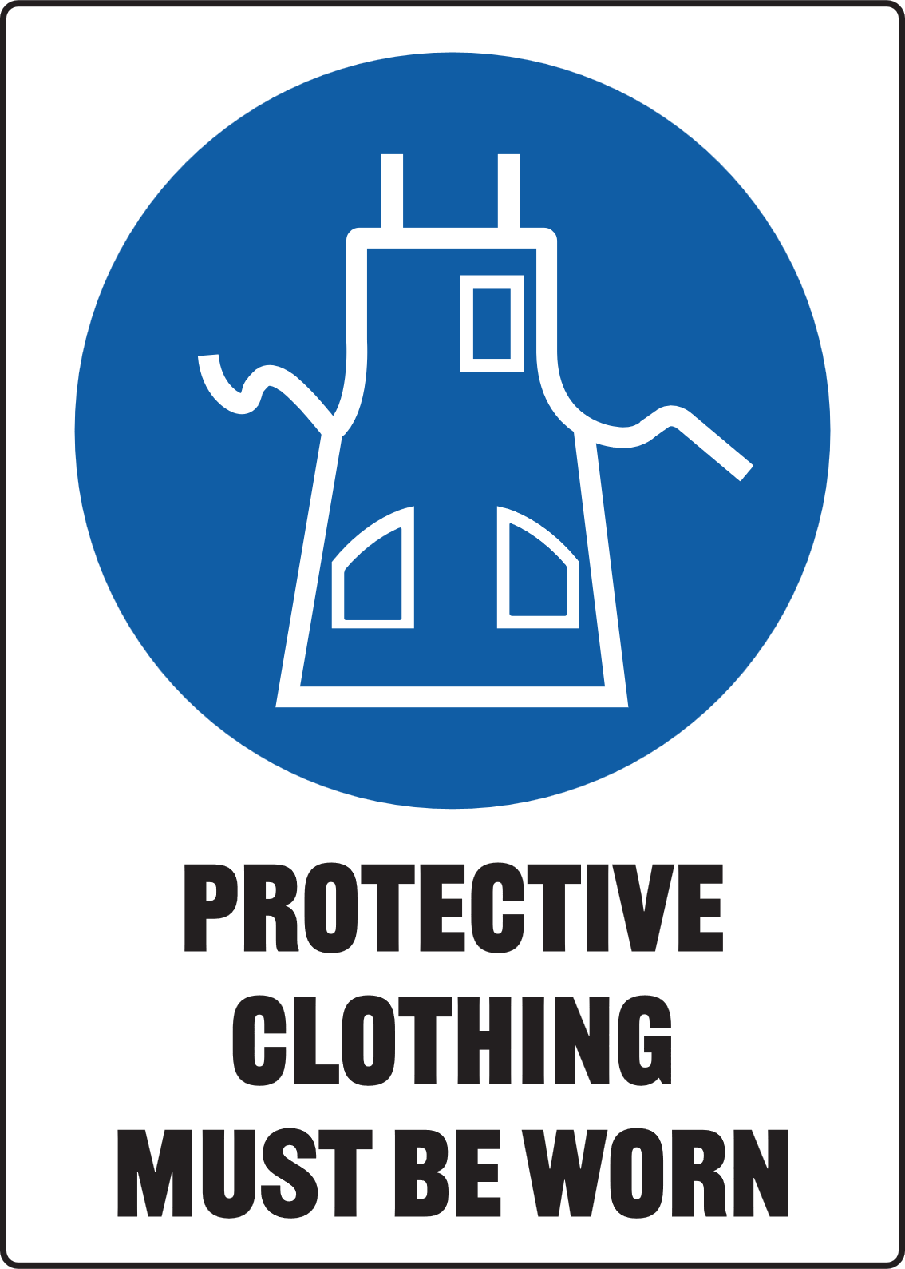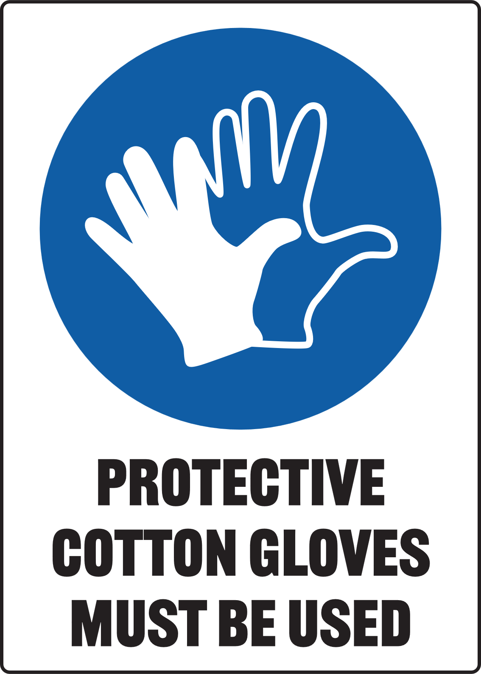

Food or drink is not to be taken into the kiln area or pottery/ceramic work area.


Pre-Operational Safety Checks
- Familiarisation: Ensure you understand all kiln operations, temperature settings and controls
- Facilities: Ensure the kiln controls and extraction system is working effectively
- Inspect equipment: Do not operate if the kiln is damaged: report any faults
- Electrical: check condition of lead, plug and controller
- Workspace: Ensure there are no trip hazards or combustible materials in the work area
- Material Safety: Ensure previously fired pieces (broken shards) are removed from the kiln
- Respiratory Protective Equipment (RPE): [Edit: insert PPE and RPE requirements; consider materials in use and controls available]
- Restrict Usage: The kiln is for heating art materials only

Operational Safety Checks
- Timing: where possible, fire the kiln when students are not present or out-of-school hours
- Operation: Set up an exclusion zone or barrier around the kiln for firing. Ensure the kiln door or any required bung/s are secured before firing
- Keep the extraction system running during entire cycle and do not open the kiln during firing
- Fire Prevention: Do not overheat the art pieces - use timer controls to manage the firing cycle
- Safety: Always use thermal gloves or tongs when handling hot workpieces or hot surfaces
- Bystander Safety: Be aware of others when moving hot materials
- Facility: After firing, leave the extraction system on when opening the kiln door and allow emissions to disperse - remove all persons from kiln room until emissions are dispersed

Housekeeping
- Maintenance: Ensure the kiln is allowed to cool completely before cleaning
- Inspections: Regularly inspect the internal, insulation materials for wear and damage
- Clean-up: Leave the kiln and the surrounding area in a safe, clean and tidy condition

Potential Hazards
- Hot surfaces Δ Electricity Δ Fire & Explosion Δ Inhaled fibres
- Pinch points (kiln door) Δ Fume emissions Δ Corrosive substances
- Cuts/grazes from ceramic surfaces Δ Respirable Crystalline Silica dust

