BLOWER VACUUM – ELECTRIC

DO NOT use this machine unless a teacher has instructed
you in its safe use and operation and has given permission.

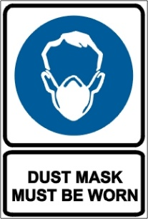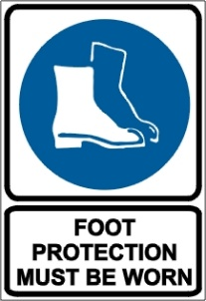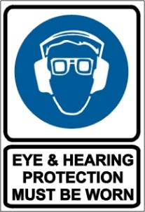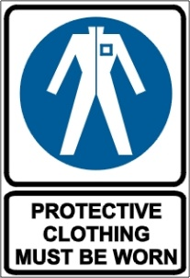

PRE-OPERATIONAL SAFETY CHECKS
- Do not use an electric blower vacuum in wet conditions.
- Do not wear jewellery or loose clothing that can be drawn into the air inlet.
- Check machine for loose/missing nuts, bolts and screws. Tighten and/or replace as needed.
- Inspect the parts of the mulching cutting head (where fitted). Replace cutting line if worn or damaged
- Ensure the debris bag is in sound condition and is properly fitted with no gaps.
- Ensure all guards are fitted, secure and functional.
- Ensure the machine and extension cord are tagged and are current.
- Ensure a tagged RCD is used when operating the machine.
- Trip test RCD before operation.
- Ensure the extension cord is in good condition.
- The extension cord must be uncoiled as coiled cables can overheat.
- Faulty equipment must not be used. Immediately report suspect machinery.

OPERATIONAL SAFETY CHECKS
- Ensure no person or animal is endangered when operating equipment.
- Adjust the shoulder harness as required to ensure it is in the most comfortable position.
- Keep a firm grip. Hold handles with fingers together encircling handles.
- Maintain a straight wrist position. Avoid using your wrist in a bent, extended or twisted position.
- Maintain footing and balance at all times. Do not stand on slippery, uneven or unstable surfaces. Do not work in odd positions or on ladders.
- Select the mode indicator to adjust the nozzle position for blow or vacuum.
- Do not pull cable around sharp objects.
- Do not direct the blower in the direction of other people.
- Take wind conditions into account. Avoid open doors and windows.
- Minimize dust by using blower at lower speeds.
- If the blower vacuum starts to vibrate abnormally, switch off and check immediately.
- Switch off and disconnect from the electricity supply before removing or replacing the debris bag.
- Do not place hands in bag when emptying. Sharp debris can cause injury.

HOUSEKEEPING
- Remove any foreign material from motor air inlet and nozzle
- Keep the work area and implement shed in a clean and tidy condition.

POTENTIAL HAZARDS
Noise Electrical hazards Flying debris Dust

This SOP should be used in conjunction with Curriculum Activity Risk Management Modules
Acknowledgement: Much of the information for this document has been sourced from content kindly provided by Department for Education SA website.

Date of last review | ______/______/______ | Signature ______________________

