CHAINSAW – ELECTRIC

Student use of this machine will require direct supervision

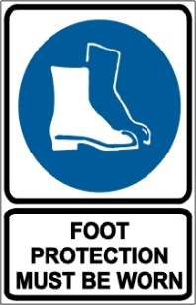

PRE-OPERATIONAL SAFETY CHECKS
- Do not use an electric chainsaw in wet conditions.
- Faulty equipment must not be used. Report suspect machinery immediately.
- Ensure that the machine and extension cord are tested and tagged for currency.
- Ensure the extension cord is in good condition.
- Ensure a tagged and tested RCD is used when operating the machine.
- Trip test the RCD before use.
- Ensure that chain guard and chain brake are functioning.
- Ensure chain is sharp and correctly tensioned.
- Ensure that safety harness, if required, is in sound condition.

OPERATIONAL SAFETY CHECKS
- Maintain a proper balance and secure footing.
- Keep a firm grip on the chainsaw with both hands, with the thumb of the hand holding the front handle wrapped around the handle.
- Start the cut with the saw chain rotating at full speed and the spiked bumper in contact with the wood.
- Pay full attention to the operation and be alert for movement of the material being cut.
- Be aware of the guide bar nose at all times when the saw chain is in motion.
- Be alert to situations that may cause material to pinch the top of the saw chain.
- Avoid the accumulation of debris.
- Ensure that no person or animal is endangered when operating equipment.

HOUSEKEEPING
- Remove any foreign material from motor and guards.
- Keep the work area and implement shed in a clean and tidy condition.

POTENTIAL HAZARDS
Kickback Pushback Pull-in
Flying debris Trip hazards Noise
Loose clothing entanglement Rotating chain

This SOP should be used in conjunction with Curriculum Activity Risk Management Modules
Acknowledgement: Much of the information for this document has been sourced from content kindly provided by Department for Education SA website.

Date of last review | ______/______/______ | Signature ______________________

