CHAINSAW – PETROL OPERATED

Student use of this machine will require direct supervision

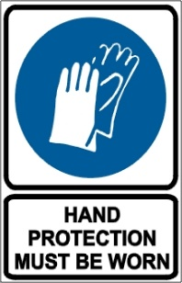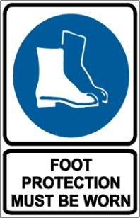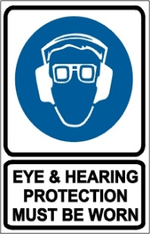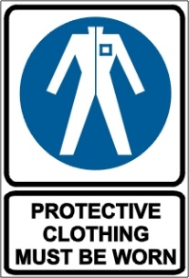

PRE-OPERATIONAL SAFETY CHECKS
- Ensure the machine is clean to facilitate detection of loose, worn or defective parts and other safety hazards.
- Inspect fuel lines, tank, and area around carburetor for fuel leaks. Do not operate unit if leaks are found.
- Faulty equipment must not be used. Report suspect machinery immediately.
- Check the effectiveness of chain brakes and operating controls.
- Ensure safety guards and other safety devices are fitted, secure and functioning.
- Check condition of the anti-vibration mountings of the handles.
- Ensure chain is sharp and correctly tensioned.

OPERATIONAL SAFETY CHECKS
- When starting the chainsaw on the ground:
- Ensure no obstructions are present particularly near the tip of the guide bar.
- Place the right foot through the rear handle and place the left hand on the front handle.
- Operate the starter with the right hand.
- Keep a firm grip on the chainsaw with both hands, with the thumb of the hand holding the front handle wrapped around the handle.
- Maintain a proper balance and secure footing when operating the chainsaw.
- Start the cut with the saw chain rotating at full speed and the spiked bumper in contact with the wood.
- Be aware of the guide bar nose at all times when the saw chain is in motion.
- Pay full attention to the operation and be alert for movement of the material being cut.
- Be alert to situations that may cause material to pinch the top of the saw chain.
- Apply chain brake when saw is at rest.
- Avoid the accumulation of debris.
- Never use a chainsaw over shoulder height.
- Allow a hot chainsaw to cool before refilling the fuel tank.

HOUSEKEEPING
- Remove any foreign material from motor and guards.
- Keep the work area and implement shed in a clean and tidy condition.

POTENTIAL HAZARDS
Kickback Pushback Pull-in
Flying debris Trip hazards Noise
Loose clothing entanglement Rotating chain

This SOP should be used in conjunction with Curriculum Activity Risk Management Modules
Acknowledgement: Much of the information for this document has been sourced from content kindly provided by Department for Education SA website.
Date of last review | ______/______/______ | Signature ______________________

