CHIPPER/SHREDDER/MULCHER

Do not use unless you have read and understood the operating manual of the machine you are using
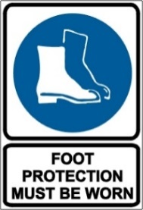
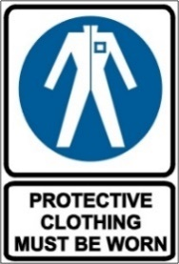

PRE-OPERATIONAL SAFETY CHECKS
- Check all bolts and screws for proper tightness to ensure the machine is in safe working condition.
- Ensure all guards are fitted, secure attached and functional.
- Never operate without the shredder hopper, chipper chute, or discharge chute properly attached to the machine.
- Be familiar with all controls and their proper operation. Review the manufacturer’s operating instructions.
- Faulty equipment must not be used. Report suspect machinery immediately.

OPERATIONAL SAFETY CHECKS
- Do not operate this machine on uneven surface.
- Never run an engine indoors or in a poorly ventilated area.
- Know how to stop the machine and disengage it quickly.
- Before starting the machine, make sure the chipper chute, feed intake, and cutting chamber are empty and free of all debris.
- Keep bystanders well clear from the machine while it is in operation.
- Do not attempt to shred or chip material larger than specified on the machine or in manual.
- Do not put hands and feet near rotating parts, or in the feeding chamber and discharge opening.
- If it becomes necessary to push material through the shredder hopper, use a small diameter stick. Do not use your hands or feet.
- Do not allow an accumulation of processed material to build up in the discharge area.
- If the impeller strikes a foreign object or if the machine should start making an unusual noise or vibration, immediately shut the engine off. Inspect for damage and make repairs as necessary.
- Never attempt to unclog either the feed intake or discharge opening, or inspect and repair the machine while the engine is running.
- Before cleaning, repairing, or inspecting, stop the engine and make certain the impeller and all moving parts have stopped. Disconnect the spark plug wire and ground it against the engine to prevent unintended starting.
- Never remove fuel cap or add fuel while the engine is hot or running. Allow engine to cool at least two minutes before refuelling.

HOUSEKEEPING
- Allow machine to cool.
- Clean away any foreign material, debris from in and around the motor, blades and guards.
- Keep the work area and implement shed in a clean and tidy condition.

POTENTIAL HAZARDS
Rotating cutting blades Noise Entanglement
Flying debris Eye injuries Kickback

This SOP should be used in conjunction with a task-based risk assessment
Acknowledgement: Much of the information for this document has been sourced from content kindly provided by Department for Education SA website.
Date of last review | ______/______/______ | Signature ______________________
Each workplace is to adjust this SOP to suit their environment, equipment, PPE, manufacturer’s instructions, training & task.

