CLAMPING TOOLS
BELT SANDER
DO NOT use any hand tool unless a teacher has instructed you
in its safe use and operation and has given permission
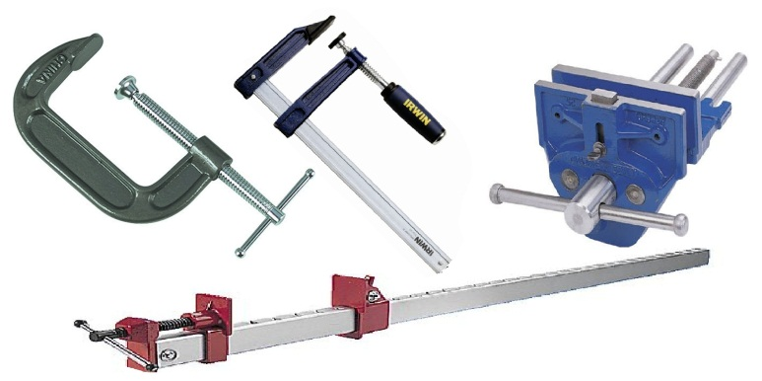
Safety glasses must be worn at all times in ITD practical workshops.
Appropriate protective footwear is also required when using clamping tools or devices.
This range of hand tools will usually include the following:
- Woodworking vice and engineer’s vice
- Sash clamp, pipe clamp and holdfast
- “G” clamp, “F” clamp and quick action clamp
- Mitre clamp, framing clamp and web clamp
OPERATIONAL SAFETY CHECKS
- It is important to choose the right clamping tool or vice for the job. They will vary widely, and are all designed for specific purposes.
- Pre-adjust clamps to an appropriate size and position. Accurately check for correct alignment.
- Use scrap wood (or shim) where necessary to protect the clamping surface of soft materials.
- DO NOT use a hammer to tighten a clamp or vice. Firm hand pressure should be applied gradually, as excessive strain may damage the clamp and the material being held.
- Never expose clamping tools or vices to excessive heat.
- Report any worn or damaged clamping tools or vices that show signs of damage.

HOUSEKEEPING
- After use, return all clamps to their appropriate storage racks.
- Leave the work area in a safe, clean and tidy condition.
- Regularly clean the face, pressure plate or jaws of the clamping tool.
Foreign debris will damage the surface of the material being held.
- Apply a little lubricant to the clamp screw threads, posts and pivot points to keep them operating freely.

Date of last review: ______________________________ Signature: _________________________________
POTENTIAL HAZARDS AND RISKS
■ Pinch and squash ■ Lacerations ■ Eye injuries

