FILES & RASPS
BELT SANDER
DO NOT use any hand tool unless a teacher has instructed you in its safe use and operation and has given permission
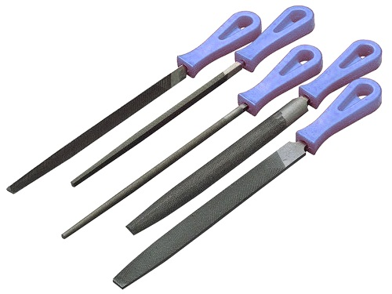
Safety glasses must be worn at all times when using files or rasps.
Appropriate protective footwear is required in ITD practical workshops.
This range of hand tools will usually include the following:
- Hand flat, 2nd cut, square, triangular, round, half round, wading and needle files
- Wood rasp and surform rasp
OPERATIONAL SAFETY CHECKS
- It is important to choose the right file or rasp for the job. They will vary widely, and are all designed for specific purposes.
- Always wear appropriate eye protection when using any file.
- NEVER use any file unless it is fitted with a protective handle covering the tang.
- Hold the file firmly and securely with both hands where possible.
- When filing, apply pressure on the forward or pushing strokes only. The file teeth will dull quickly if excess down force is applied on the return stroke.
- NEVER use a file for prying or hammering. The tang is soft and bends easily – and the body is hard and extremely brittle. Serious eye injuries can occur if a file shatters.
- NEVER hit two files together. This action could create fine metal shards, resulting in eye injury.

POTENTIAL HAZARDS AND RISKS
■ Lacerations from sharp cutting edges ■ Pinch and squash ■ Dust and splinters ■ Eye injuries

Date of last review: ______________________________ Signature: _________________________________
HOUSEKEEPING
- Leave the work area in a safe, clean and tidy condition.
- Brush all hand files clean, and return them to their appropriate storage cupboard or rack.
- Keep all files in a dry environment when in storage. Immediately dry files that become wet.
- NEVER oil a file. Oil or grease will cause a file to slide and not cut cleanly or efficiently.
- Regularly maintain the condition of hand files. Replace files when they are dull or broken. Replace file handles that are missing or damaged.

