HAND SAWS
BELT SANDER
DO NOT use any hand tool unless a teacher has instructed you in its
safe use and operation and has given permission
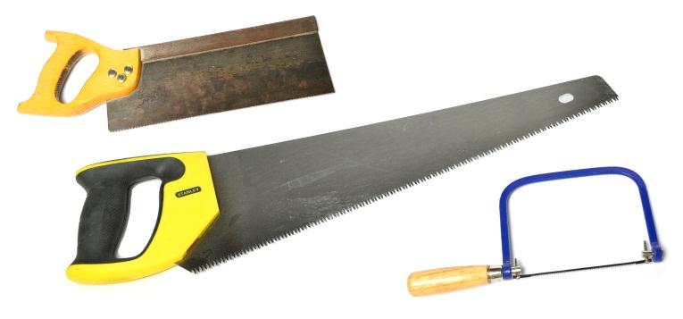
Safety glasses must be worn at all times in ITD practical workshops.
Appropriate protective footwear is also required when using saws.

This range of hand tools will usually include the following:
- Hand saw, rip saw and cross-cut saw
- Tenon saw, dovetail saw, coping saw, fret saw and keyhole saw
- Hacksaw
- Hole saws
OPERATIONAL SAFETY CHECKS
- It is important to choose the right hand saw or cutting tool for the job. They will vary widely, and are all designed for specific purposes.
- Inspect the condition of the saw teeth and the “set” required for an effective cutting action.
- For most hand-held saws, apply pressure on the forward or pushing stroke. Avoid excessive effort as this may cause the blade to jam, over-heat, bend or break.
- Both the coping saw and fret saw are designed for an effective cutting action on the backward or pulling stroke. This helps maintain accurate control and keeps the blade tight.
- For all hand saw frames with replaceable blades, check that all new blades are fitted correctly with the teeth aligned to the direction of the cutting action, as required.
- Take care to protect the sharp, exposed teeth of any hand saw blade and hole saws.
- Comment.
- Comment.
- Comment.

POTENTIAL HAZARDS AND RISKS
■ Lacerations from sharp cutting edges ■ Pinch and squash ■ Dust and splinters ■ Eye injuries
HOUSEKEEPING
- Leave the work area in a safe, clean and tidy condition.
- Wipe all hand saws clean, and return them to their appropriate storage cupboard or rack.
- Regularly maintain the condition of hand saws. They must be sharpened and “set” as often as necessary, by an ITD teacher or qualified TA.
- Replace the blades in all framed hand saws when they are, dull, bent, twisted or broken.

Date of last review: ______________________________ Signature: _________________________________

