MEASURING TOOLS
BELT SANDER
DO NOT use any hand tool unless a teacher has instructed you in its
safe use and operation and has given permission
 |  | Safety glasses must be worn at all times in ITD practical workshops. | 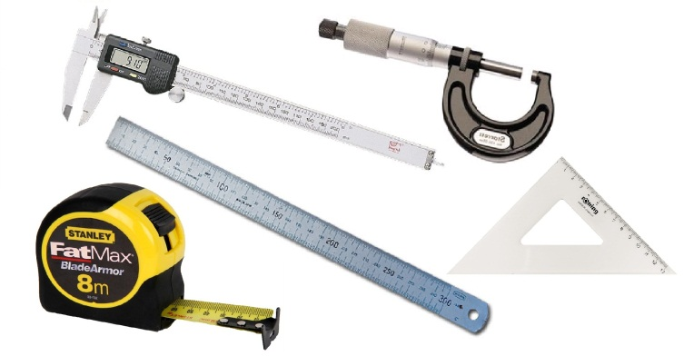
 |  | Appropriate protective footwear is also required in all ITD workshops.

This range of hand tools will usually include the follow:
- Stainless steel ruler, folding ruler, retractable tape measure and set squares
- Calipers – inside, outside and odd-leg, Vernier calipers, digital calipers and micrometer
- Dumpy or laser level, spirit level, line level
OPERATIONAL SAFETY CHECKS
- It is important to choose the right measuring tool for the job. They will vary widely, and are all designed for specific purposes.
- Never misuse or abuse any of these accurately machined and calibrated measuring tools.
- To attain an accurate measurement reading, carefully handle and align the device. Take the time to “measure twice – cut once”.
- Always try to keep your measuring tools clean and protected – away from the regular hand tools and power tools on your work bench.
- Some measuring instruments may require regular re-calibration to maintain their accuracy.

Date of last review: ______________________________ Signature: _________________________________
POTENTIAL HAZARDS AND RISKS
■ Lacerations from sharp cutting edges ■ Pinch and squash ■ Eye injuries

HOUSEKEEPING
- Leave the work area in a safe, clean and tidy condition.
- Return all measuring hand tools to their appropriate storage cupboard, in a dry environment.
- Regularly clean and maintain the condition of all measuring instruments.
- Lubricate the hinge point on all calipers. Adjust and sharpen as required.
- Inspect and clean the spindle and anvil of micrometers. Re-calibrate as required.

