PLANES & SCRAPERS
BELT SANDER
DO NOT use any hand tool unless a teacher has instructed you in its
safe use and operation and has given permission
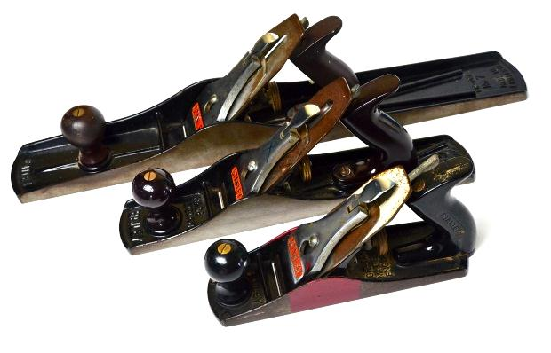
Safety glasses must be worn at all times in ITD practical workshops.
Appropriate protective footwear is also required when using planes.

Department of Education
Organisational Safety and Wellbeing
This range of hand tools will usually include the following:
- Jack plane – No.5, smoothing plane – No.4, and jointing plane or try plane – No.7
- Block plane, router plane and rebate plane
- Spokeshaves – Flat and convex sole
- Cabinet scrapers

- Torque Wrench
- Pipe wrench or stillson wrench
- Allen Keys

POTENTIAL HAZARDS AND RISKS
■ Lacerations from sharp cutting edges ■ Pinch and squash ■ Eye injuries

HOUSEKEEPING
- Leave the work area in a safe, clean and tidy condition.
- Return all wood planes and spokeshaves to their appropriate storage cupboard – CAREFULLY.
- Sharp edges must be protected. Store these tools where their blades cannot be damaged or become a hazard.
- Regularly maintain wood planes and spokeshaves. Blades must be sharpened and honed as often as necessary, by an ITD teacher or qualified TA.

Date of last review: ______________________________ Signature: _________________________________
OPERATIONAL SAFETY CHECKS
- It is important to choose the right wood plane or scraping tool for the job. They will vary widely, and are all designed for specific purposes.
- Ensure the blade has been sharpened, honed and secured to its backing iron firmly. Carefully inspect the protrusion of the blade. Ensure it is “set” correctly for the operation intended.
- Secure the work piece for planing, shaping or smoothing. Use a vice, clamp, stop or hold-fast.
- Always plane at a comfortable height. Use both hands to hold and push the wood plane.
- Spokeshaves and cabinet scrapers however, are more often drawn towards the operator.
- All planes and spokeshaves must be used with particular care to protect the protruding blade from accidental damage.

