SCREWDRIVERS
BELT SANDER
DO NOT use any hand tool unless a teacher has instructed you in its
safe use and operation and has given permission
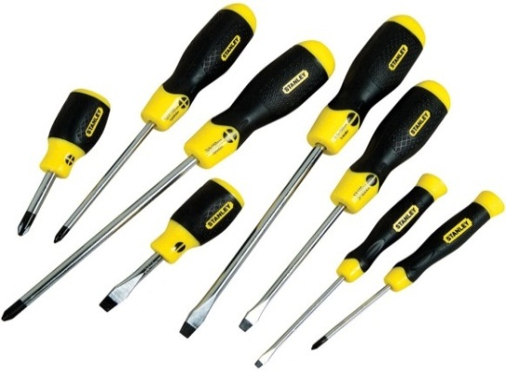
Safety glasses must be worn at all times in ITD practical workshops.
Appropriate protective footwear is also required in all ITD workshops.

This range of hands tools will usually include the following:
- Flat blade, slotted or straight head, phillips-head and posidrive screwdrivers
- Ratchet screwdrivers, electrician’s insulated screwdrivers and jeweller’s screwdriver sets
- Multi-bit driver sets and impact drivers
- Hex socket, torx, tri-wing, clutch and one-way drivers

OPERATIONAL SAFETY CHECKS
- It is important to choose the right screwdriver for the job. They will vary widely, and are all designed for specific purposes.
- Always match the screwdriver to the screw head, both in terms of size and type.
- Always wear appropriate eye protection when using any of the thread cutting tools.
- Avoid misuse and abuse of these precision tools.
- Do not lean or push on a screwdriver with any more force than is necessary to maintain the required drive force contact within the screw head
- Contoured or soft handle grips will help to keep your hand from slipping.
- Use a vise or clamp to hold your work piece if it is small or likely to move easily.
Date of last review: ______________________________ Signature: _________________________________
POTENTIAL HAZARDS AND RISKS
■ Lacerations from sharp cutting edges ■ Pinch and squash ■ Eye injuries

HOUSEKEEPING
- Leave the work area in a safe, clean and tidy condition.
- Clean and return all screwdrivers to their appropriate storage racks.
- Inspect your screwdrivers for apparent damage or wear. Poorly maintained screwdrivers will be of little use – ineffective as a tool and possibly dangerous if they slip.
- Never attempt to re-grind the case hardened blade or tip of any screwdriver. Replace the damaged tool with a new one.

