SPANNERS & WRENCHES
BELT SANDER
DO NOT use any hand tool unless a teacher has instructed you in its
safe use and operation and has given permission
 |  | Safety glasses must be worn at all times in ITD practical workshops. | 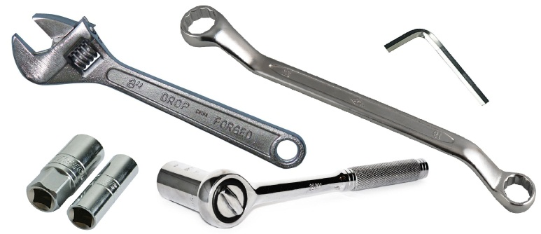
 |  | Appropriate protective footwear is also required when using spanners or wrenches.
OPERATIONAL SAFETY CHECKS
- It is important to choose the right spanner or wrench for the job. They will vary widely, and are all designed for specific purposes.
- Spanners and wrenches must be sized correctly for the nut or bolt to be turned.
- Do not select or use a spanner or wrench that is possibly defective.
- Turn a spanner by pulling on the shank or handle. This action is more efficient and effective.
- When using a wrench, adjust the movable jaws to fit, and always pull the handle towards the side with the adjustable jaw.
- Use both hands on larger spanners and wrenches. DO NOT attempt to increase the pulling leverage by adding an extension bar or pipe to the handle of any a spanner or wrench.

This range of hand tools will usually include the follow:
- Open ended spanner, ring spanner, combination spanner
- Adjustable wrench or shifting spanner
- Socket wrench and tube spanner
- Torque wrench
- Pipe wrench or stillson wrench
- Allen keys

Date of last review: ______________________________ Signature: _________________________________
POTENTIAL HAZARDS AND RISKS
■ Pinch and squash ■ Impact and striking ■ Lacerations ■ Eye injuries

HOUSEKEEPING
- Leave the work area in a safe, clean and tidy condition.
- Return all spanners and wrenches to their appropriate storage cupboard.
- Never attempt to repair any spanner, wrench or Allen key. Immediately report the problem.
- Discard and replace any spanner or wrench that shows signs of “rounding” or cracking of the jaws, handle or drive head.

