THREADING TOOLS
BELT SANDER
DO NOT use any hand tool unless a teacher has instructed you in its
safe use and operation and has given permission
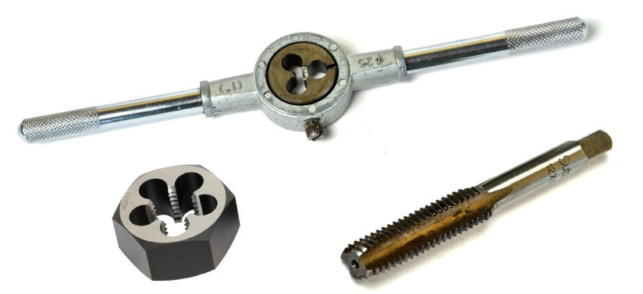
Safety glasses must be worn at all times in ITD practical workshops.
Appropriate protective footwear is also required in all ITD workshops.

This range of hands tools will usually include the following:
- Taps – tapered, intermediate and bottoming or plug
- Tap wrench and “T” wrench
- Button dies and die nuts
- Die wrench or die stock
OPERATIONAL SAFETY CHECKS
- It is important to choose the right thread cutting tool for the job. They will vary widely, and are all designed for specific purposes, for producing both internal and external threads.
- Always wear appropriate eye protection when using any of the thread cutting tools.
- Avoid misuse and abuse of these precision thread cutting tools.
- All taps, dies and die nuts should have their thread diameter and thread pitch clearly indicated – e.g. the correct tool to cut a 10mm Ø thread with a 1.5mm pitch will be marked as: M10 x 1.5
- Use a suitable cutting lubricant for all tapping, threading and reaming operations. This will vary dependent on the material being cut, i.e. steel, steel alloys, cast iron, aluminium, etc.
- When tapping an internal thread, the tap drill size must be calculated – i.e. drill = Ø – pitch
- The cutting action should be backed off every half turn to break off (and clear) the waste from the thread being created.

Date of last review: ______________________________ Signature: _________________________________
POTENTIAL HAZARDS AND RISKS
■ Lacerations from sharp cutting edges ■ Pinch and squash ■ Eye injuries

HOUSEKEEPING
- Leave the work area in a safe, clean and tidy condition.
- Clean and return all threading tools to their appropriate storage containers.
- Inspect all cutting edges and internal flutes for apparent damage or dullness. Poorly maintained cutting tools may seize or produce an inferior thread if they are in poor condition.

