WOODWORKING CHISELS
BELT SANDER
DO NOT use any hand tool unless a teacher has instructed you in its
safe use and operation and has given permission
 |  | Safety glasses must be worn at all times in ITD practical workshops. | 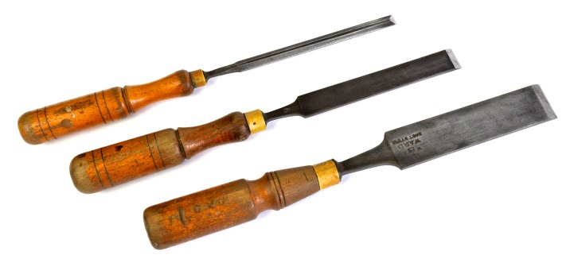
 |  | Appropriate protective footwear is also required when using chisels.
This range of hand tools will usually include the follow:
- Bevel edged chisel, butt chisel, firmer chisel, paring chisel, mortise chisel and gouge
- Woodturning chisels or Lathe tools
OPERATIONAL SAFETY CHECKS
- It is important to choose the right chisel for the job. They will vary widely, and are all designed for specific purposes.
- Only select and use chisels that are sharp and in good condition. Ensure that the cutting edge is not dull or chipped.
- Eye protection must be worn when using any chisel.
- Always ensure that both hands remain behind the cutting blade and on the chisel when removing fine waste – particularly when hand paring and finishing.
- When a mallet is required, strike the end of the chisel cleanly and deliberately, and only with enough force to achieve an accurate result.
- Work away from the body when striking a chisel with force.
- Never place a chisel down where it can be knocked to the floor. Serious injury could result.
- Avoid deliberate misuse. Never use a chisel as a pry, a wedge or as a screwdriver.
- Never carry a chisel in your pocket.

POTENTIAL HAZARDS AND RISKS
■ Lacerations from sharp cutting edges ■ Impact or striking ■ Splinters ■ Eye injuries
HOUSEKEEPING
- Leave the work area in a safe, clean and tidy condition.
- Return all chisels to their appropriate storage cupboard – CAREFULLY.
- Sharp edges must be guarded. Store all chisels where their blades cannot be damaged or become a hazard.
- Regularly maintain the condition of woodworking chisels. They must be sharpened and honed as often as necessary, by an ITD teacher or qualified TA.

Date of last review: ______________________________ Signature: _________________________________

