SOP Review, Update and Print instructions
DO NOT PRINT THIS PAGE
- Review the SOP Document:
- Manufacturer’s Instructions: Refer to the equipment manual for specific safety and operational guidelines. Incorporate any additional details into the SOP as necessary.
- Feedback: Consult with users to confirm that the SOP accurately reflects practical usage. Make any needed revisions based on their input.
- Assess PPE Requirements:
- Evaluate if new or additional personal protective equipment (PPE) is required based on the risks associated with the equipment. Address risks such as dust and fumes by selecting appropriate PPE and updating the SOP with relevant PPE checks and icons.
- Display and Accessibility:
- Print the reviewed SOP, ensuring it is signed and dated. Post the printed SOP near the equipment or where it is easily accessible to users.
- Schedule and Document Review:
- Plan to review and update the SOP annually or whenever work processes change.
- Footer Details: Date of Review = When the school review was completed. Reviewed By = Who completed the school review. Next Review = insert date (e.g. max one year ahead).
Personal Protective Equipment (PPE) Signage
add/remove from the SOP as appropriate for your school/machine
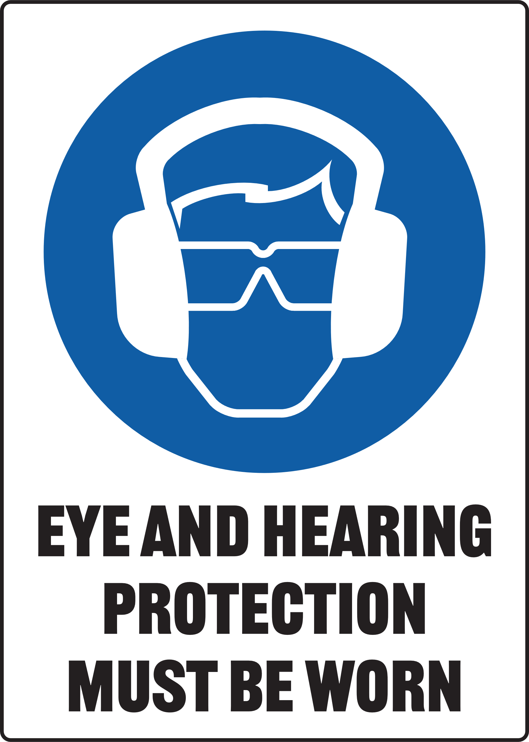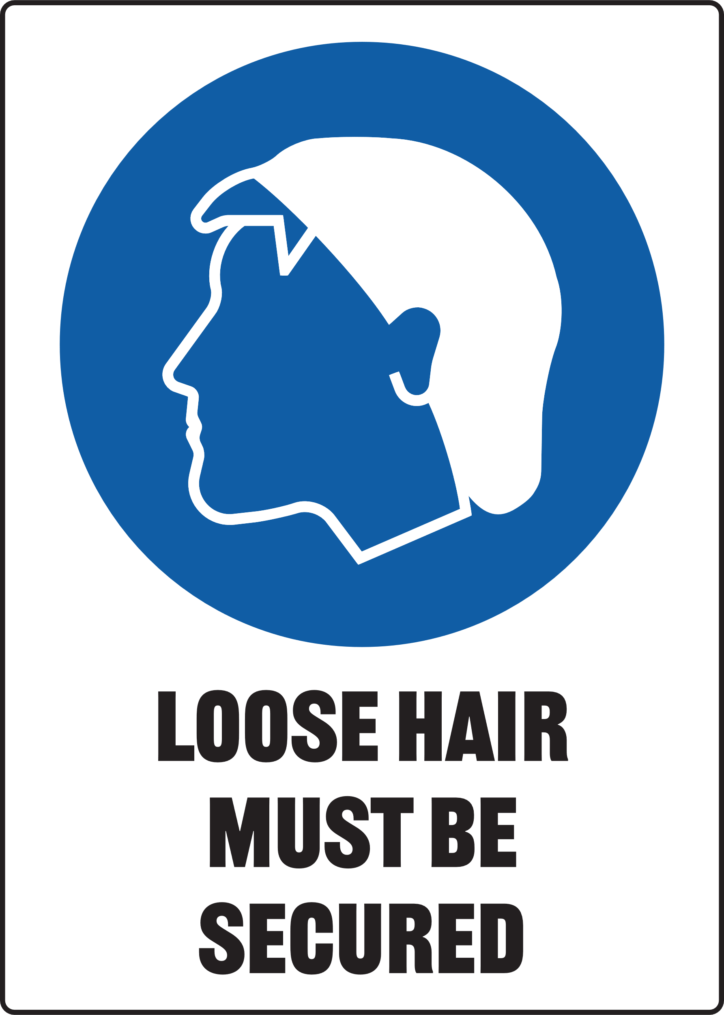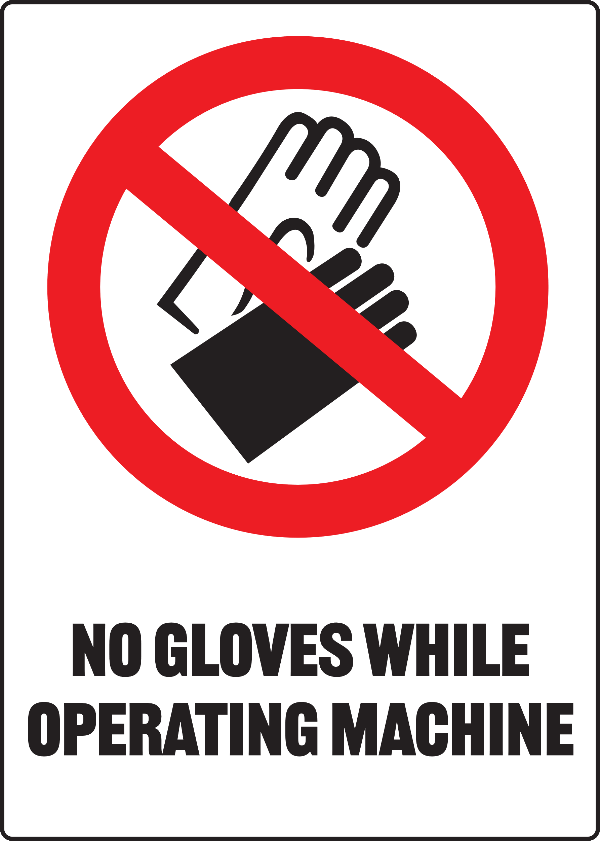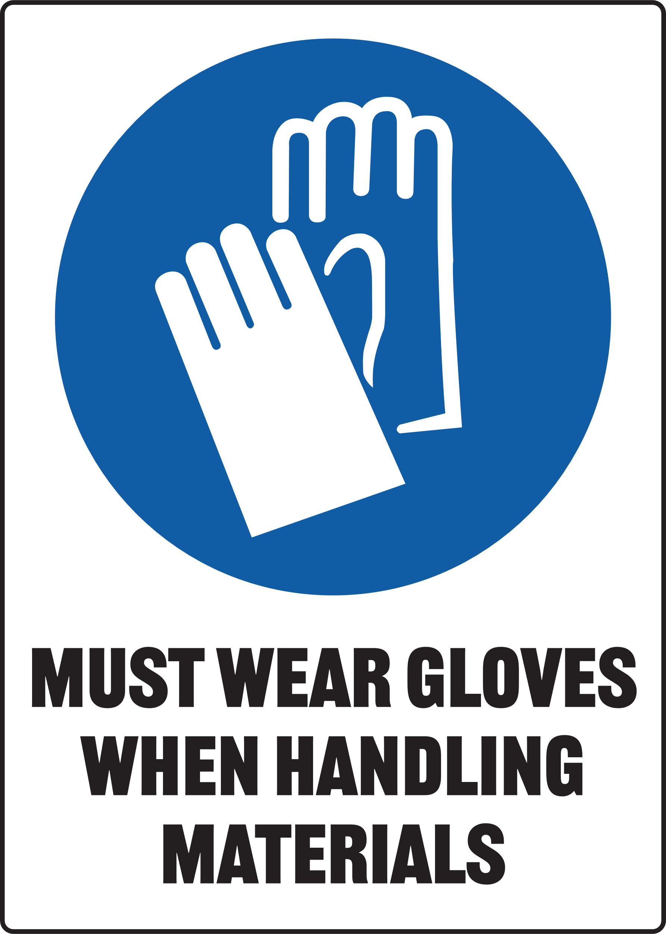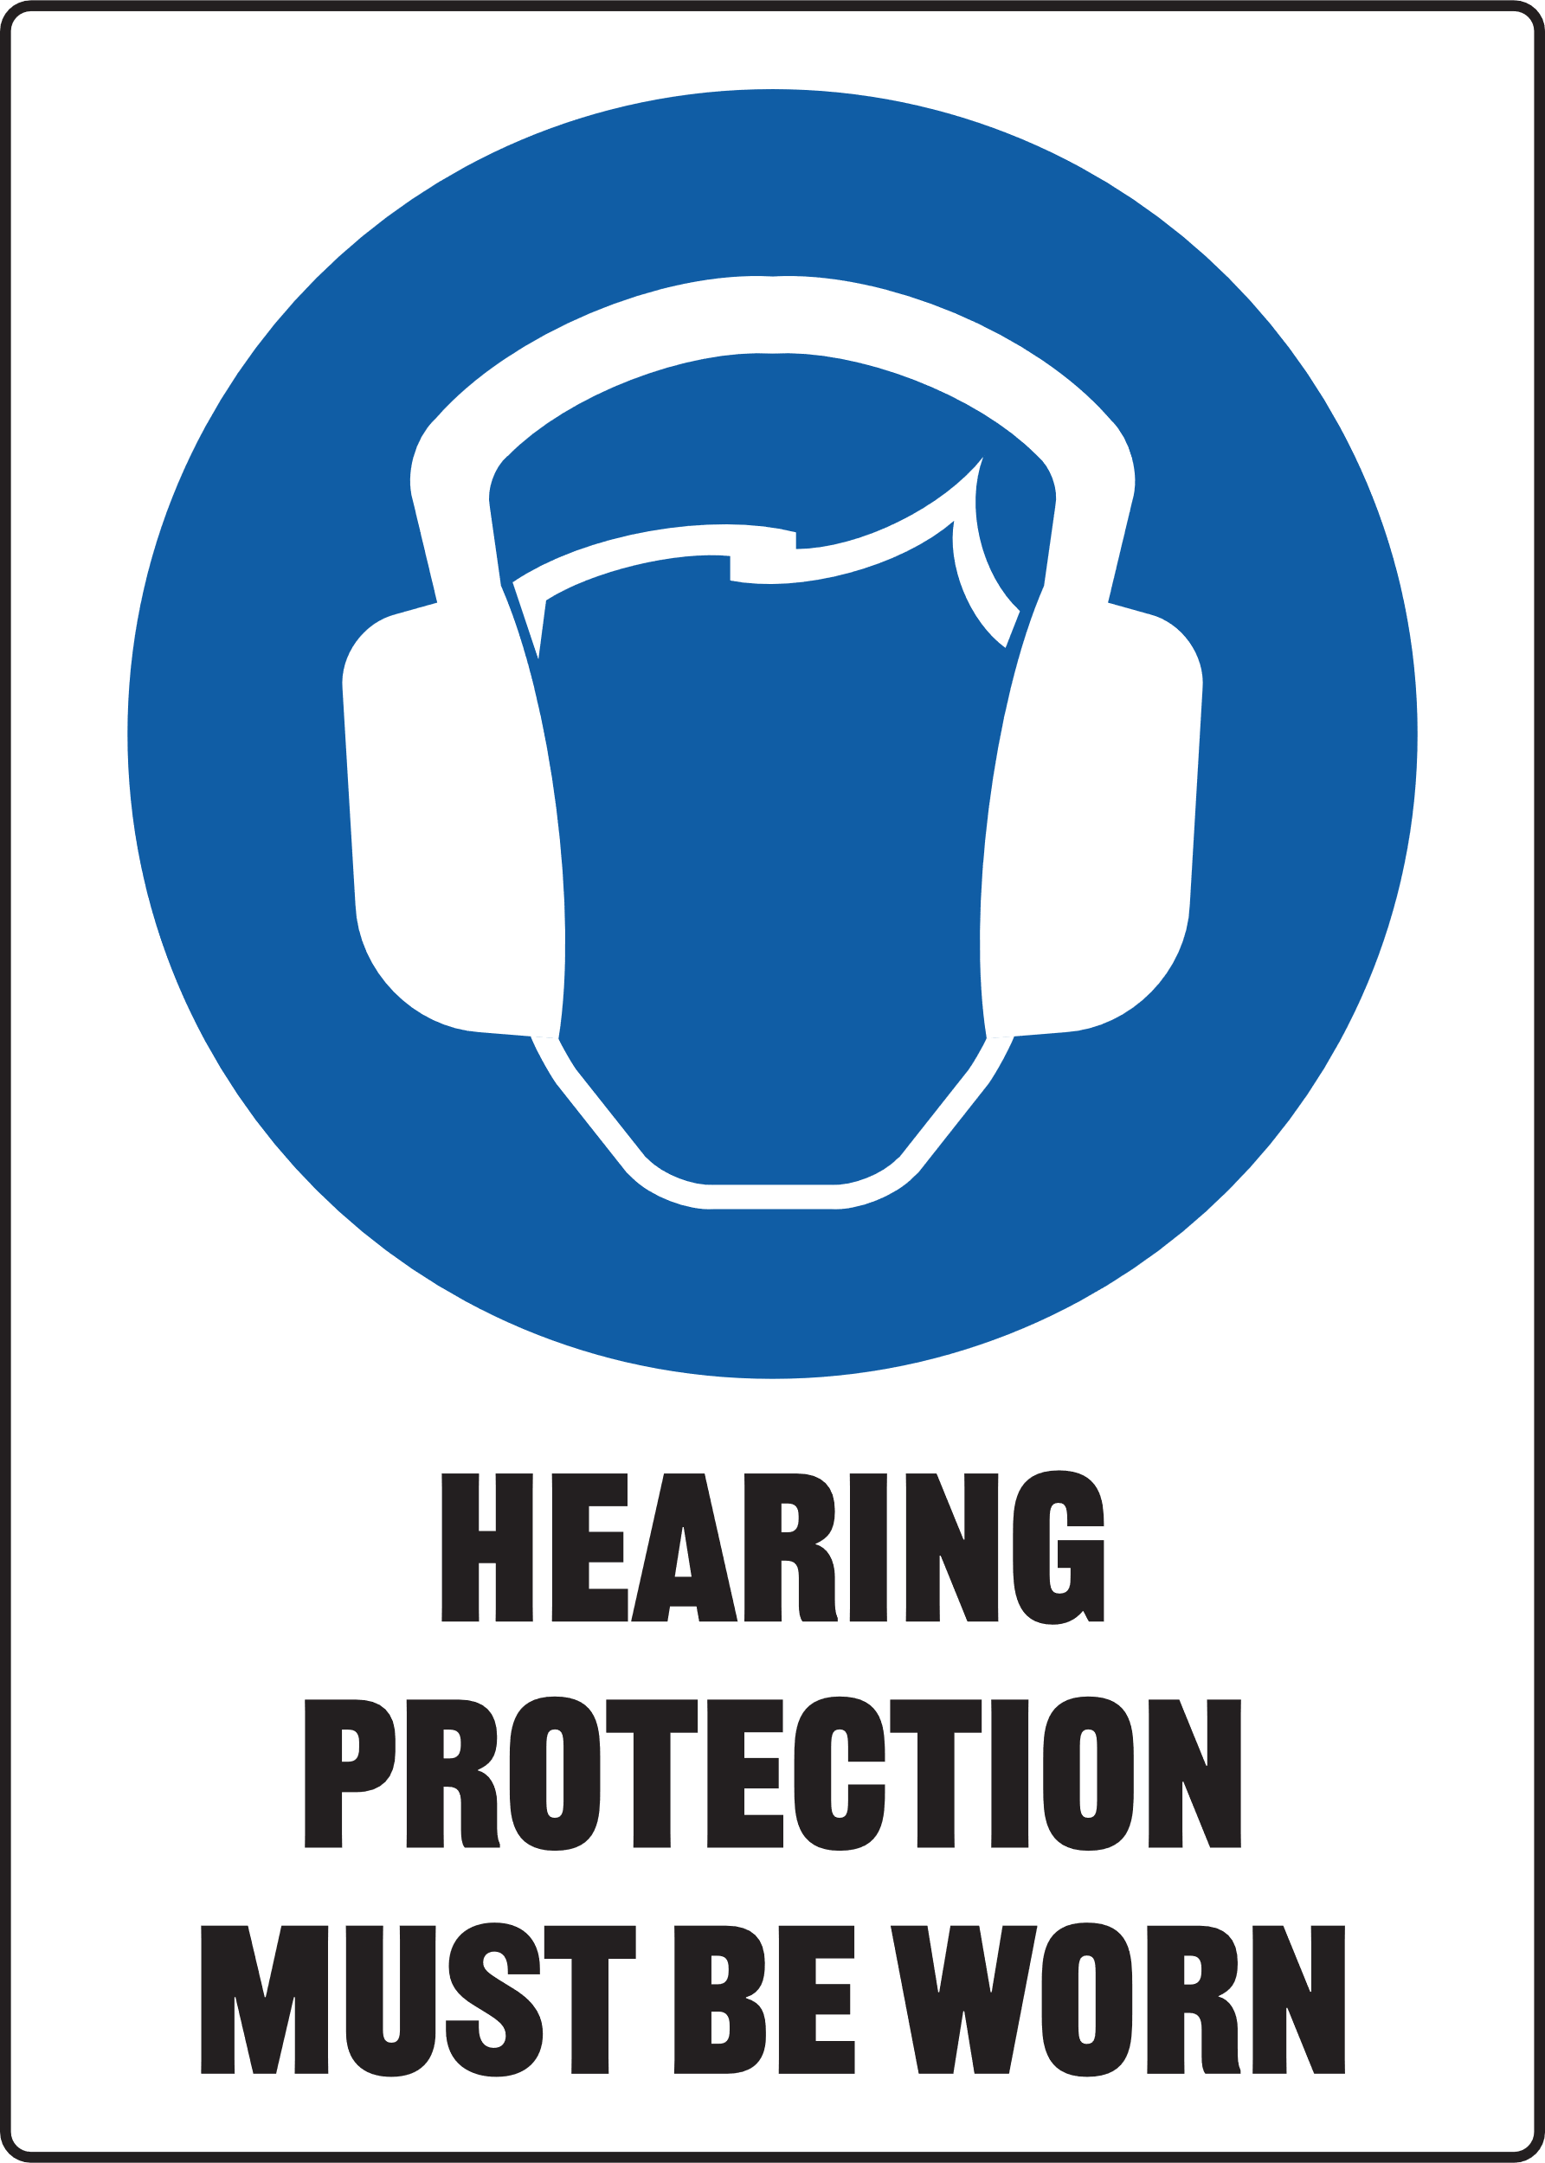
MANAGING RESPIRATORY HAZARDS
Ensure you manage risk of exposure to dust and fumes. Select the appropriate RPE signage for your SOP
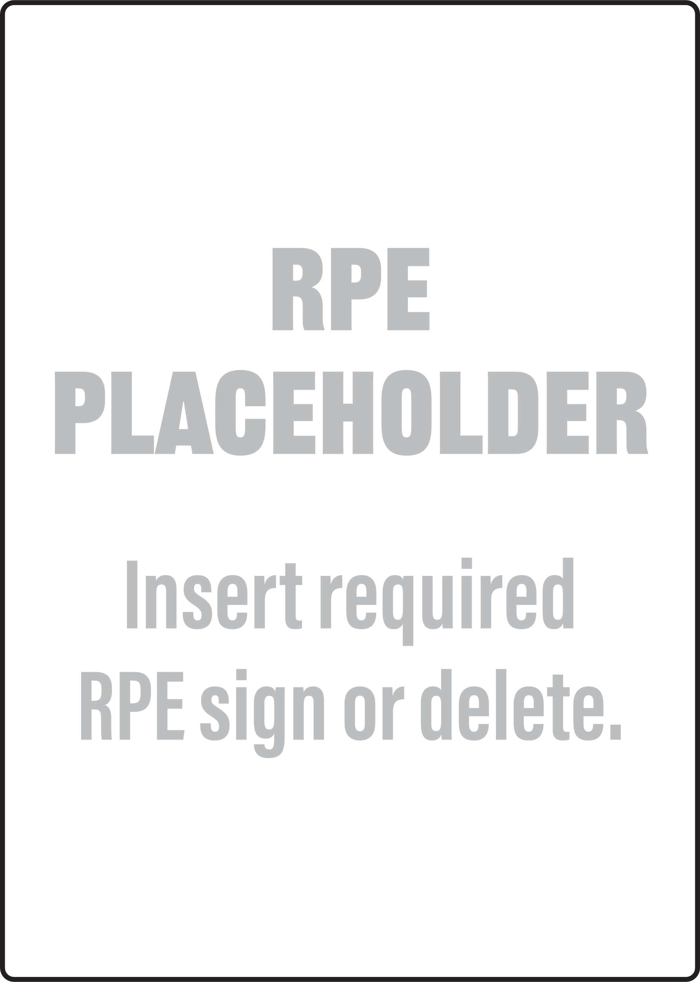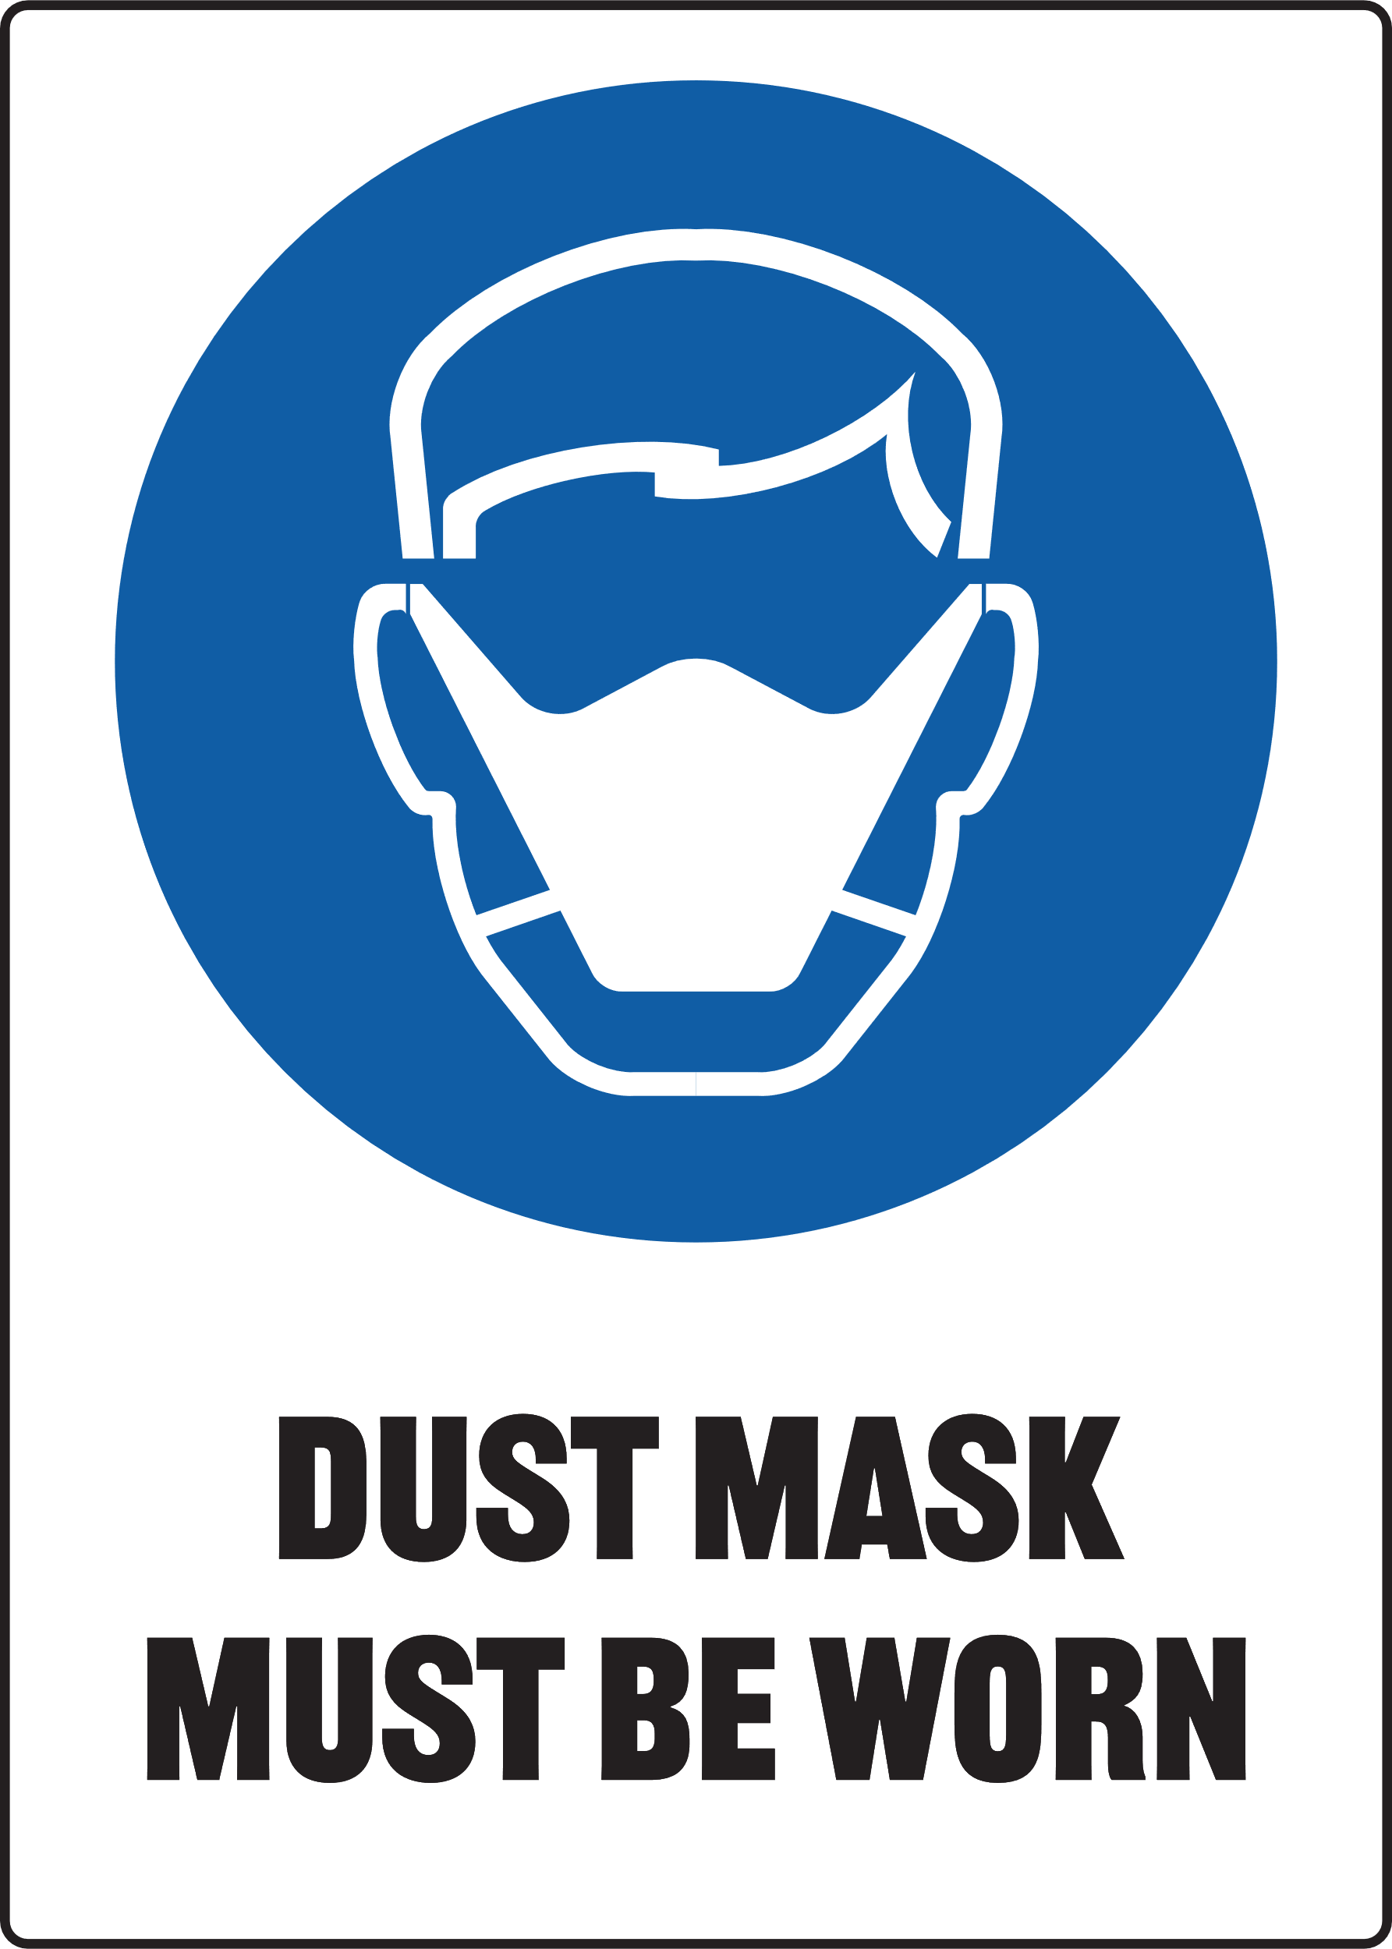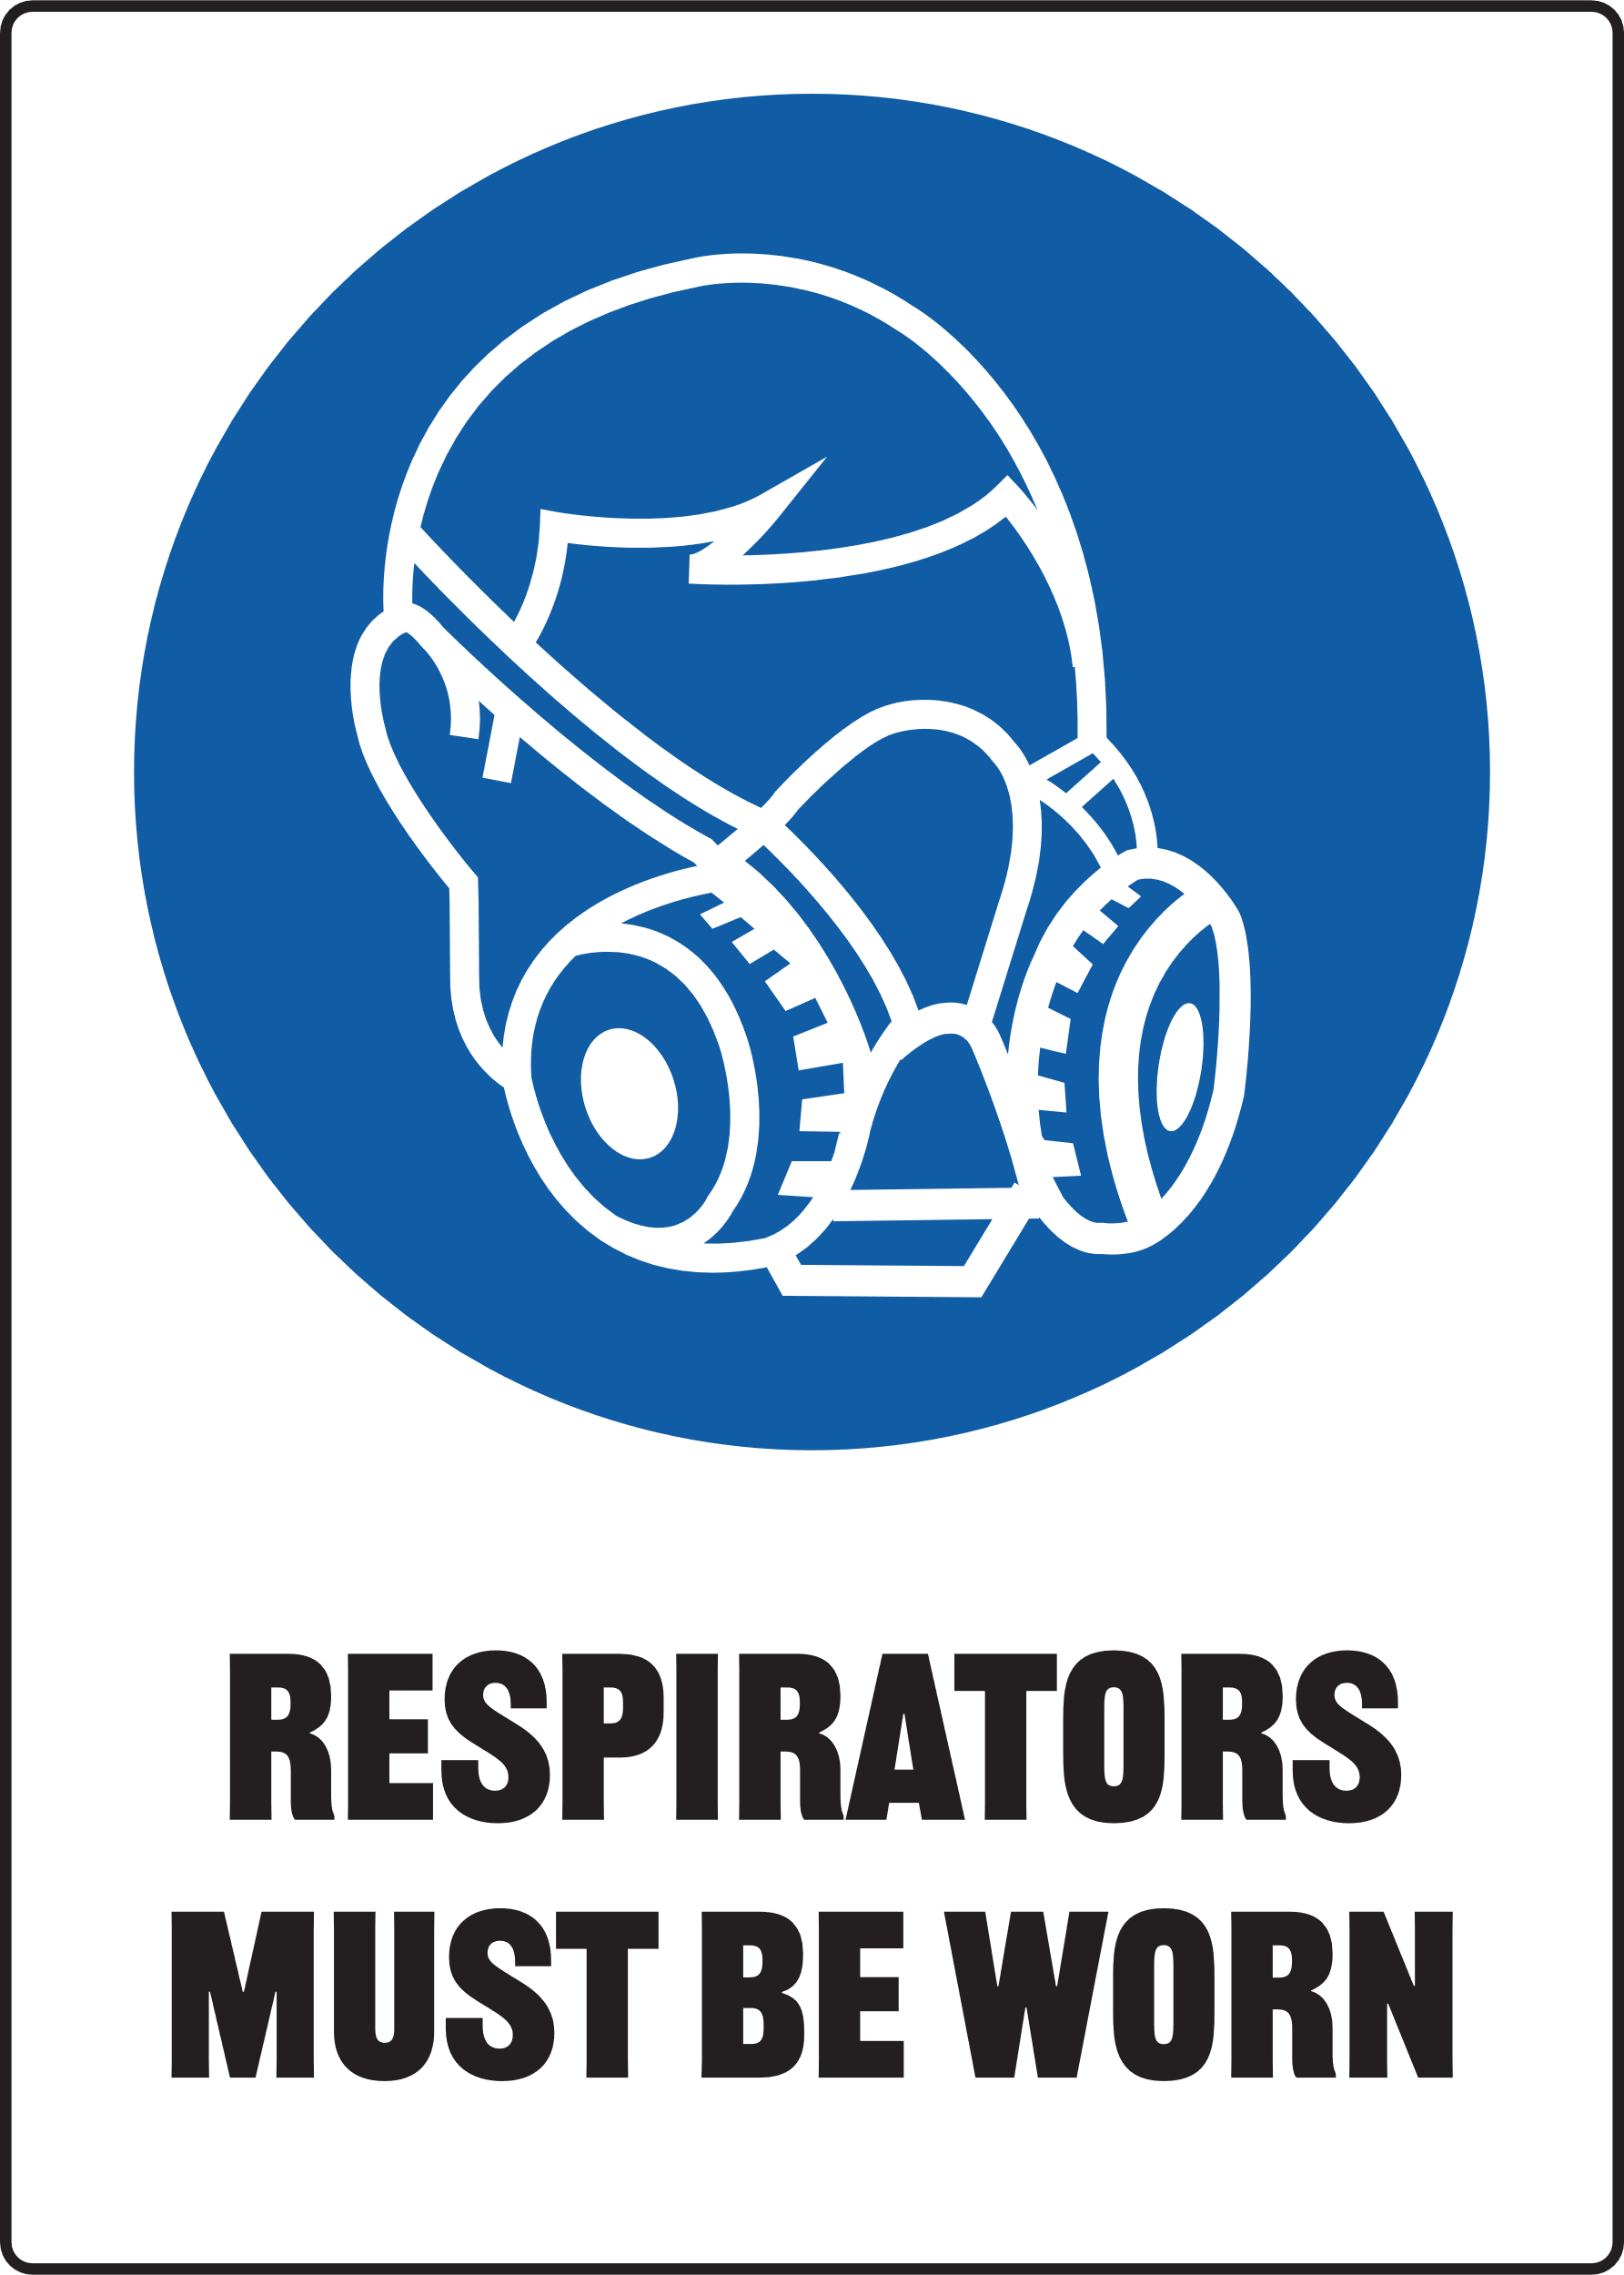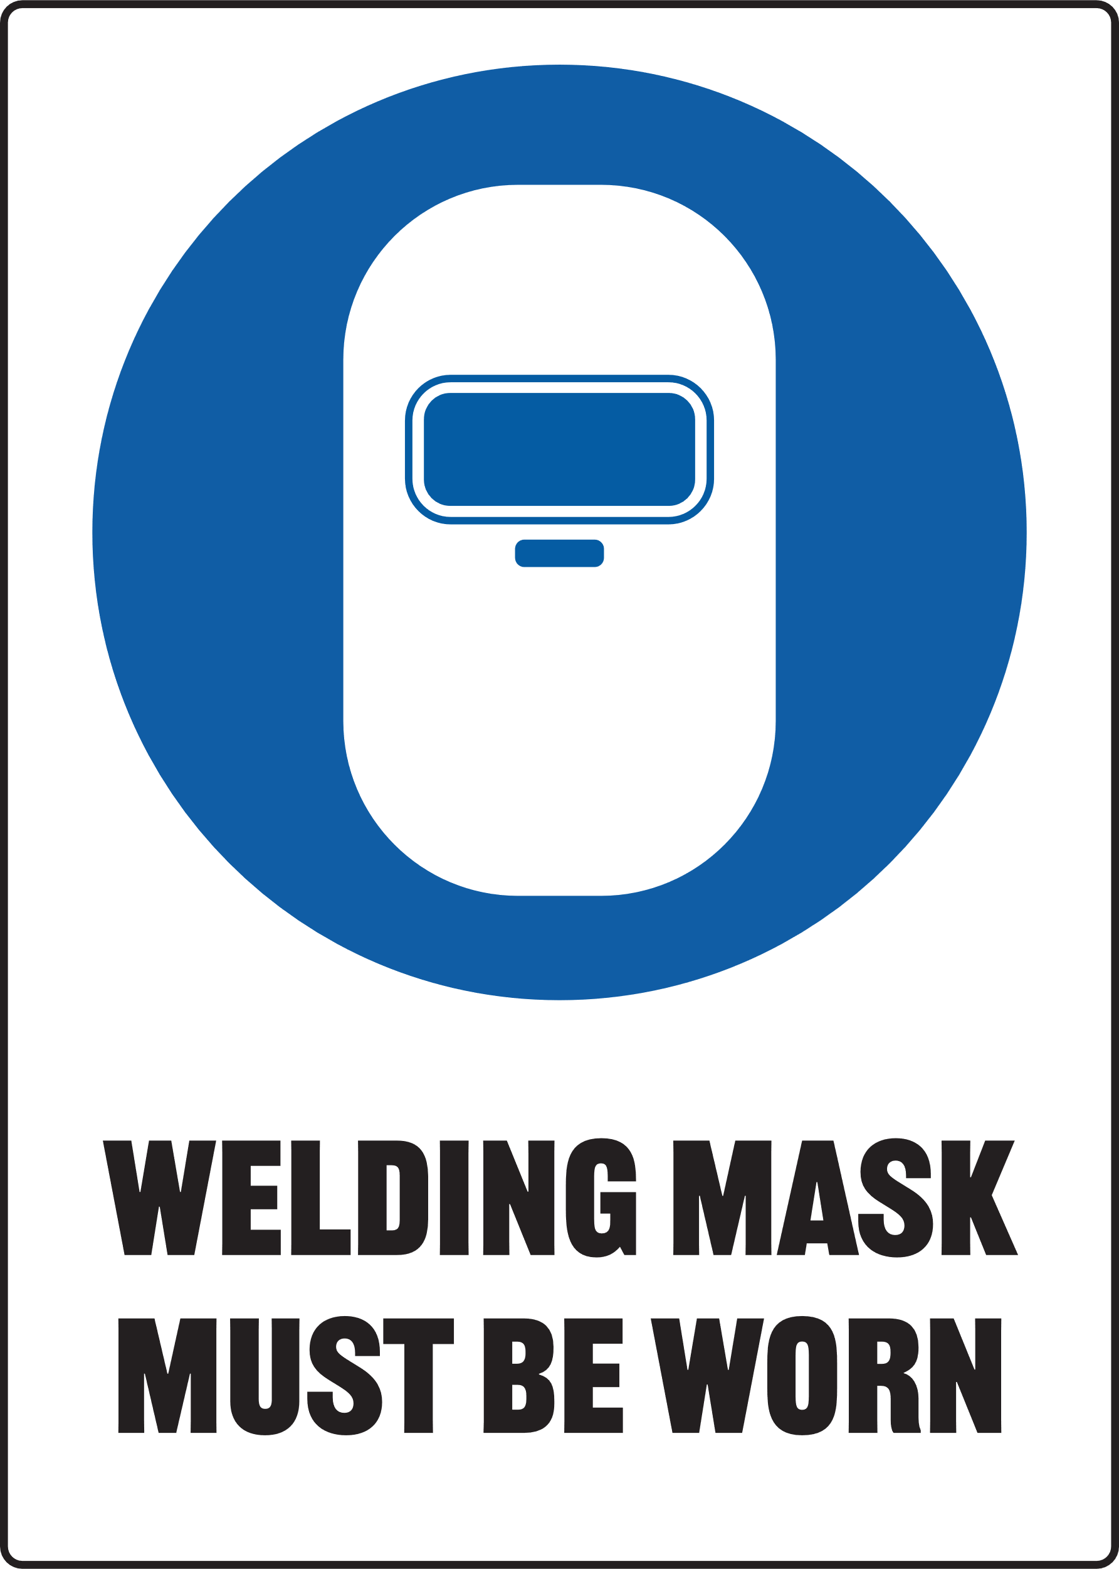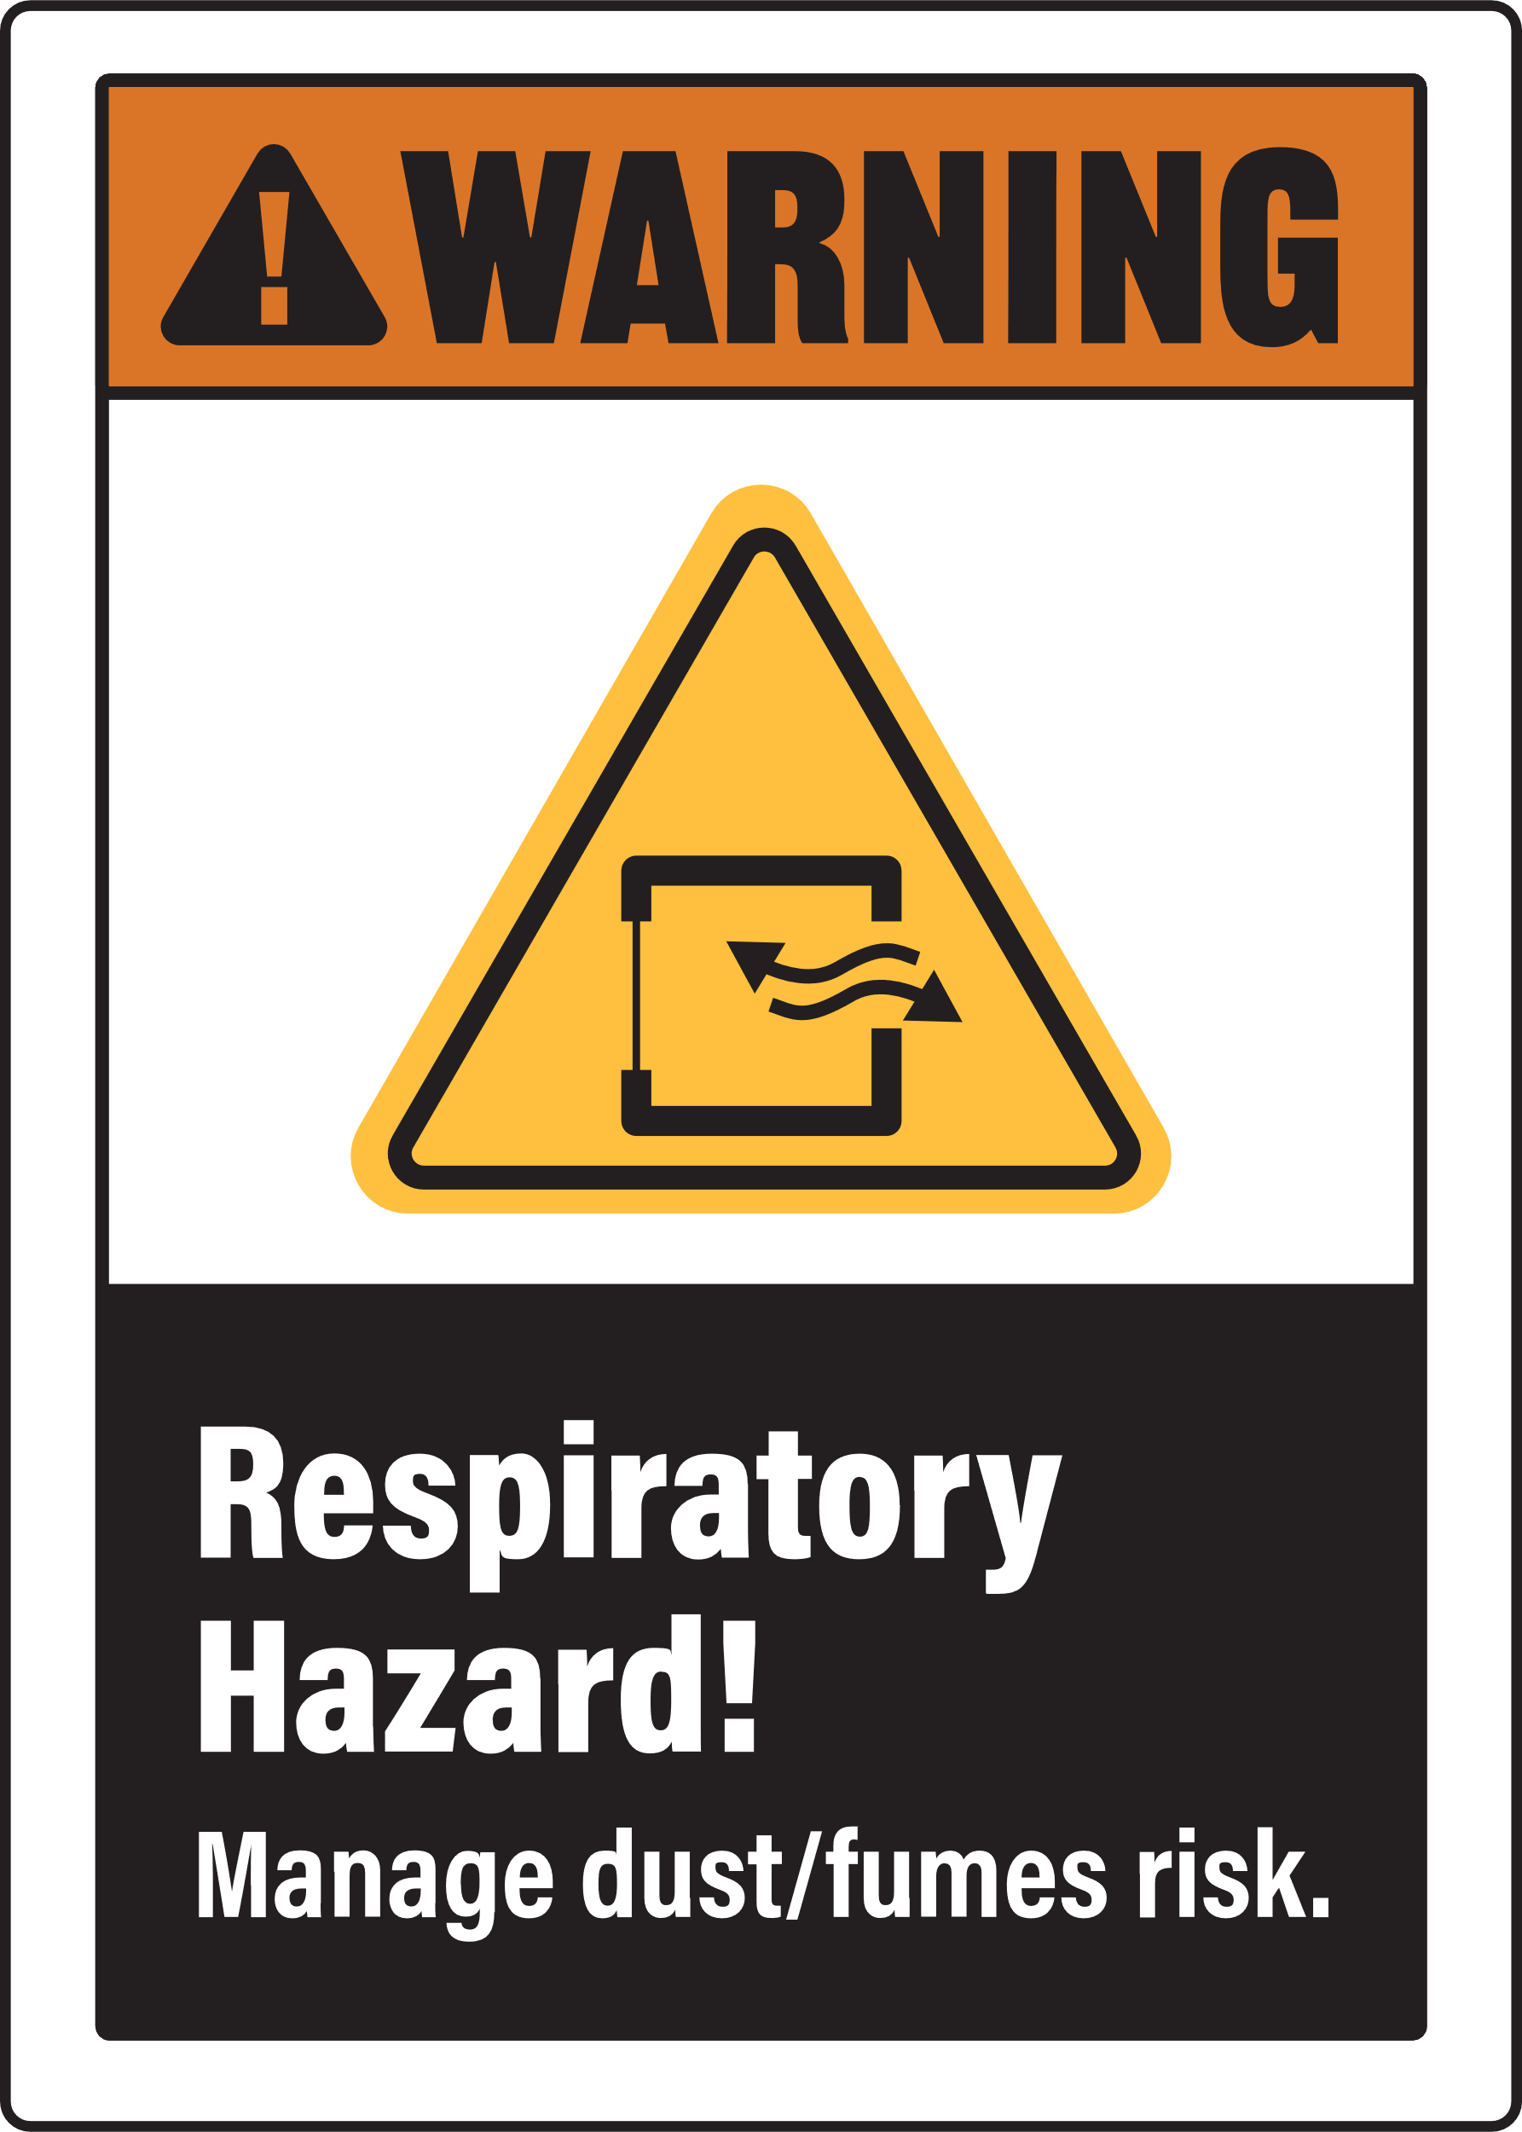

Print Settings:
  - Open Print Menu: Go to the 'File' menu and select 'Print'.
  - Adjust Print Settings:
- In the Print dialog box, under 'Settings', choose 'Custom Print' or 'Print Specific Pages'.
- Ensure that the starting page number is set to '2' to print the second page of the document.
  - Colour Printing:
- Make sure to select 'Print in Colour' if this option is available.
Document Preview: Note that the print preview of the document will display the first page, but it will not be printed with the above settings.


Hydraulic Press
Only use this machine if you have been given instructions on how to use it safely and have been given permission
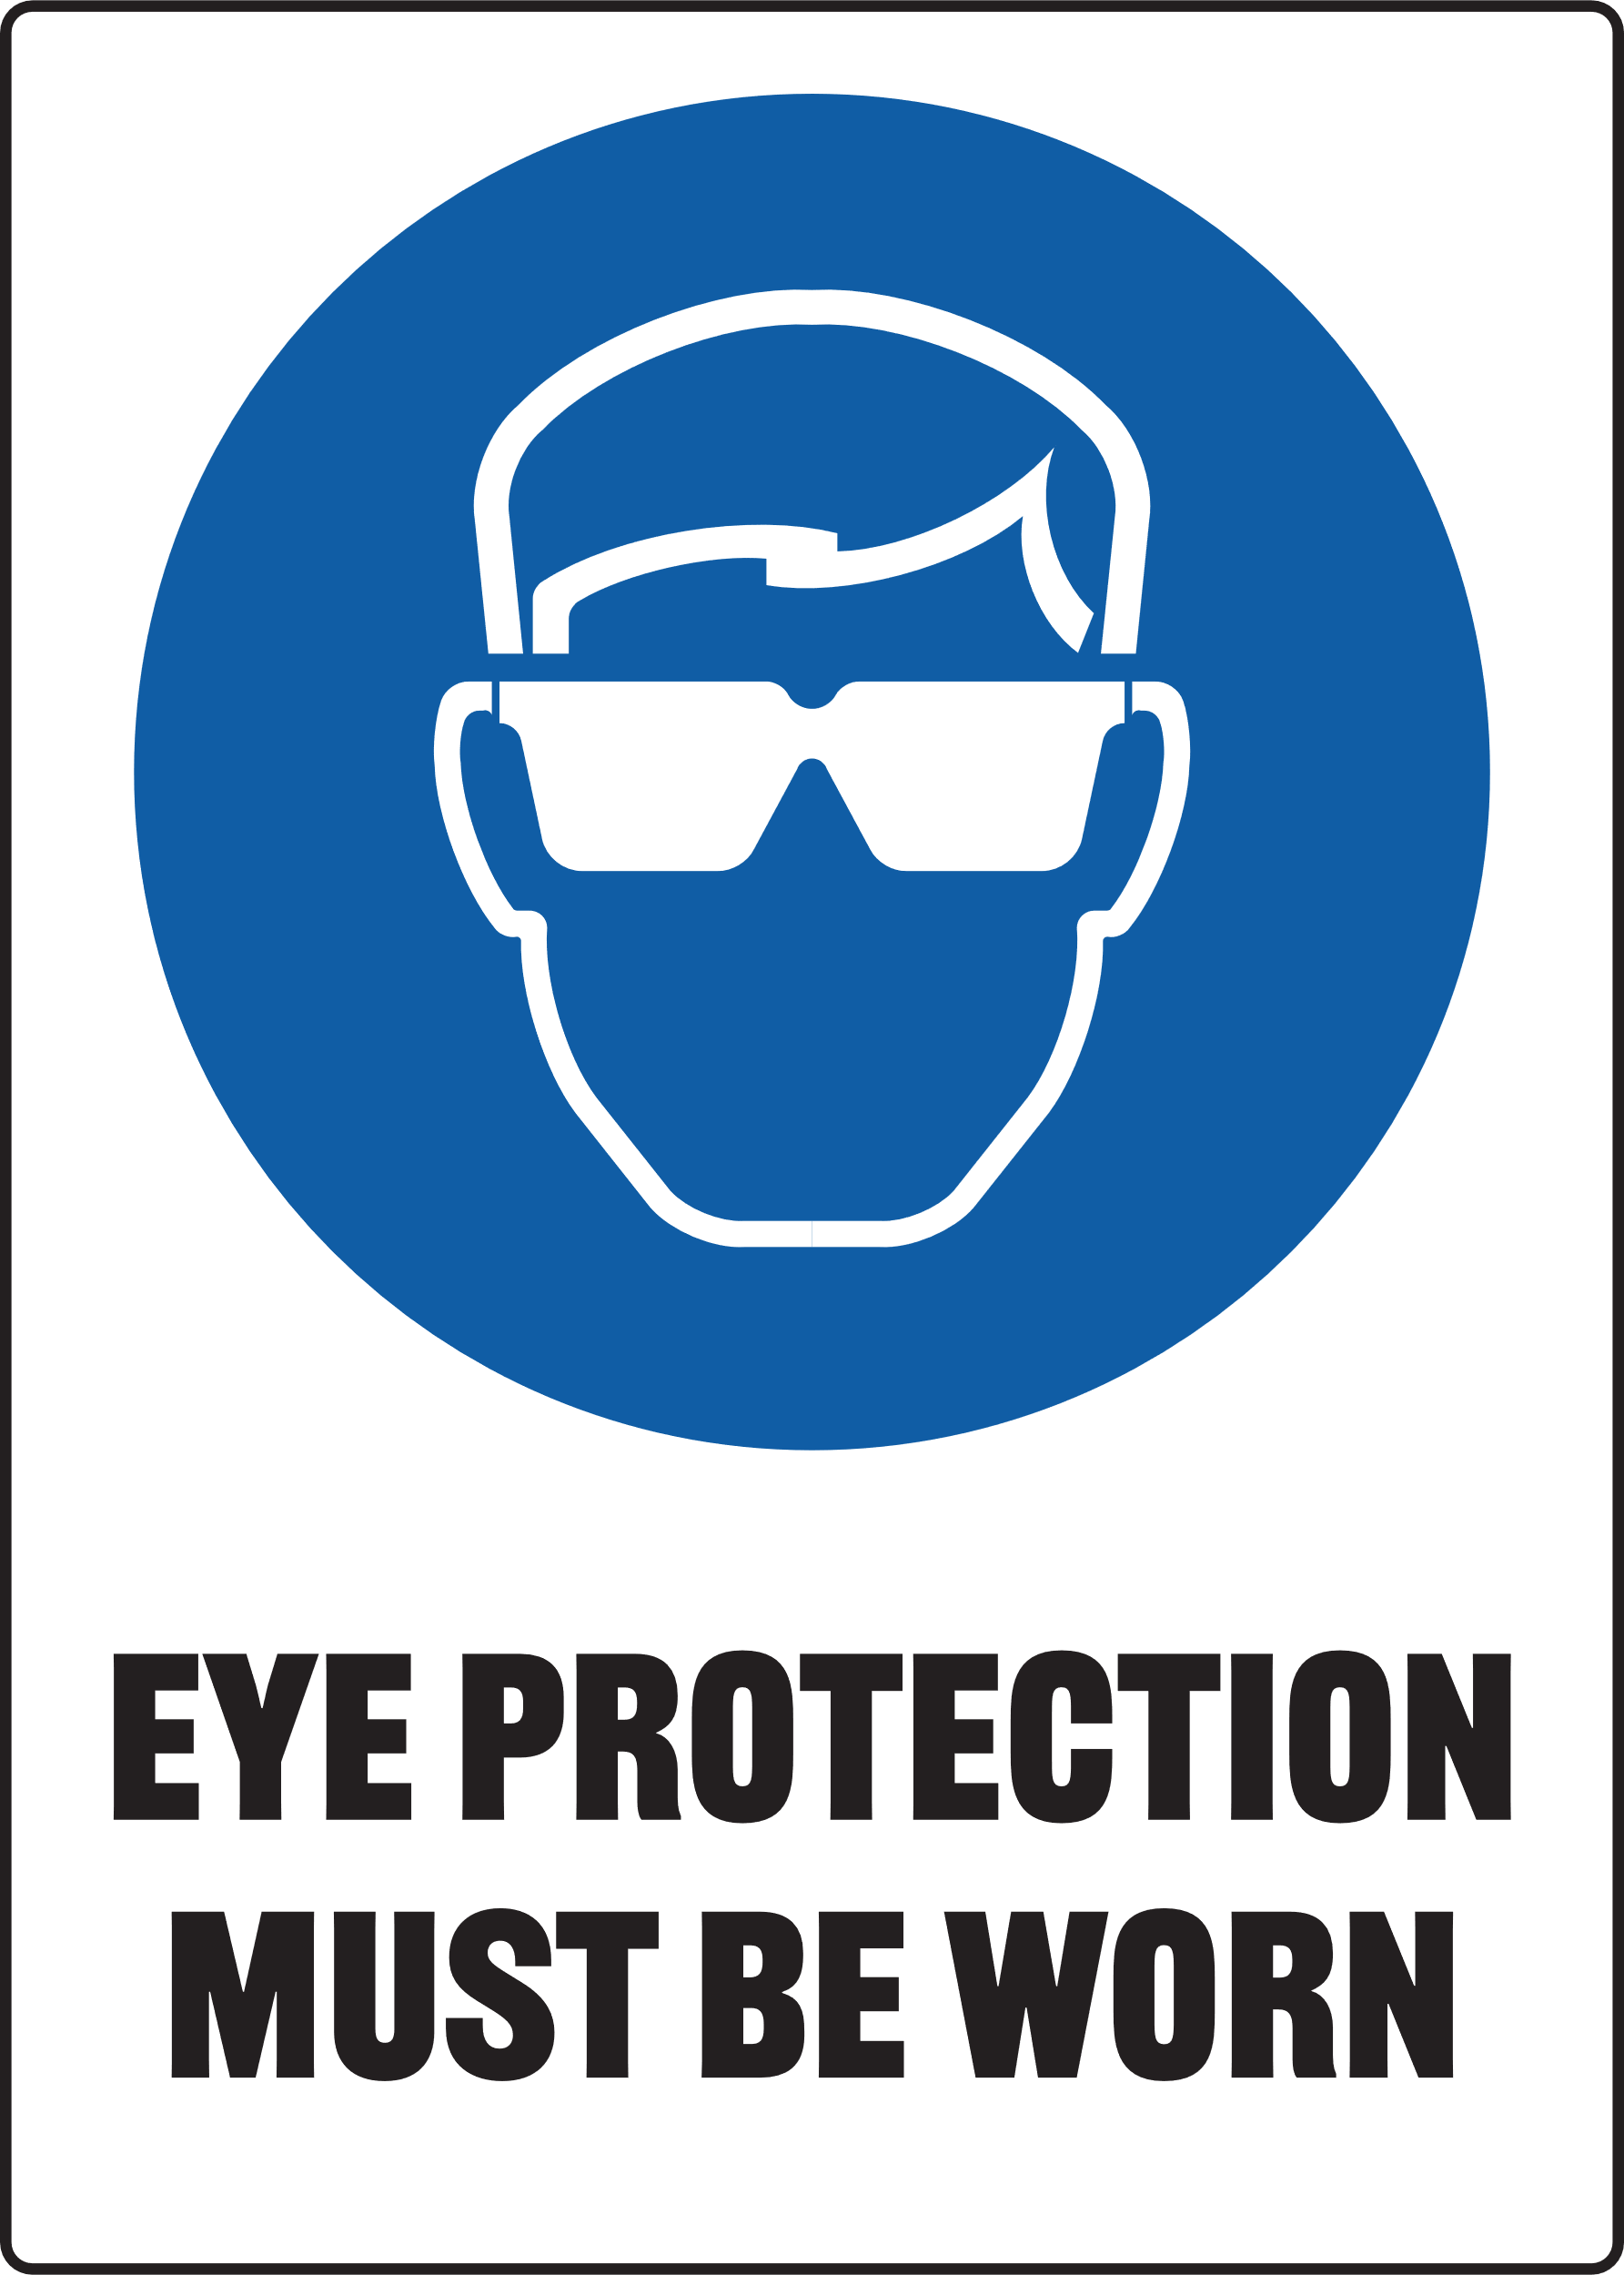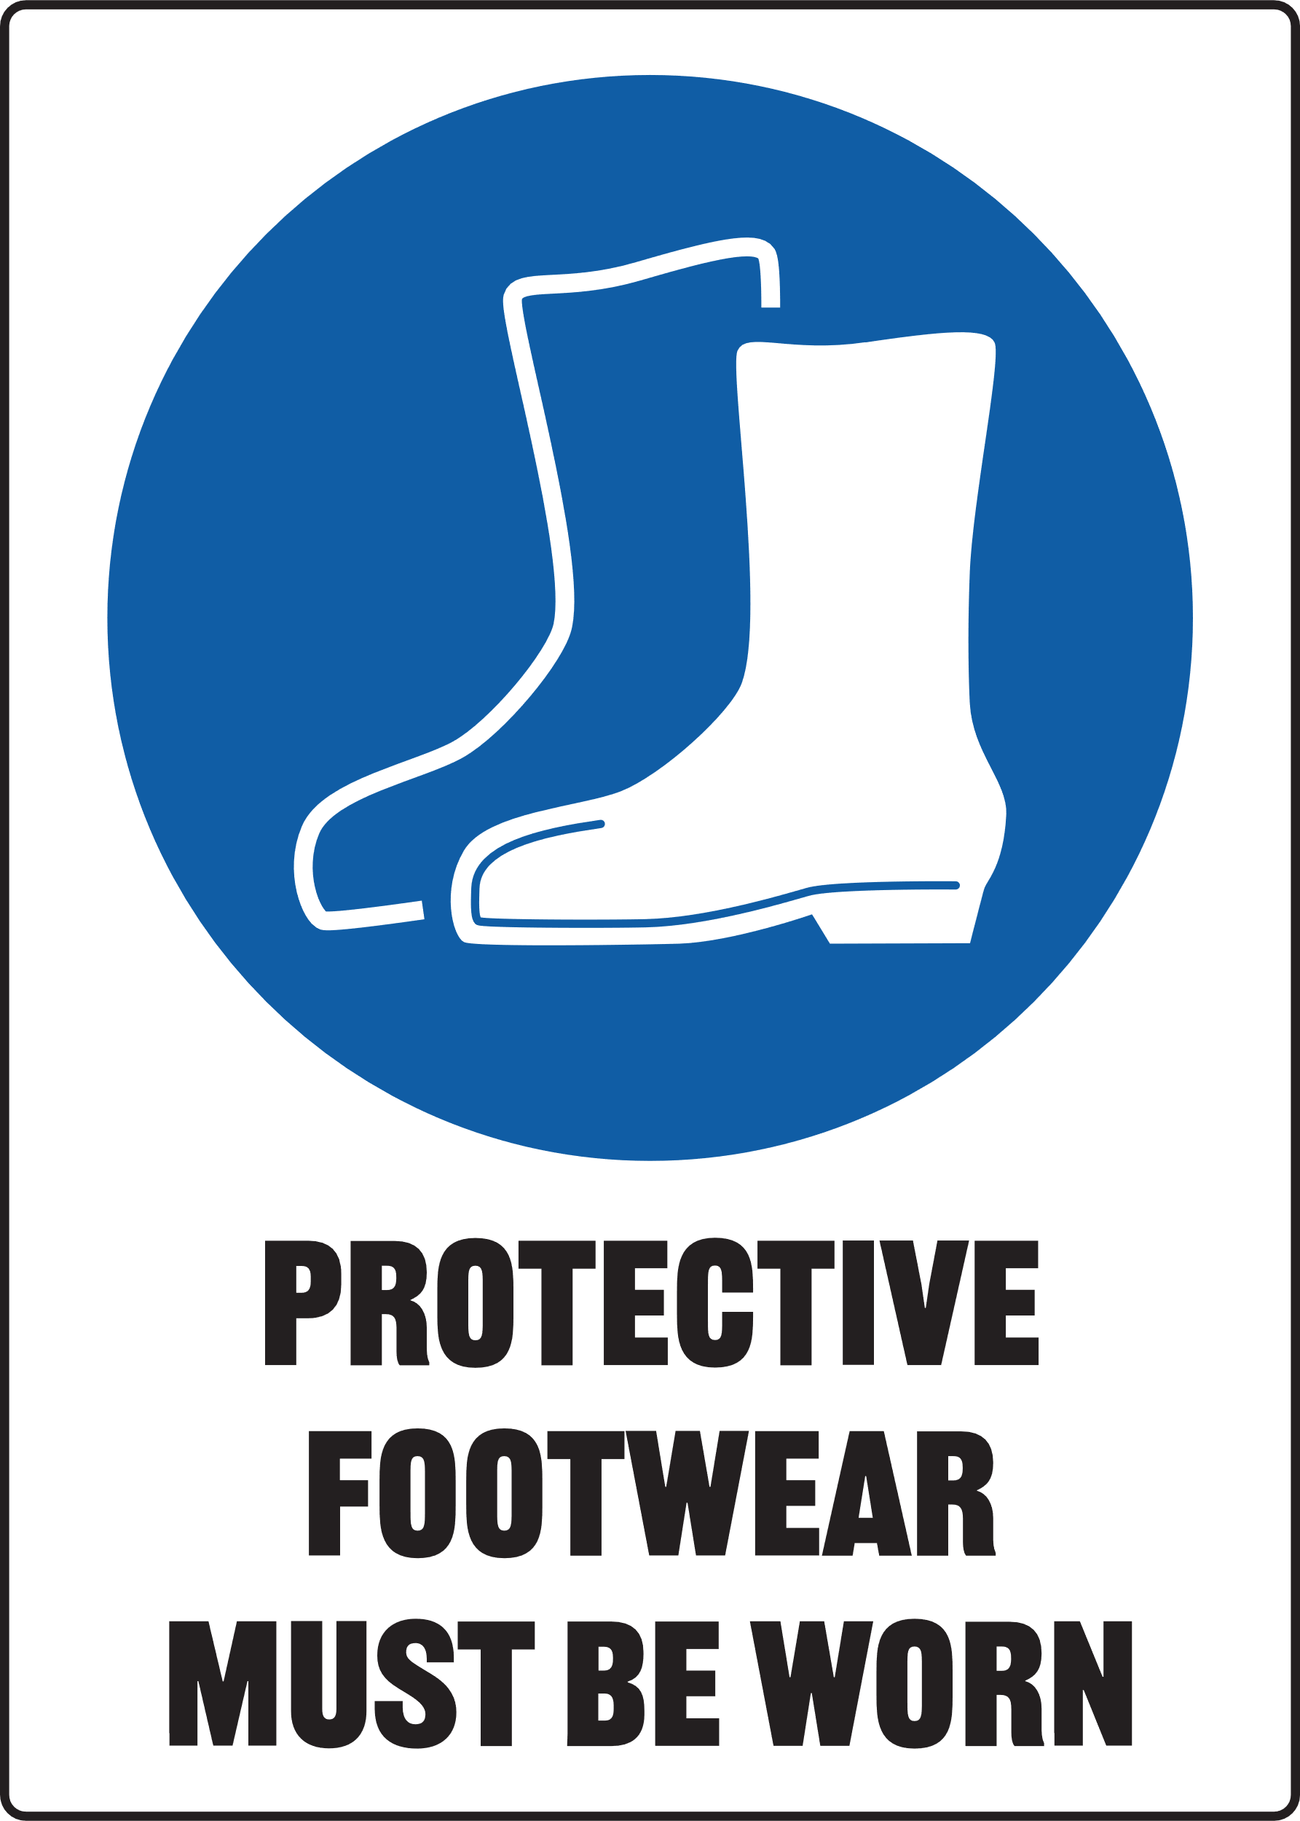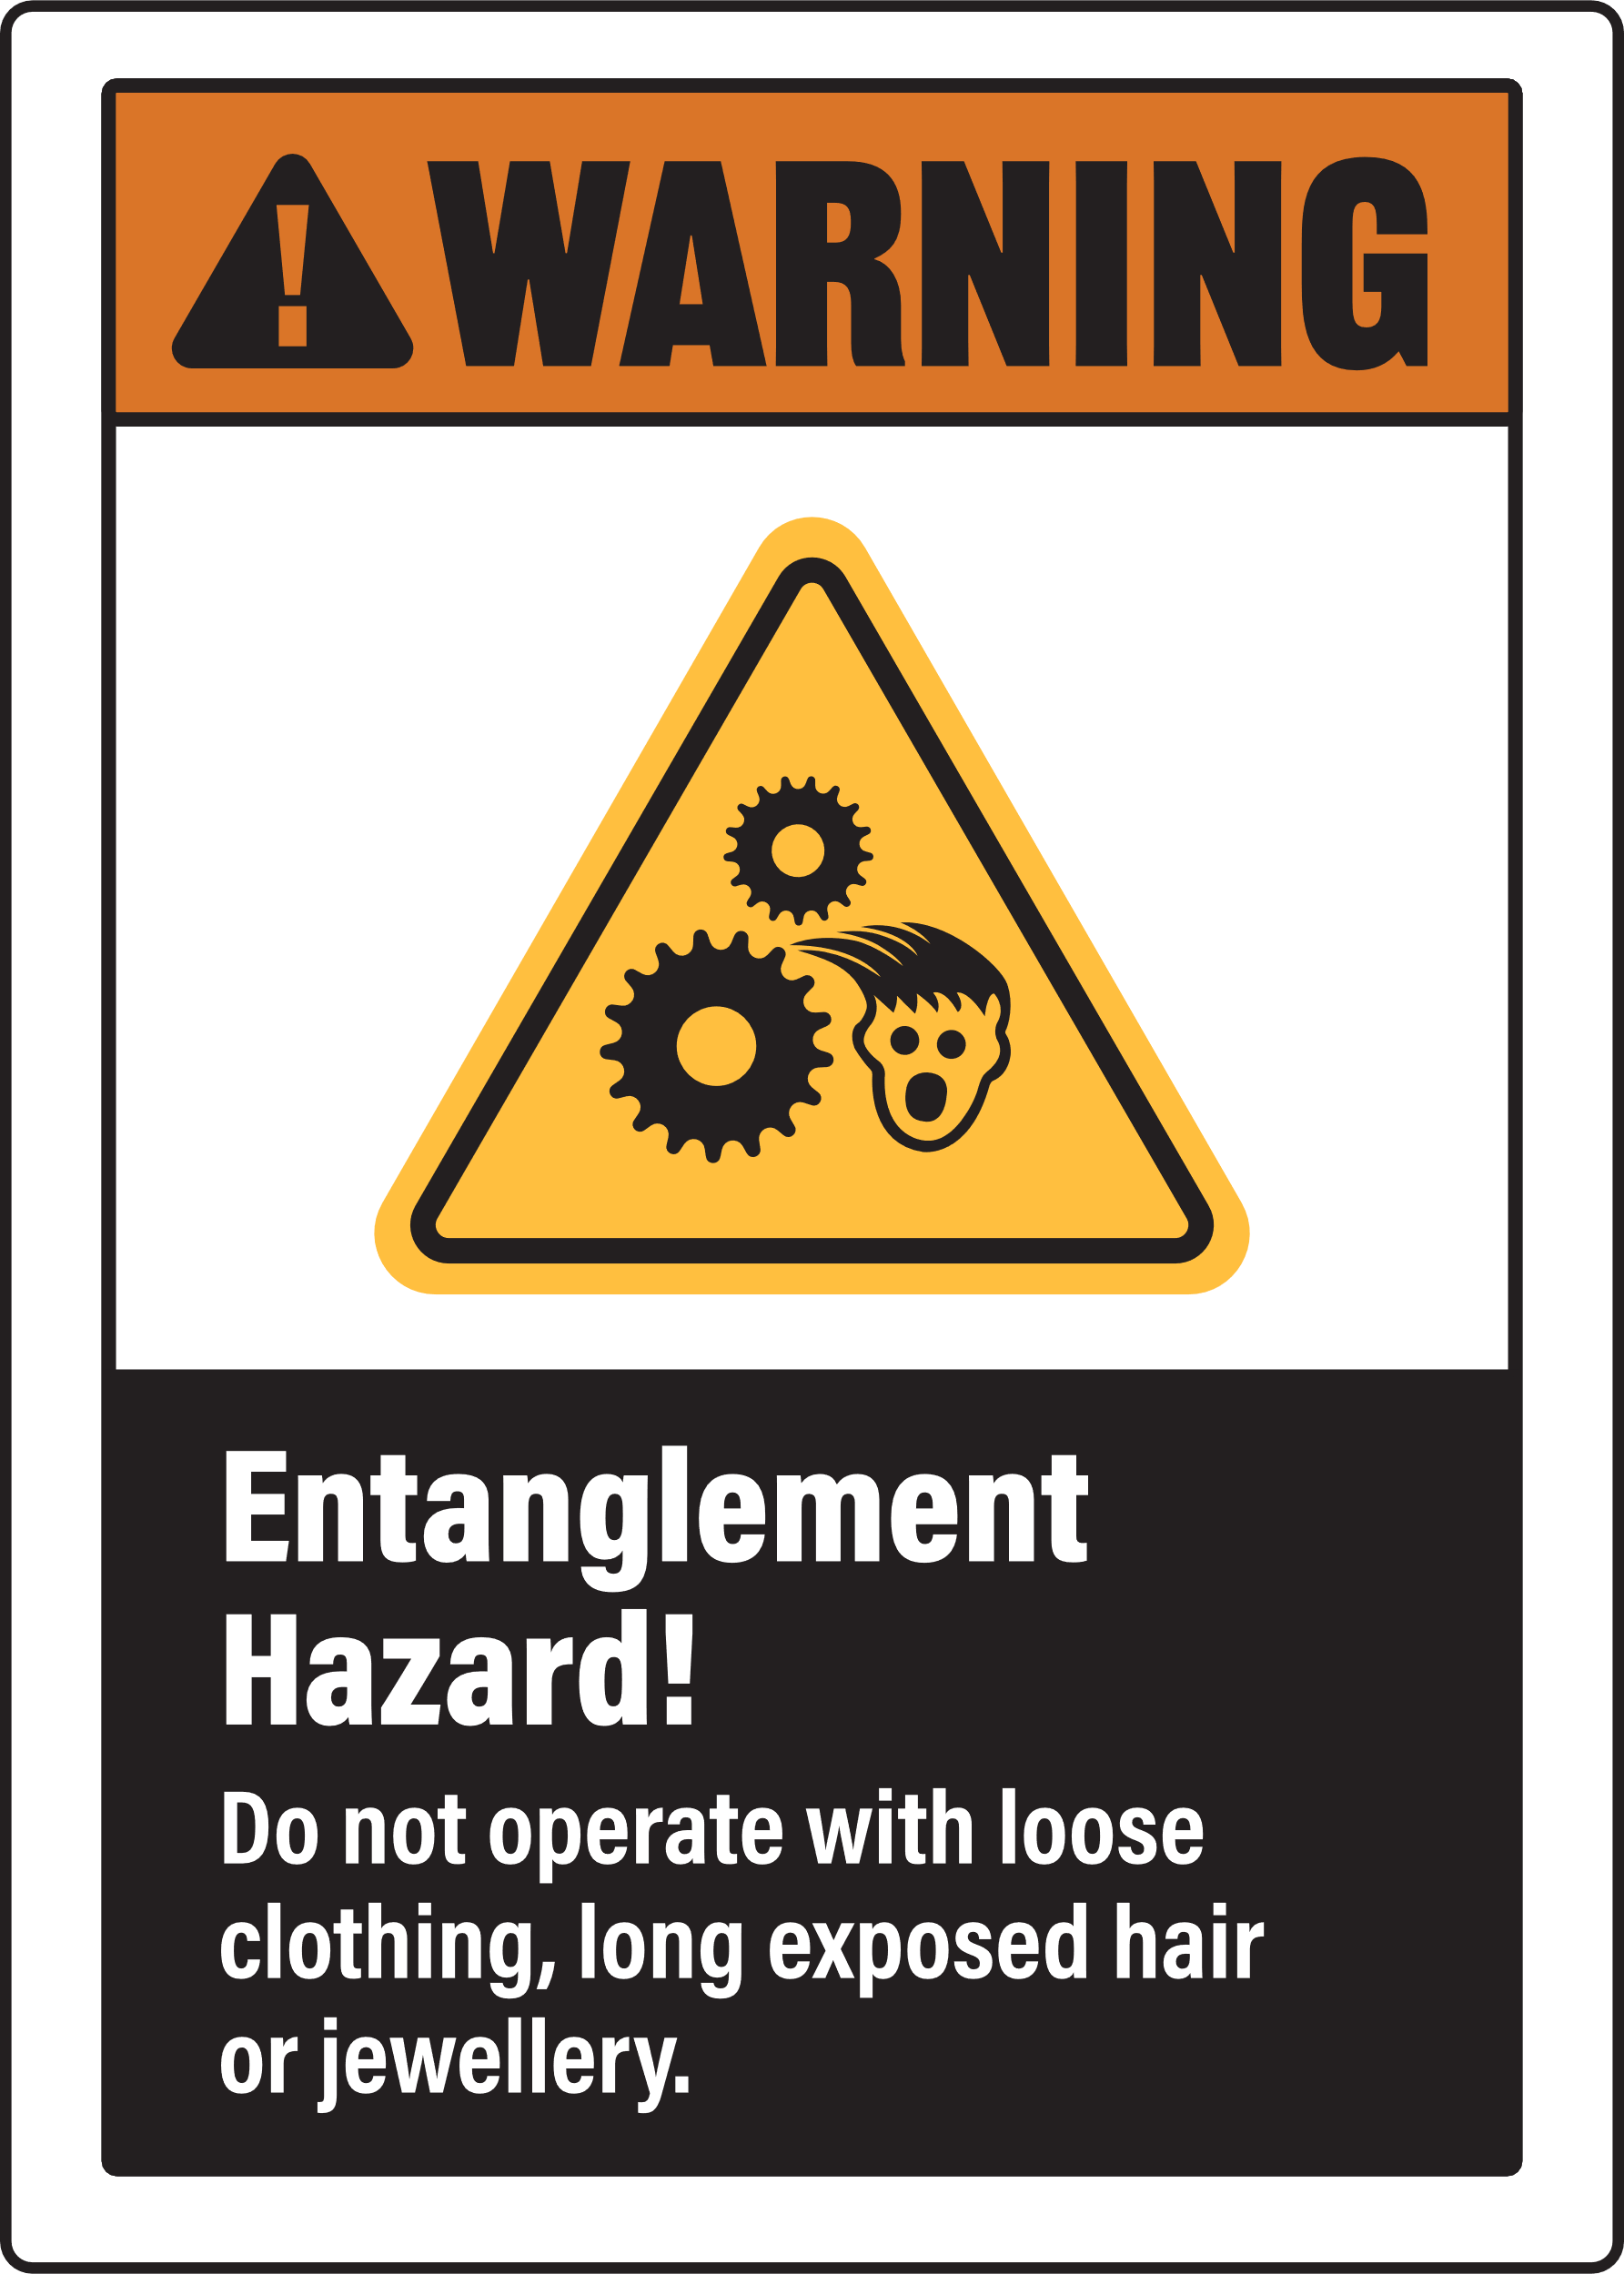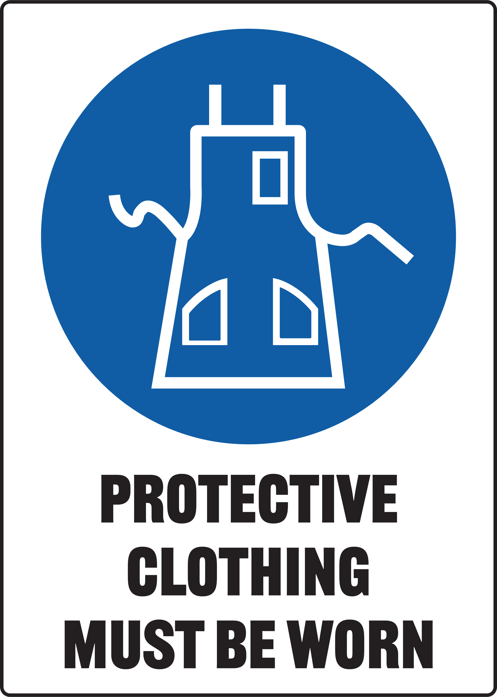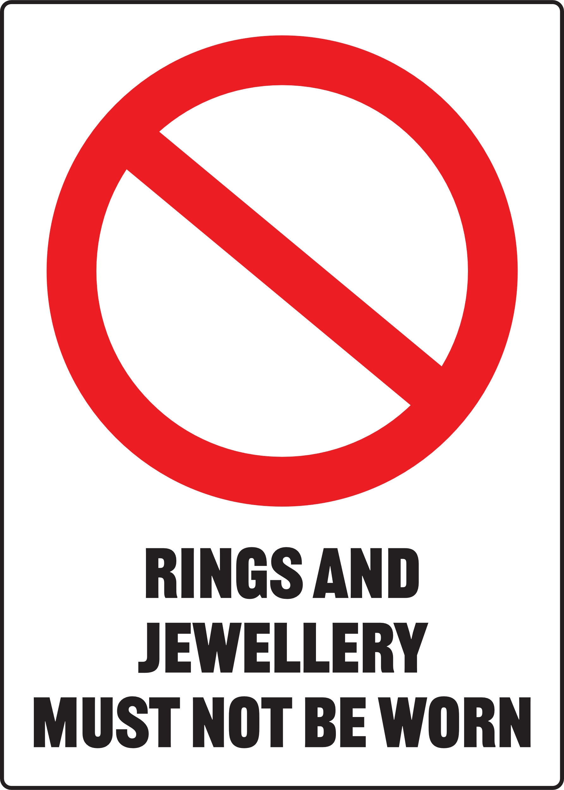

Ensure you wear appropriate PPE when using this machine

Pre-Operational Safety Checks
- Ensure you are familiar with the operation of the hydraulic press
- Check for any hydraulic fluid leaks
- The press table must be clean and steel weights are flat and secure on press table
- Any forming die or cutting die must be inspected for safe use i.e. no cracks
- Ensure safety glasses or goggles are available and are worn by all persons in the vicinity
- Any test piece, project or material (work piece) to be pressed must be of an appropriate thickness and safe to use on this equipment
- Faulty equipment must not be used. Immediately report suspect machinery

Operational Safety Checks
- Place your work piece securely on the press table
- Ensure the pressure valve is closed before operation
- Use the press handle, in a pumping action, to slowly lower the press hammer
- Use your shoulder muscles when operating – NOT your lower back
- Keep hands and fingers away from all clamping and moving parts
- Carefully and accurately align the press hammer face with the work piece to allow an even force to be applied
- Once the press hammer makes contact with the work piece, closely watch the PSI gauge and note the pressure applied
- Once the work piece is pressed sufficiently, release the hammer pressure at the release valve
- DO NOT apply excessive force with the press
- Turn power off when activity is completed

Housekeeping
- After use, clean the press down and return any tools and equipment to the appropriate storage areas – including the press handle
- Place all scrap or waste in the appropriate bin

Potential Hazards
- High pressure Δ Beware of high forces applied Δ Pinch and squash
- Laceration injuries Δ Eye injuries – flying or shattering objects
- Potentially uneven forces being applied to the work piece

