LINE TRIMMER – ELECTRIC

DO NOT use this machine unless a teacher has instructed you in its safe use and operation and has given permission.

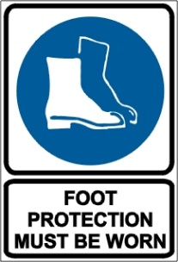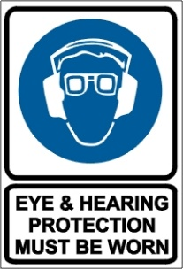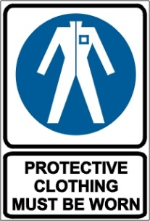

PRE-OPERATIONAL SAFETY CHECKS
- Do not use the line trimmer in wet conditions.
- Ensure that the cutting head guard is fitted, secure and functional.
- Ensure that the nylon line cutter is functional.
- Load the nylon line cutting head only with nylon trimmer line of the proper diameter.
- Ensure that the cutting head is tightened.
- Ensure that the harness (if fitted) is in sound condition.
- Ensure that the machine and extension cord are tagged and the tags are current.
- Ensure the machine is operated from an RCD protected circuit.
- Trip test external RCD before operation.
- Ensure that the extension cord is in good condition.
- Faulty equipment must not be used. Report suspect machinery immediately.

OPERATIONAL SAFETY CHECKS
- Adjust the handle to a position for comfort and good balance.
- Maintain a straight wrist position. Avoid using your wrist in a bent, extended or twisted position for extended periods.
- Take periodic breaks to minimize repetition and rest your hands.
- Watch especially for ejected material and ensure that no person or animal is endangered when operating equipment.
- Maintain footing and balance at all times. Do not work on slippery, uneven or unstable surfaces.
- Ensure extension cable is well clear of cutting head at all times.
- Always keep both hands on the control handles. Do not operate one-handed.
- Do not raise the line head above knee height.
- Keep clear of moving machine parts.
- Keep clear of fences, wires, posts, rocks, etc. to prevent kick out and cutting head damage.

HOUSEKEEPING
- Remove any foreign material from motor, cutting head and guards.
- Keep the work area and implement shed in a clean and tidy condition.

POTENTIAL HAZARDS
Ejected material Vibrating machinery Entanglement Electrical hazards

This SOP should be used in conjunction with Curriculum Activity Risk Management Modules
Acknowledgement: Much of the information for this document has been sourced from content kindly provided by Department for Education SA website.

Date of last review | ______/______/______ | Signature ______________________

