MMA WELDER
DO NOT use this equipment unless a teacher has instructed you in its safe use and operation and has given permission

Approved safety glasses must be worn at all times in addition to a welding helmet. | Long and loose hair must be contained or restrained.
Appropriate protective footwear with substantial uppers must be worn. | 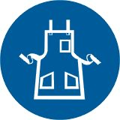  Close fitting protective clothing or overalls, leather apron and spats must be worn.
Appropriate welding mask with correct grade lens must be worn | Oil free leather gloves must be worn when using this equipment.
Rings and jewellery must not be worn. | 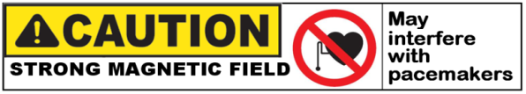

PRE-OPERATIONAL SAFETY CHECKS
- Check workspace to ensure that no slip/trip hazards are present.
- Check work area is clean and free of grease, oil and flammable material.
- Ensure the equipment and work area is dry to avoid electric shocks.
- Inspect gloves to ensure they are free from holes and are dry to avoid electric shocks.
- Check the electrode holder and work leads are in good condition.
- Ensure the fume extractor unit is on before welding commences.
- Close the UV curtain or erect safety screens to ensure the protection of others.

DO NOT use faulty equipment – report this immediately to your teacher.

OPERATIONAL SAFETY CHECKS
- Keep the welding leads as short as possible and coil them to minimise inductance.
- Ensure the electrode holder has no electrode in it before turning on the welder.
- Ensure current is correctly set according to electrode selection.
- Do not use bare hands and never wrap electrode leads around yourself.
- When welding is finished or interrupted, remove electrode stub from holder and switch off power source.

HOUSEKEEPING
- Switch off the machine and fume extraction.
- Hang up electrode holder and welding cables and leave the work area in a safe, clean and tidy state.

POTENTIAL HAZARDS
- Electric shock Radiation burns to eyes or body Flying sparks Fire
- Fumes Body burns due to hot or molten materials Cuts and lacerations

