INSTRUCTIONS – each SOP must reflect your site, equipment and activities
1. Read:
Review: Read and review the SOP contents against local operating practice
Manufacturer’s Instructions: Align the SOP with the equipment’s instruction manual for technical safety
2. Consult:
Feedback: Consult with users to ensure the SOP reflects practical site usage
PPE Assessment: Identify personal protective equipment (PPE) requirements for specific material or hazards
3. Update:
Customisation: Edit the SOP content to reflect instruction manual feedback and specific site-based risks. Adjust PPE requirements to reflect assessed needs
4. Footer Details
Date of Review: Record the date the school review was completed
Reviewed By: Who completed the school review
Next Review: SOP must be reviewed annually or with any change to process or equipment
Version: Retain for tracking template control
5. Approve and Print:
Finalise: Ensure the reviewed SOP is signed and dated
Visibility: Provide the colour printed SOP where it is easily accessible to all operators/users
6. Schedule Review:
Maintenance: Review and update this SOP annually, or immediately if equipment, work processes, or legislation changes

Personal Protective Equipment (PPE) Signage
Add or remove icons from the SOP template as appropriate for your specific piece of equipment
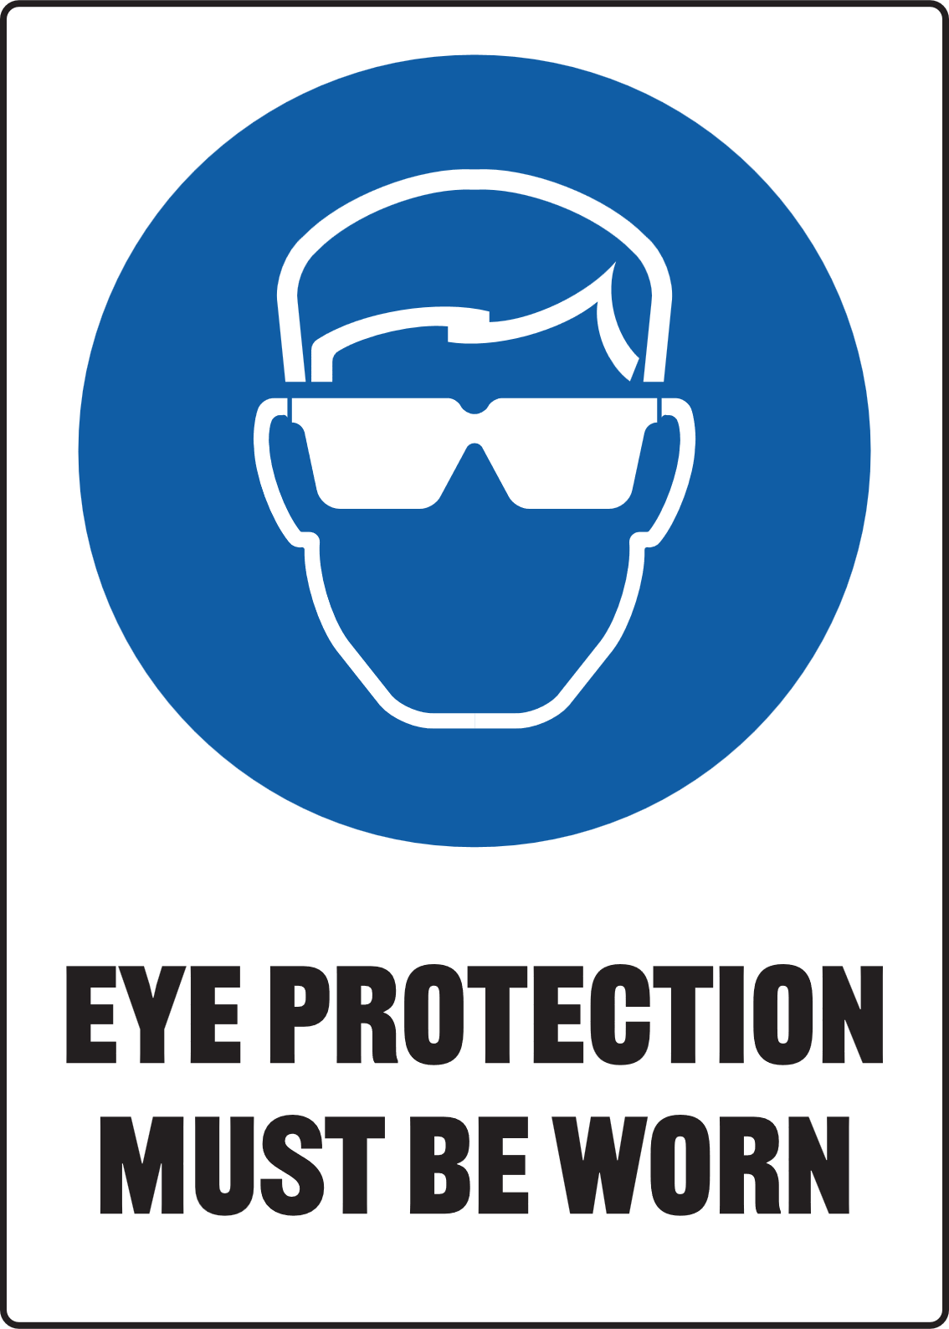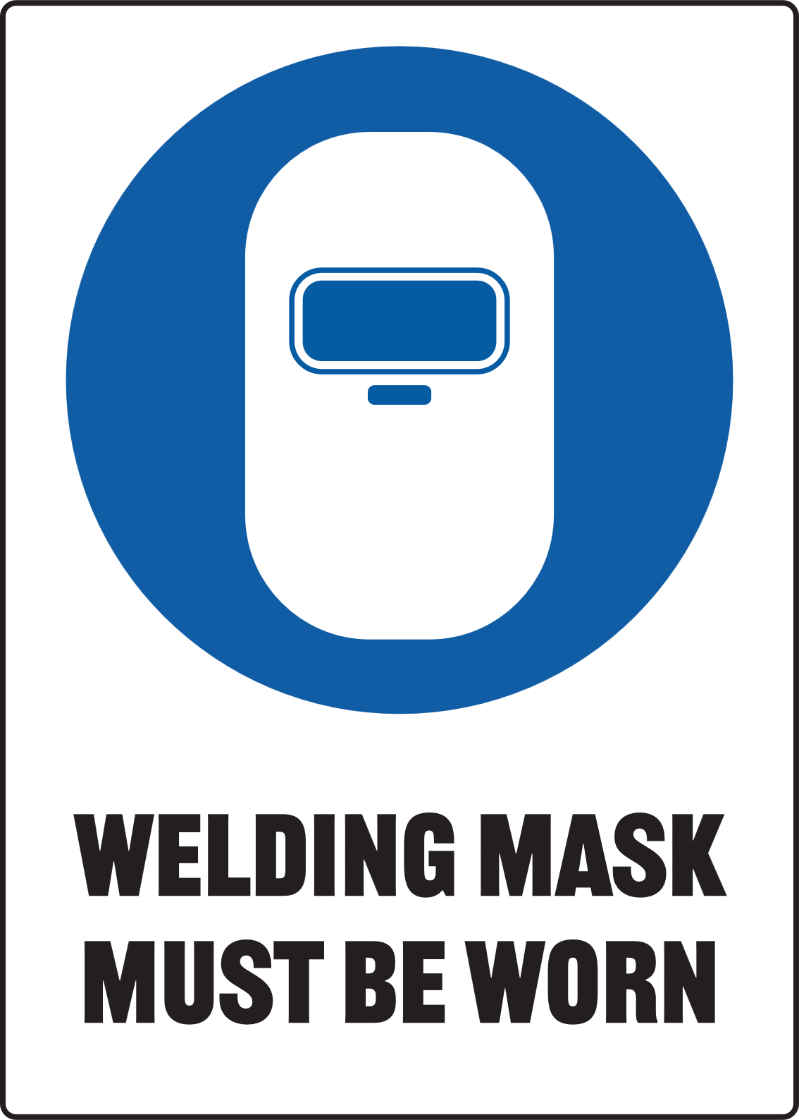

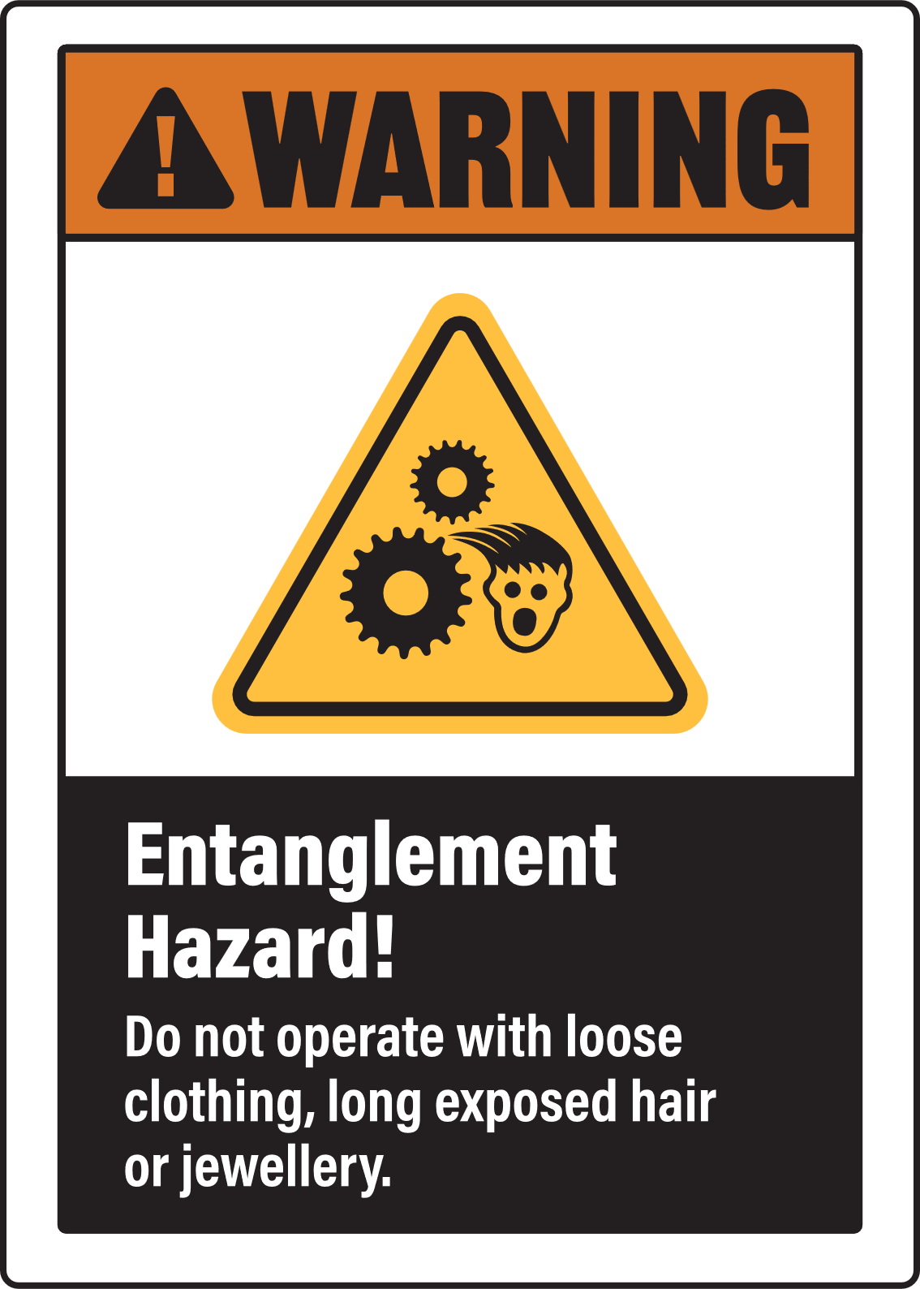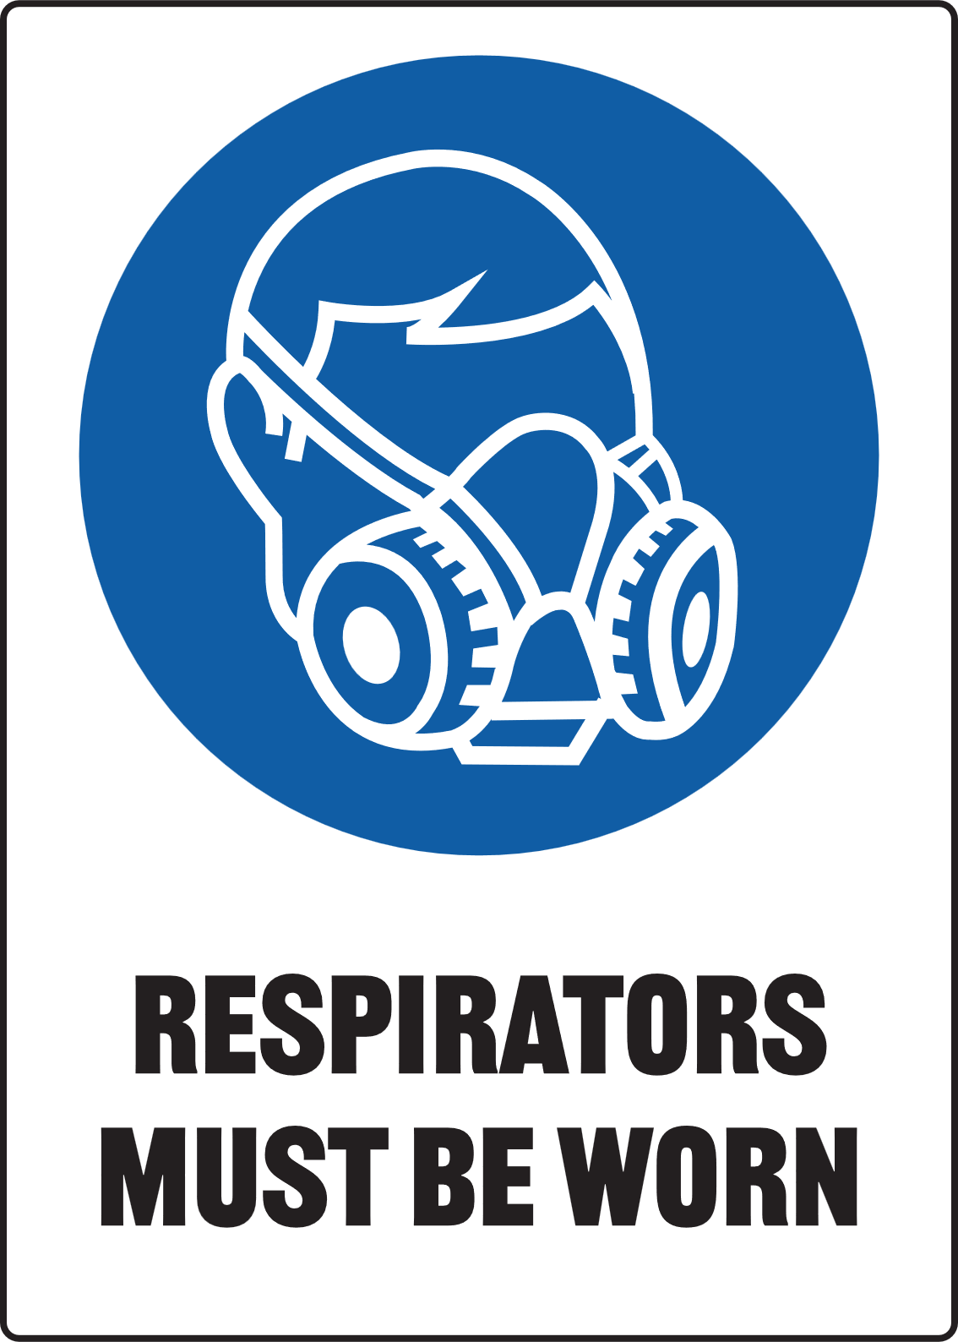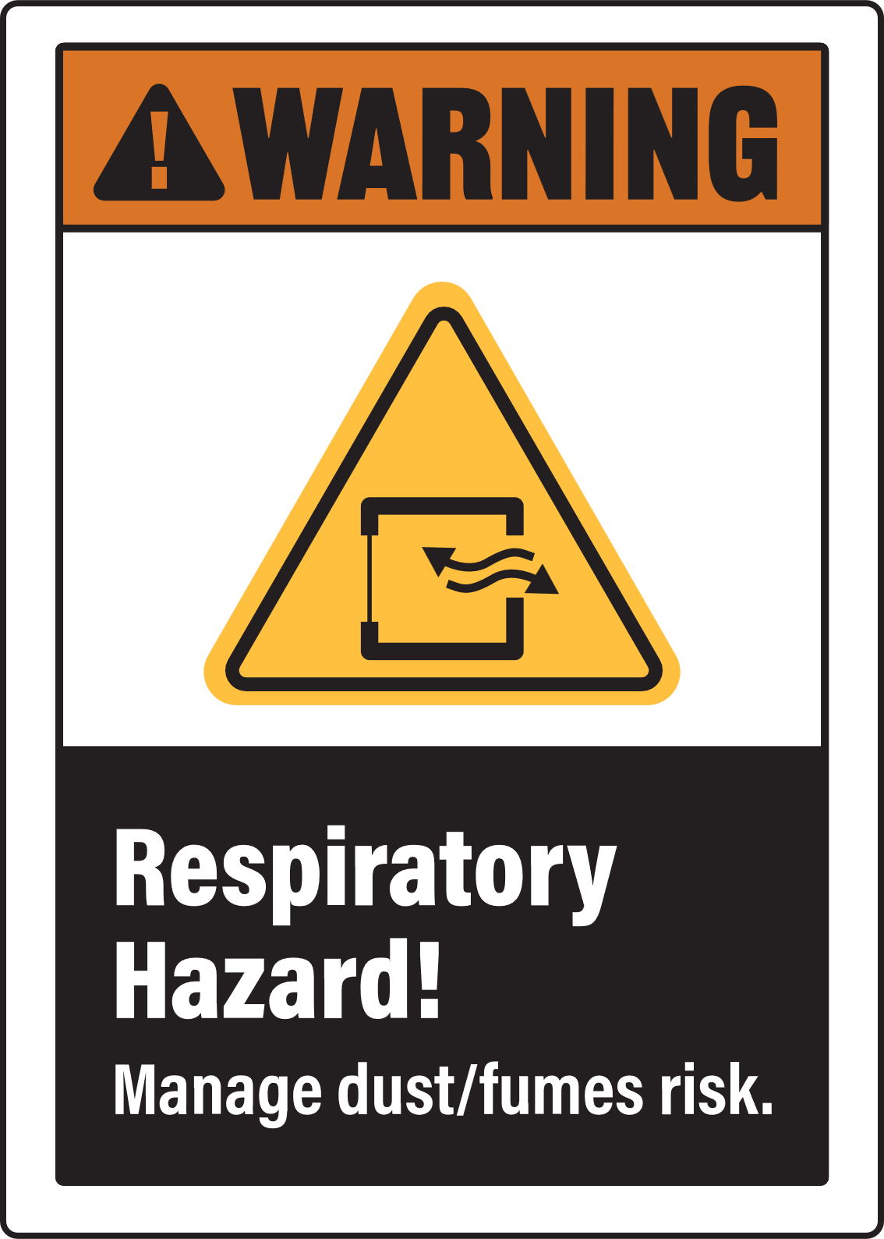

ONLY PAGE 2 REQUIRES PRINTING FOR ON-SITE DISPLAY


PLASMA CUTTER
(manual hand torch)

Only use this machine if you have been given instructions on how to use it safely and have been given permission
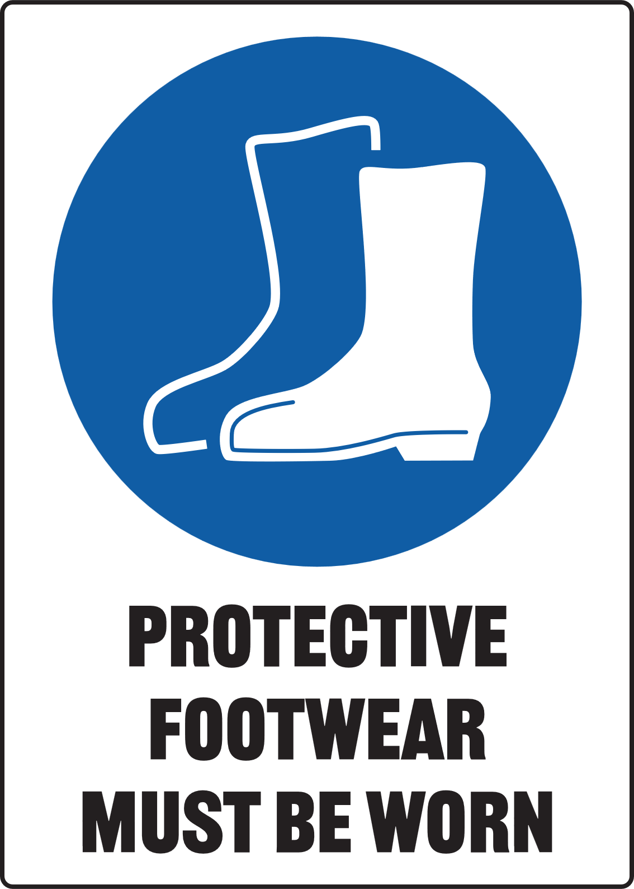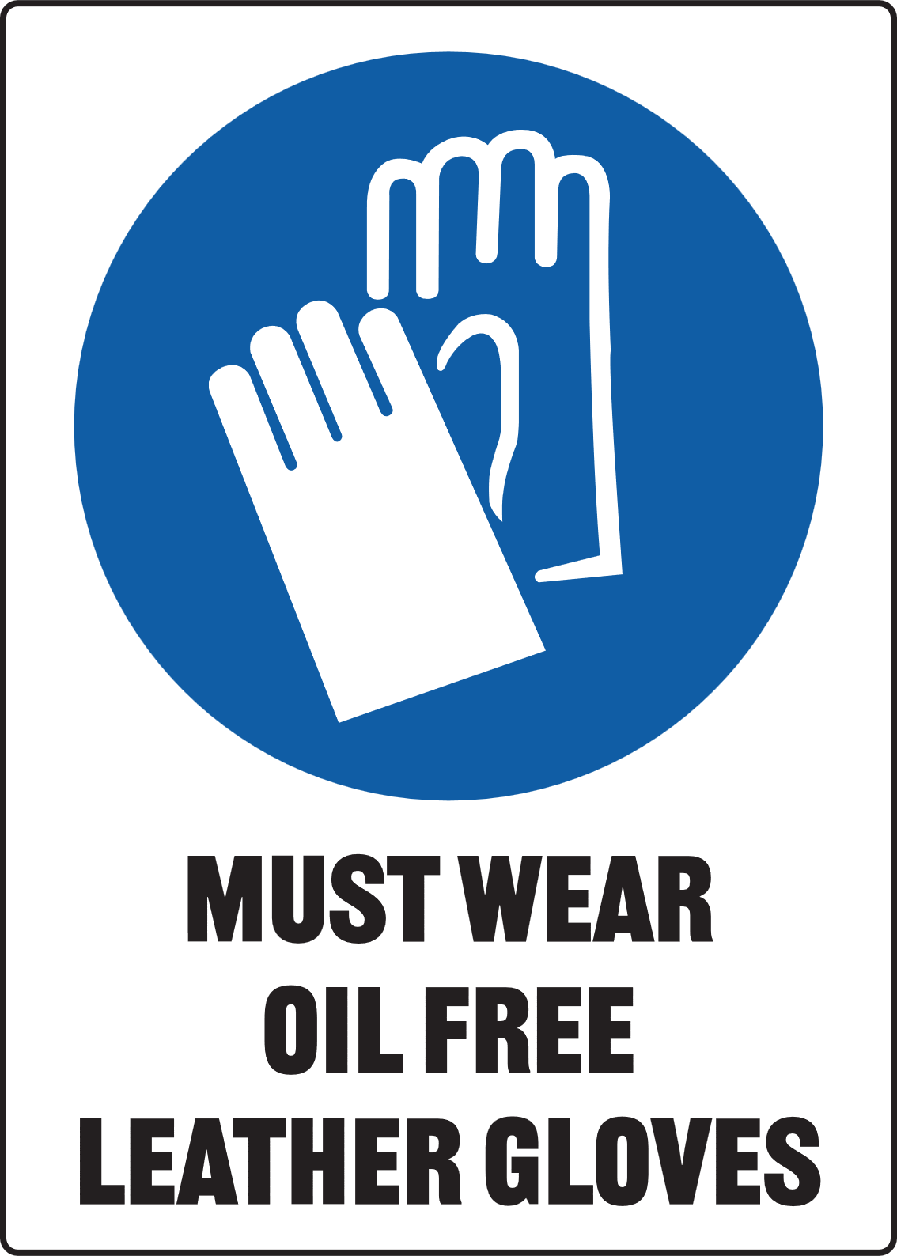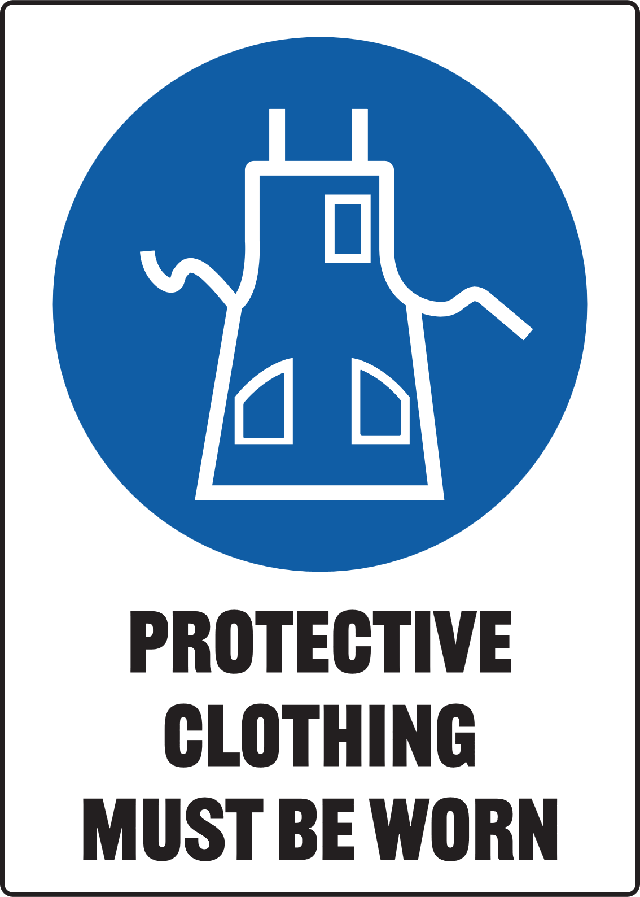

High-voltage arc and intense UV radiation. Flying molten metal is a severe burn risk. Use eye protection and extraction.

Pre-Operational Safety Checks
- Clear the Zone: Ensure workspace is clean, dry and free of flammables or trip hazards
- Inspect Equipment: Check torch, cables, and ground clamp for damage; ensure the nozzle is clean
- Flash Protection: Position welding screens to block sparks and high intensity arc flash
- Fume Control: Confirm the workspace is ventilated and ensure the fume extraction system is switched on
- Air Supply: Check that the compressed air line is connected and the pressure is set correctly
- Medical Check: Ensure all persons in the immediate area are aware that welding creates magnetic fields that can affect pacemakers and medical implants

Operational Safety Checks
- Work Setup: Use tongs or pliers to move work; never hold hot metal with gloves
- Earth Clamp: Ensure the work clamp is attached to clean metal for a good electrical circuit
- Cutting Path: Ensure the area beneath the cut is clear of cables, feet or flammable debris
- Cutting Direction: Pull the torch toward you rather than pushing it
- Trigger Safety: Keep fingers away from the trigger until the torch is in the cutting position
- Handling: Do not touch the torch tip or the workpiece immediately after cutting

Housekeeping
- Power Down: Switch off the machine and the compressed air supply at the wall
- Bleed Lines: Press the torch trigger (with power off) to release trapped air pressure
- Safe Storage: Neatly coil the torch lead and ground cable; hang the torch on its hook
- Clean up: Remove slag and off-cuts; leave the work area in a safe, clean, and tidy state

Potential Hazards
- Strong Magnetic Fields: Can disrupt pacemakers or medical implants. Wearer must seek medical advice before entering the welding zone
- Arc Flash Δ Electric Shock Δ Fumes and Gases
- Compressed Air Δ Flying sparks Δ Burns and Hot Materials

