ROTARY SLASHER – TRACTOR OPERATED

DO NOT use this machine unless a teacher has instructed you in its safe use and operation and has given permission.

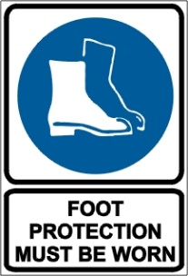

PRE-OPERATIONAL SAFETY CHECKS
- Operate only with roll over protection structure (ROPS) and seatbelt equipped tractors.
- Ensure that all guards are fitted, secure and functional.
- Ensure that the three-point linkage, securing pinions and safety chains are in sound condition.
- Ensure that the blades and fasteners are in sound condition.
- Ensure that hydraulic rams, hoses and couplings are in sound condition.
- Ensure that the rotary slasher is attached according to manufacturer’s specification.
- Faulty equipment must not be used. Report suspect machinery immediately.

OPERATIONAL SAFETY CHECKS
- Keep clear of moving machine parts.
- Allow no passengers on tractor or rotary slasher.
- Do not use rotary cutter with bystanders in area.
- Be sure the transmission is out of gear and the mower blade clutch disengaged before starting the engine.
- Allow moving parts on rotary slasher to stop before repair.
- Securely support the mower before working underneath. Chock tractor wheels.
- Lock up raised wings (where fitted) before transport.
- Do not cut with raised wings (where fitted) in raised or transport position.
- Before dismounting the tractor:
- Lower rotary cutter to ground and allow moving parts to stop.
- Stop engine and set brake.
- Remove key for unattended equipment.

HOUSEKEEPING
- Remove any foreign material from blades, fasteners, guards and hydraulic rams.
- Keep the work area and implement shed in a clean and tidy condition.

POTENTIAL HAZARDS
Rapidly rotating blades Noise
Eye injuries Flying debris

This SOP should be used in conjunction with Curriculum Activity Risk Management Modules
Acknowledgement: Much of the information for this document has been sourced from content kindly provided by Department for Education SA website.

Date of last review | ______/______/______ | Signature ______________________

