ROUND HAY BALER

THIS MACHINE IS NOT FOR STUDENT USE

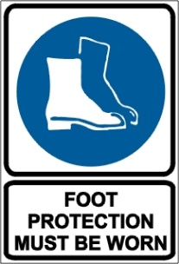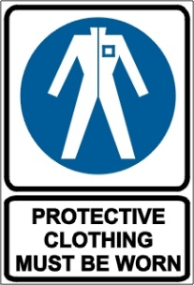

Never leave the tractor seat with the engine running, even if the PTO is disengaged.

PRE-OPERATIONAL SAFETY CHECKS
- Follow the manufacturers' safety recommendations for machinery operation.
- Ensure all guards are in place, especially the power take-off (PTO) guards.
- Drive shafts and other moving parts must be guarded. Inverted U-shaped guards are inadequate.
- Carefully check for loose or missing nuts, bolts, screws, guards or bent teeth.
- Replace bent or missing pickup teeth to ensure effective feeding of material into the feed rolls.
- Inspect all belts or chains for evidence of wear or breakage. Maintain belt tension according to the manufacturer’s recommendations.
- Belt lengths should be matched to prevent slippage that can cause blockages and heat build-up.
- Before replacing a belt or chain, consult the operator’s manual for instructions on securing the upper chain or moving load from the belt tension springs.
- Check the slip clutch, roll scraper and rear gate latch to ensure they are adjusted and functioning according to the manufacturer’s recommendations.
- Ensure the hydraulic hoses are clean, in good repair and hooked up correctly.
- Ensure the hay baler is attached according to manufacturer’s specification.
- Check the twine feeding and cutting mechanisms to see that they are working properly and that the twine is in good condition.
- Faulty equipment must not be used. Report suspect machinery immediately.

OPERATIONAL SAFETY CHECKS
- When working on this equipment disengage the PTO, turn off the tractor, lock the tractor brakes, and remove the ignition key. Chock the baler wheels. Ensure all moving parts have completely stopped.
- Operate the machine at a safe speed.
- When operating over rough terrain or on hillsides, take care to avoid holes or obstacles that can tip a windrower or throw you from the machine.
- Never try to remove blockages or make adjustments until you have disengaged the power take-off and shut off the tractor engine.
- Never attempt to feed the material into the baler by hand or feet.
- Never attempt to hand feed or remove twine from the machine while it is running.
- When ejecting a bale, ensure the area behind the baler is clear before raising the tailgate. Do not eject on a downward slope as the bale may continue to roll.
- If the tailgate must be opened for maintenance or repair, install a mechanical hydraulic cylinder lock out device to prevent accidental gate closing.

HOUSEKEEPING
- Remove excessive grease or grass build up on moving parts.
- Clean the baler to remove accumulated crop debris.

POTENTIAL HAZARDS
Entanglement hazards Noise
Thrown object hazards Crushing hazards

This SOP should be used in conjunction with Curriculum Activity Risk Management Modules
Acknowledgement: Much of the information for this document has been sourced from content kindly provided by Department for Education SA website.
Date of last review | ______/______/______ | Signature ______________________

