SOP Review, Update and Print instructions
DO NOT PRINT THIS PAGE
- Review the SOP Document:
- Manufacturer’s Instructions: Refer to the equipment manual for specific safety and operational guidelines. Incorporate any additional details into the SOP as necessary.
- Feedback: Consult with users to confirm that the SOP accurately reflects practical usage. Make any needed revisions based on their input.
- Assess PPE Requirements:
- Evaluate if new or additional personal protective equipment (PPE) is required based on the risks associated with the equipment. Address risks such as dust and fumes by selecting appropriate PPE and updating the SOP with relevant PPE checks and icons.
- Display and Accessibility:
- Print the reviewed SOP, ensuring it is signed and dated. Post the printed SOP near the equipment or where it is easily accessible to users.
- Schedule and Document Review:
- Plan to review and update the SOP annually or whenever work processes change.
- Footer Details: Date of review = When the school review was completed. Reviewed by = Who completed the school review. Next Review = insert date (e.g. max one year ahead).
Personal Protective Equipment (PPE) Signage
add/remove from the SOP as appropriate for your school/machine
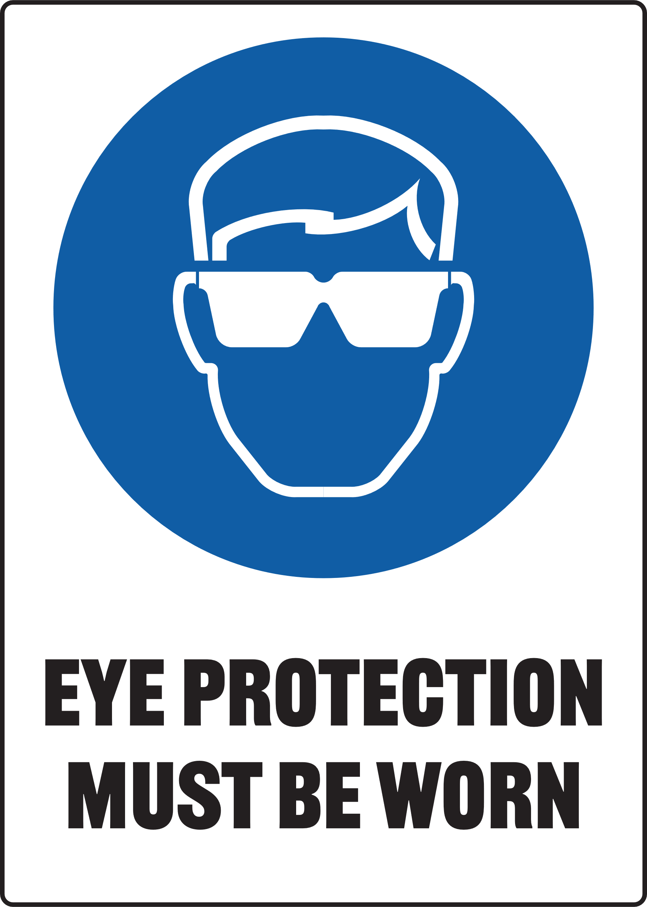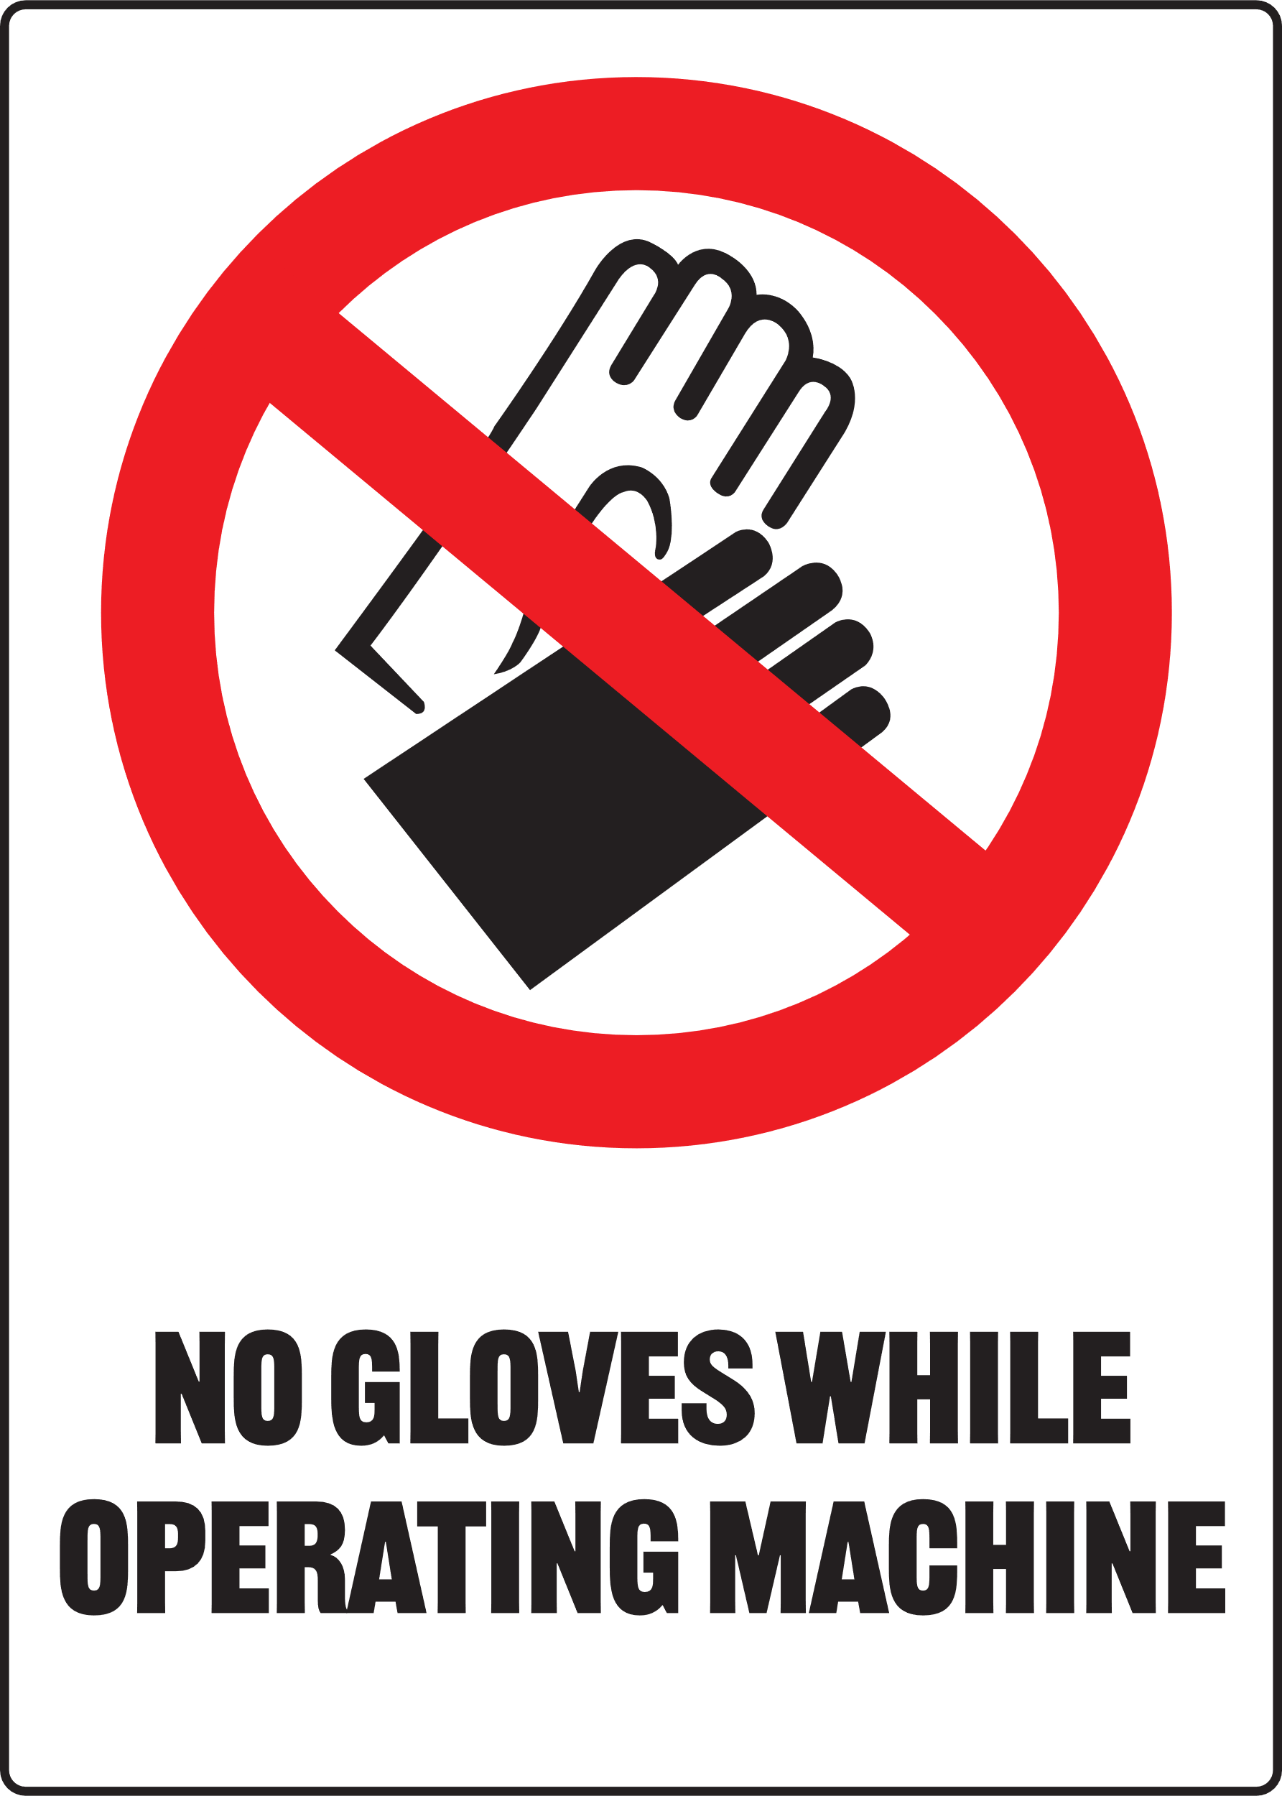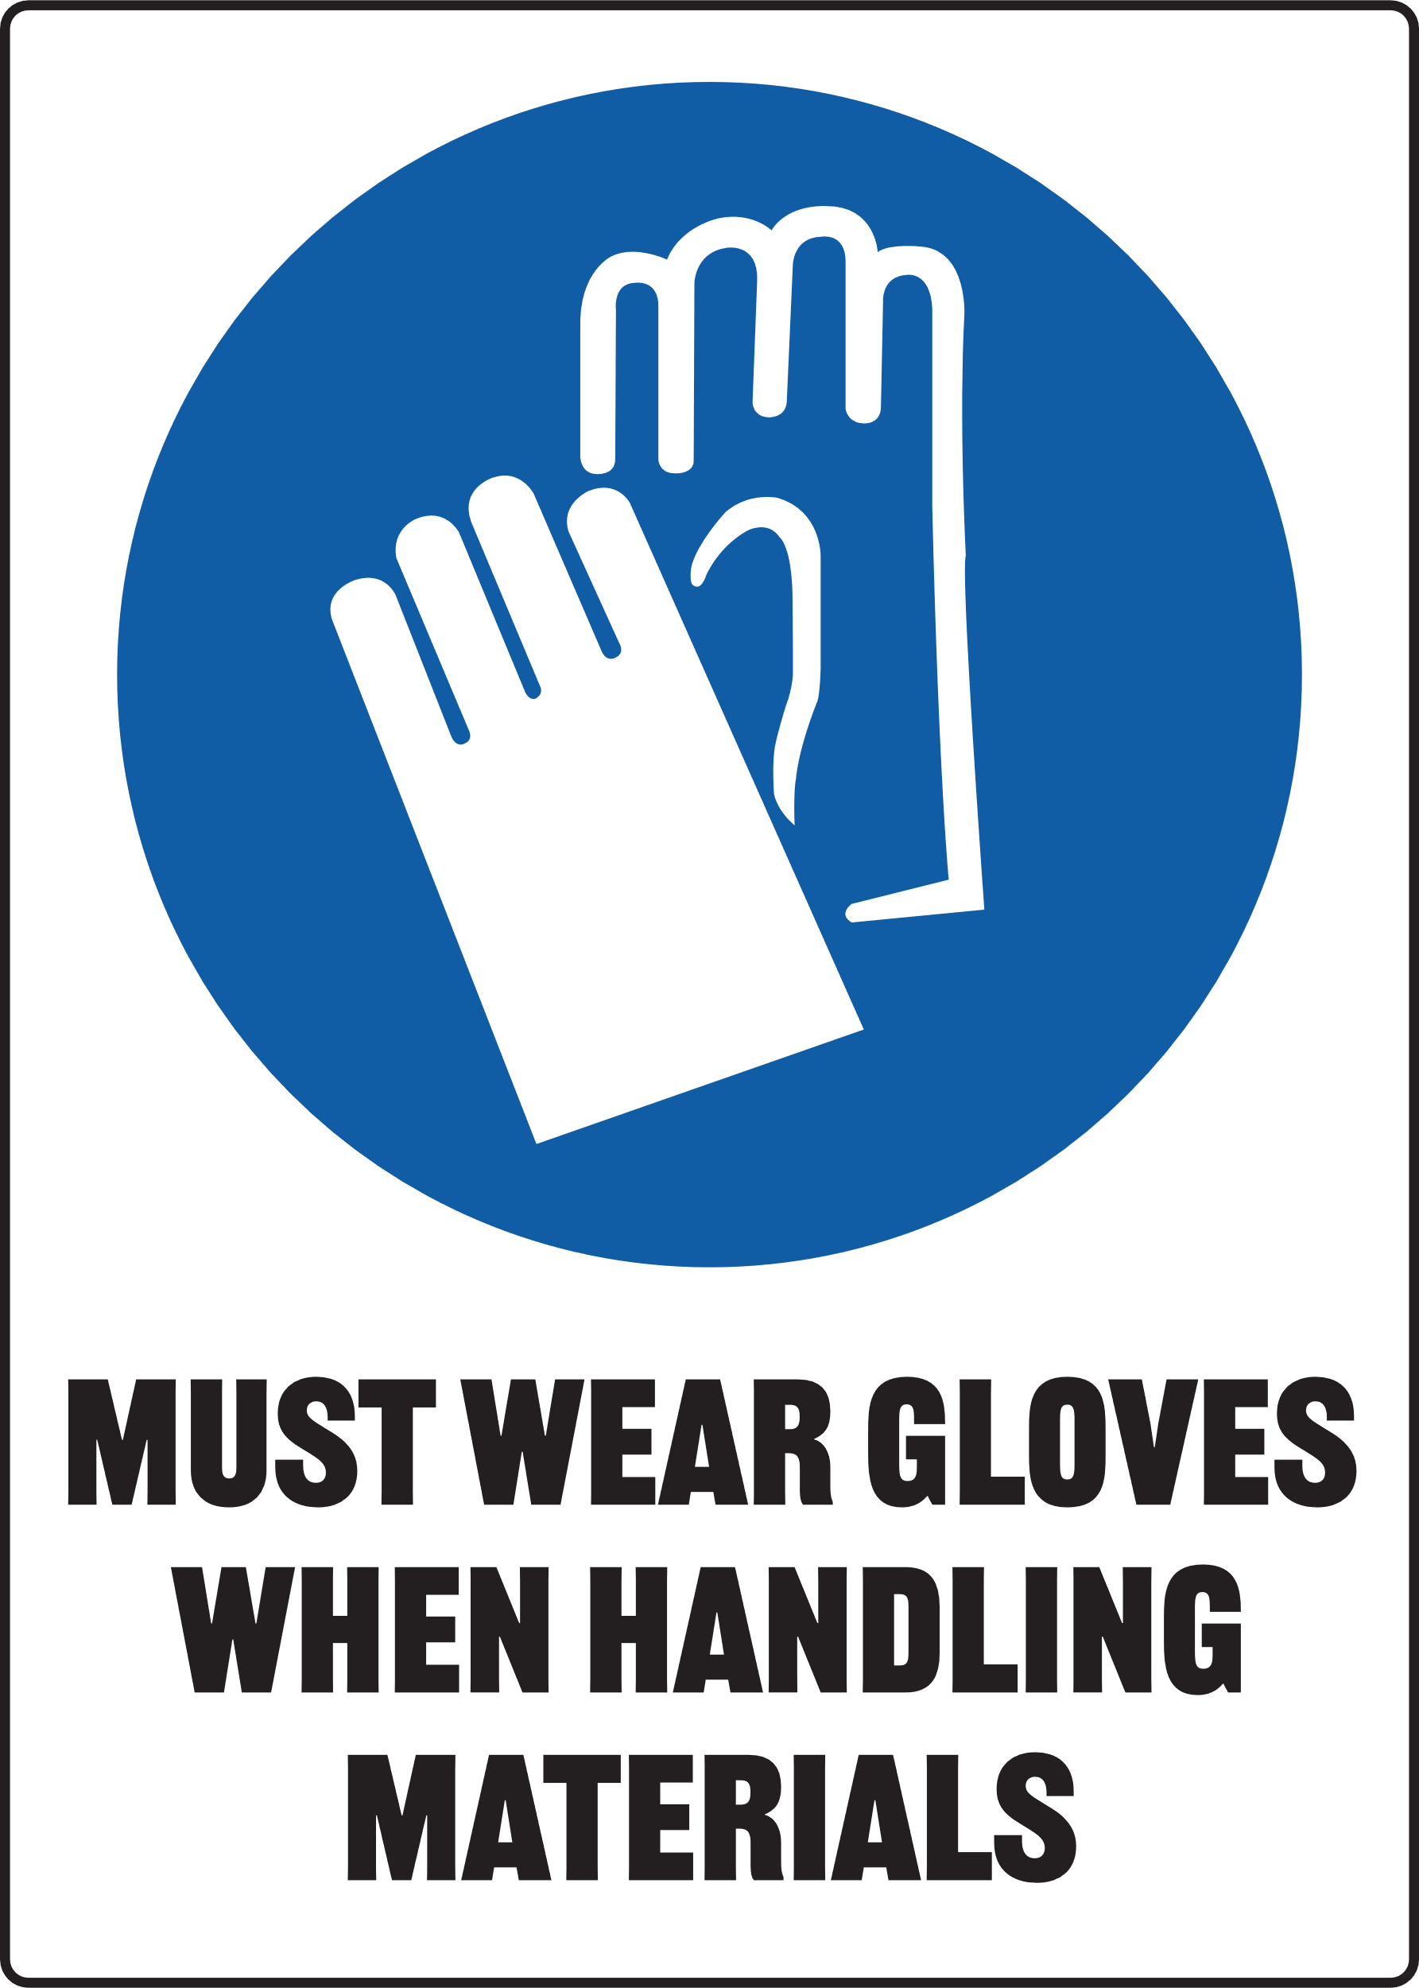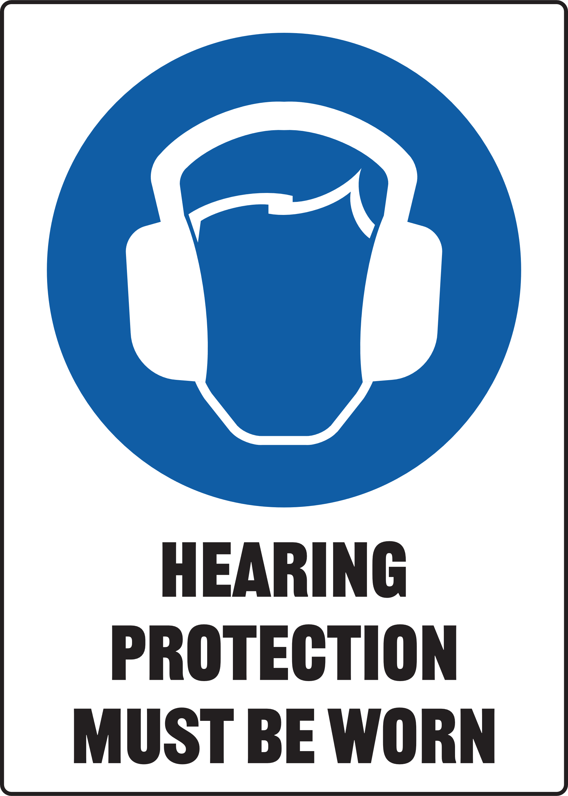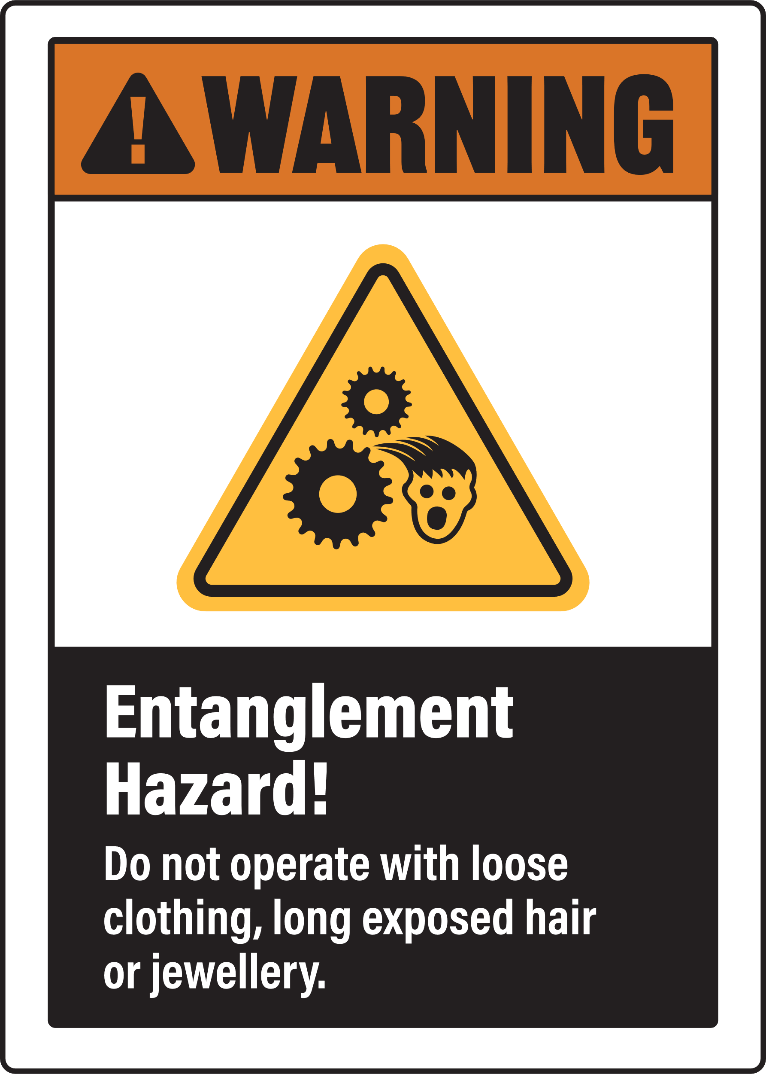
MANAGING RESPIRATORY HAZARDS
Ensure you manage risk of exposure to dust and fumes by selecting the appropriate PPE signs for your SOP
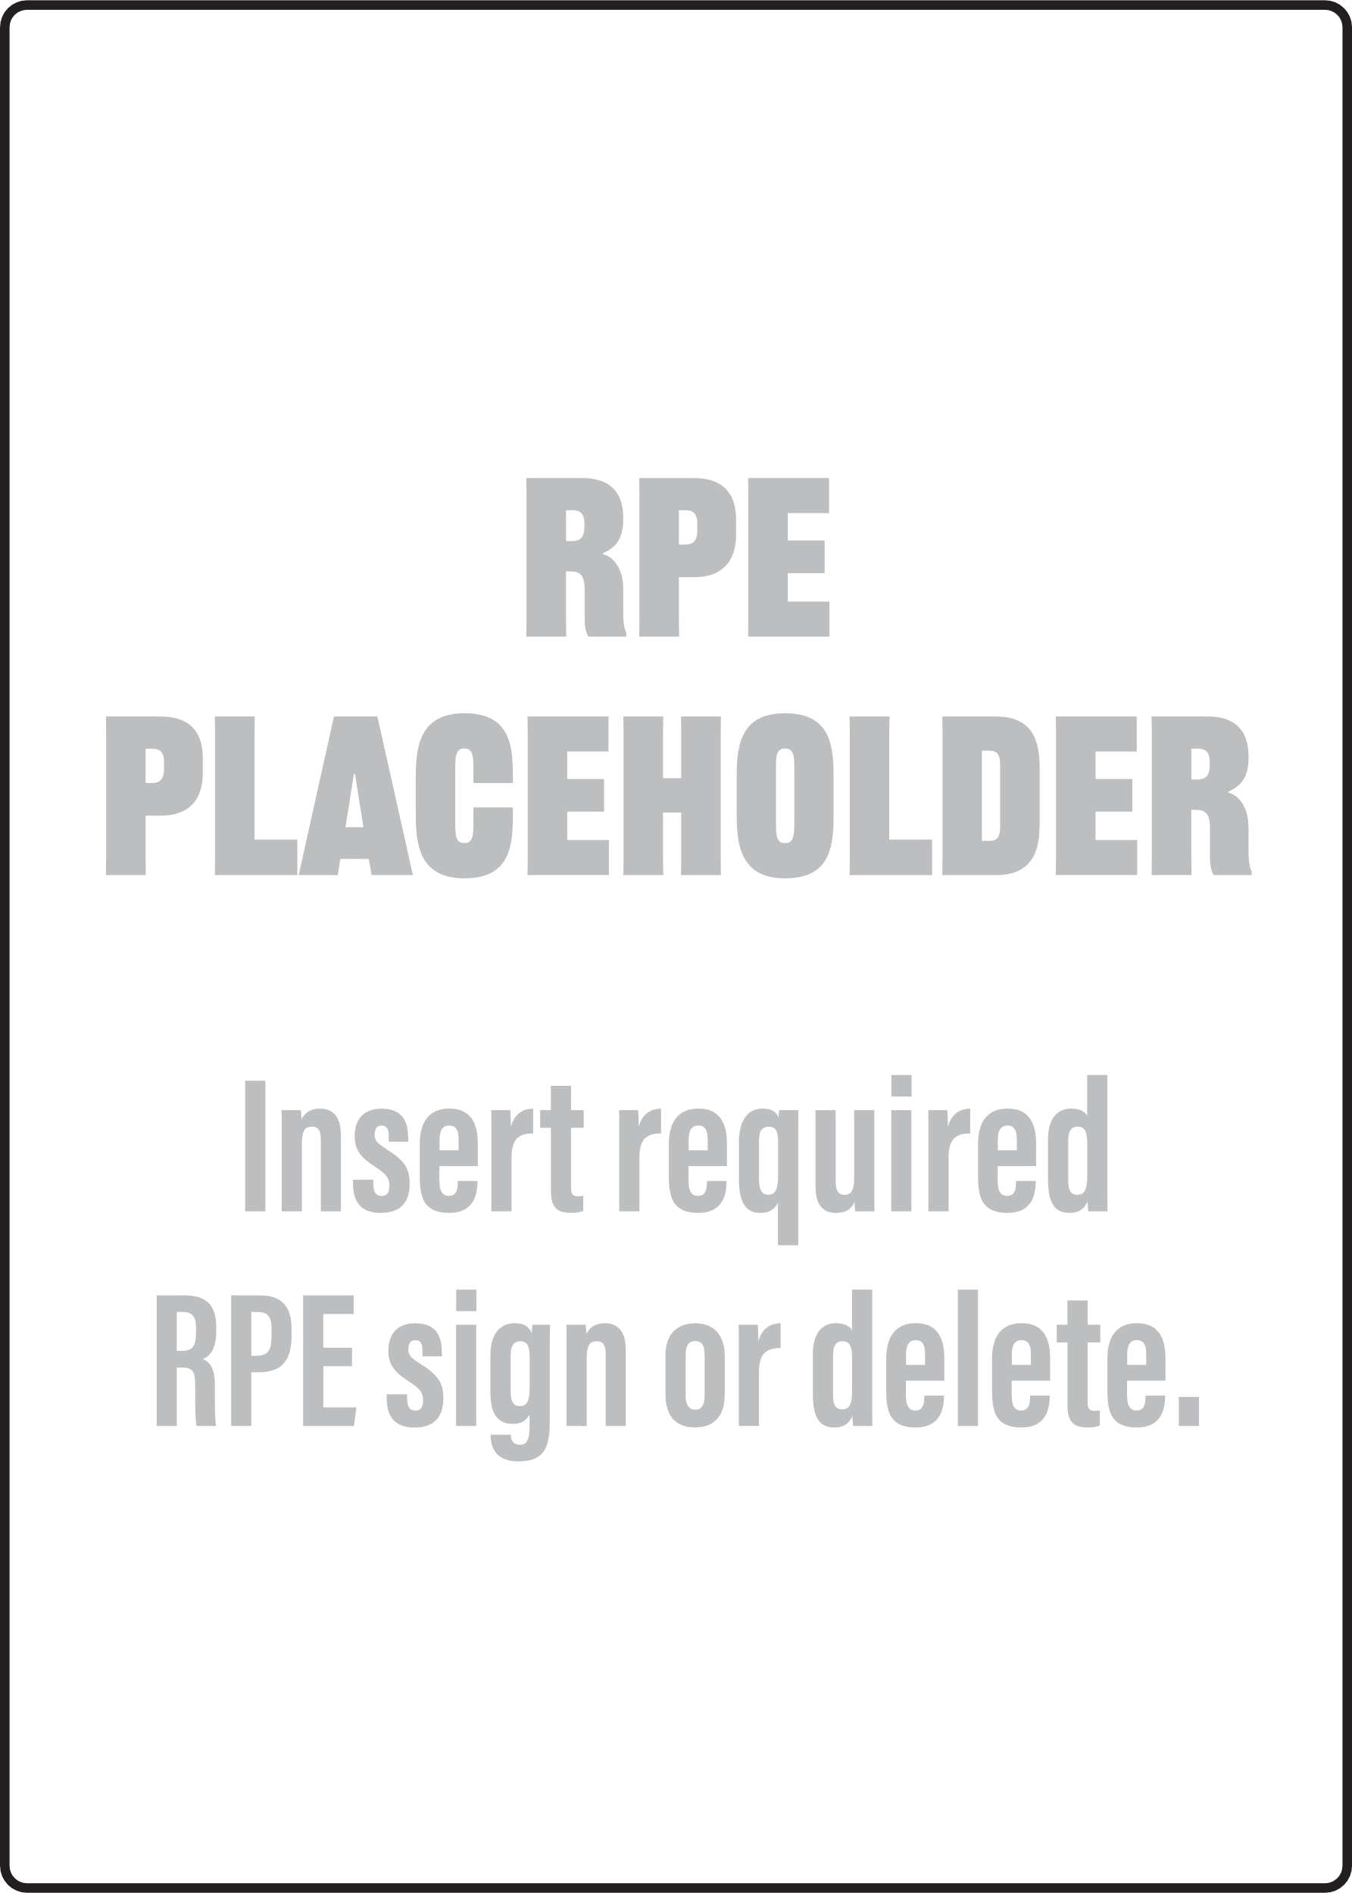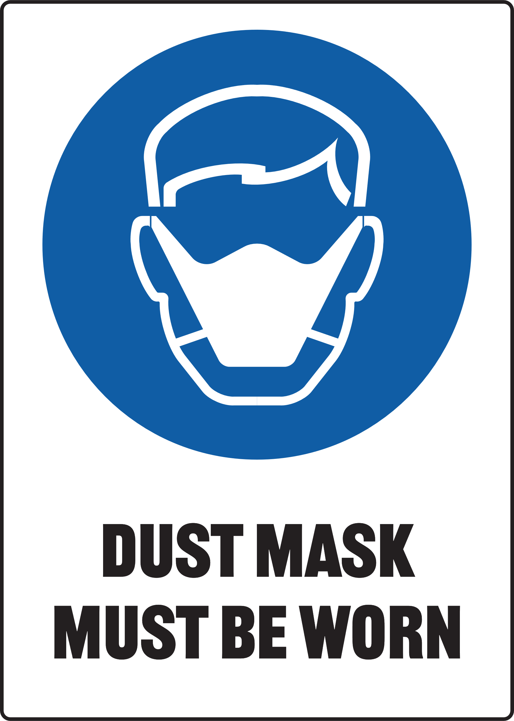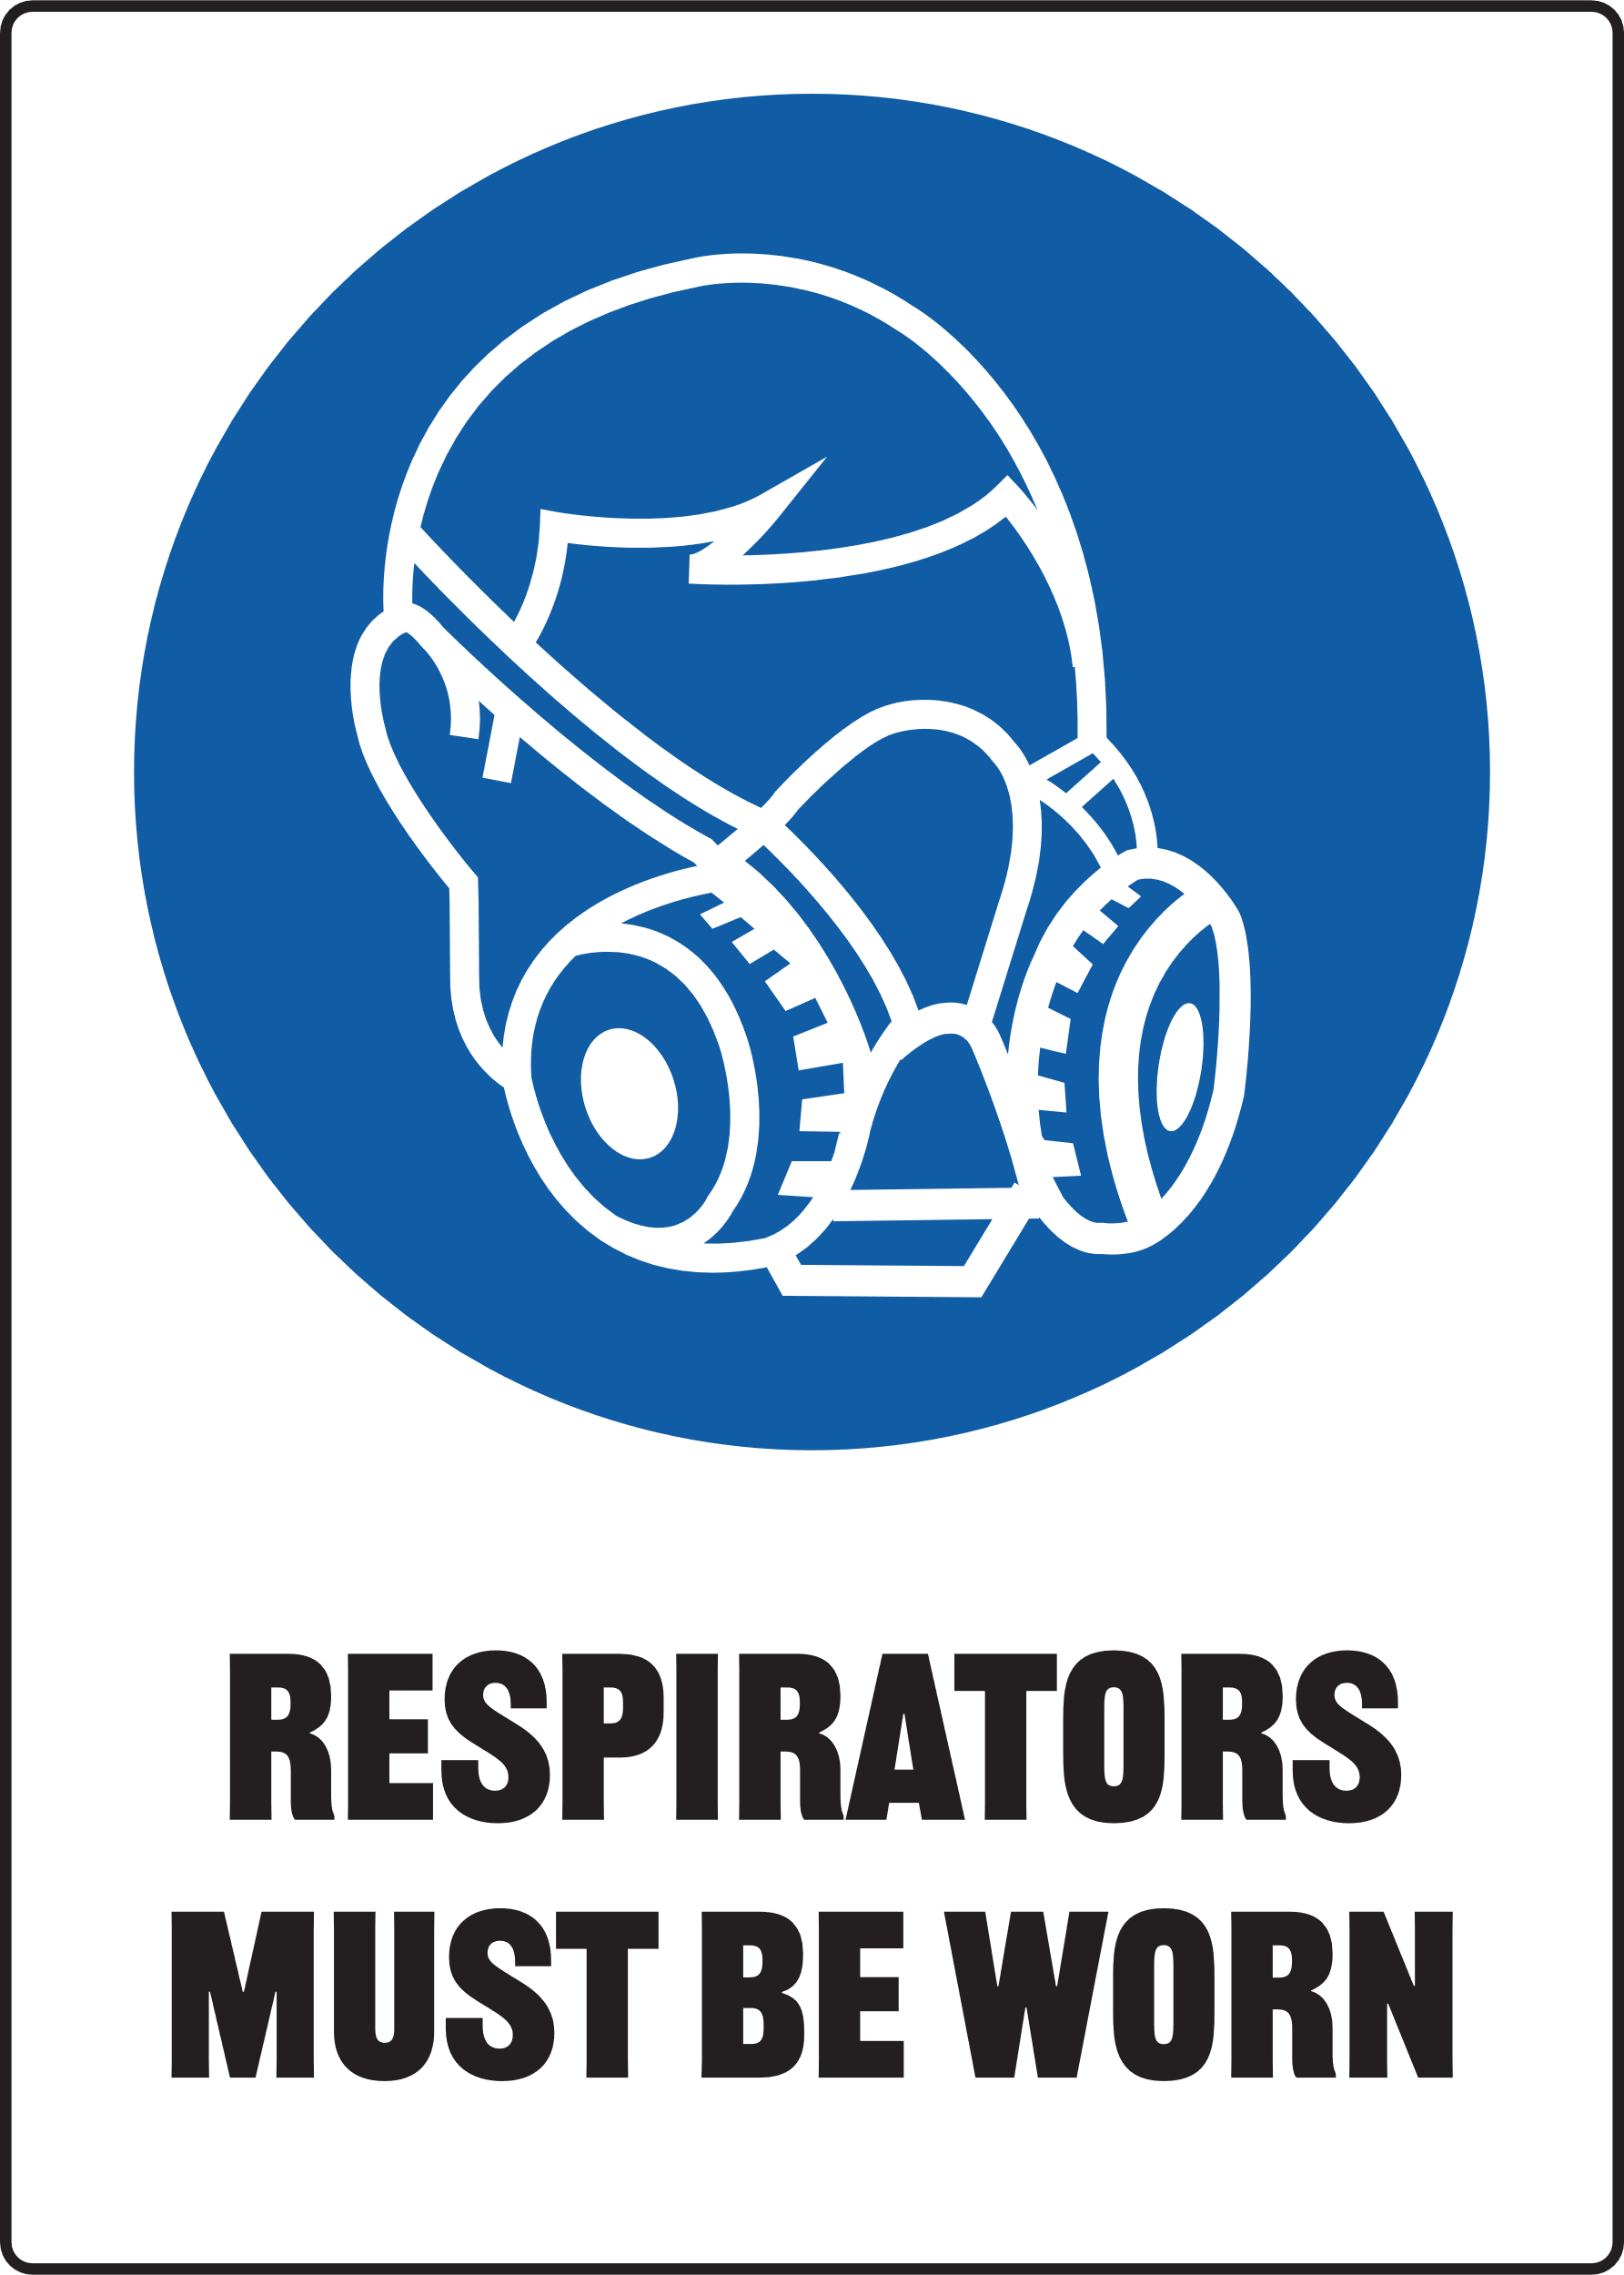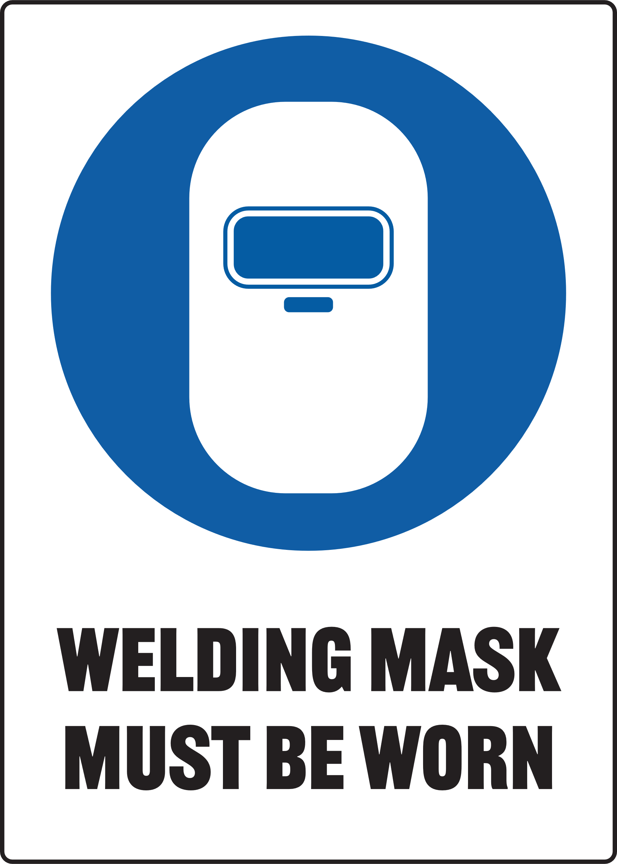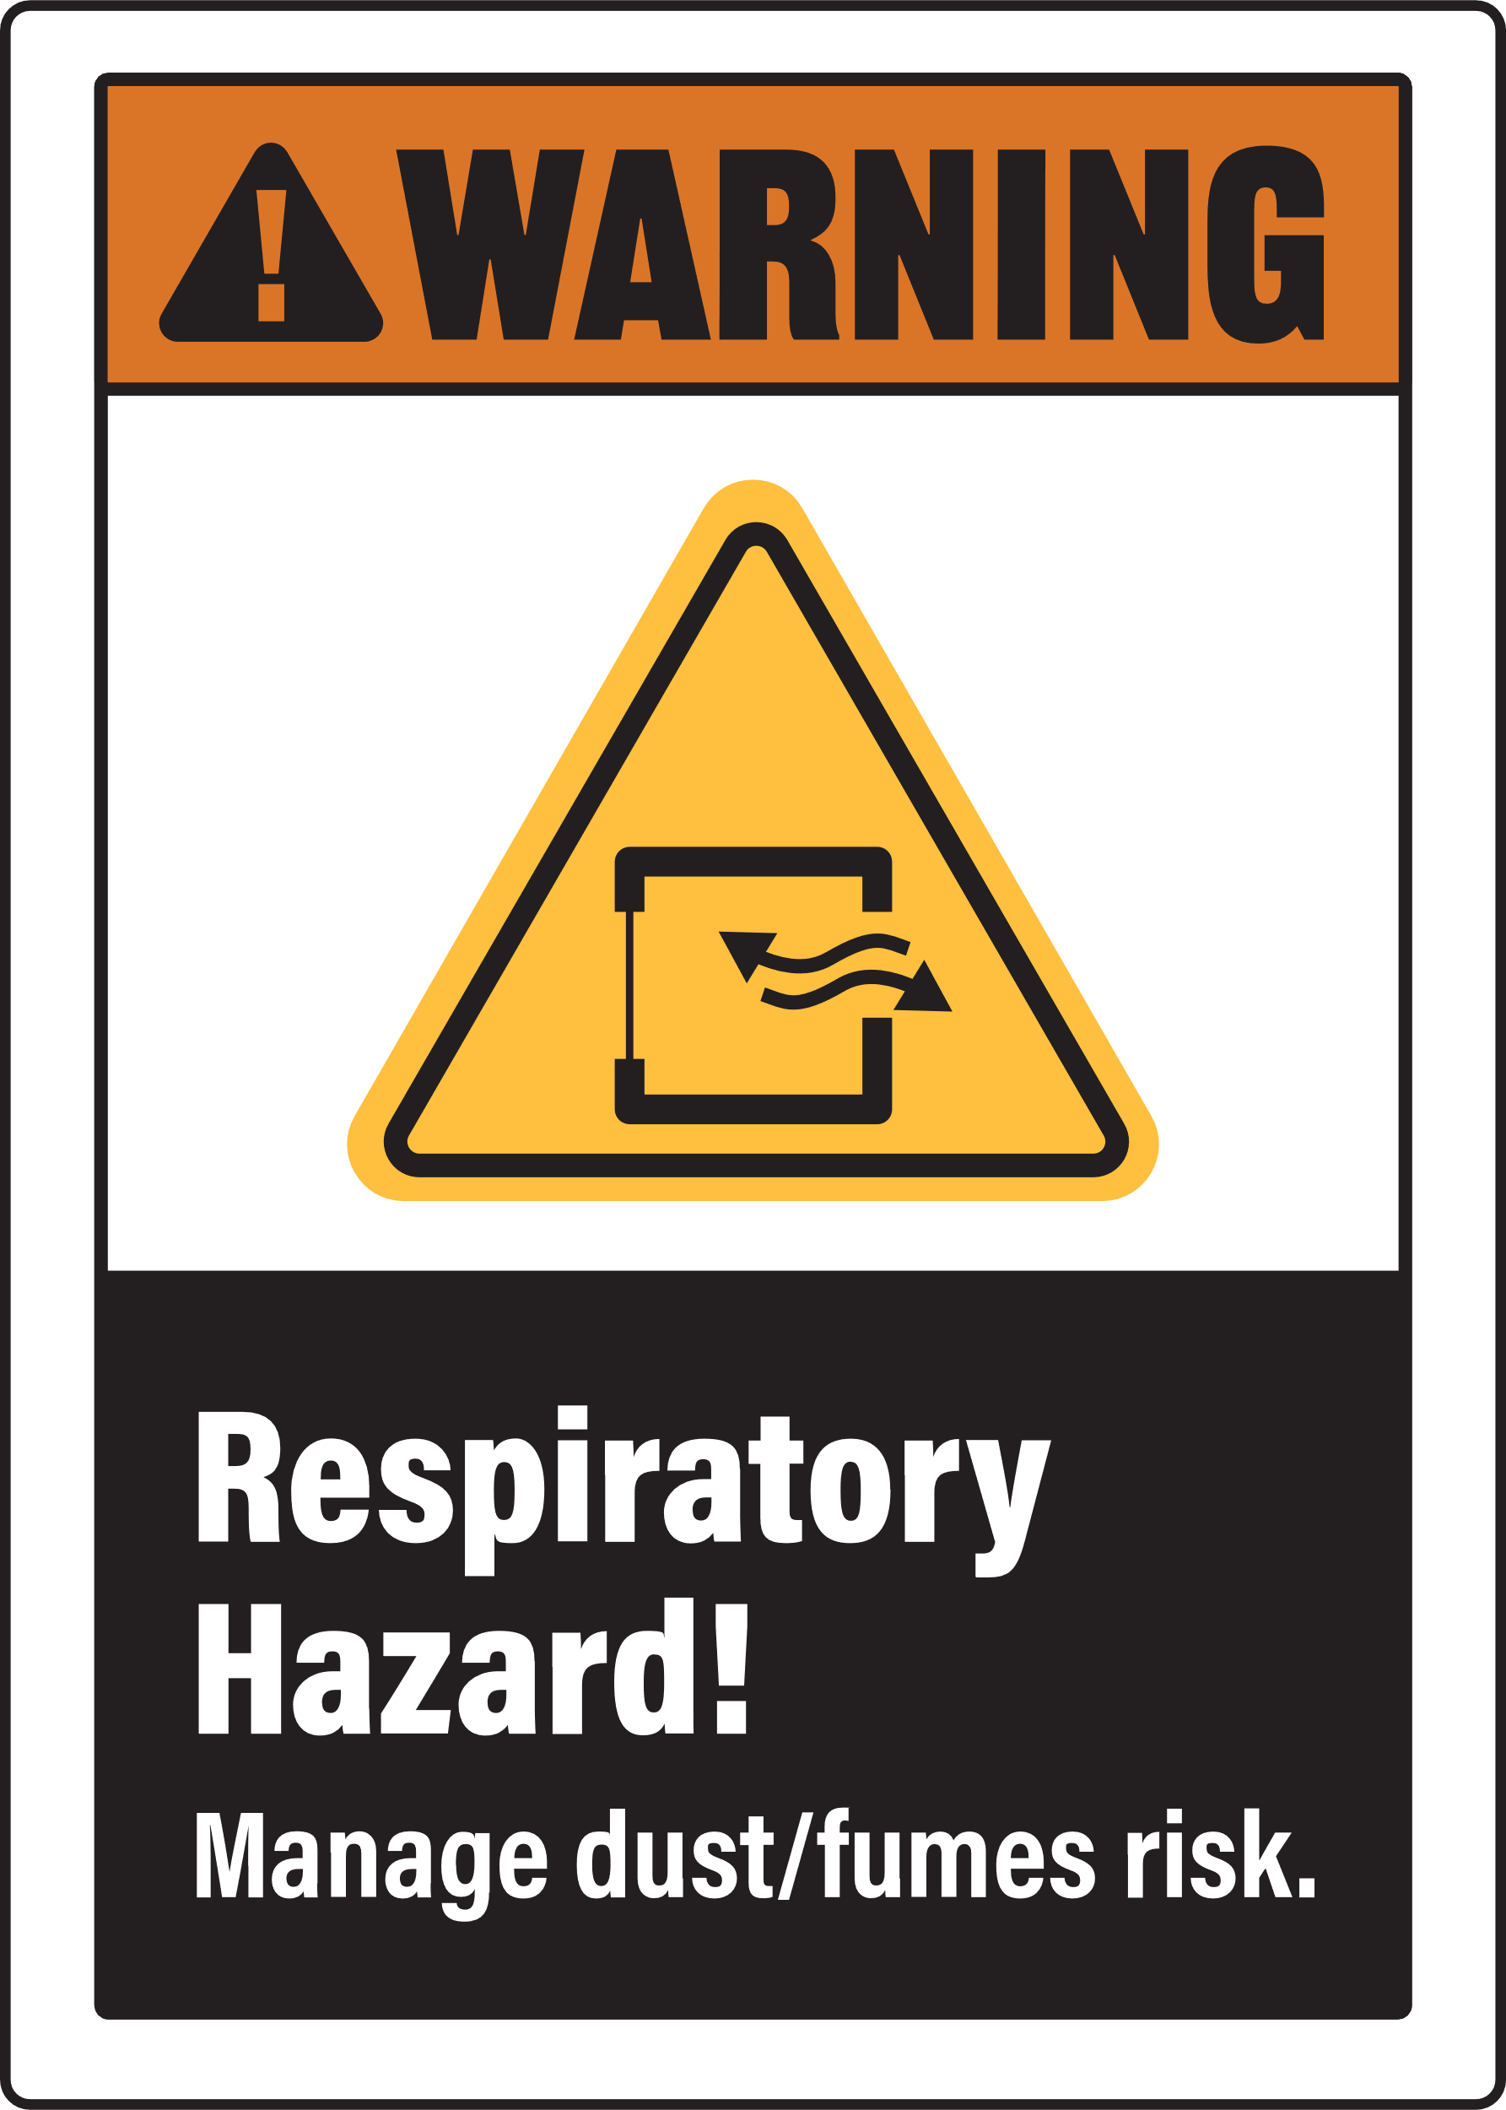

Print Settings:
  - Open Print Menu: Go to the 'File' menu and select 'Print'.
  - Adjust Print Settings:
- In the Print dialog box, under 'Settings', choose 'Custom Print' or 'Print Specific Pages'.
- Ensure that the starting page number is set to '2' to print the second page of the document.
  - Colour Printing:
- Make sure to select 'Print in Colour' if this option is available.
Document Preview: Note that the print preview of the document will display the first page, but it will not be printed with the above settings.


Power Hacksaw - Metal
Only use this machine if you have been given instructions on how to use it safely and have been given permission
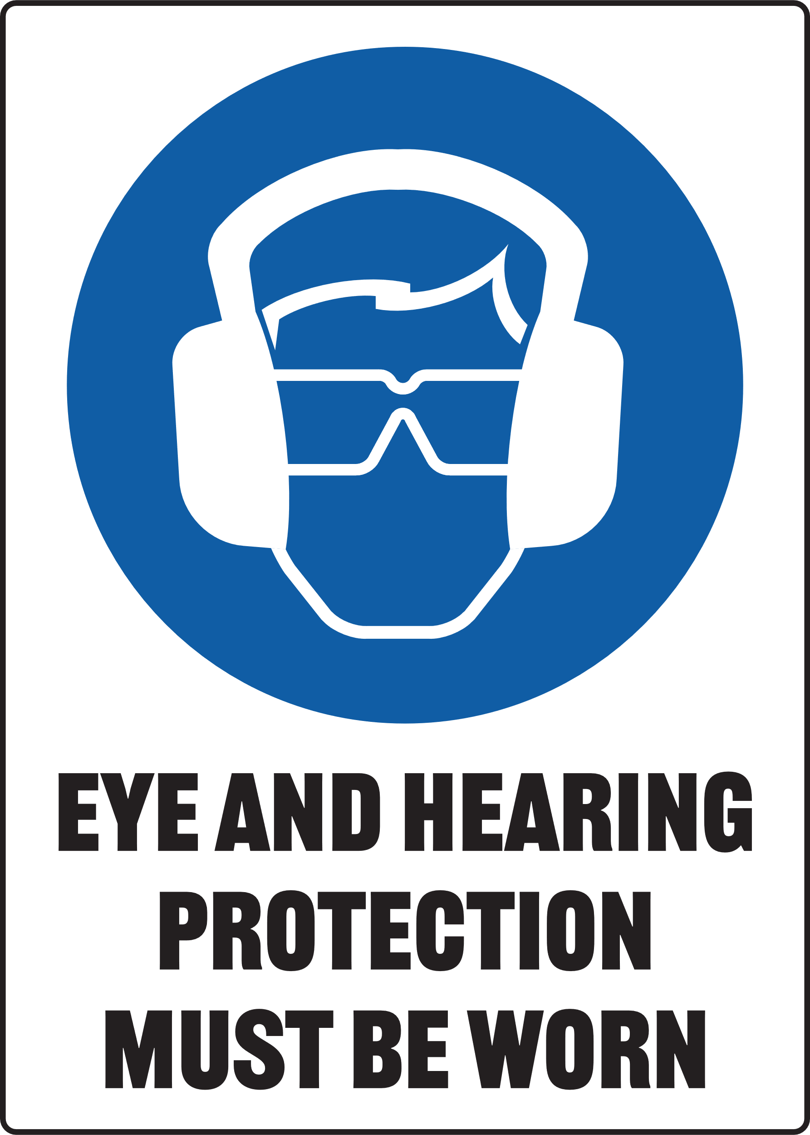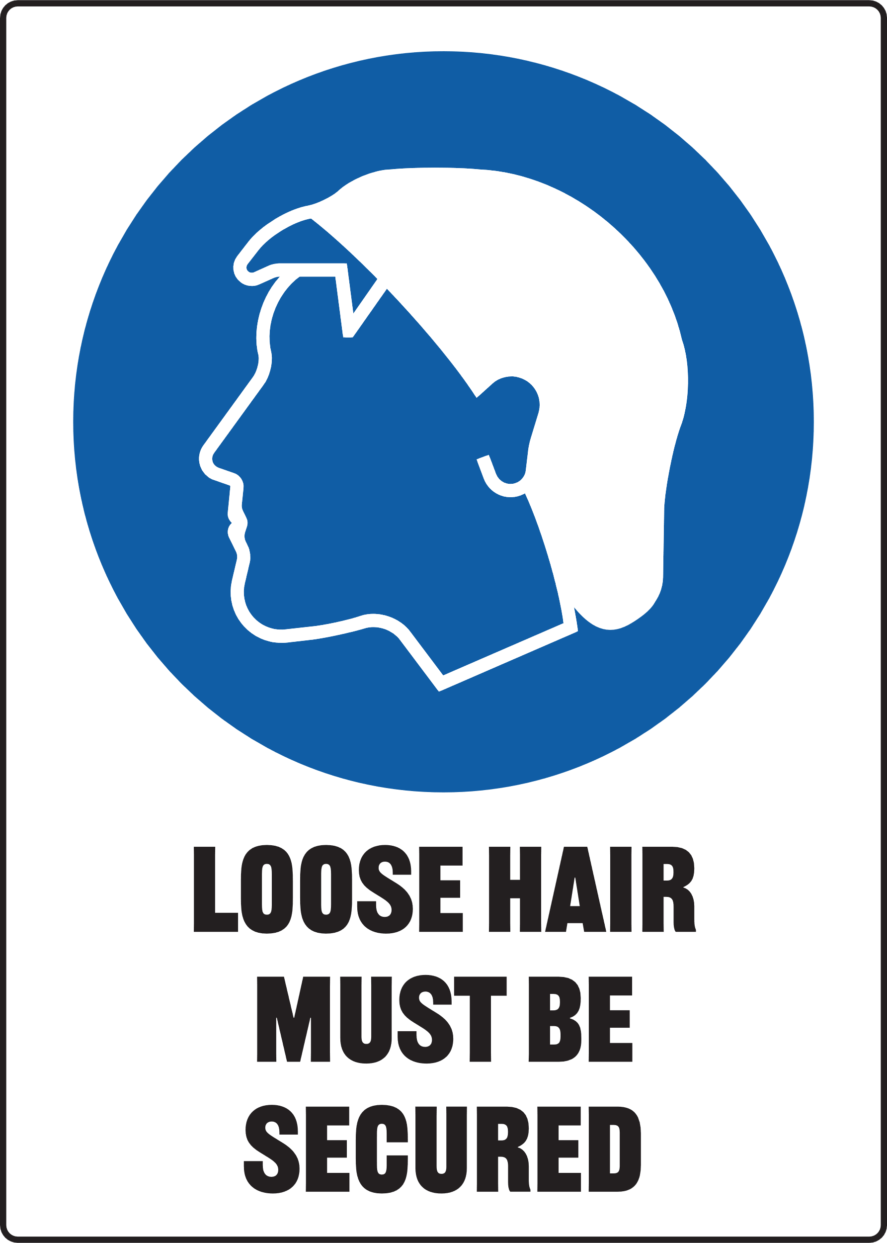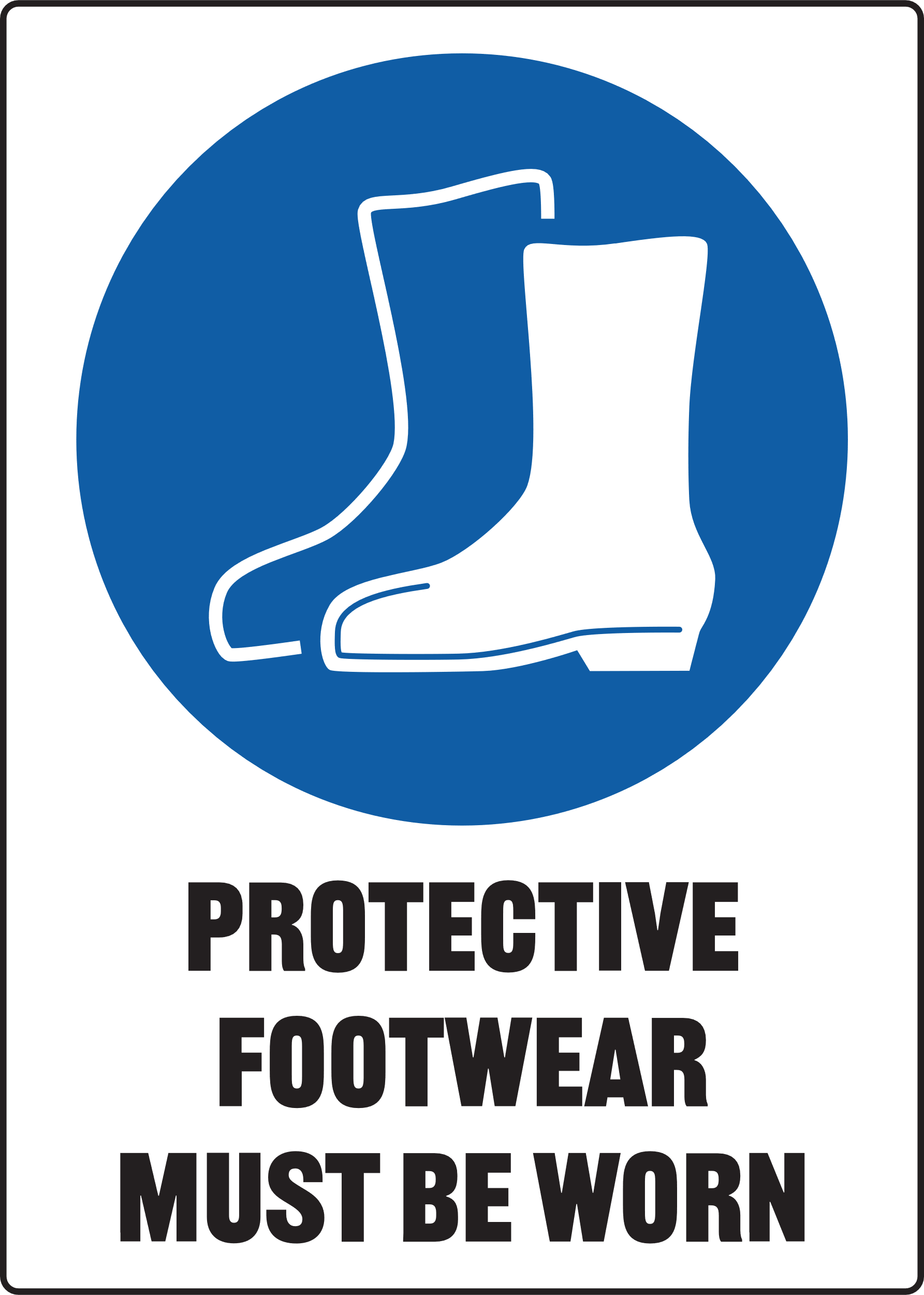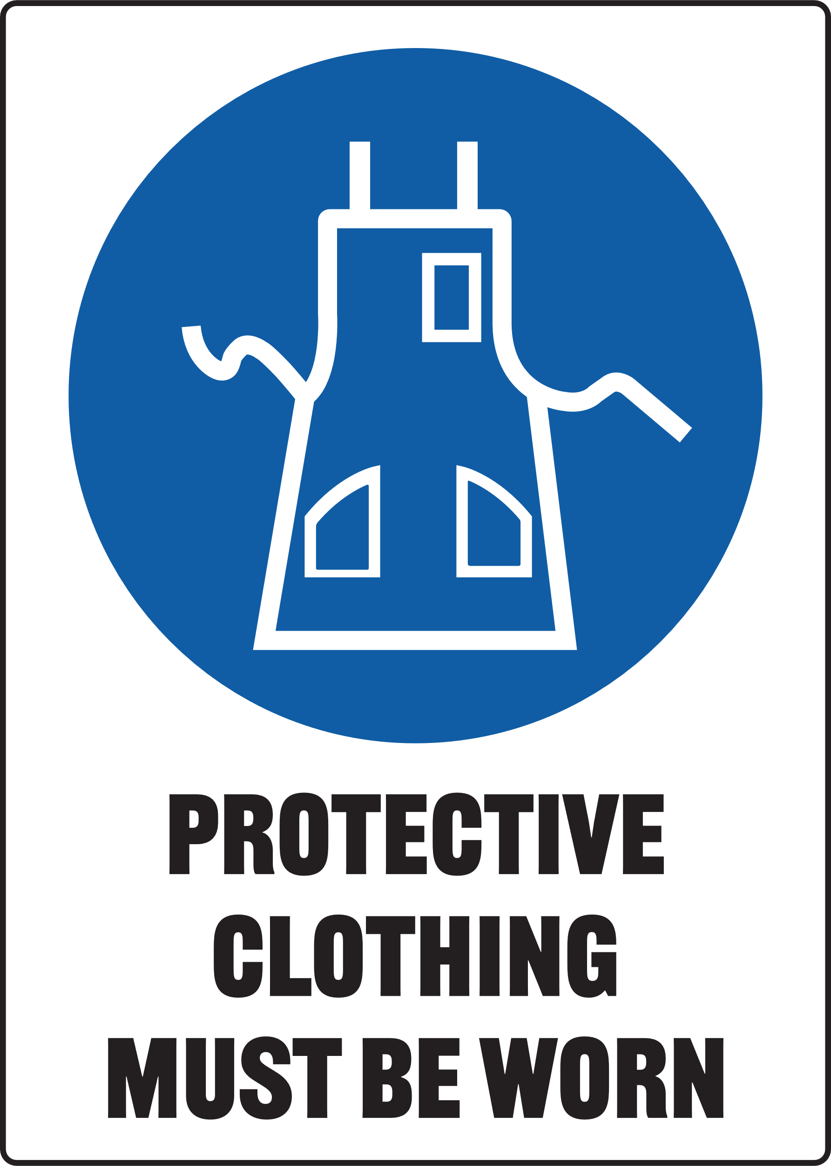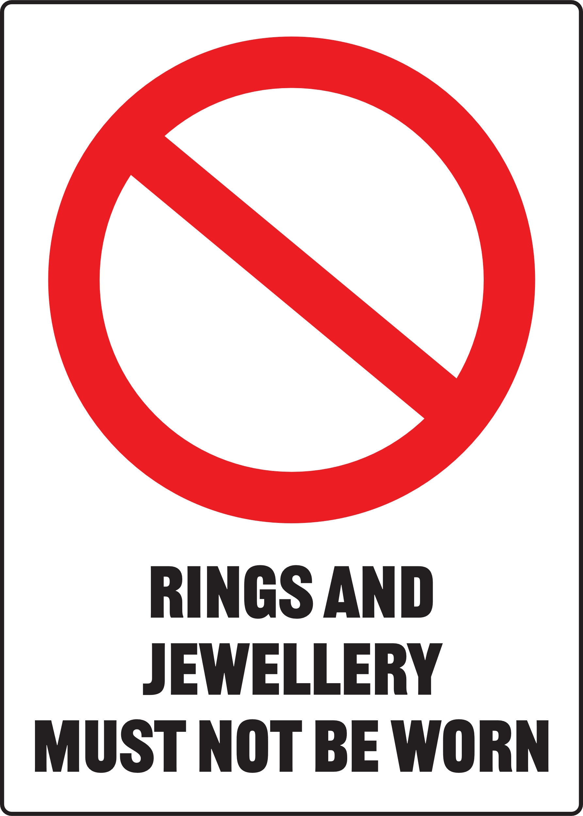

Only one person may operate this machine at any one time

Pre-Operational Safety Checks
- Ensure no slip/trip hazards are present in workspaces and walkways
- Ensure saw blade is in good condition, teeth are present and blade is tight
- Locate and ensure you are familiar with the operation of the ON/OFF starter and emergency stop (if fitted)
- Ensure the material is tightly clamped in the work vice
- Ensure that the work piece is secure
- Support overhanging work and signpost if it presents a hazard
- Check coolant delivery system to allow for sufficient flow of coolant
- Faulty equipment must not be used. Report suspect machinery immediately

Operational Safety Checks
- Ensure that the work piece is secure
- Support overhanging work, and signpost and create exclusion zone if it presents a hazard
- Ensure no-one stands in front of the saw when it is started
- Keep clear of moving machine parts
- Direct coolant onto blade before starting cut
- Never leave the machine running unattended
- Before making adjustments or before cleaning swarf accumulations switch off and bring the machine to a complete standstill

Housekeeping
- Switch off the machine
- Leave machine and floor in a safe, clean and tidy state

Potential Hazards
- Reciprocating saw arm Δ Metal Splinter Δ Sharp edges and burrs
- Entanglement Δ Noise Δ Eye injury

! Not Permitted
- Attempting to cut very small items that can’t be clamped securely
- Attempting to cut material other than metal

