SOP Review, Update and Print instructions
DO NOT PRINT THIS PAGE
- Review the SOP Document:
- Manufacturer’s Instructions: Refer to the equipment manual for specific safety and operational guidelines. Incorporate any additional details into the SOP as necessary.
- Feedback: Consult with users to confirm that the SOP accurately reflects practical usage. Make any needed revisions based on their input.
- Assess PPE Requirements:
- Evaluate if new or additional personal protective equipment (PPE) is required based on the risks associated with the equipment. Address risks such as dust and fumes by selecting appropriate PPE and updating the SOP with relevant PPE checks and icons.
- Display and Accessibility:
- Print the reviewed SOP, ensuring it is signed and dated. Post the printed SOP near the equipment or where it is easily accessible to users.
- Schedule and Document Review:
- Plan to review and update the SOP annually or whenever work processes change.
- Footer Details: Date of Review = When the school review was completed. Reviewed By = Who completed the school review. Next Review = insert date (e.g. max one year ahead).
Personal Protective Equipment (PPE) Signage
add/remove from the SOP as appropriate for your school/machine
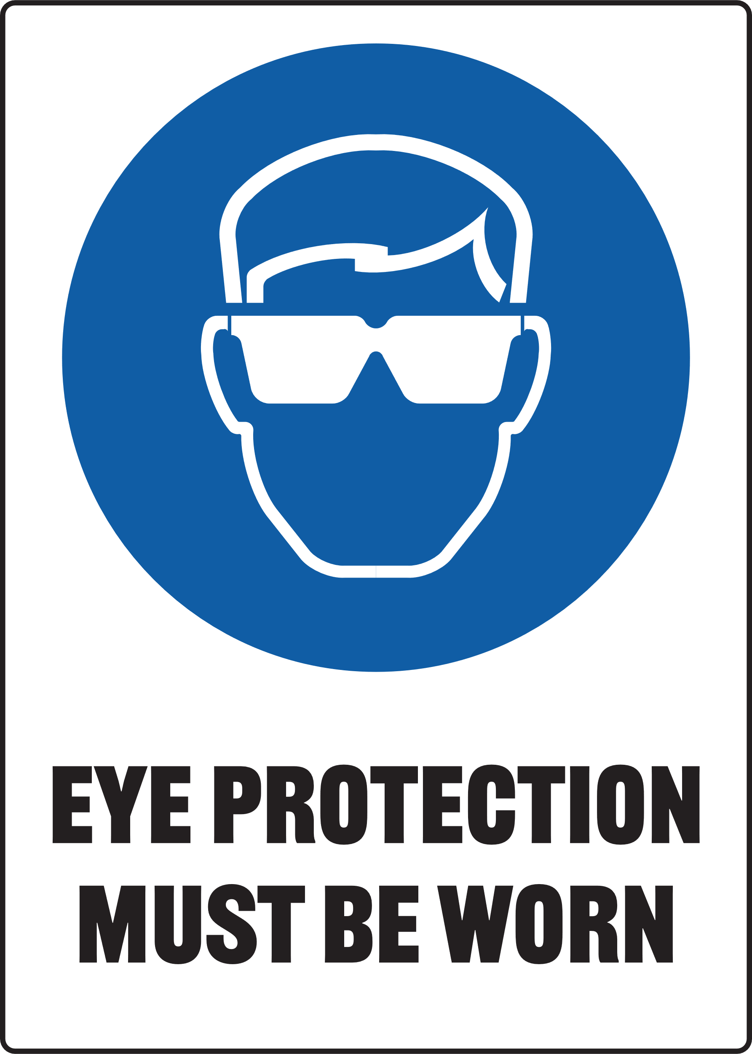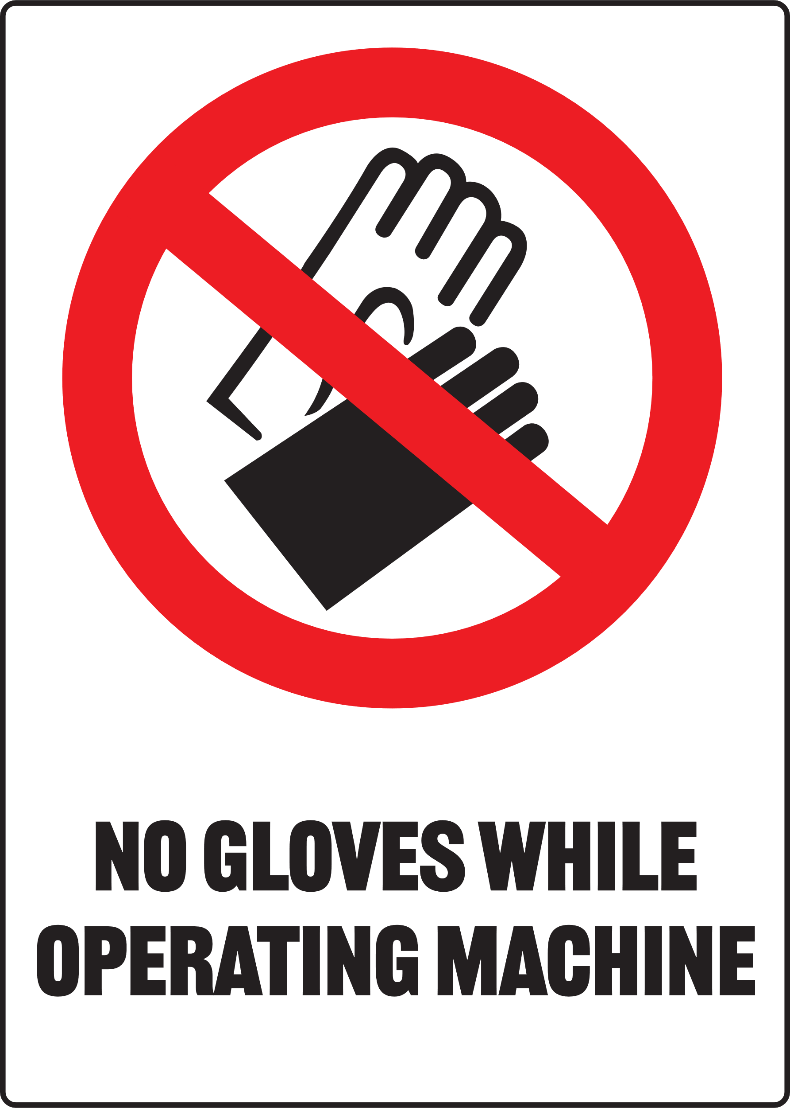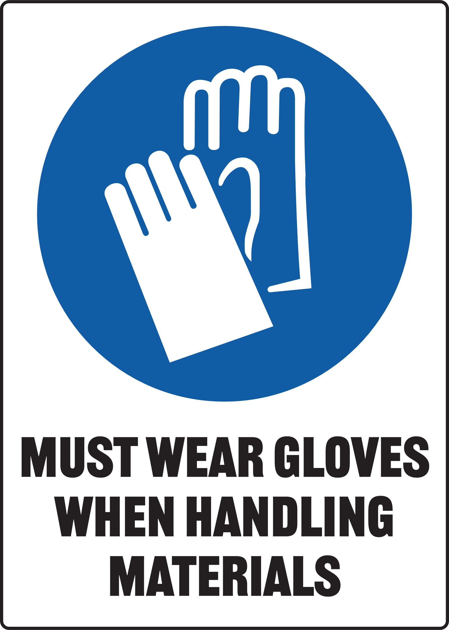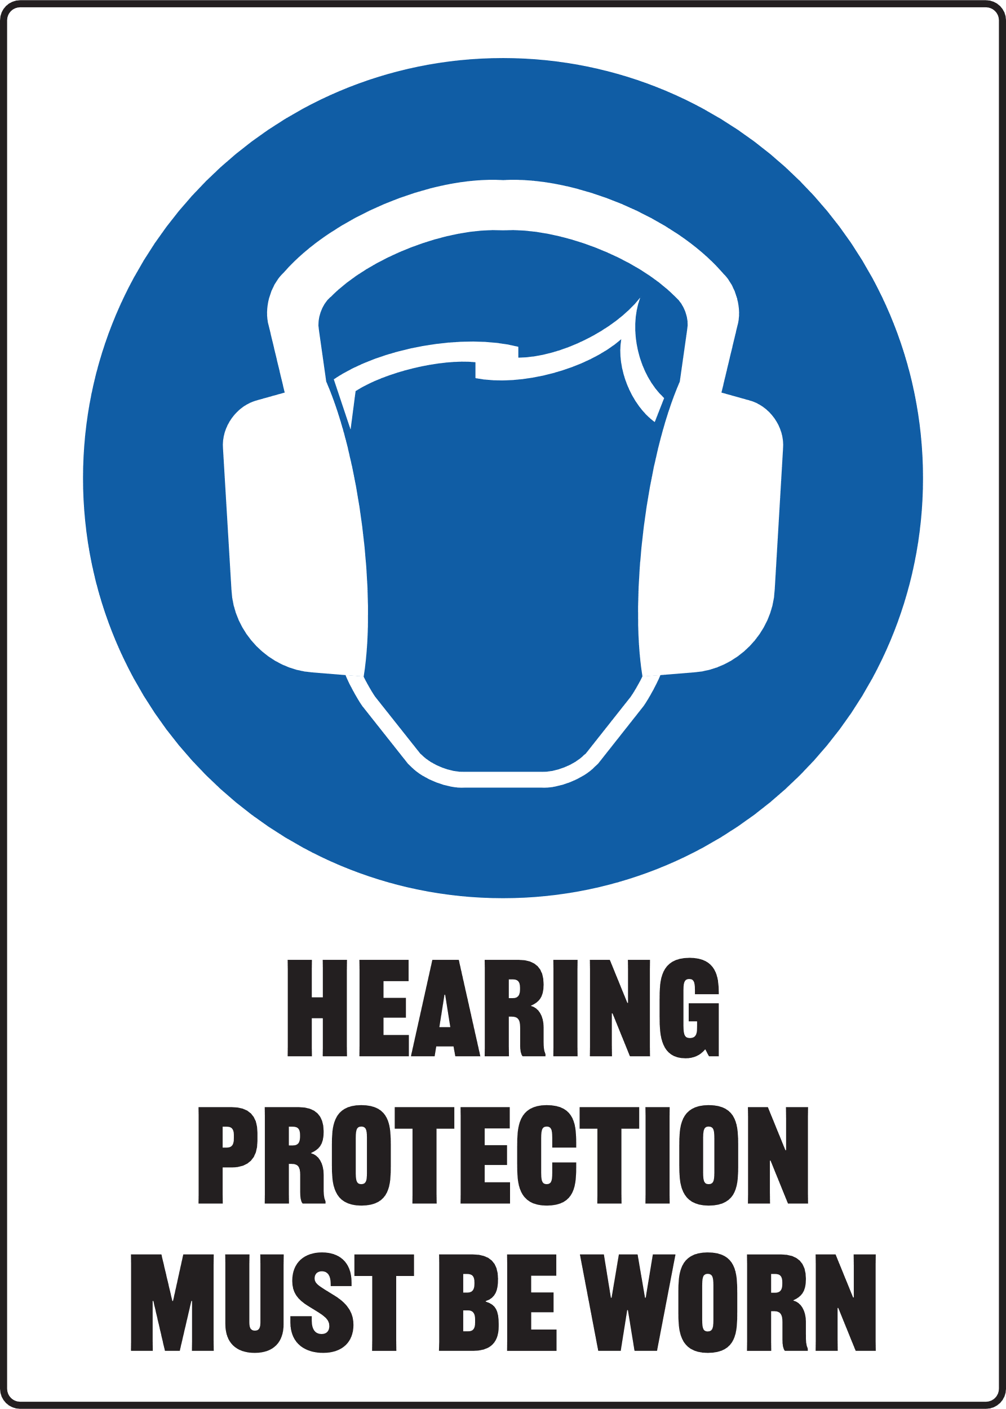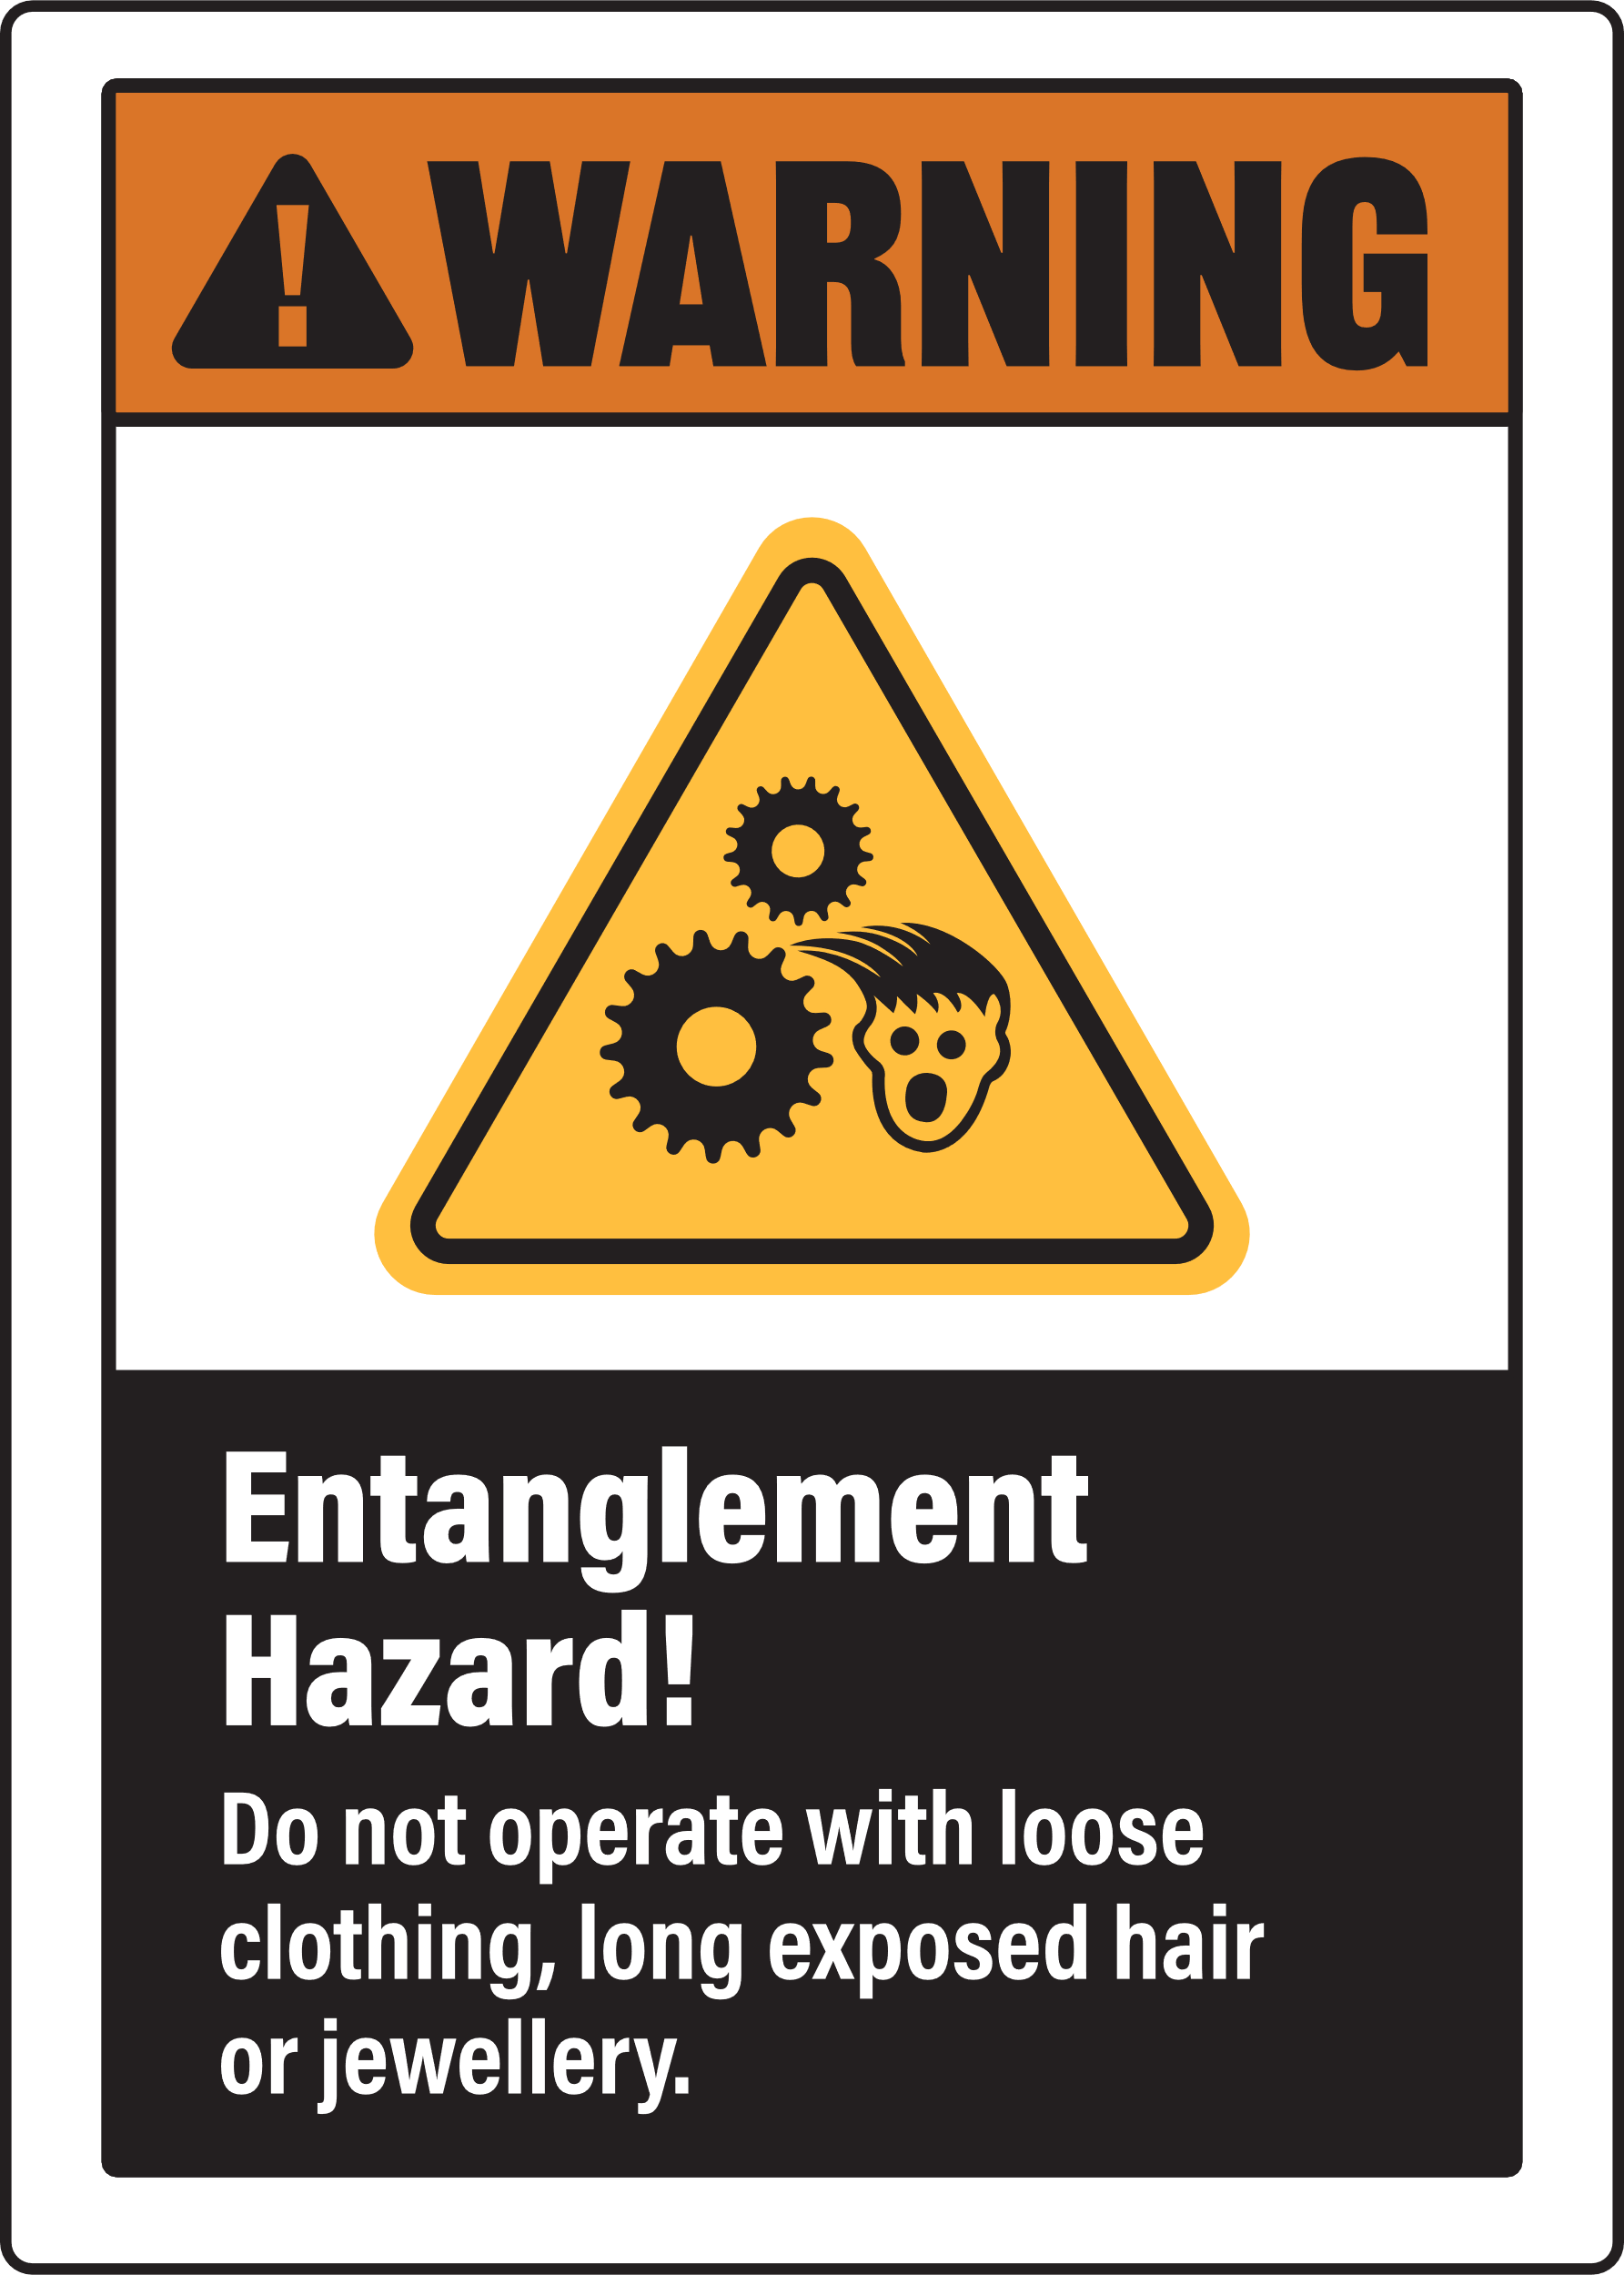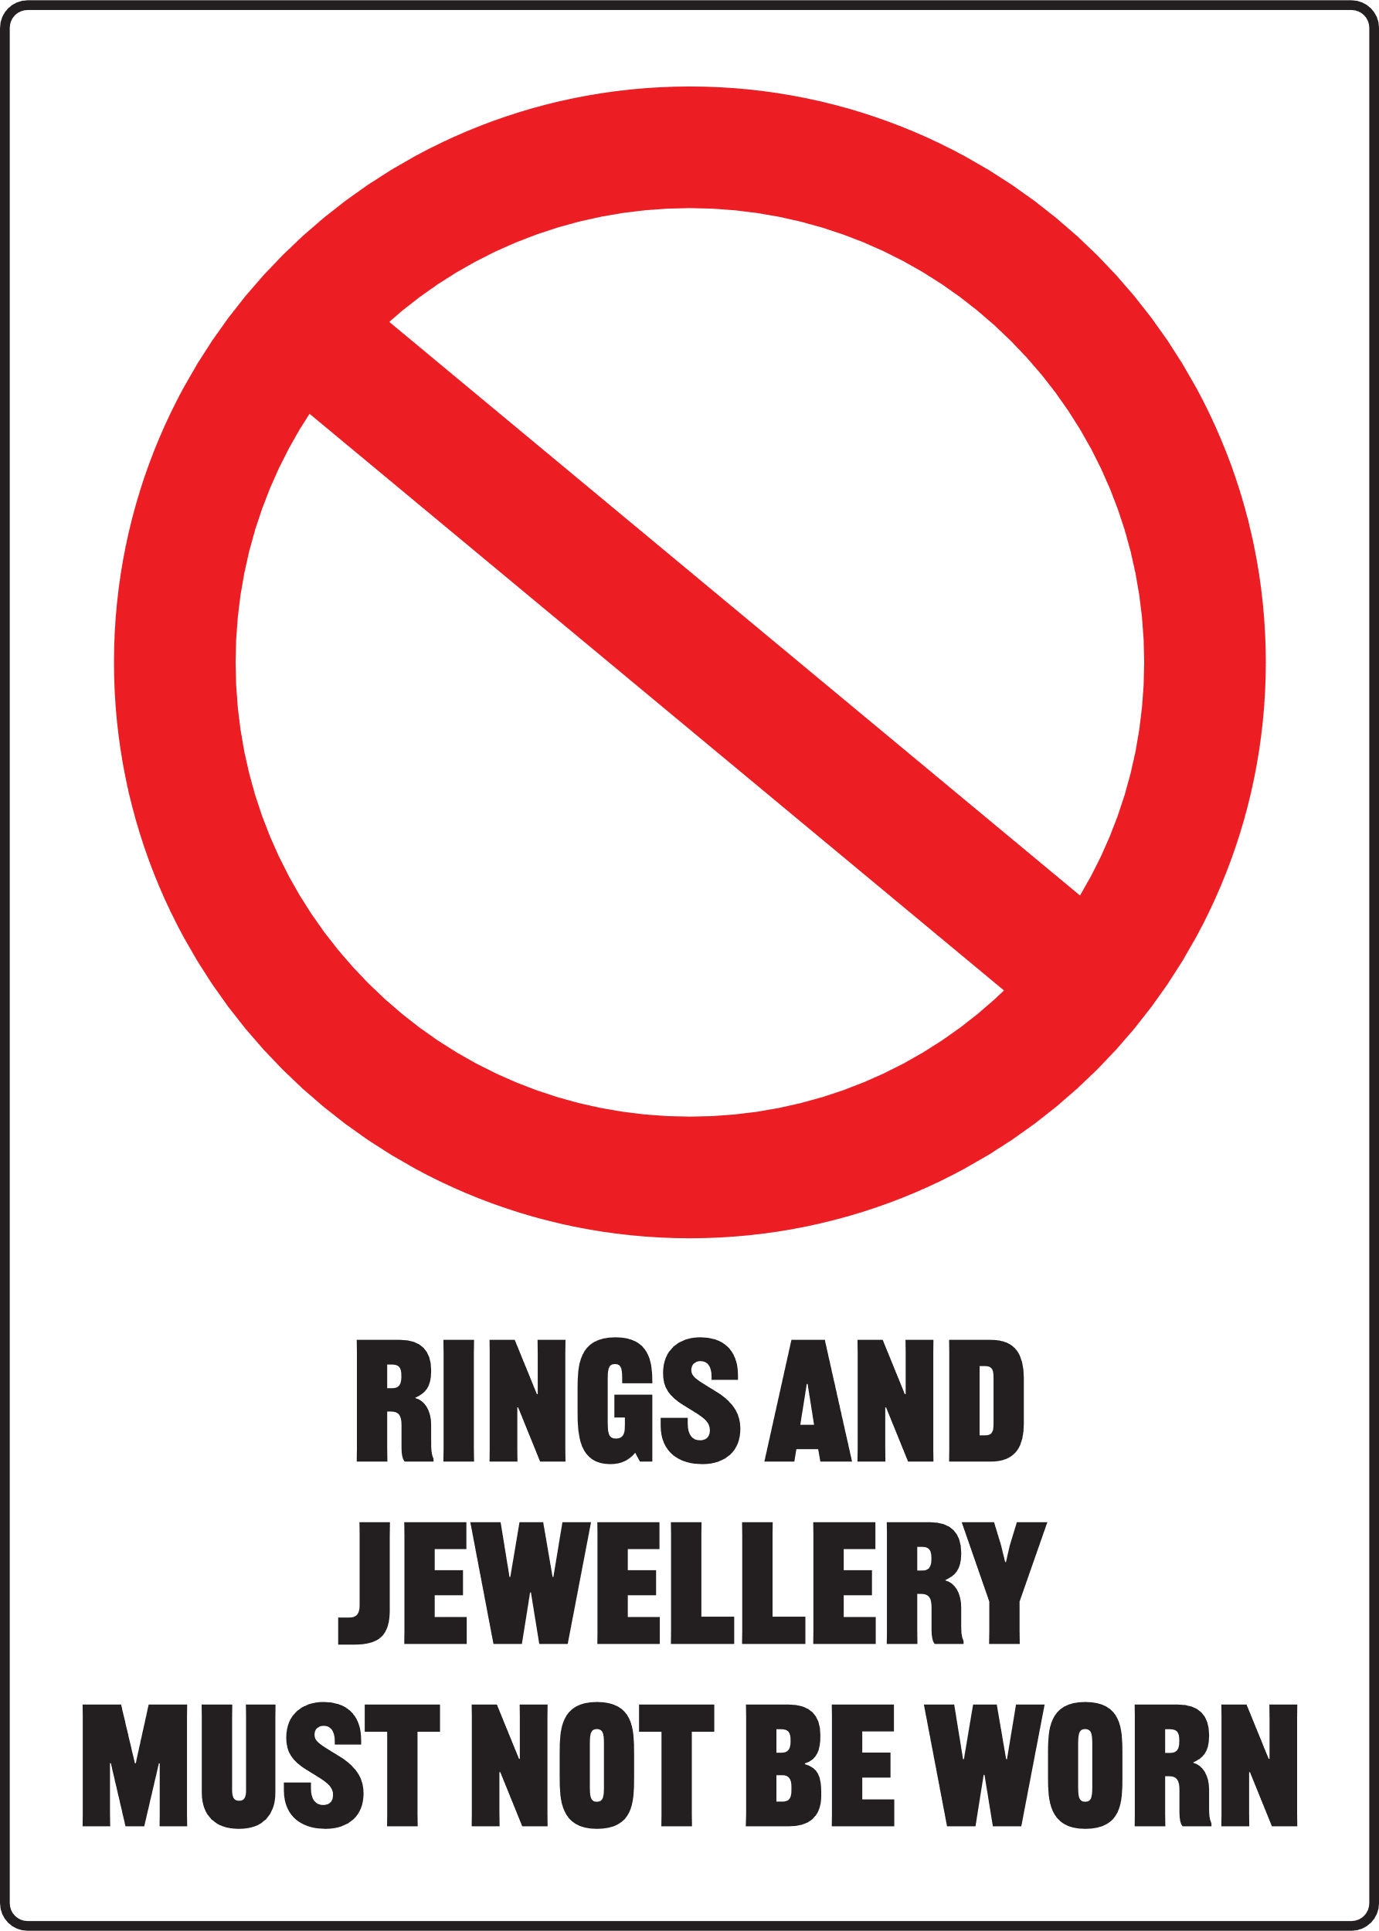
MANAGING RESPIRATORY HAZARDS
Ensure you manage risk of exposure to dust and fumes by selecting the appropriate PPE signs for your SOP
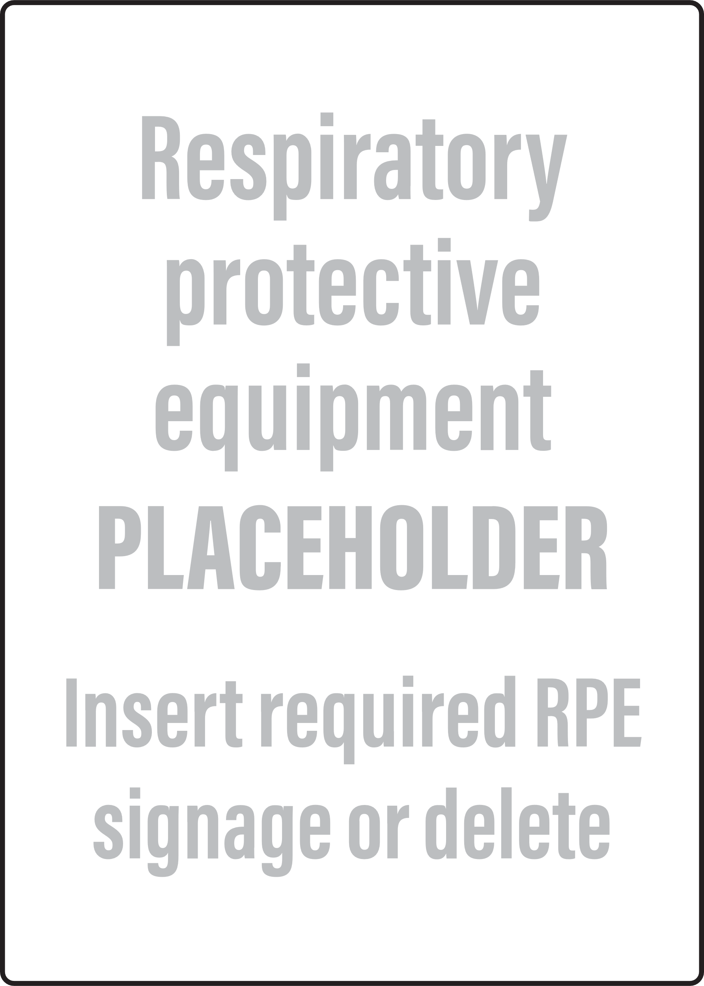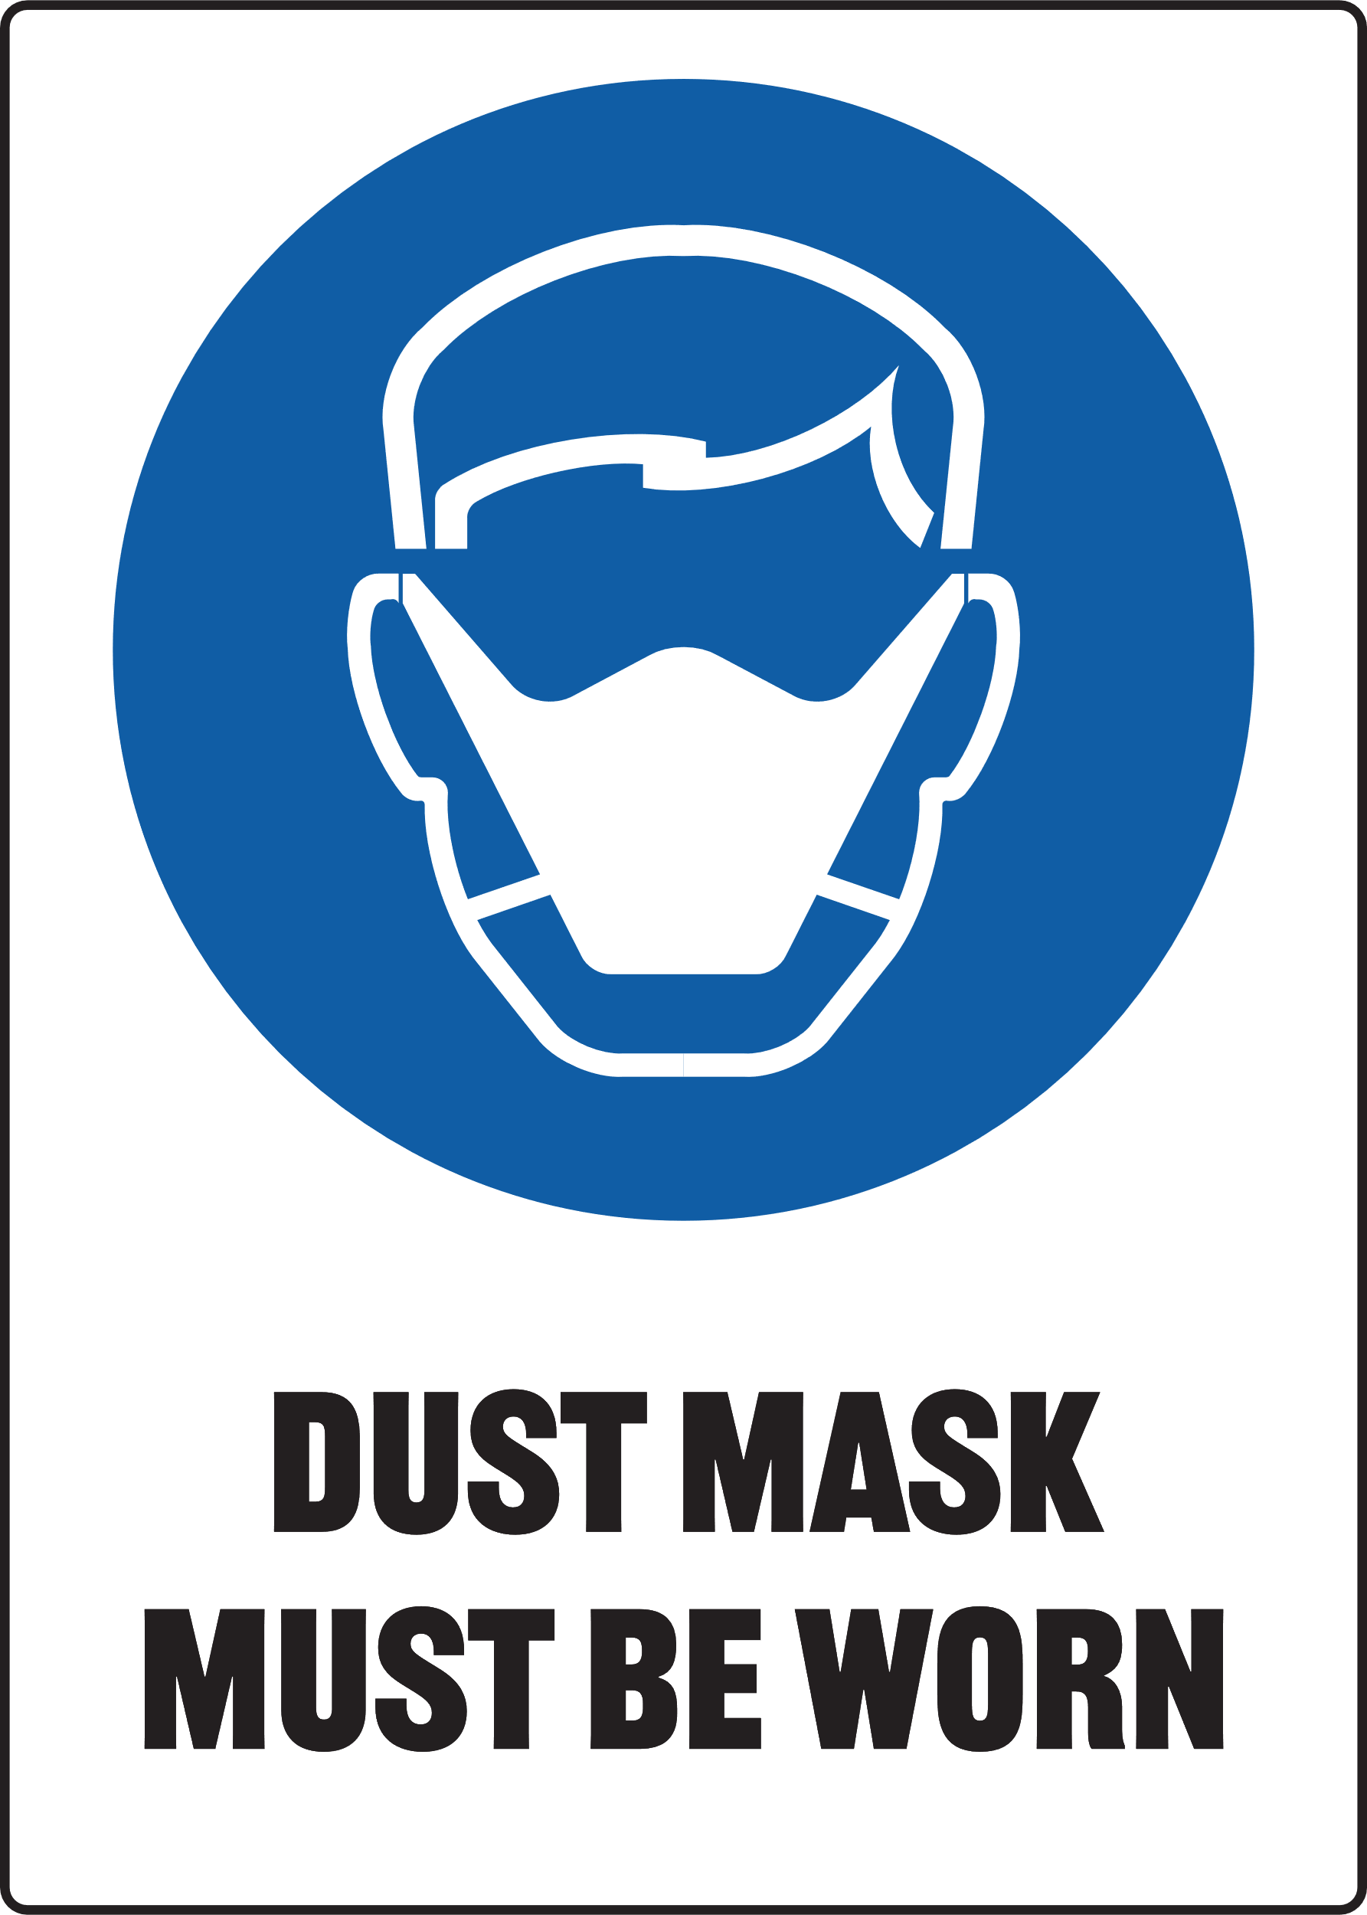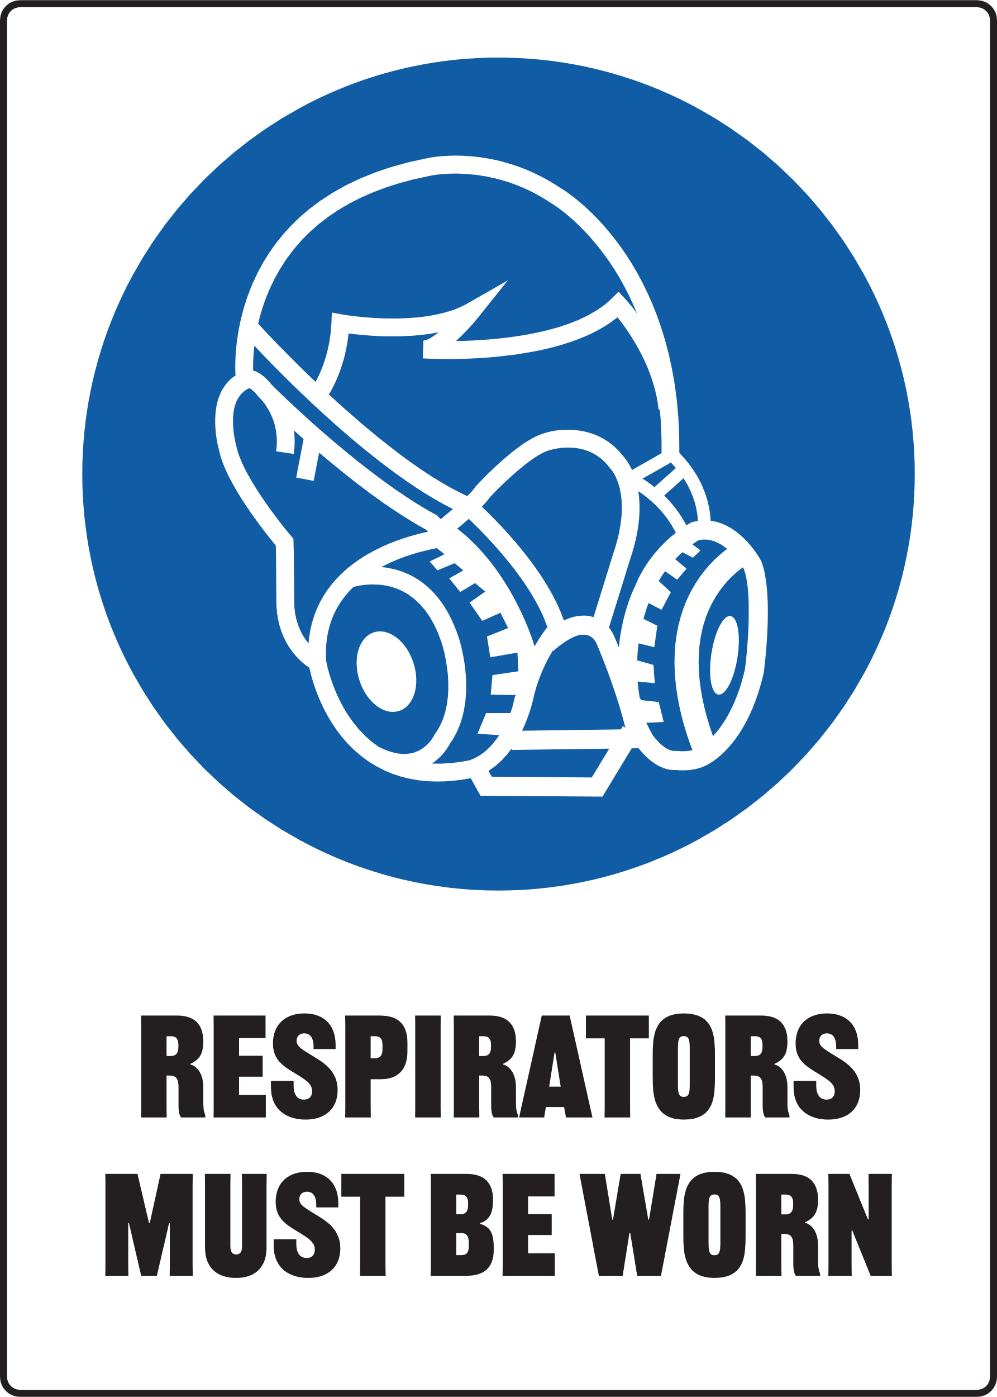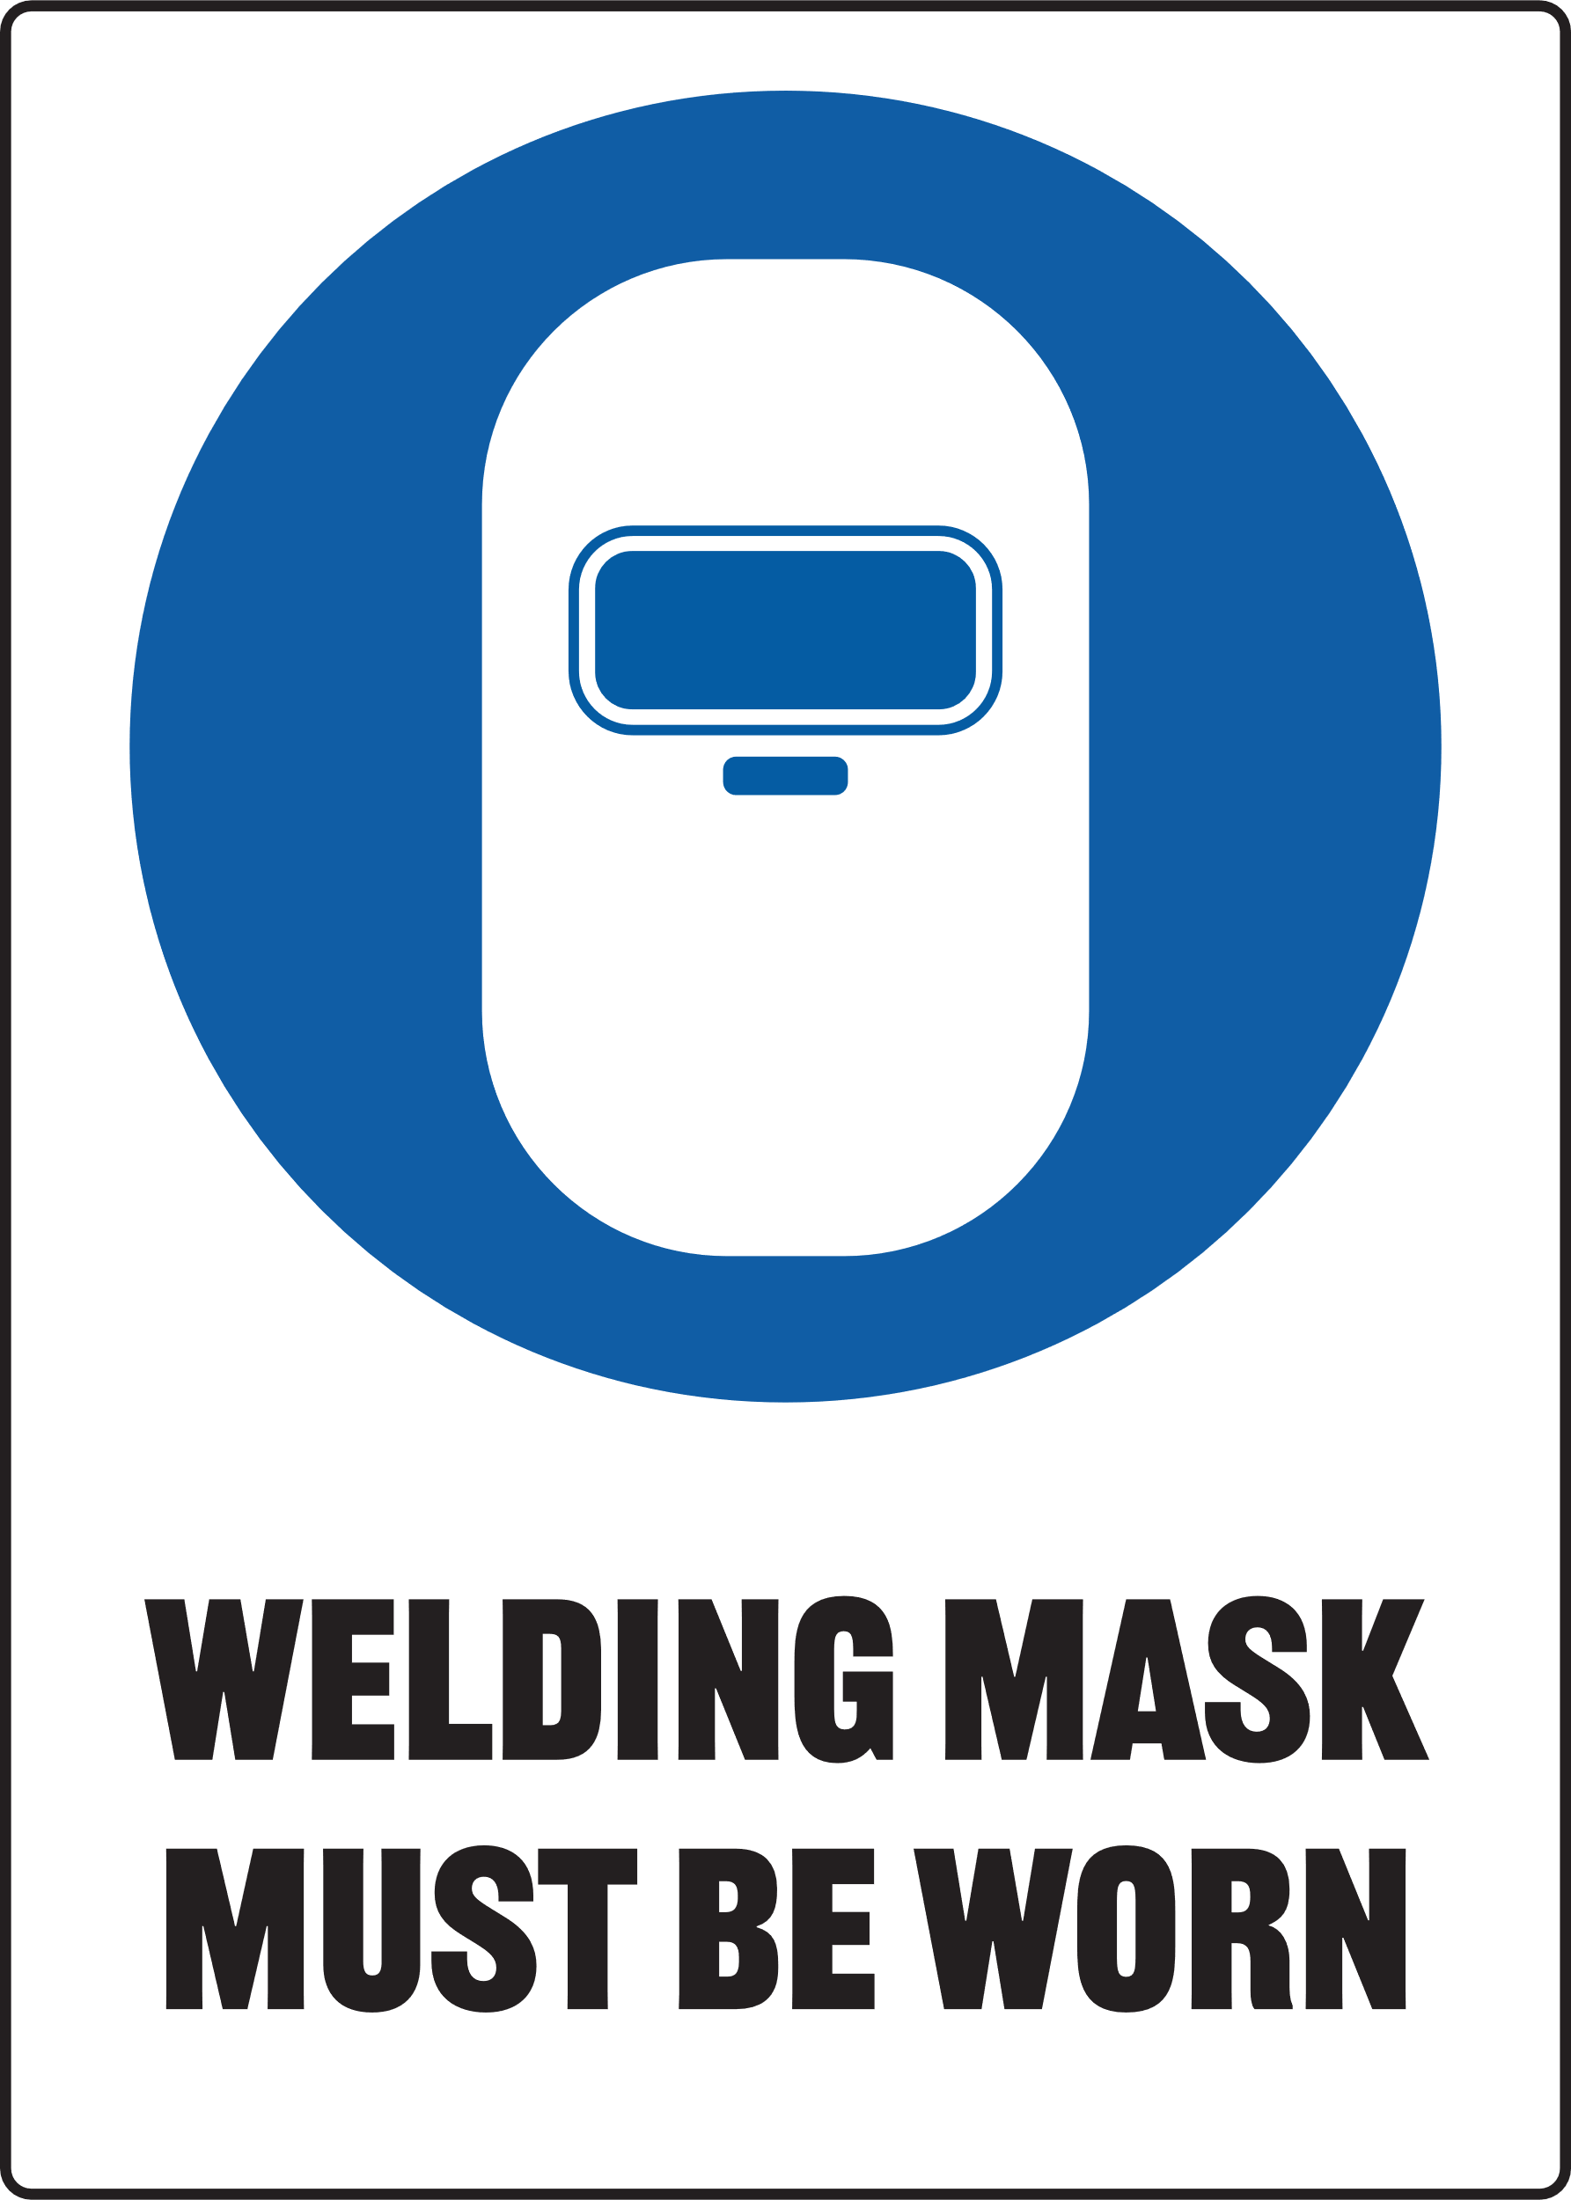

Print Settings:
  - Open Print Menu: Go to the 'File' menu and select 'Print'.
  - Adjust Print Settings:
- In the Print dialog box, under 'Settings', choose 'Custom Print' or 'Print Specific Pages'.
- Ensure that the starting page number is set to '2' to print the second page of the document.
  - Colour Printing:
- Make sure to select 'Print in Colour' if this option is available.
Document Preview: Note that the print preview of the document will display the first page, but it will not be printed with the above settings.


Surface Planer
Only use this machine if you have been given instructions on how to use it safely and have been given permission
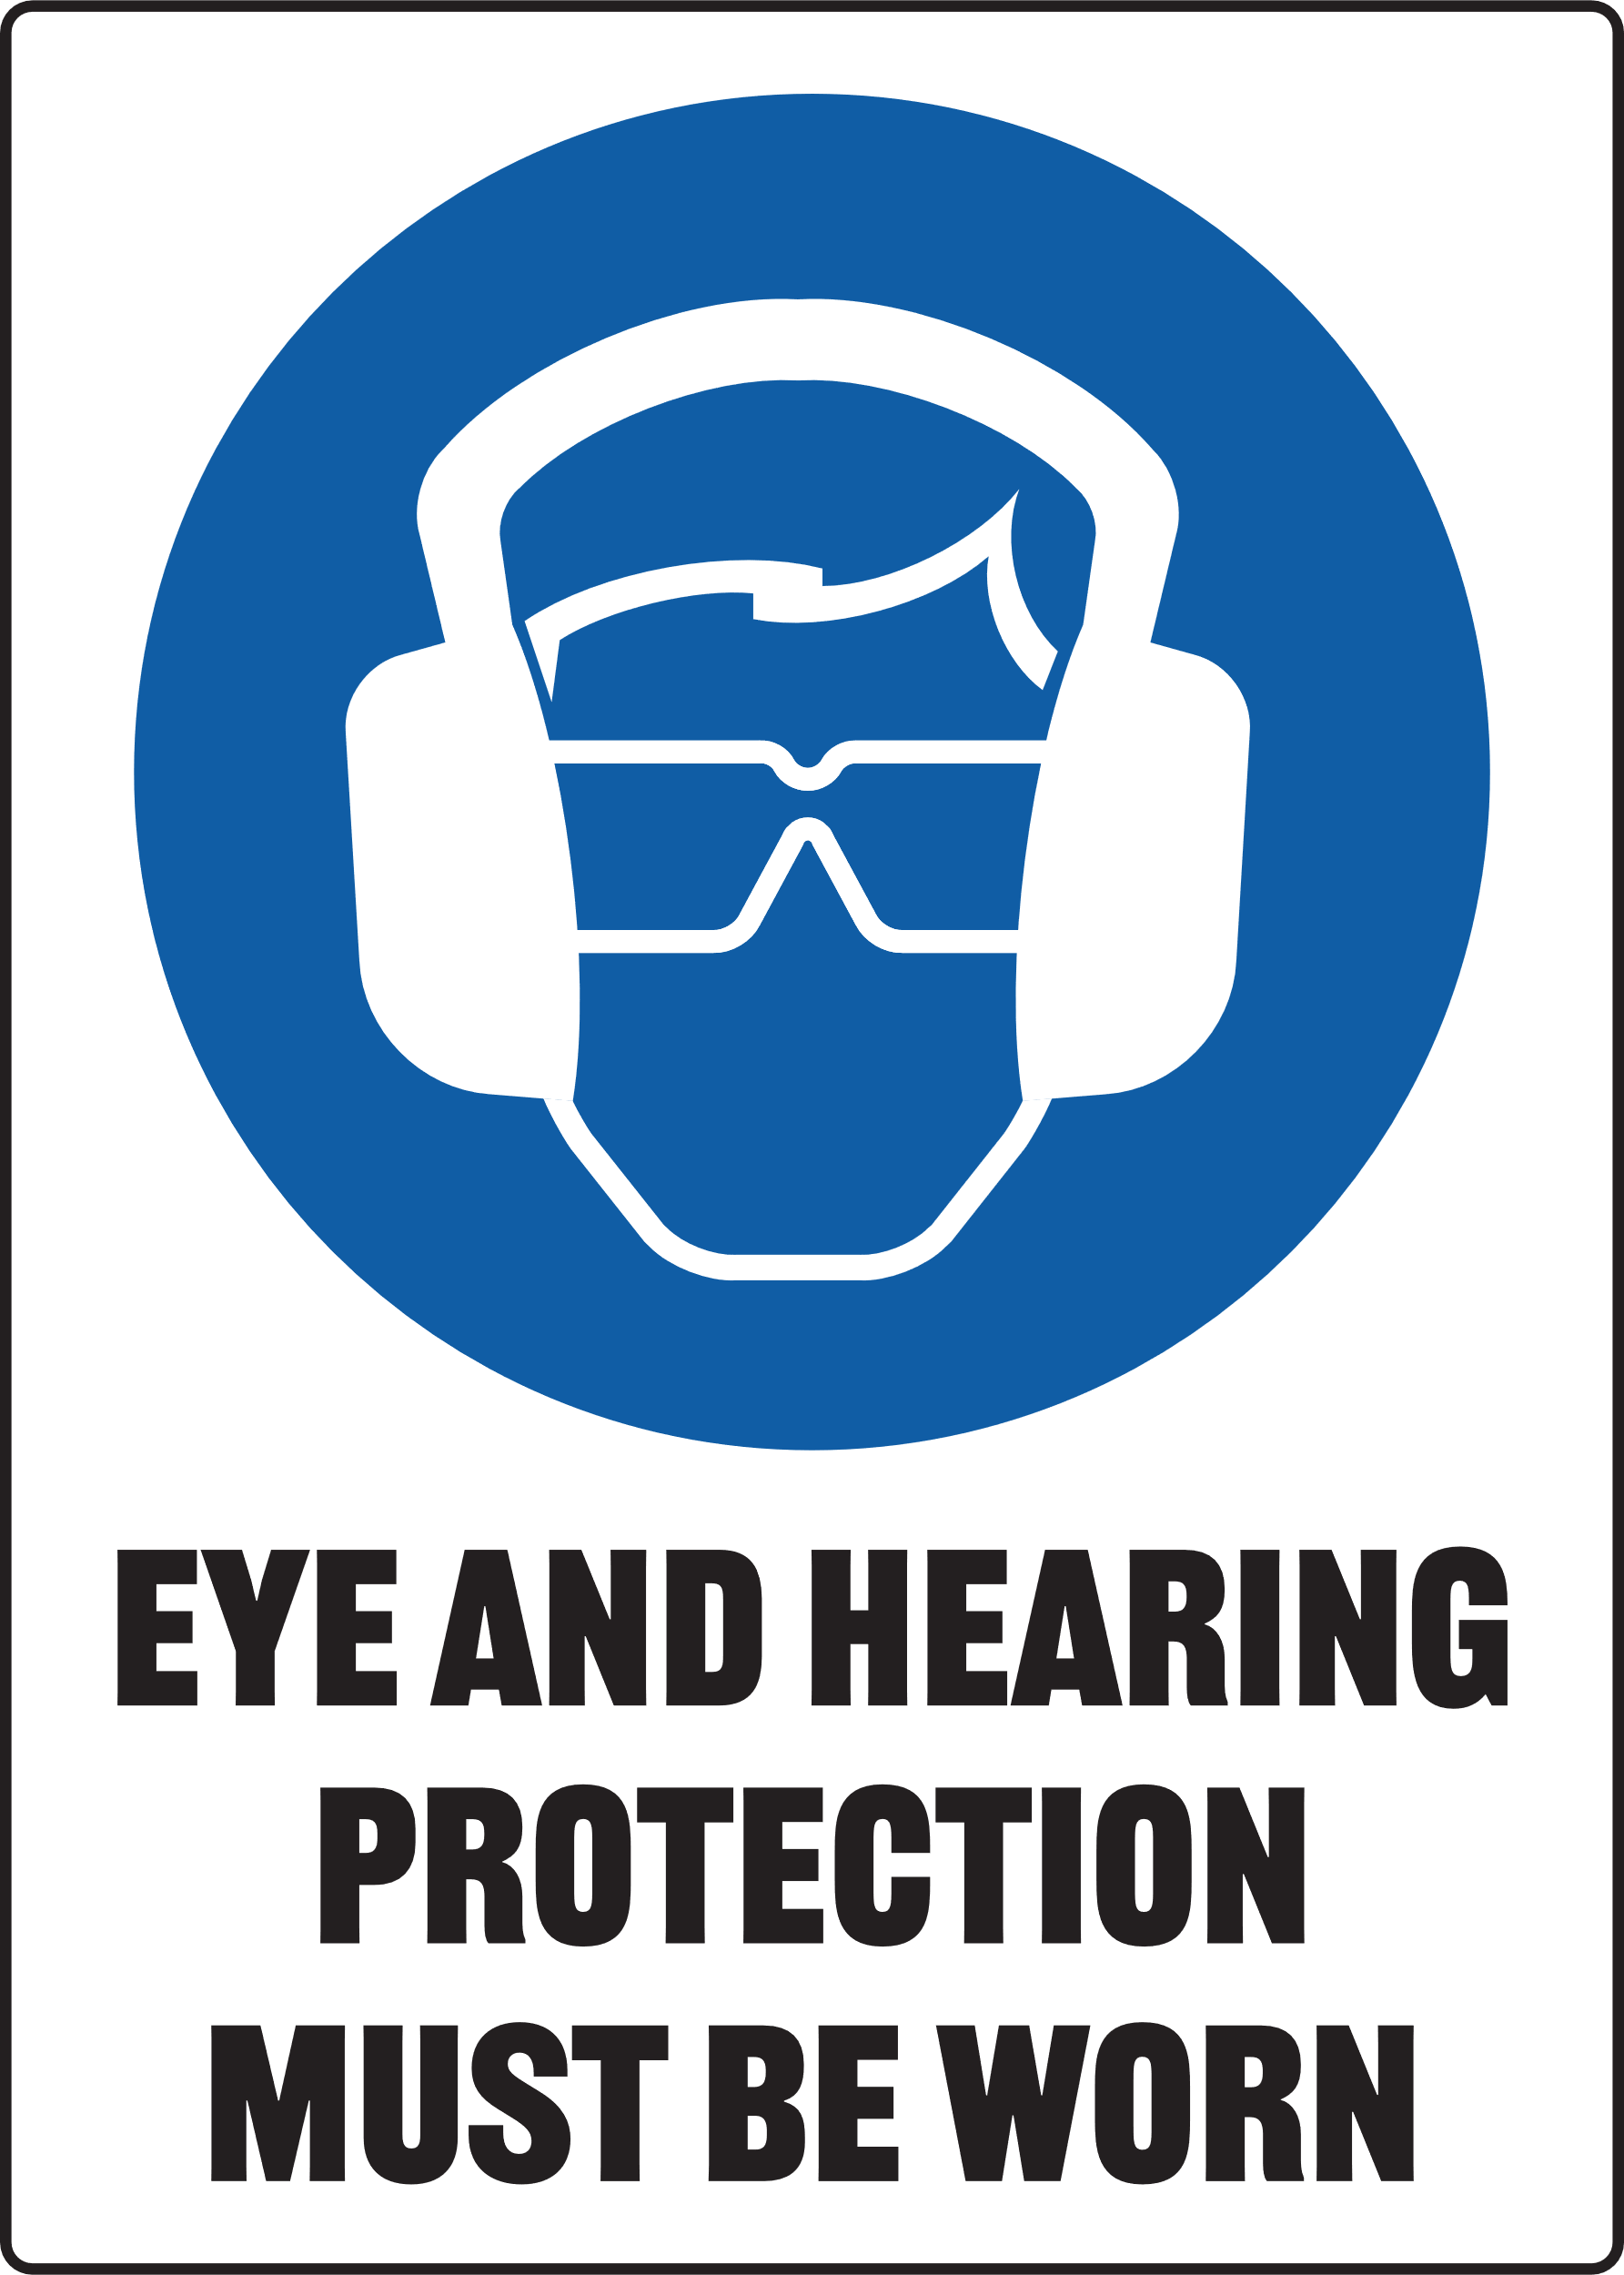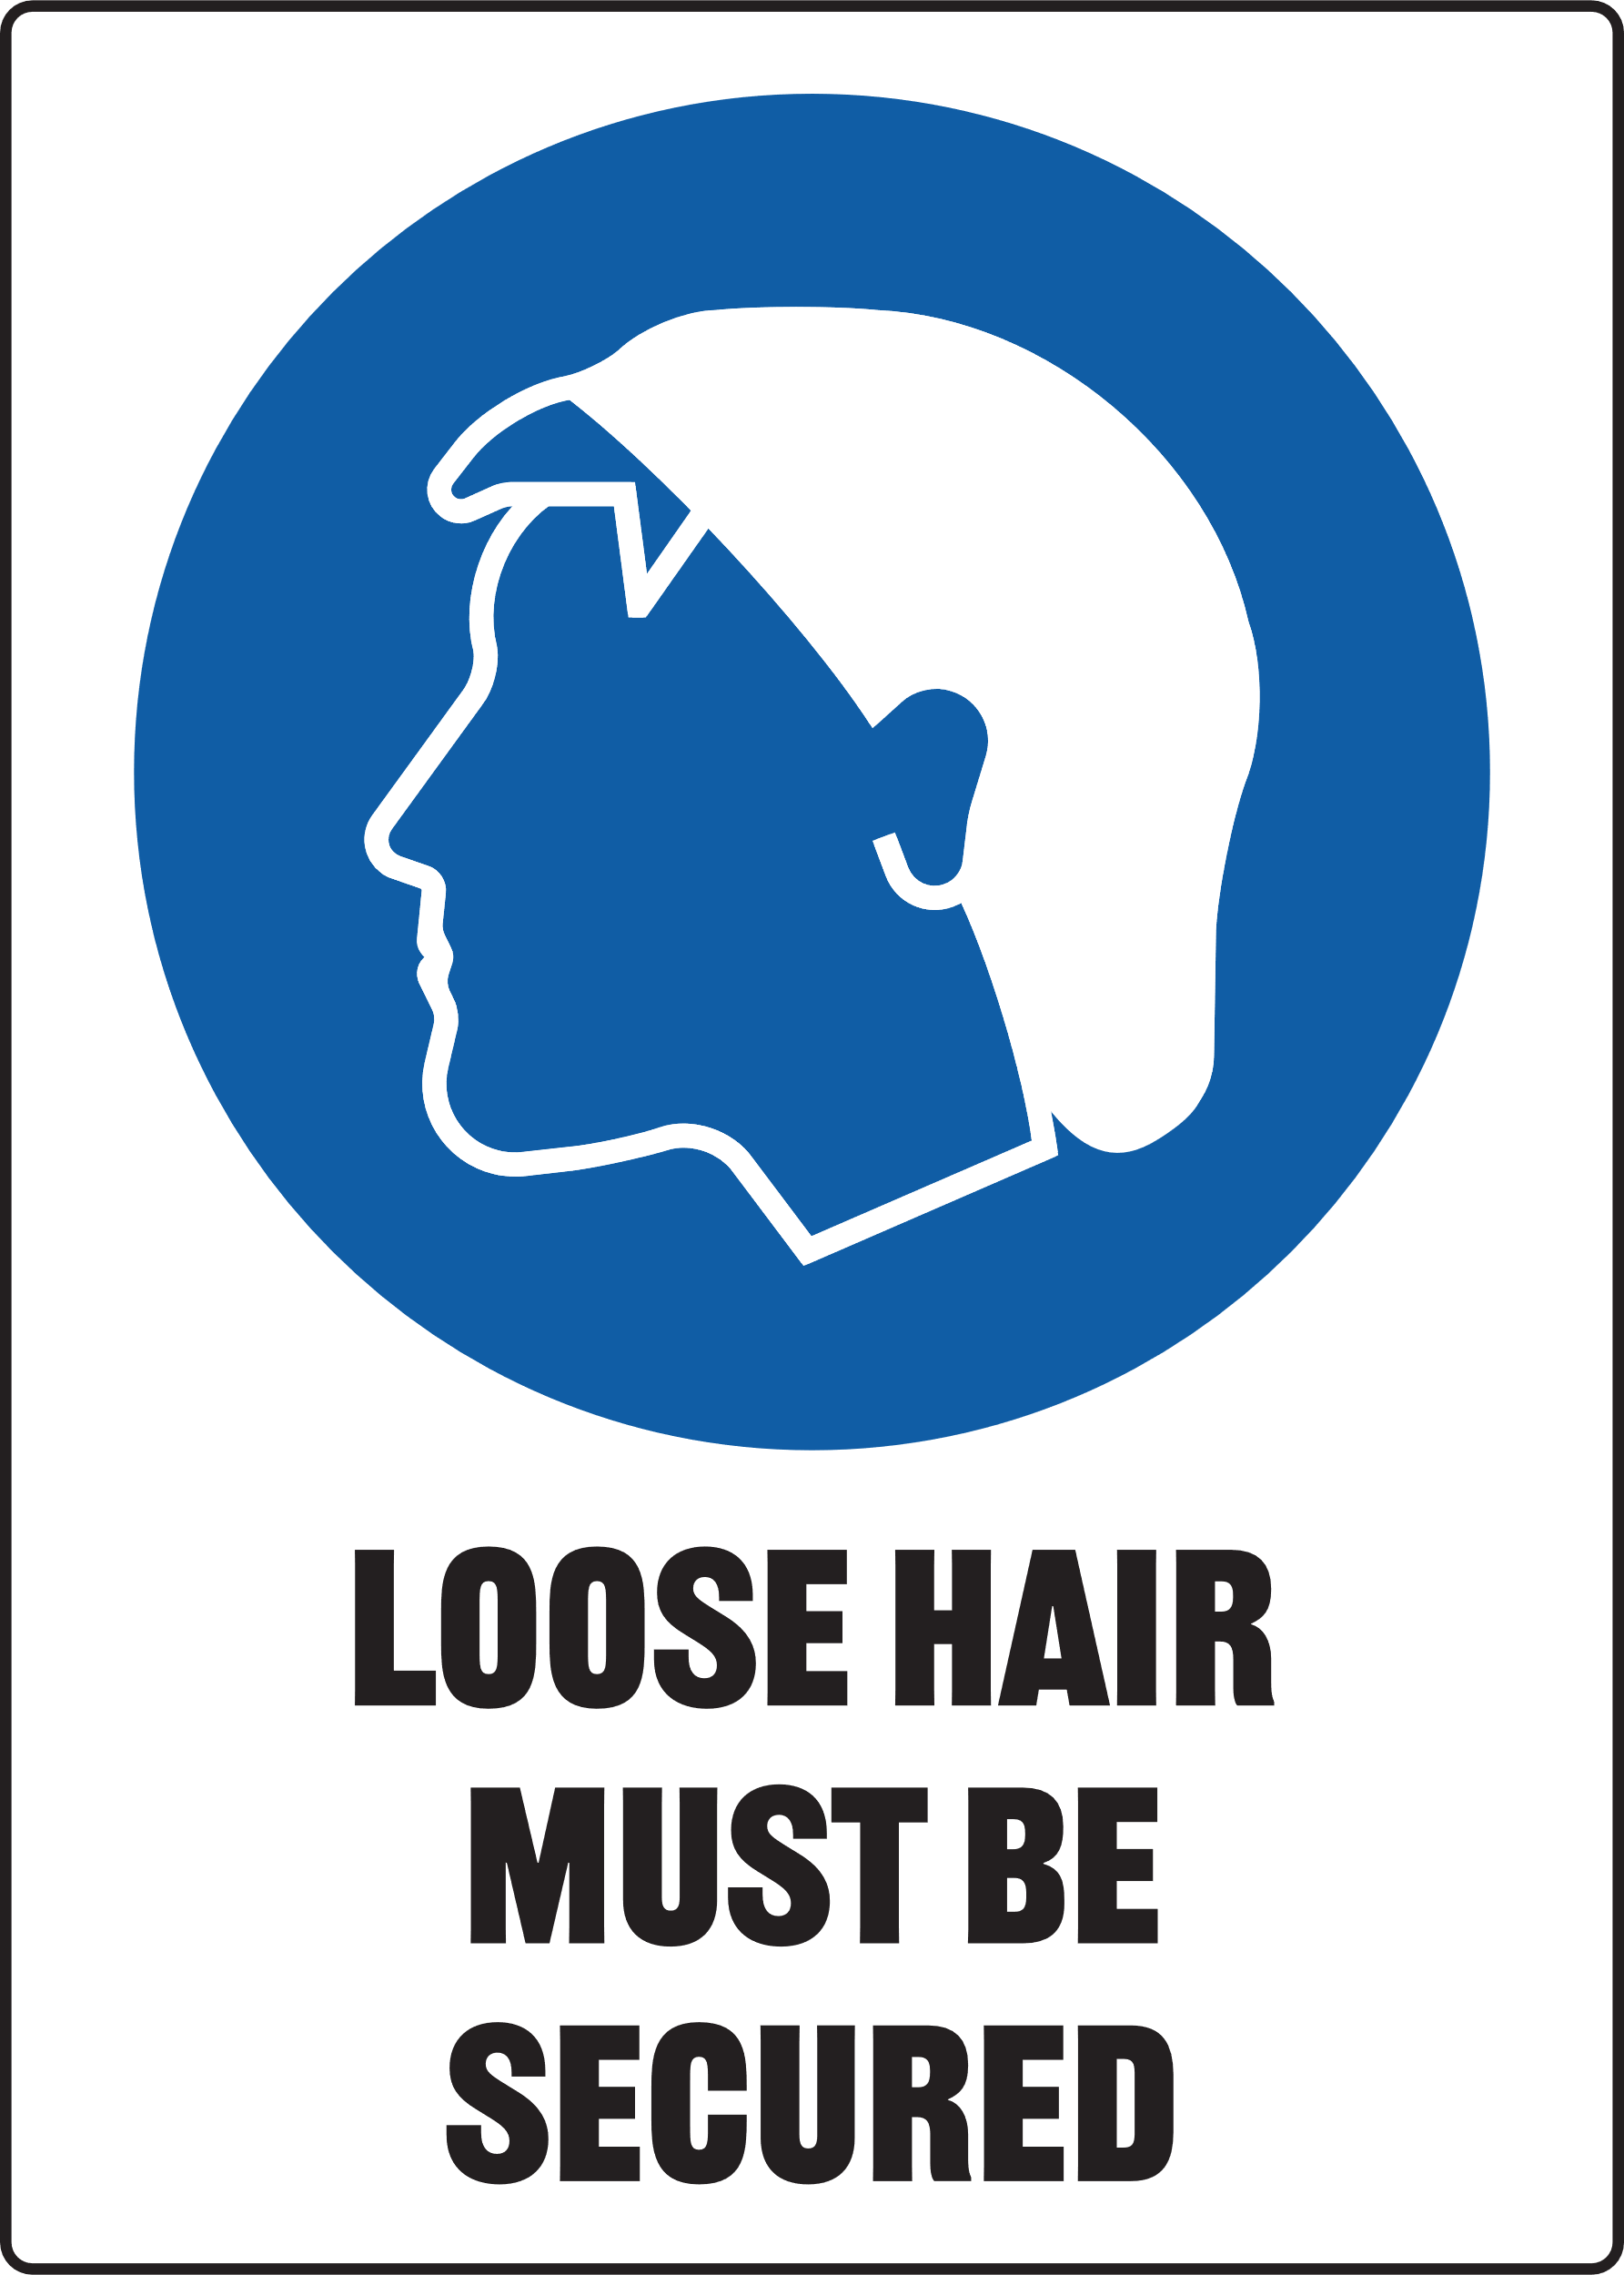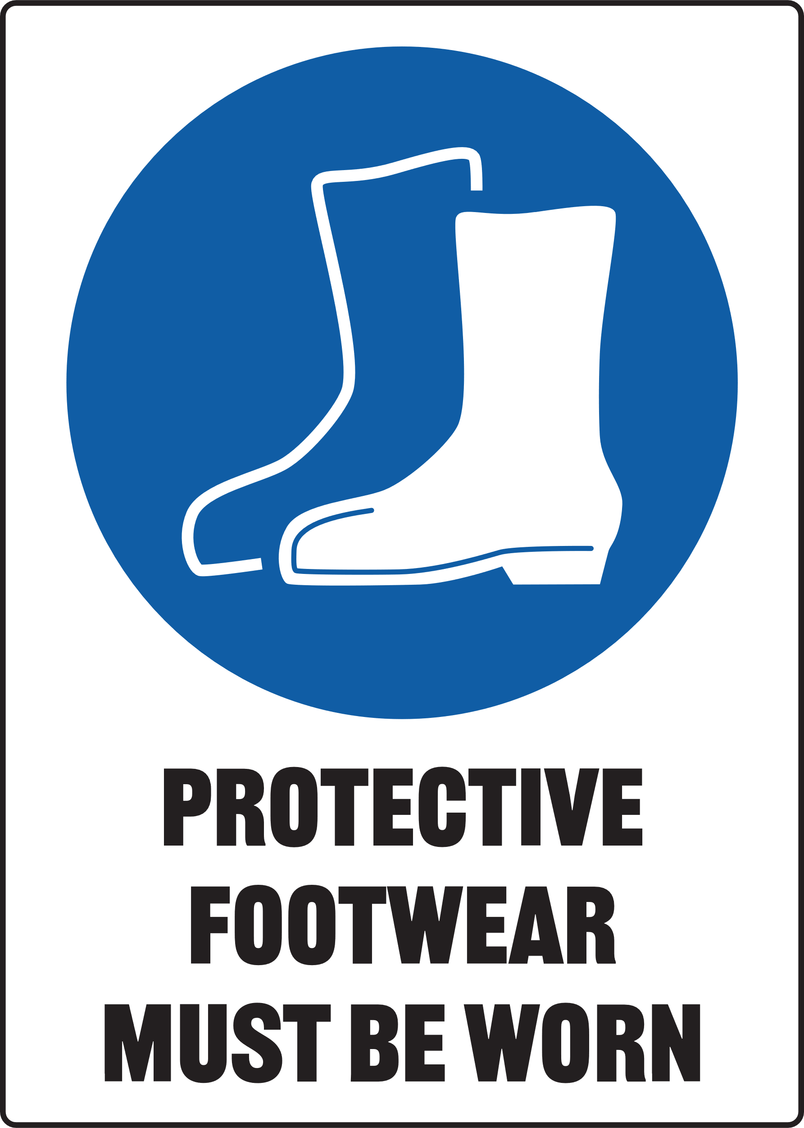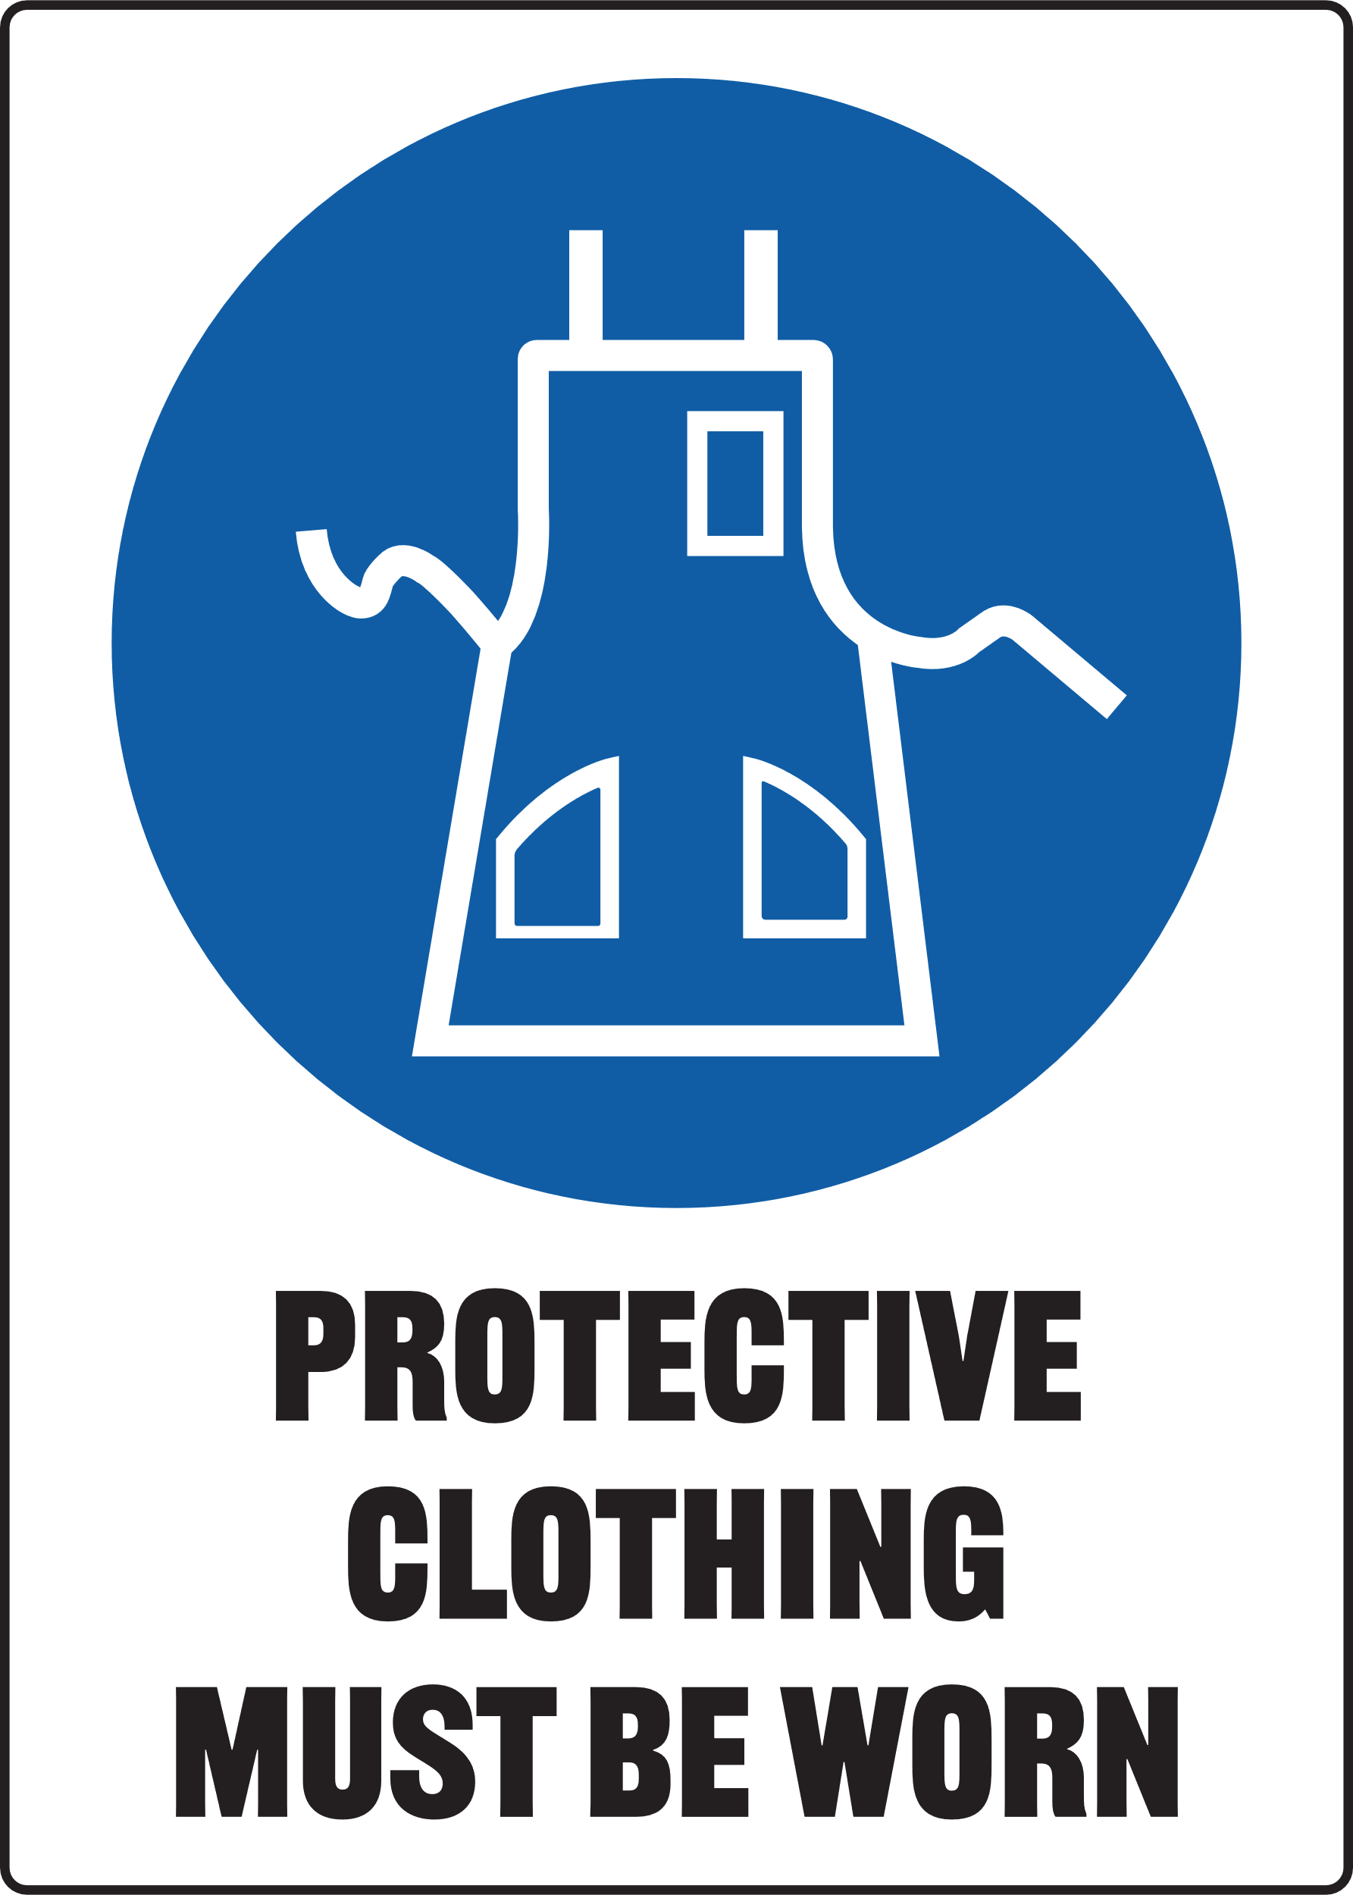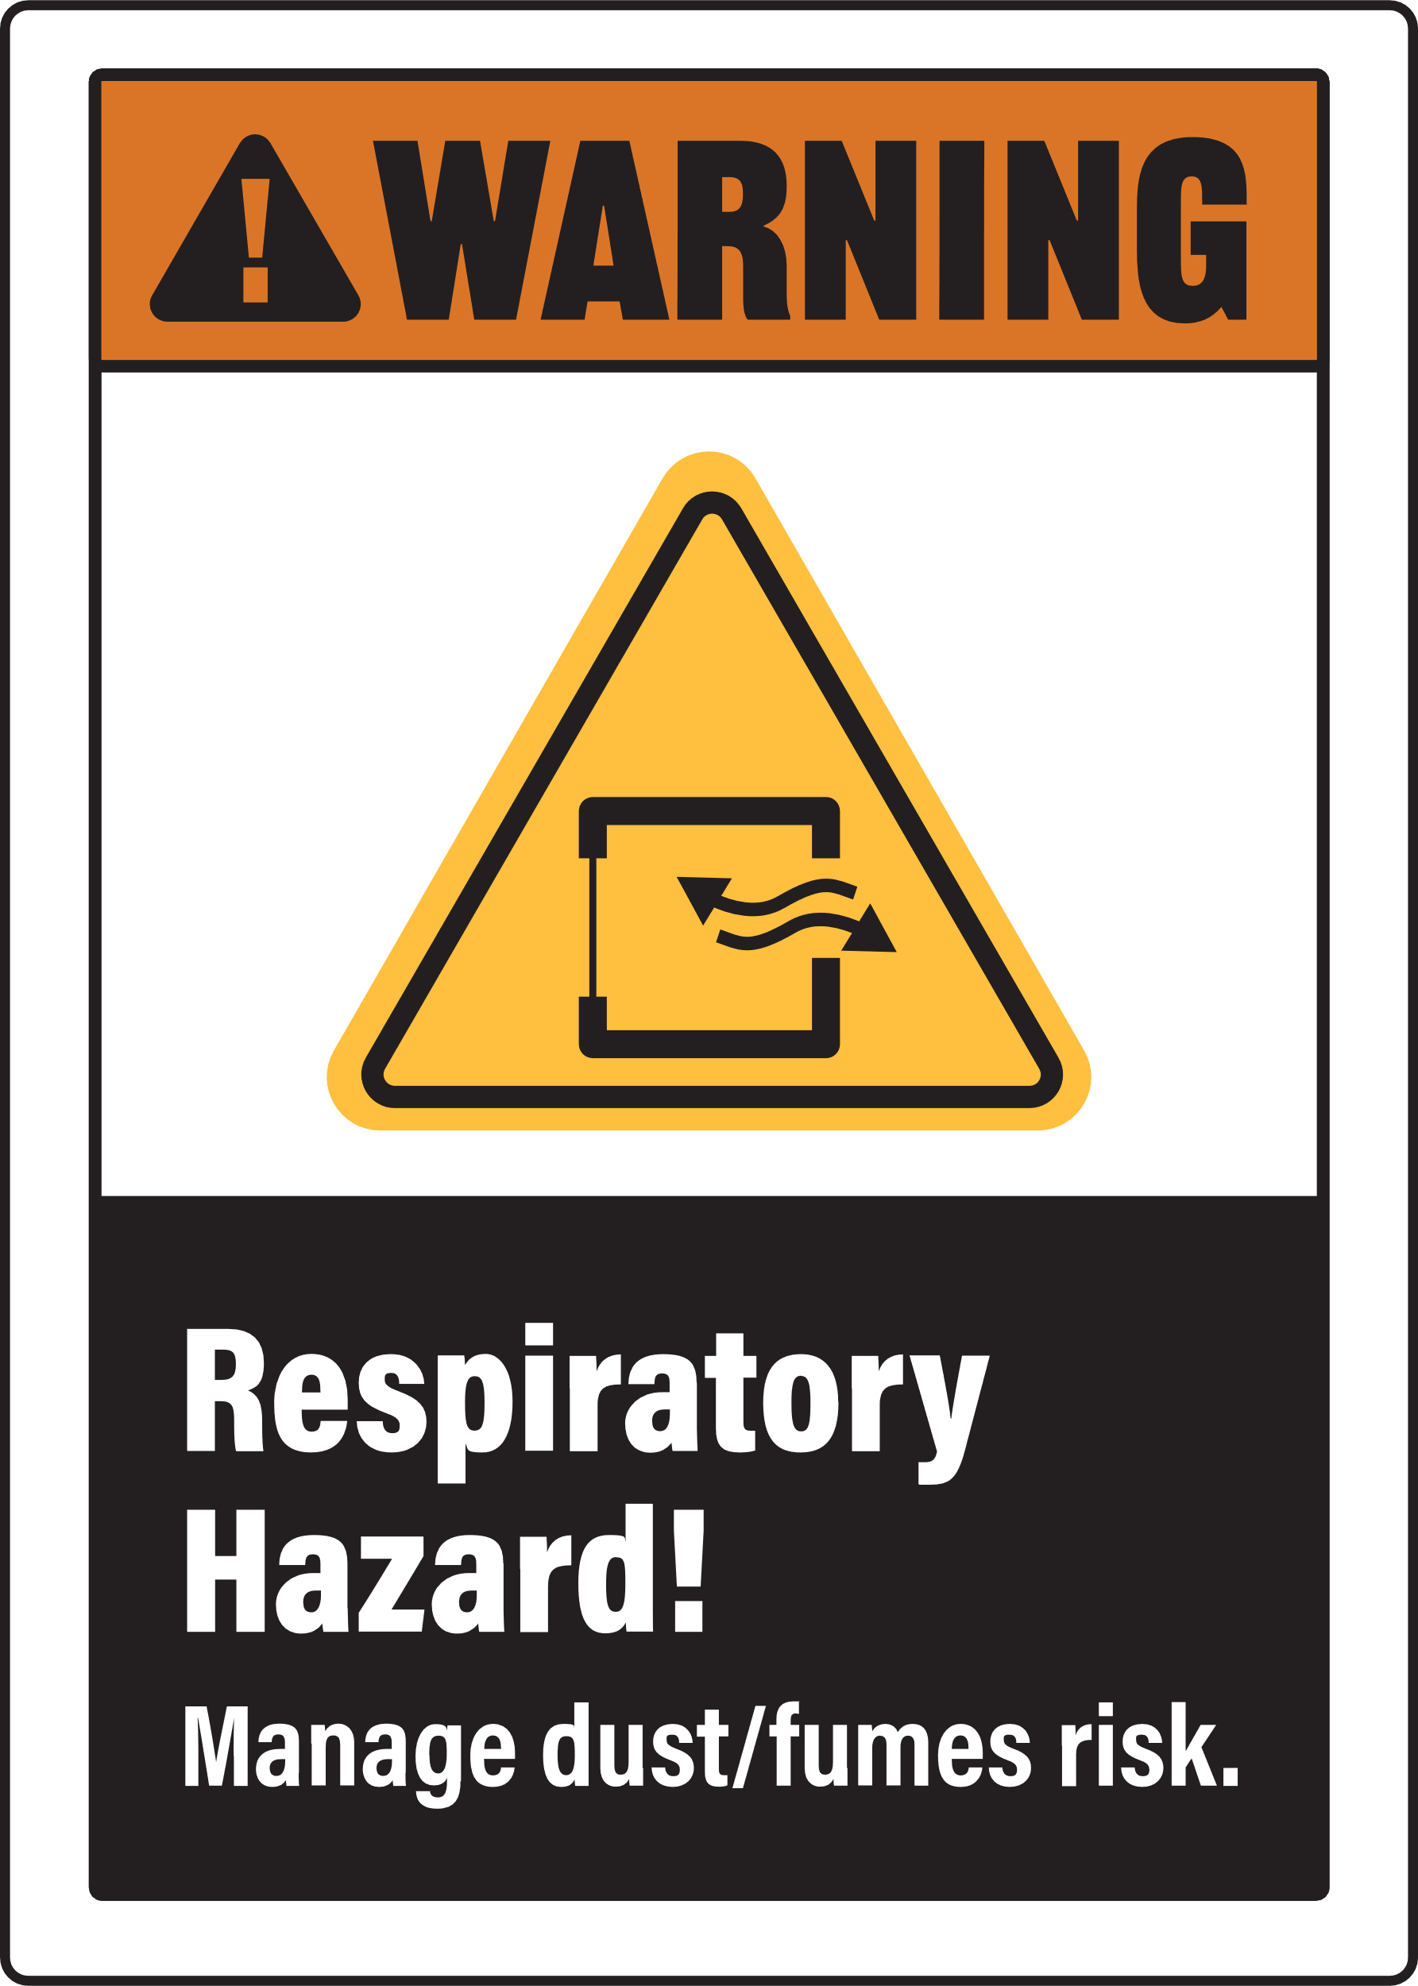

Do not plane short lengths or stock with structural defects

Pre-Operational Safety Checks
- Check workspaces are clear and no slip/trip-hazards are present
- Check safety guards are adjusted and operate to give maximum protection
- Where a bridge guard is fitted adjust the guard to ensure a maximum of 2mm clearance between guard and the timber
- Locate and ensure you are familiar with the operation of the ON/OFF starter and emergency stop
- Set depth of cut and lock table. Never make a single cut greater than 2mm deep
- Check and lock fence in position
- Start the dust extraction unit before using the machine
- Faulty equipment must not be used. Immediately report suspect equipment

Operational Safety Checks
- NEVER attempt to surface stock less than 300mm long x 20mm wide x 15mm thick
- Hands must not be closer than 100mm from the cutter head when it is rotating
- Use push blocks wherever possible
- Operator should stand to side of in-feed table to avoid possible kickbacks
- Place cupped boards with the concave side against the table
- Plane with the grain. Hold the workpiece firmly and apply even feed rate
- Never leave the machine unattended while it is running
- Before making any adjustments switch off and wait for the cutter head to completely stop

Housekeeping
- Switch off and isolate machine. Reset all guards to a fully closed position after use
- Reset the depth of cut to zero after use
- Leave the machine in a safe, clean and tidy state

Potential Hazards
- Exposure to moving and rotating components Δ Splinters Δ Eye injury
- Pinch and squash Δ Ejected material Δ Wood dust Δ Electrical

