SOP Review, Update and Print instructions
DO NOT PRINT THIS PAGE
- Review the SOP Document:
- Manufacturer’s Instructions: Refer to the equipment manual for specific safety and operational guidelines. Incorporate any additional details into the SOP as necessary.
- Feedback: Consult with users to confirm that the SOP accurately reflects practical usage. Make any needed revisions based on their input.
- Assess PPE Requirements:
- Evaluate if new or additional personal protective equipment (PPE) is required based on the risks associated with the equipment. Address risks such as dust and fumes by selecting appropriate PPE and updating the SOP with relevant PPE checks and icons.
- Display and Accessibility:
- Print the reviewed SOP, ensuring it is signed and dated. Post the printed SOP near the equipment or where it is easily accessible to users.
- Schedule and Document Review:
- Plan to review and update the SOP annually or whenever work processes change.
- Footer Details: Date of Review = When the school review was completed. Reviewed By = Who completed the school review. Next Review = insert date (e.g. max one year ahead).
Personal Protective Equipment (PPE) Signage
add/remove from the SOP as appropriate for your school/machine
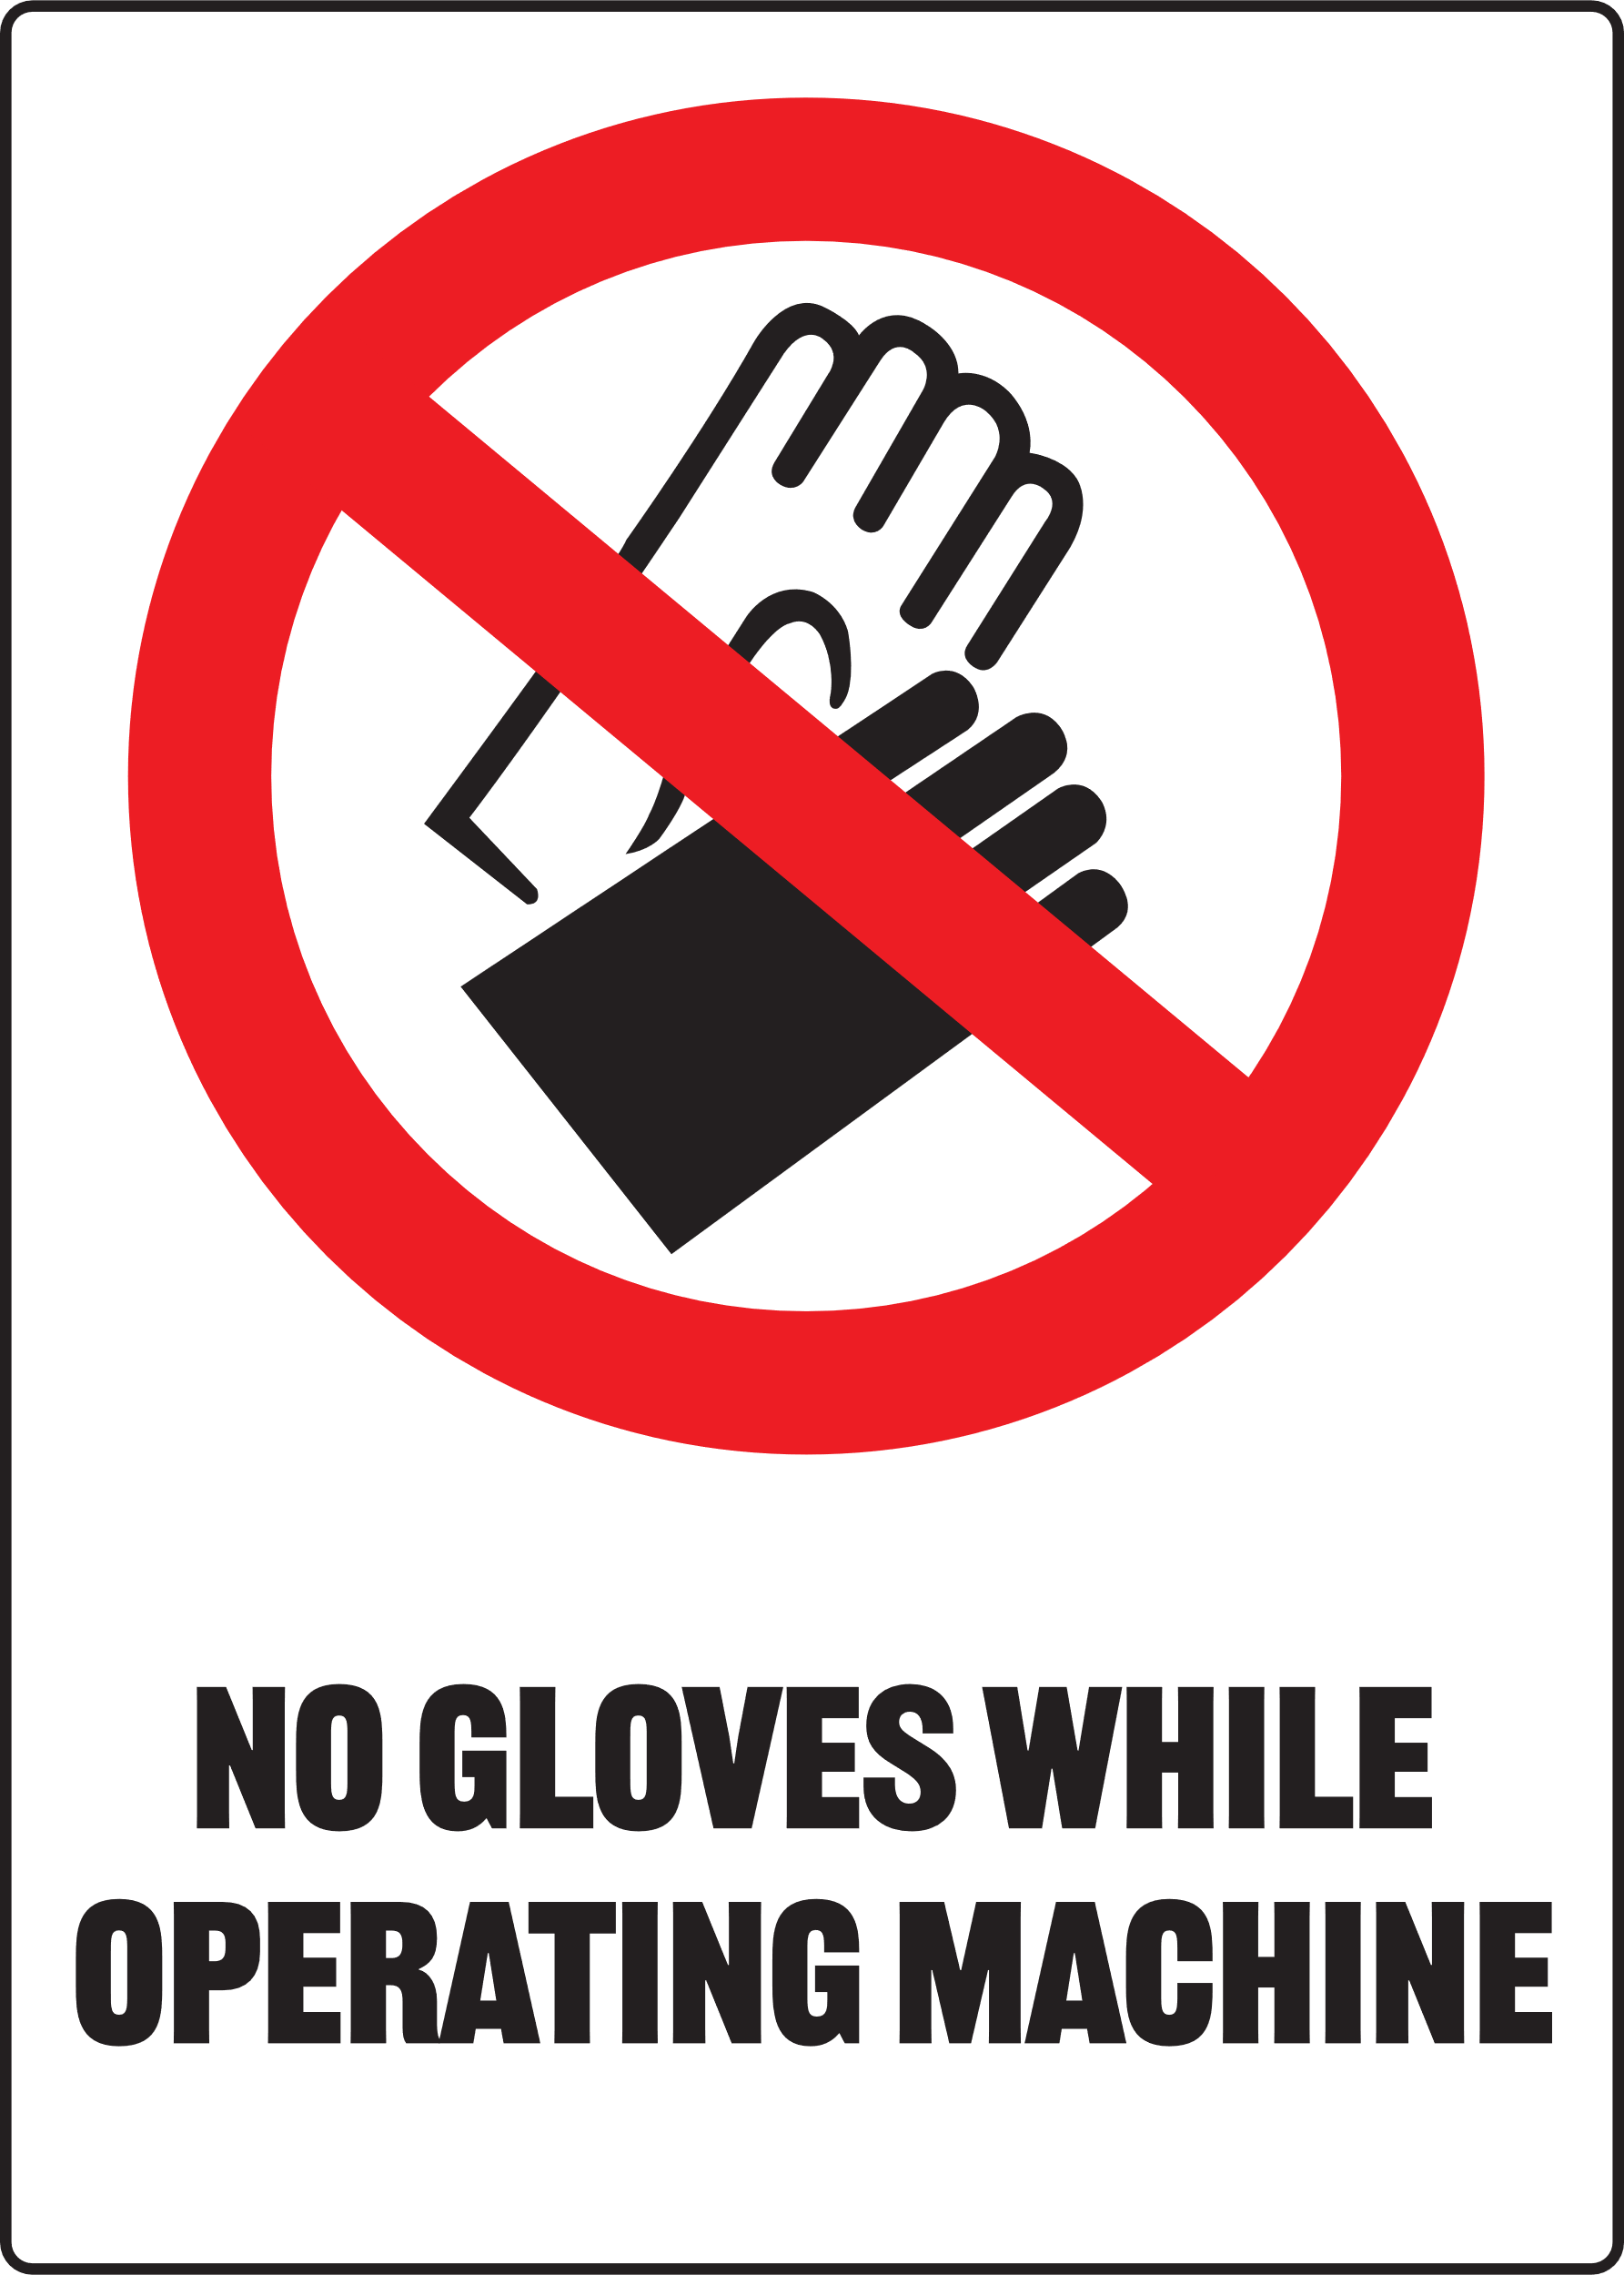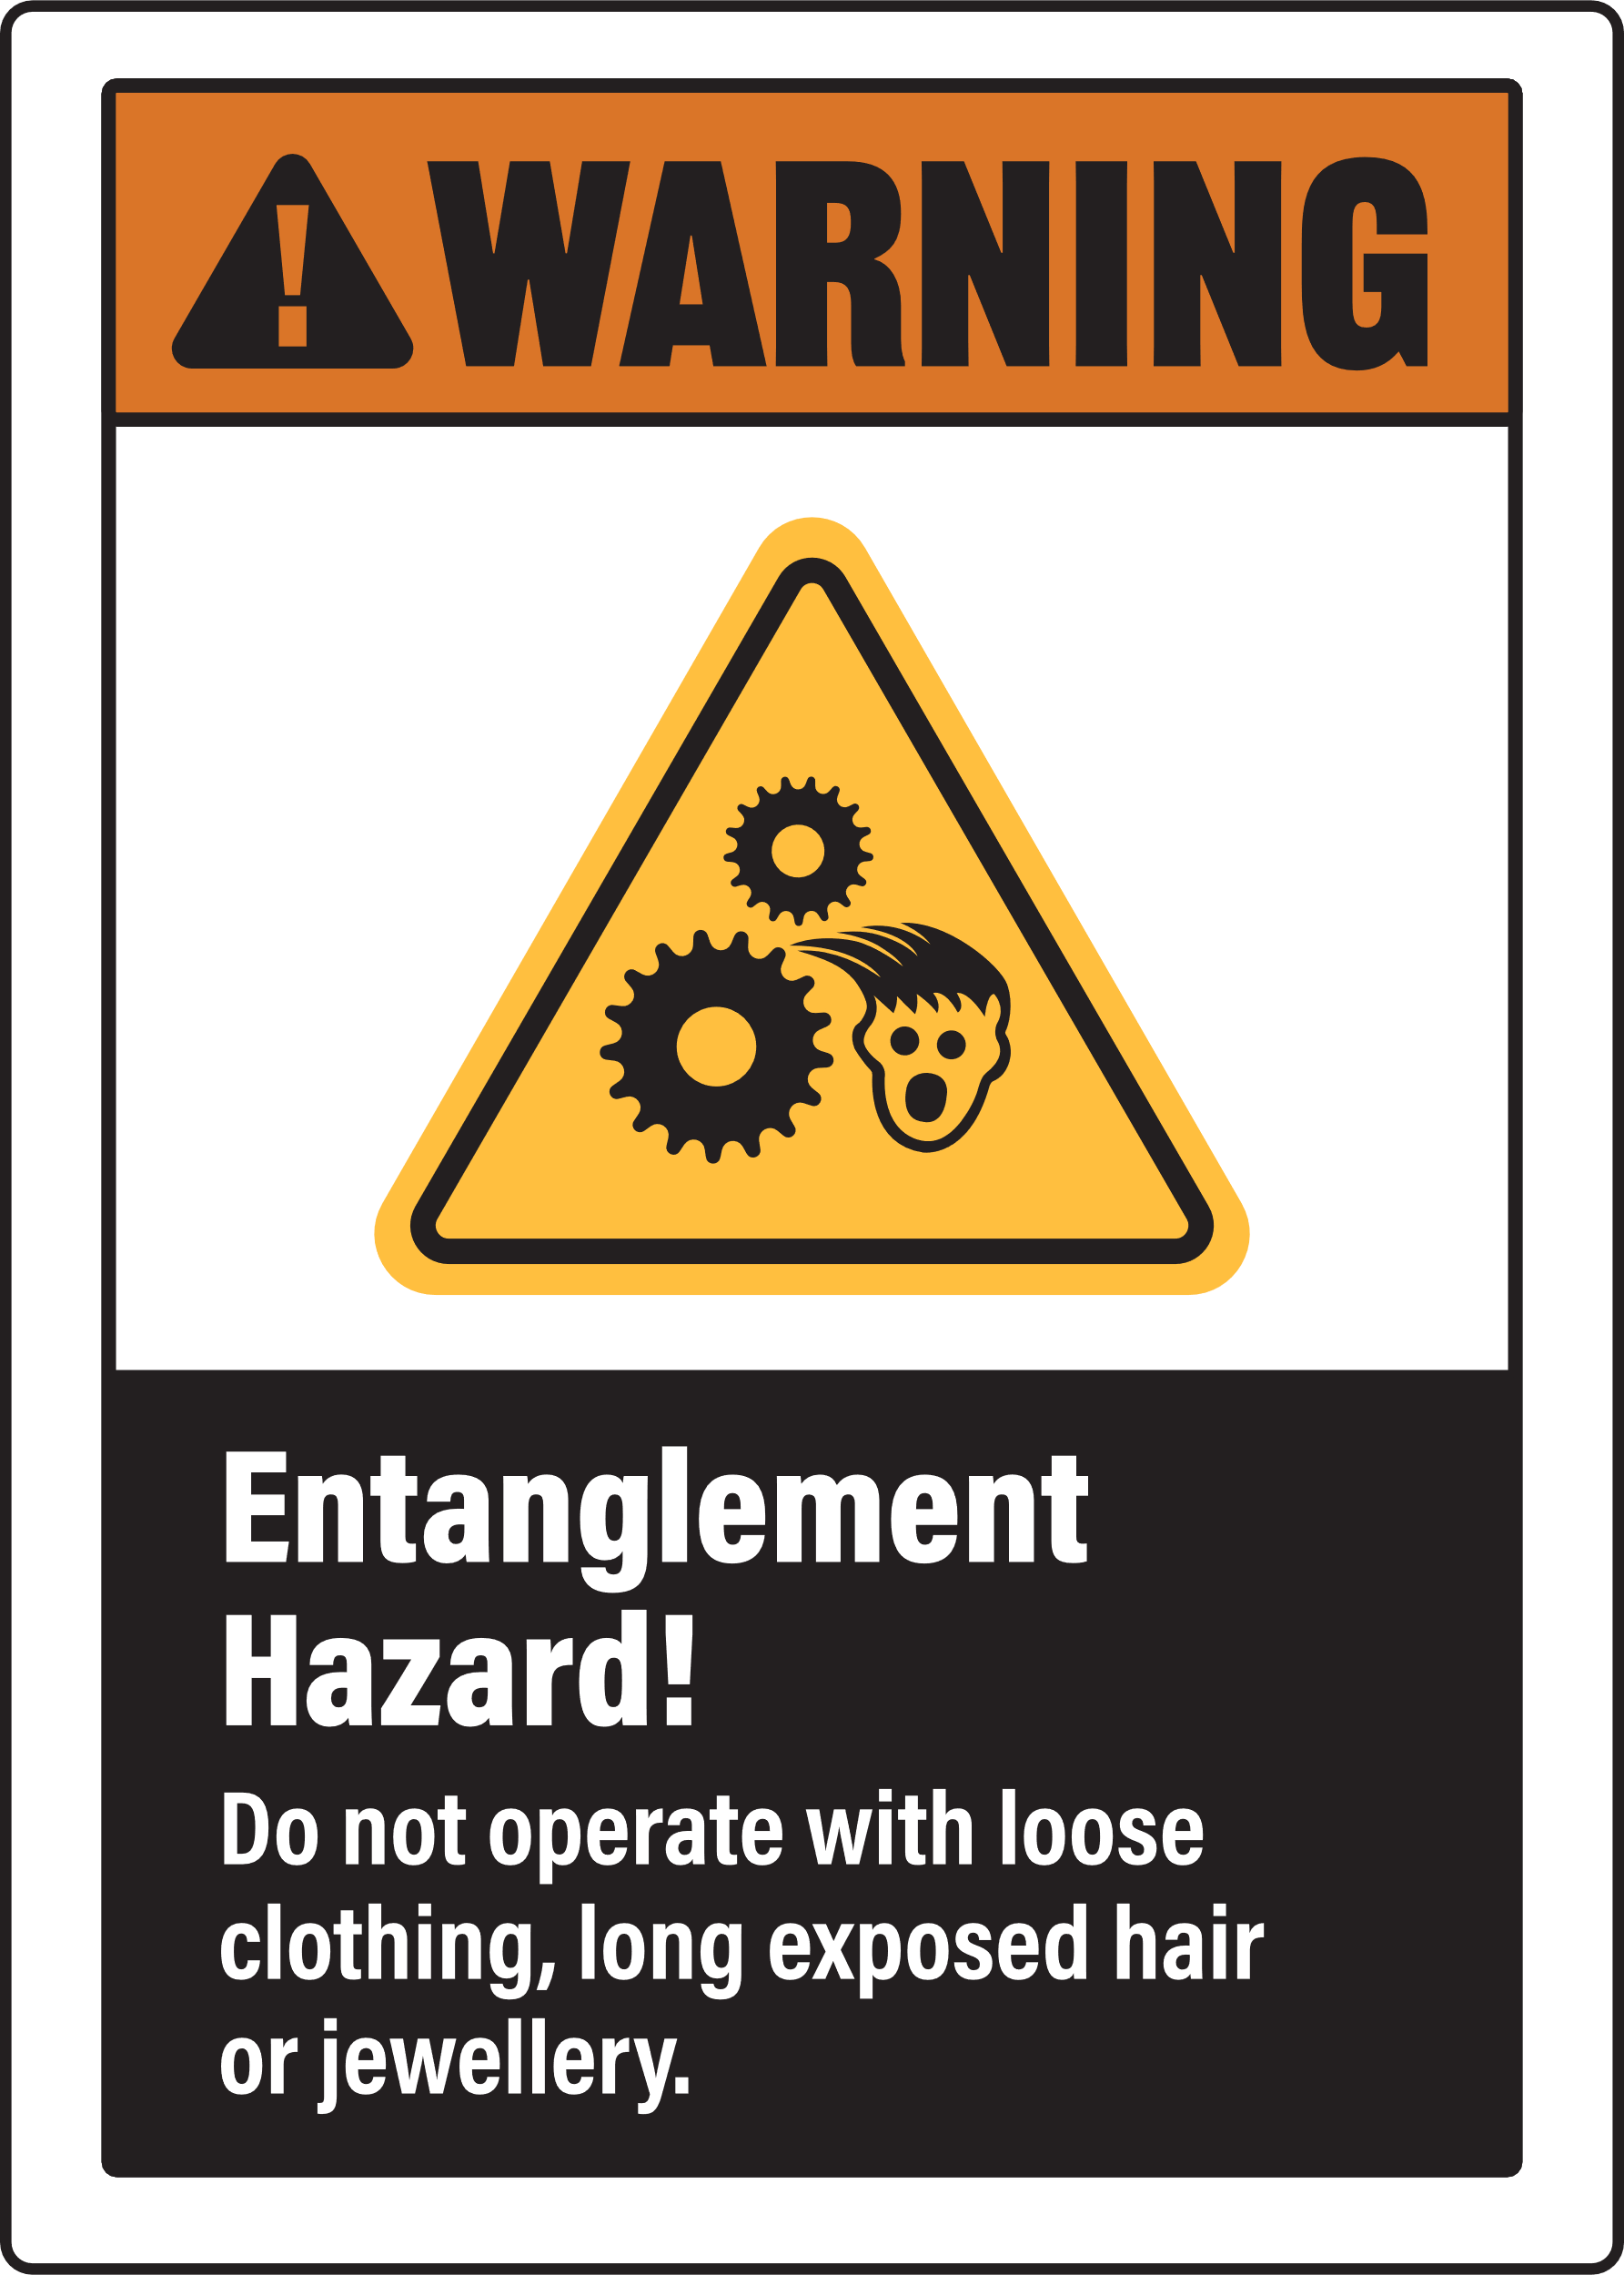
MANAGING RESPIRATORY HAZARDS
Ensure you manage risk of exposure to dust and fumes by selecting the appropriate PPE signs for your SOP
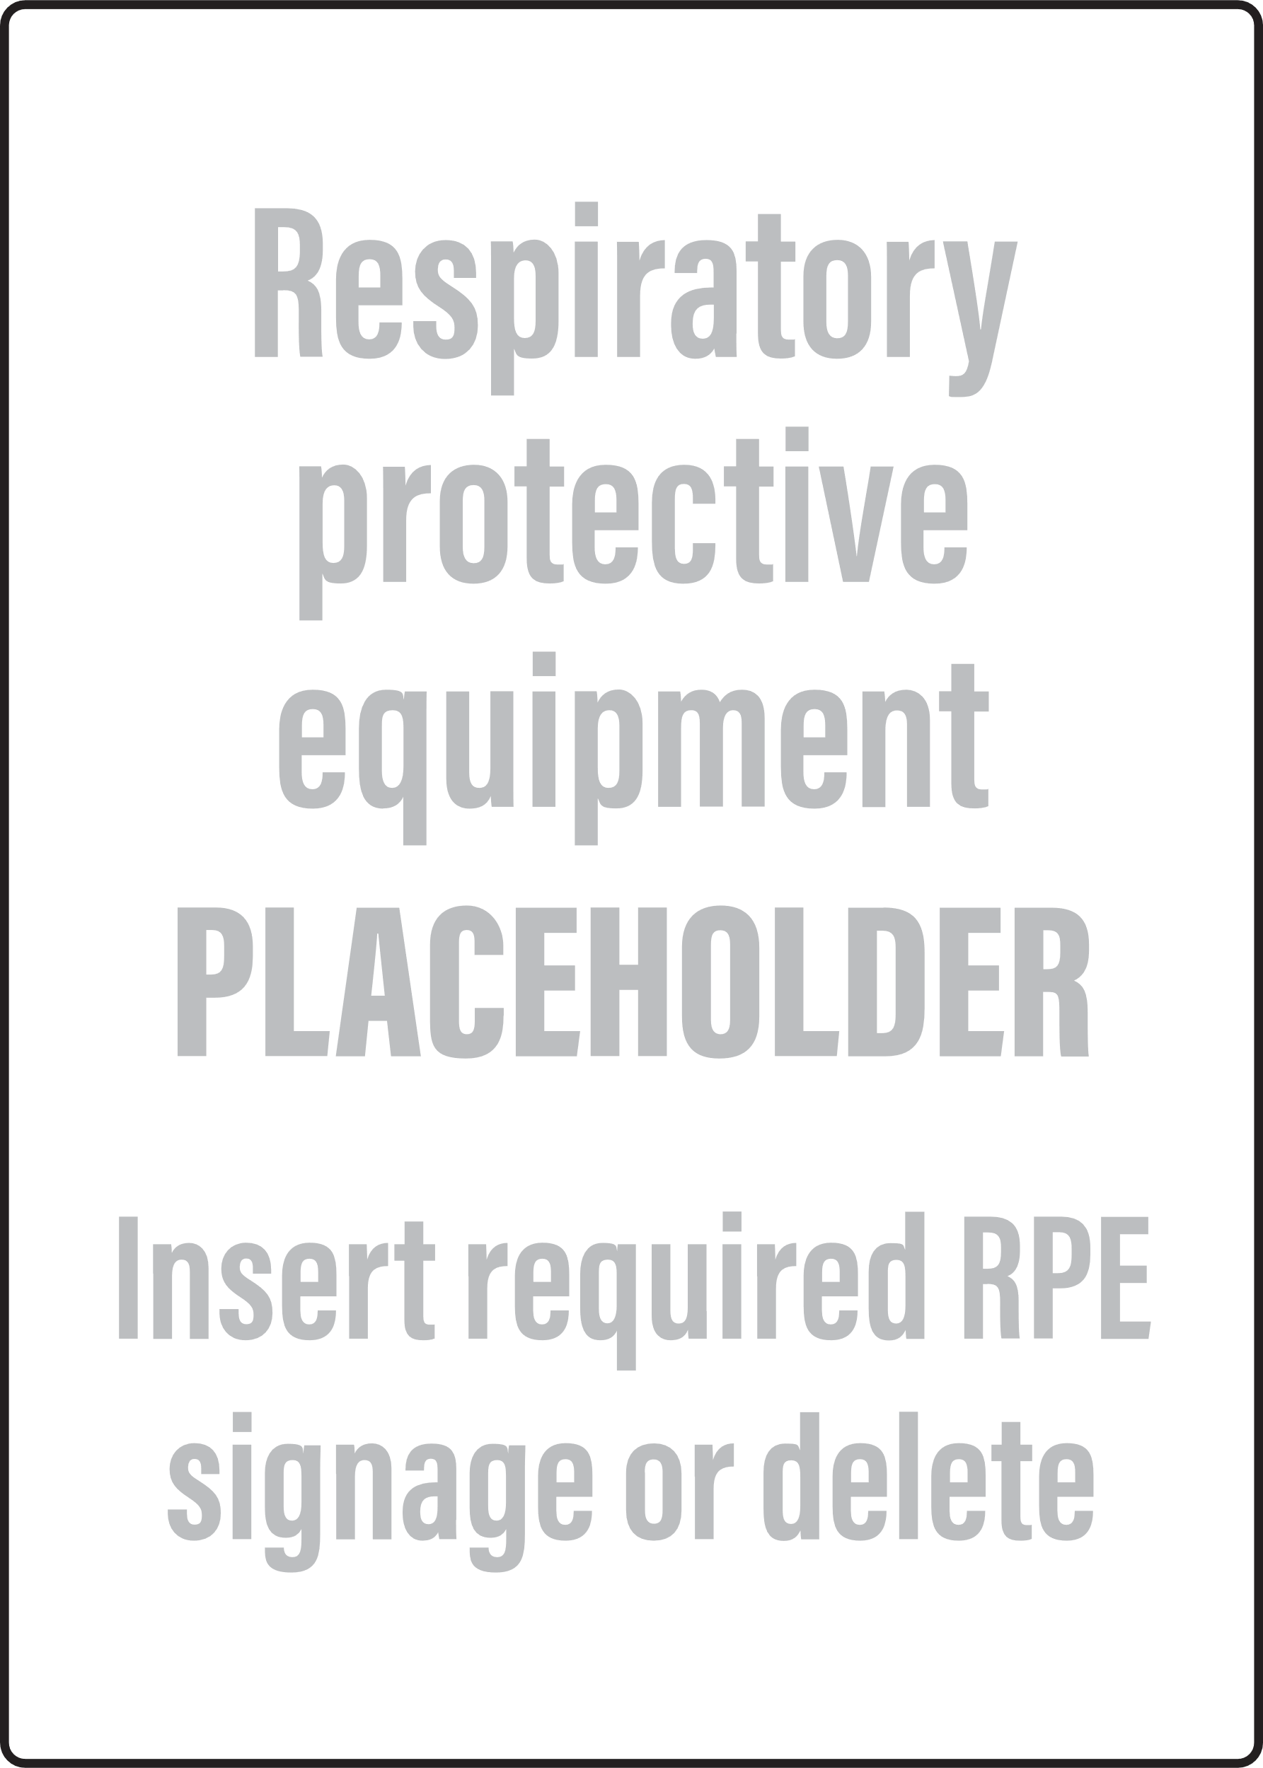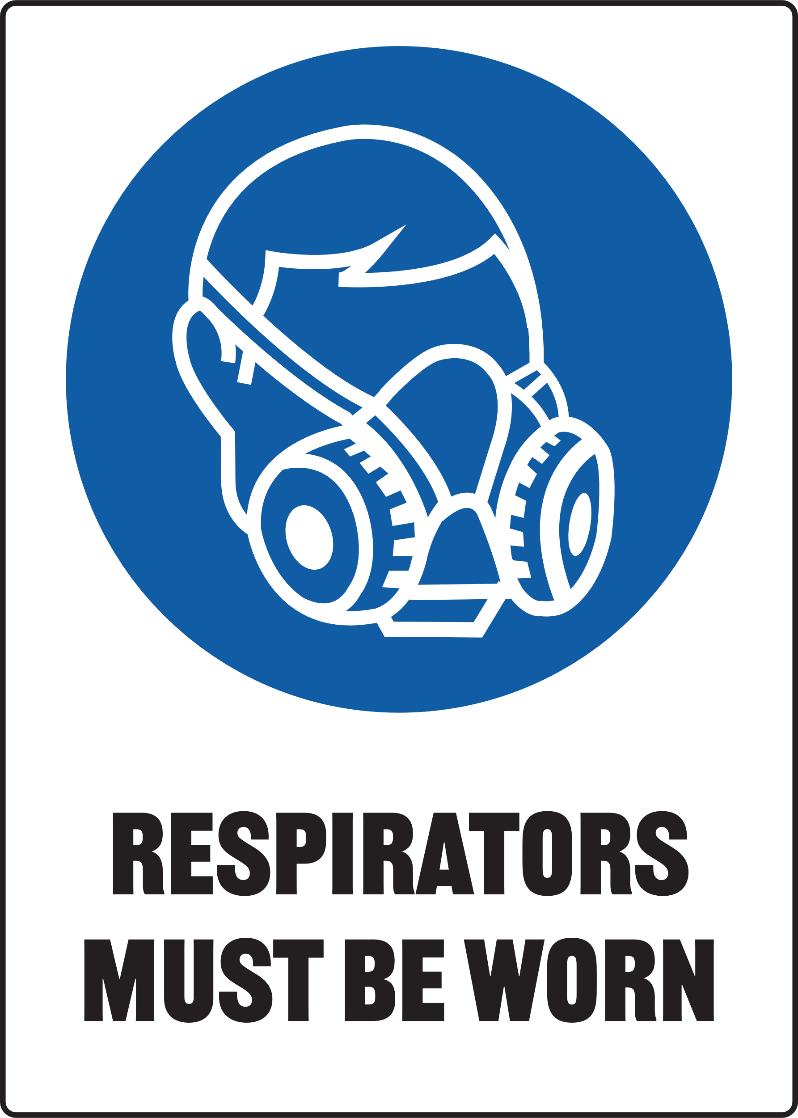

Print Settings:
  - Open Print Menu: Go to the 'File' menu and select 'Print'.
  - Adjust Print Settings:
- In the Print dialog box, under 'Settings', choose 'Custom Print' or 'Print Specific Pages'.
- Ensure that the starting page number is set to '2' to print the second page of the document.
  - Colour Printing:
- Make sure to select 'Print in Colour' if this option is available.
Document Preview: Note that the print preview of the document will display the first page, but it will not be printed with the above settings.


Thicknesser
Only use this machine if you have been given instructions on how to use it safely and have been given permission
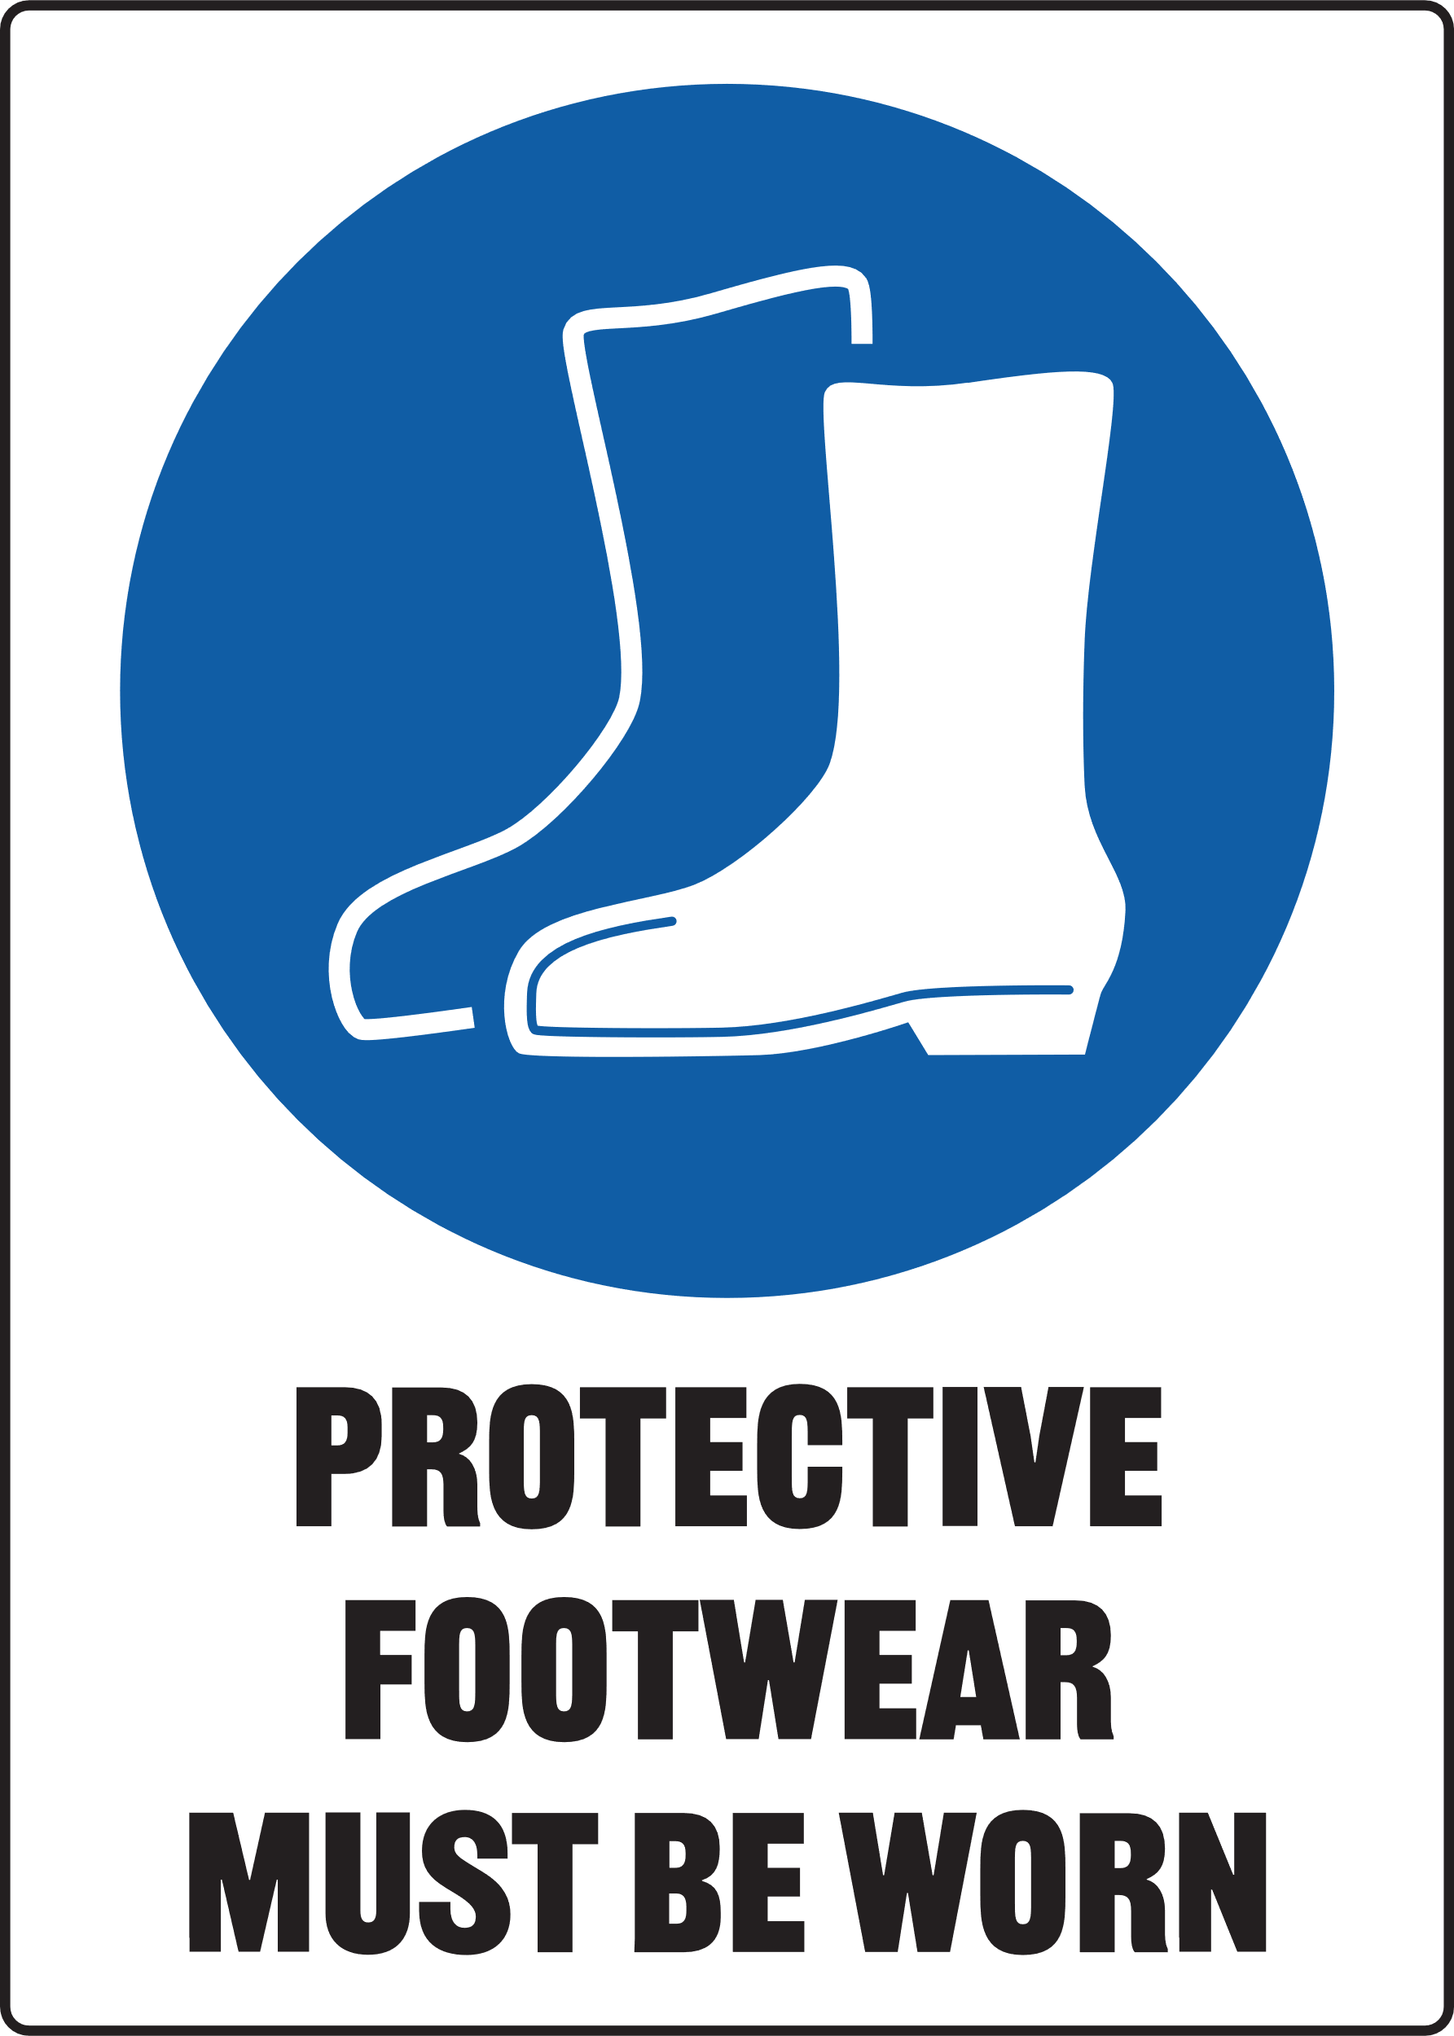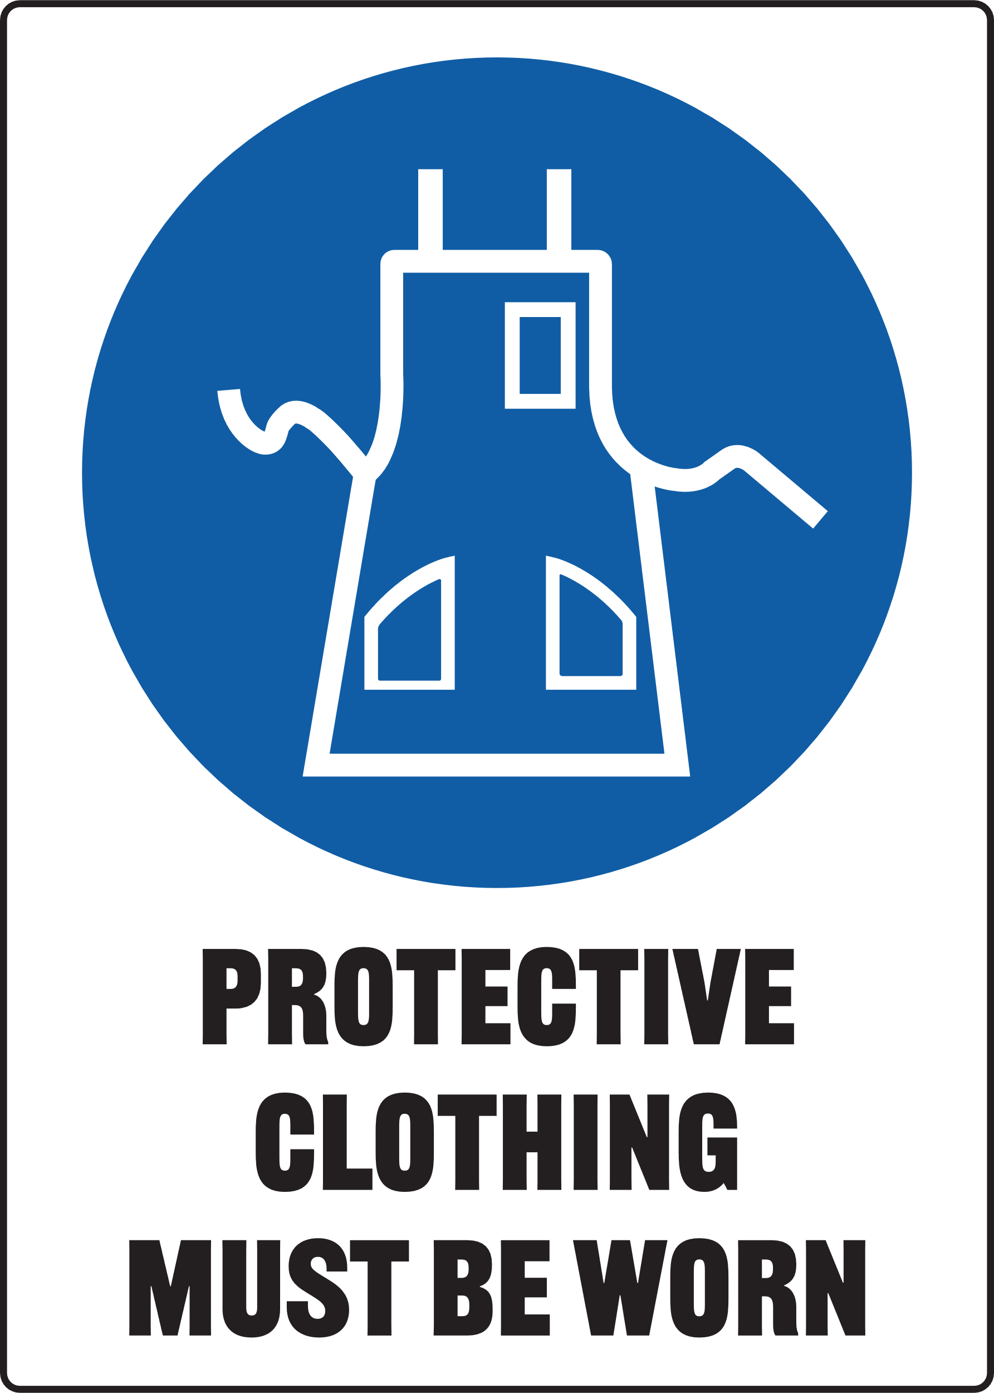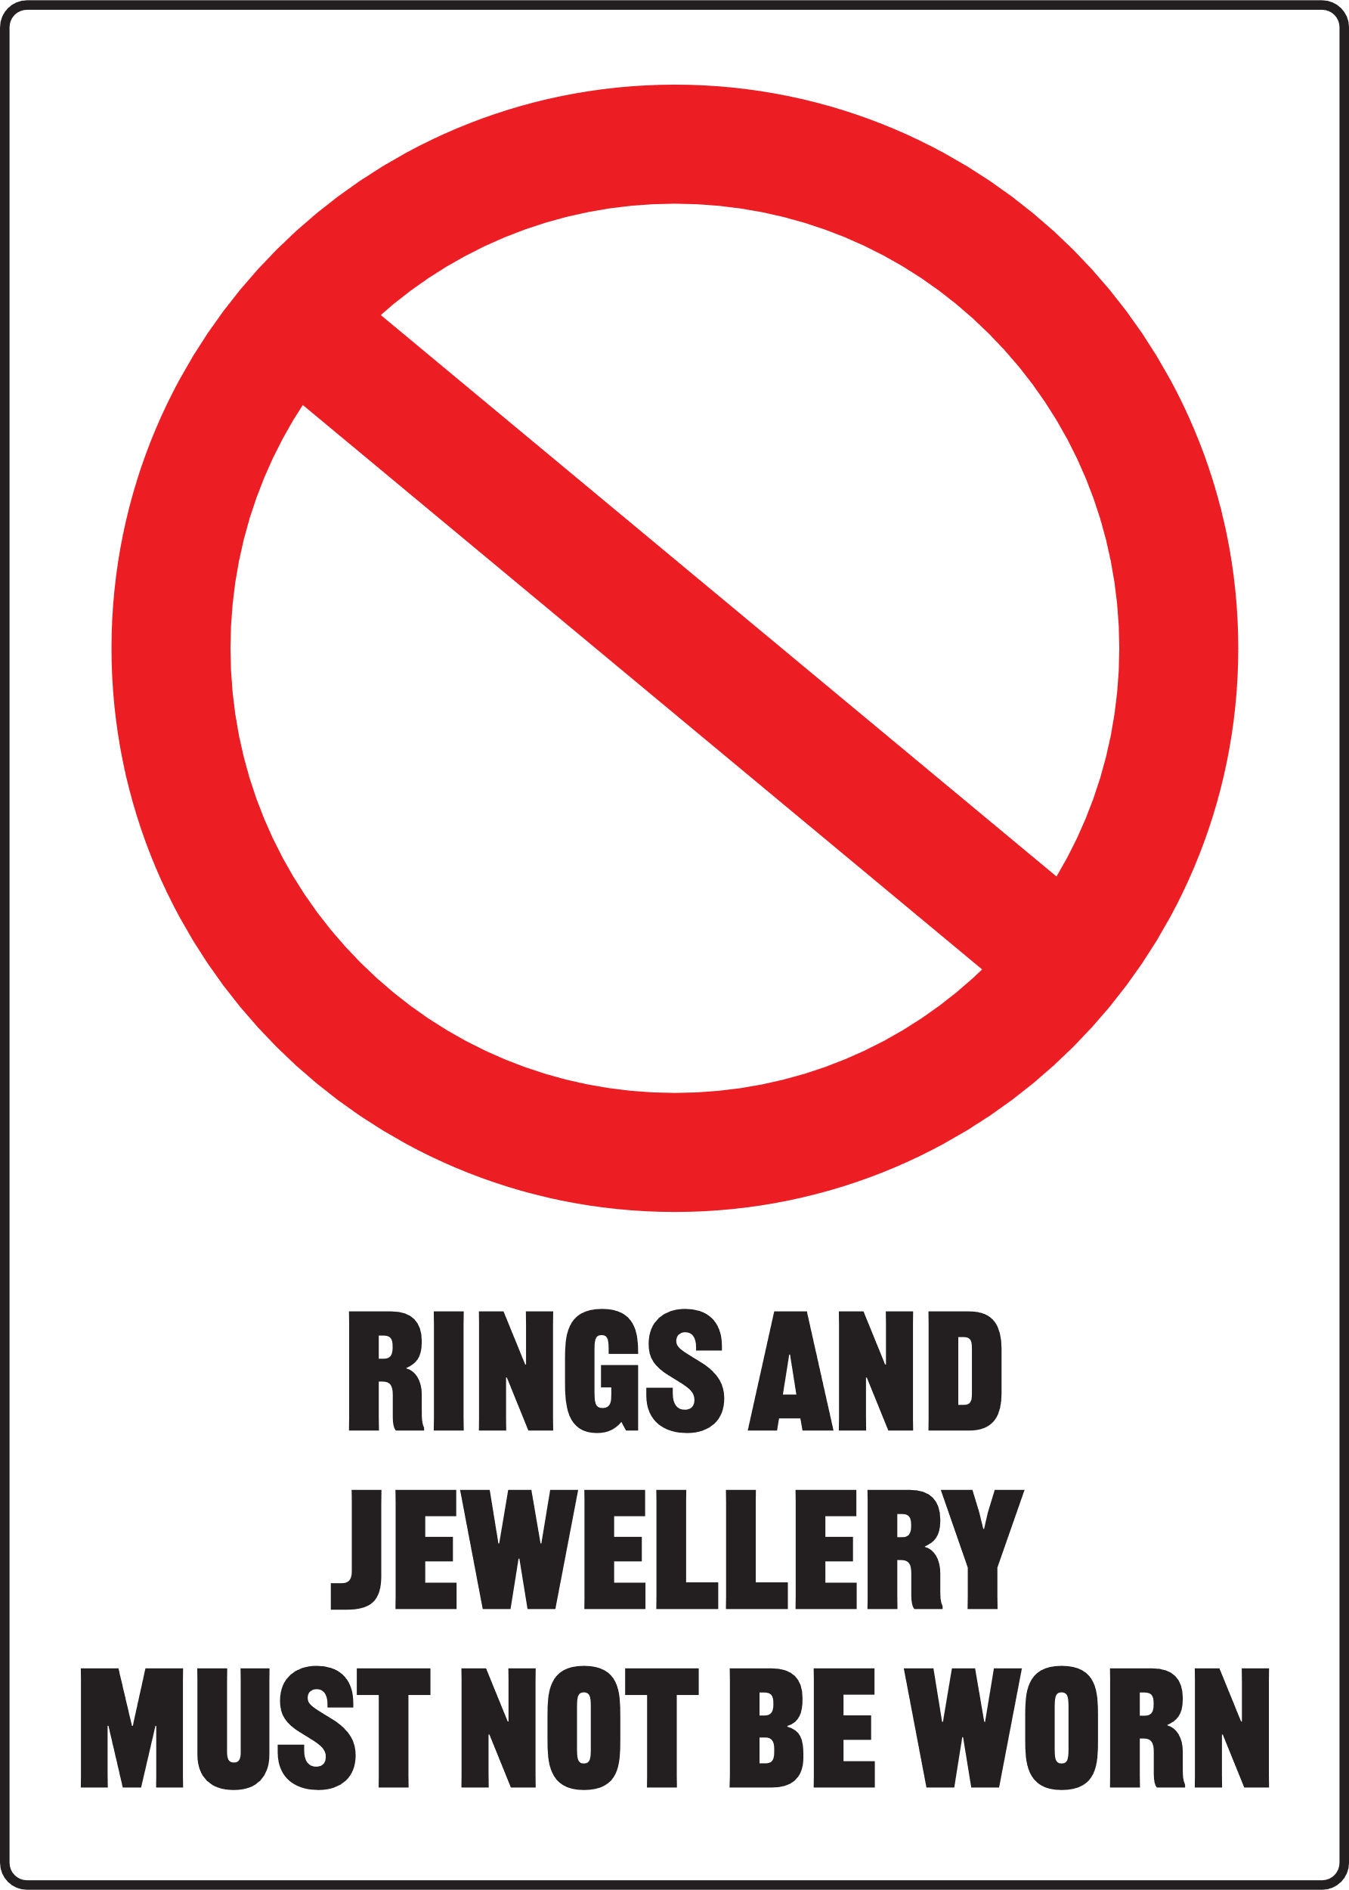

Make sure all safety guards are in place before using the Thicknesser

Pre-Operational Safety Checks
- Check workspaces and walkways to ensure that no slip/trip hazards are present
- Check material to be planed for defects, splits, dead knots, or nails
- Ensure in-feed table is clear of debris and free from gum or resin residue
- Locate and ensure you are familiar with the operation of the ON/OFF starter and Emergency stop
- Do not exceed maximum 2mm depth of cut
- Ensure all locks are securely tightened before operating the machine
- Start the dust extraction unit before using the machine
- Faulty equipment must not be used. Immediately report suspect machinery

Operational Safety Checks
- Never leave the machine running unattended
- Timber less than 300 mm in length must not be planed on this machine
- Feed timber to machine with the grain
- Feed only one piece of timber at a time
- Never look through machine feed opening when cutter block is revolving
- Never plane any timber with embedded nails, etc
- Stand to one side of material being fed through machine in case of kickback
- Before making adjustments or before clearing the in-feed or out-feed tables switch off and bring the machine to a complete standstill

Housekeeping
- Switch off the machine
- Leave machine and floor in a safe, clean and tidy state

Potential Hazards
- Exposure to moving and rotating components - timber may be flung back violently
- Eye injury Δ Pinch and squash Δ Flying chips and debris Δ Excessive noise

