WALK-BEHIND MOWER

DO NOT use this machine unless a teacher has instructed
you in its safe use and operation and has given permission.

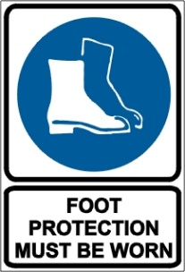

PRE-OPERATIONAL SAFETY CHECKS
- Wear proper clothing and personal protective equipment (PPE).
- Ensure mower is clean. Dirt, oil and debris contribute to fires.
- Ensure all guards are fitted, secure and functional.
- Ensure cutting blades are sharp, secure and in good condition. Damaged blades can cause a dangerous imbalance.
- Repair or replace any loose, broken, missing or damaged parts.
- Faulty equipment must not be used. Report suspect machinery immediately.

OPERATIONAL SAFETY CHECKS
- Clear the area to be mowed of debris that may be thrown.
- Be aware of the potential for ejected material and ensure that no person or animal is endangered when operating the mower.
- Avoid mowing in wet conditions due to lack of traction.
- Maintain a proper balance and secure footing when starting the mower.
- Keep clear of moving machine parts.
- Operate at a speed slow enough to keep control over unexpected hazards.
- Mow in a forward direction.
- When mowing on a slope, mow across the slope – this keeps a better distance between the operator and the mower in case of a slip.
- Never leave the machine running unattended.
- Always shut off the mower, remove spark plug lead and allow it to come to a complete standstill before adjusting or clearing grass clogs.
- Allow the mower to cool before refuelling. Use only approved safety containers to store fuel.
- Turn off fuel supply when mowing has concluded.

HOUSEKEEPING
- Clean away any oil and debris from in and around engine and catcher parts.
- Keep the work area or implement shed in a clean and tidy condition.

POTENTIAL HAZARDS
Rapidly rotating cutting blades Noise Ejected material and flying debris

This SOP should be used in conjunction with Curriculum Activity Risk Management Modules
Acknowledgement: Much of the information for this document has been sourced from content kindly provided by Department for Education SA website.
Date of last review | ______/______/______ | Signature ______________________

