WALK-BEHIND ROTARY CULTIVATOR

DO NOT use this machine unless a teacher has instructed
you in its safe use and operation and has given permission.

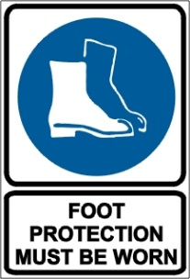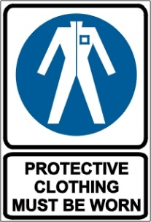

PRE-OPERATIONAL SAFETY CHECKS
- Read the owner’s manual and safety instructions before operating.
- Know the location and function of all controls.
- Ensure all guards are fitted, secure and functional.
- Check unit for loose/missing nuts, bolts and screws. Tighten and/or replace as needed.
- Look for signs of damage to tillage tines. Replace if required.
- Inspect fuel lines, tank, and area around carburetor for fuel leaks. Do not operate unit if leaks are found.
- Faulty equipment must not be used. Immediately report suspect machinery.

OPERATIONAL SAFETY CHECKS
- Watch especially for ejected material and ensure that no person or animal is endangered when operating.
- Adjust the handles to a position for comfort and good balance.
- Set the tine depth according to soil conditions. See operator’s manual.
- Ensure the cultivator is securely held and is on firm and even ground before starting.
- Keep clear of rotating machine parts whilst the engine is operating.
- Maintain a straight wrist position Avoid using your wrist in a bent, extended or twisted position for extended periods.
- Be alert for rocks and other obstruction when operating the rotary hoe.
- Use extreme caution when reversing or pulling the machine towards the operator.
- Shut down immediately if the unit starts to shake or vibrate. Do not operate the cultivator until the problem is corrected.
- Always stop the engine and disconnect spark plug wire before cleaning the tines or undertaking maintenance.
- Exercise extreme care when refuelling to avoid spilling fuel onto hot motor or exhaust.

HOUSEKEEPING
- Clean away any foreign material, debris from in and around the motor, tines and guards.
- Keep the work area and implement shed in a clean and tidy condition.

POTENTIAL HAZARDS
Trip hazards Noise Foot injuries
Entanglement Flying debris

This SOP should be used in conjunction with Curriculum Activity Risk Management Modules
Acknowledgement: Much of the information for this document has been sourced from content kindly provided by Department for Education SA website.
Date of last review | ______/______/______ | Signature ______________________

