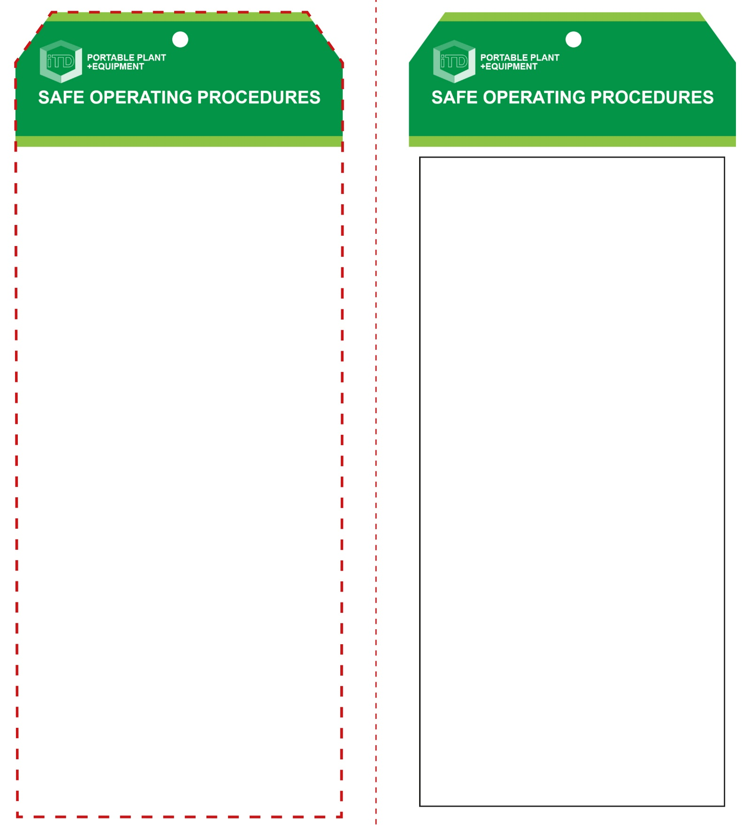

**Students must read this important information before using the equipment**

|  |  |
| --- | --- |
| Has your teacher given you instruction on the safe use and operation of this equipment? | |
|  | |
| Has your teacher given permission  for you to use this equipment? | |
|  | Approved safety glasses *must* be worn at all times in all ITD workspaces. |
|  | Appropriate protective footwear with substantial uppers *must* be worn in all ITD workspaces. |
| Hand Protection circle | Protective cotton gloves must be worn when using hot plastics. |
|  | Close fitting, protective clothing or a workshop apron is encouraged. |
|  | Long and loose hair must be contained or restrained. |
| Prohibition circle | Rings and jewellery must not be worn. |
| **PRE-OPERATIONAL SAFETY CHECKS**   1. Ensure no slip/trip hazards are present in workspaces and walkways. 2. Be aware of other people in the immediate vicinity. 3. Faulty equipment must not be used. Immediately report suspect machinery. | |

**OPERATIONAL SAFETY CHECK**

|  |
| --- |
| **Never operate a faulty electrical power tool. Report it to your teacher.** |
| 1. Keep clear of moving machine parts. 2. Familiarise yourself with and check all machine operations and controls. 3. Pre-heat the injection moulder to be sure the machine has reached the required temperature to run. 4. Never leave the machine turned on and hot when unattended. 5. Before making adjustments or cleaning material accumulations, switch off the machine. |
| **Never leave this machine unattended while switched on.** |
| **HOUSEKEEPING**   1. Switch off the machine when work has been completed. 2. Leave the work area in a safe, clean and tidy condition.   **POTENTIAL HAZARDS AND RISKS**  ■ Hot machinery parts and materials  ■ Crush points  ■ Hair/loose clothing entanglement  ■ Eye injuries |

**Injection Moulder**

**Injection Moulder**

**Front Reverse**

**Assembly instructions:**

1. Carefully fold this page in half vertically down the centre line
2. This should align ‘Front’ and ‘Reverse’ sides, then glue the halves back to back
3. Cut out the ‘Tag’ shape along the RED dotted outlines indicated on the ‘Front’ side
4. Laminate and trim to size with a clear 2 mm border
5. Securely fasten an 8mm (ID) brass eyelet and washer where indicated.