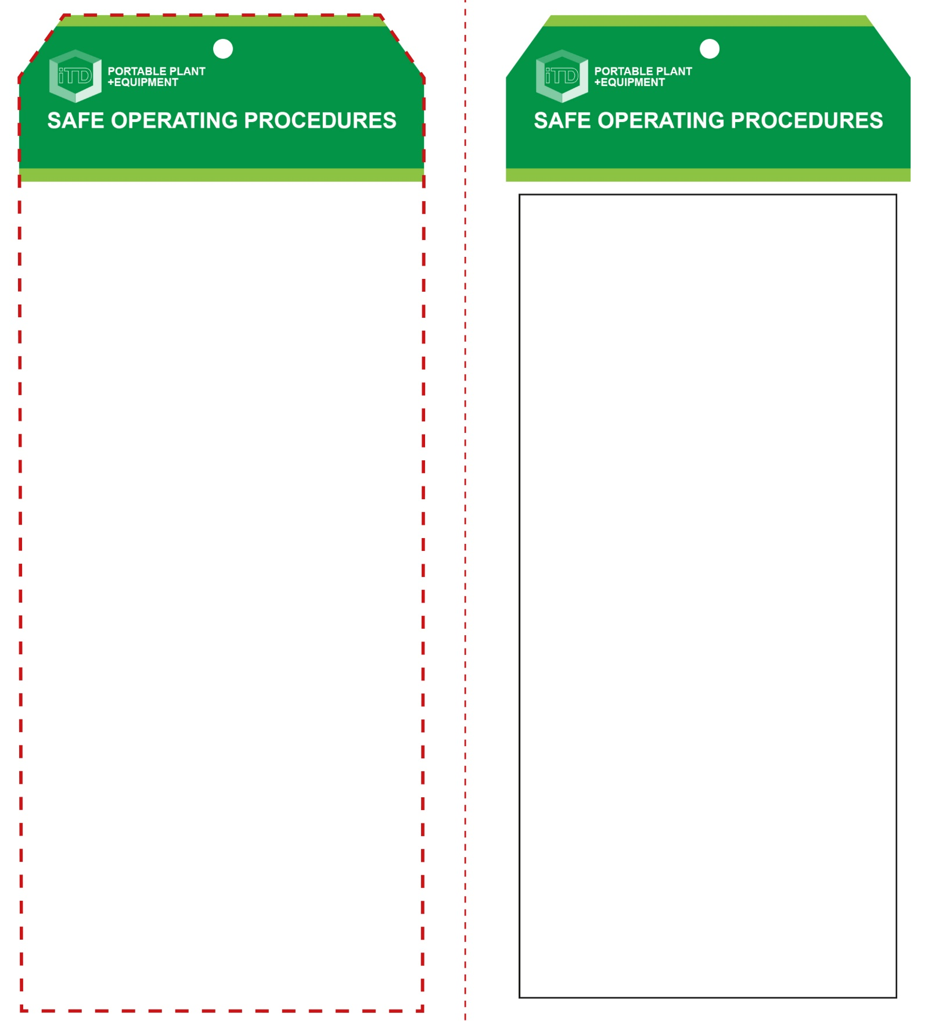

**Students must read this important information before using the equipment**

|  |  |
| --- | --- |
| Has your teacher given you instruction on the safe use and operation of this equipment? | |
|  | |
| Has your teacher given permission  for you to use this equipment? | |
|  | Approved safety glasses and face shield *must* be worn at all times in all ITD workspaces. |
|  | Appropriate protective footwear with substantial uppers *must* be worn in all ITD workspaces. |
|  | Hearing protection *(Class 5 – SLC80 >26 dB)* *must* be worn at all times when using this power tool. |
|  | A mask *should* be worn when excessive airborne dust or fumes are created. |
|  | Contain or restrain long and loose hair and remove exposed rings or jewellery. |
|  | Wear close fitting protective clothing, overalls, leather gloves, etc. |
| **PRE-OPERATIONAL SAFETY CHECKS**   1. Ensure you have a suitable, safe work area free of slip/trip hazards and flammable materials. 2. If charging a grinding disc, check for appropriateness and arbor hole size. 3. Inspect the grinding disc for chips and cracks. 4. Ensure all guards are in place and in good working order. 5. Check that the grinding disc guarding covers half of the rotating disc. 6. Familiarise yourself with the ON/OFF switch. | |

**OPERATIONAL SAFETY CHECK**

|  |
| --- |
| **Never operate a faulty electrical power tool. Report it to your teacher.** |
| 1. Fit the battery only after all grinding disc adjustments have been made. 2. Do not fit a grinding disc that has been dropped, damaged or become wet at any stage. 3. Ensure your work piece is secured and supported. 4. Keep fingers, hands and clothing clear of the disc. 5. Use the grinder only in a designated work area – preferably behind a portable screen. 6. Be aware of flying hot sparks. Hold the grinder so that any sparks fly away from you and anyone nearby, and away from all flammable materials. 7. Allow the grinder to reach operating speed, then apply load gradually. Maintain a constant pace to avoid uneven surfaces. 8. Maintain complete control. Always operate with both hands. Keep a proper and steady footing at all times. 9. Do not apply excessive force and avoid prolonged use. 10. Grinder will not operate if the battery charge is too low. 11. Violent kickback can occur, particularly when cutting. 12. Leather gloves must be worn when handling hot metal. 13. Turn off after use. Do not place the grinder down until the disc has stopped rotating. |
| **Serious injuries can be caused by kickback** |
| **HOUSEKEEPING**   1. After use, return the battery for recharging. 2. Leave the work area in a safe, clean and tidy condition.   **POTENTIAL HAZARDS AND RISKS**  ■ Rotating sharp parts ■ Electricity  ■ Hot sparks ■ Burns  ■ Eye injuries ■ Noise  ■ Dust and fumes  **POTENTIAL HAZARDS AND RISKS**  ■ Never grind where hot sparks can accidentally be directed towards people or flammable materials. |

**Angle Grinder (cordless)**

**Angle Grinder (cordless)**

**Front Reverse**

**Assembly instructions:**

1. Carefully fold this page in half vertically down the centre line
2. This should align ‘front’ and ‘reverse’ sides, then glue the halves back to back
3. Cut out the ‘tag’ shape along the RED dotted outlines indicated on the ‘front’ side
4. Laminate and trim to size with a clear 2mm border
5. Securely fasten an 8mm (ID) brass eyelet and washer where indicated.