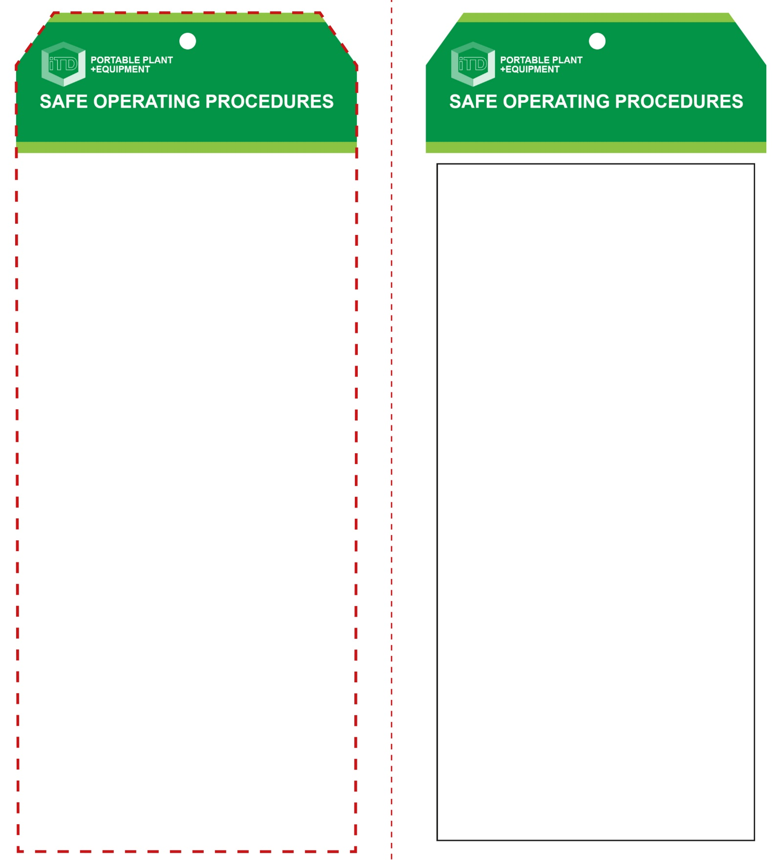

**Students must read this important information before using the equipment**

|  |  |
| --- | --- |
| Has your teacher given you instruction on the safe use and operation of this equipment? | |
|  | |
| Has your teacher given permission  for you to use this equipment? | |
|  | Approved safety glasses *must* be worn at all times in all ITD workspaces. |
|  | Appropriate protective footwear with substantial uppers *must* be worn in all ITD workspaces. |
|  | Rings and jewellery *must not* be worn when using this portable power tool. |
| **PRE-OPERATIONAL SAFETY CHECKS**   1. Ensure this power tool has a suitable safe work area. 2. Dial to the correct cutting depth to suit the size of the biscuits to be used. 3. Ensure all safety guards are serviceable and in place. 4. Make all machine adjustments with the power lead disconnected from the AC isolating switch. 5. Ensure adequate dust ventilation or extraction. | |

**OPERATIONAL SAFETY CHECK**

|  |
| --- |
| **Never operate a faulty electrical power tool. Report it to your teacher.** |
| 1. Use a vice or clamp to securely hold the work piece and support any over-hanging portion. 2. Set the fence height and the correct biscuit ‘size’ adjustment knob to assure accurate positioning and correct depth for cutting (slotting). 3. Do not hold your work piece by hand, if at all possible. 4. Keep the sole plate pressed firmly on the work piece. 5. Do not apply excessive force – this could cause the cutter disc to burn the work piece. 6. Before cleaning away waste material and inspecting the results of the slotting process, always bring the machine to a complete stop and keep hands away from the disc. 7. If any unforeseen problems arise while machining, stop immediately, switch off and report it to your teacher. 8. Turn off immediately after use. Do not place the machine down until the disc has stopped rotating. |
| **Adjust fences and depth gauges accurately** |
| **HOUSEKEEPING**   1. Return this tool to the appropriate storage cupboard 2. Leave the work area in a safe, clean and tidy condition.   **POTENTIAL HAZARDS AND RISKS**  ■ Moving, rotating and sharp parts  ■ Electricity ■ Noise ■ Excessive dust ■ Eye injuries |

**Biscuit Jointer**

**Biscuit Jointer**

**Front Reverse**

**Assembly Instructions:**

1. Carefully fold this page in half vertically down the centre line
2. This should align “Front” & “Reverse” sides, then glue the halves back to back
3. Cut out the “Tag” shape along the RED dotted outlines indicated on the “Front” side
4. Laminate & trim to size with a clear 2 mm border
5. Securely fasten an 8mm (ID) brass eyelet and washer where indicated.

*Website link to this SOP document:* <http://education.qld.gov.au/health/safety/hazards/equip-resources.html>