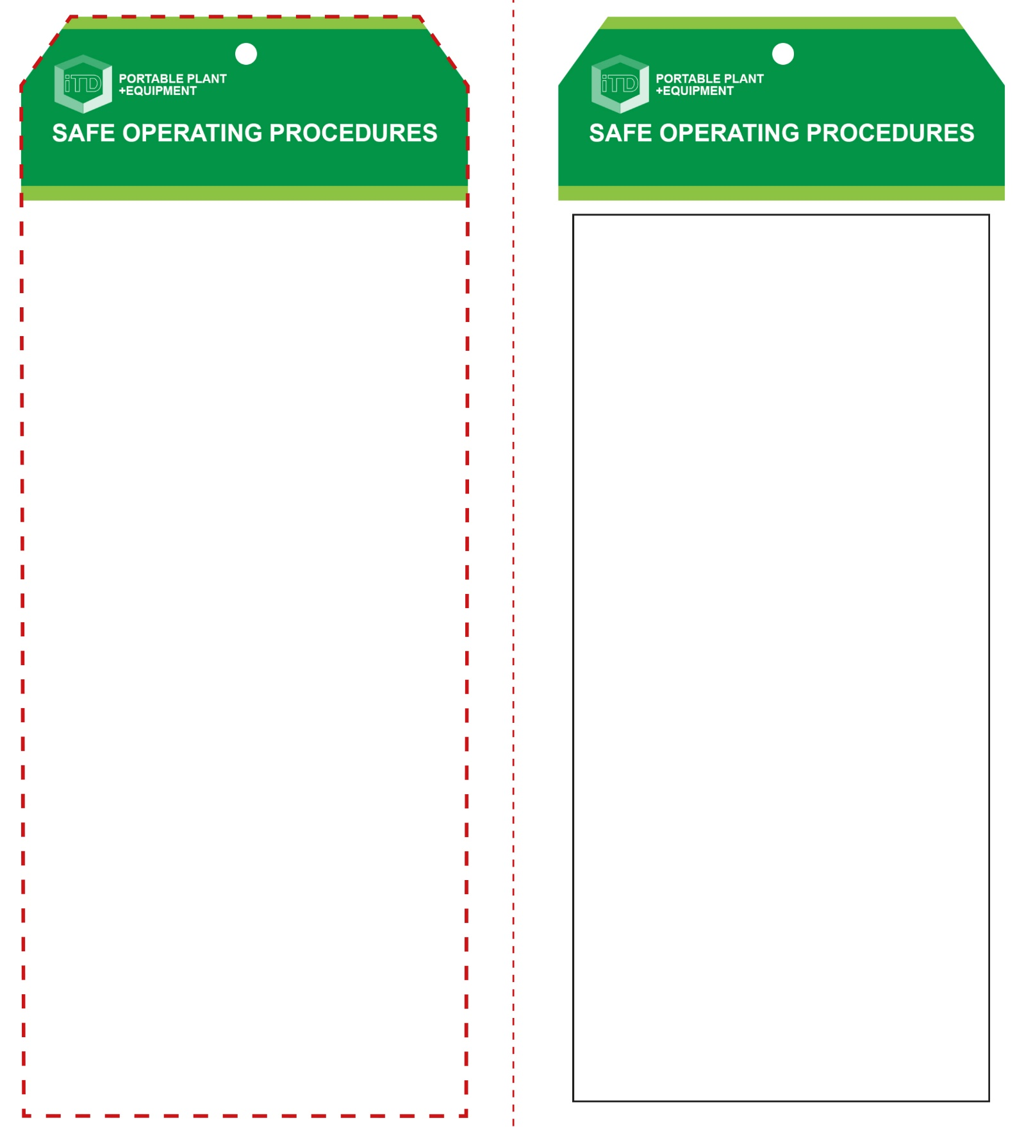

**Students must read this important information before using the equipment**

|  |  |
| --- | --- |
| Has your teacher given you instruction on the safe use and operation of this equipment? | |
|  | |
| Has your teacher given permission  for you to use this equipment? | |
|  | Approved safety glasses *must* be worn at all times in all ITD workspaces. |
|  | Appropriate protective footwear with substantial uppers *must* be worn in all ITD workspaces. |
|  | Wearing a suitable protective workshop apron is advised. |
| **PRE-OPERATIONAL SAFETY CHECKS**   1. Ensure this machinery has a suitable safe work area. 2. Ensure all safety guards are serviceable and in place. 3. Check the general condition of the blow forming table. 4. Ensure that all air connections are secure. 5. Ensure that all clamping arrangements are adequate, secure and correctly adjusted. 6. Use only low air pressures – 105-140 kPa. 7. Have your teacher check all adjustments i.e. heat settings and air pressures, before attempting to blow mould (or blow form) an article. 8. Ensure adequate dust and fume ventilation or extraction. | |

**OPERATIONAL SAFETY CHECK**

|  |
| --- |
| **Never operate a faulty electrical power tool. Report it to your teacher.** |
| 1. Take particular care when blow moulding very hot thermoplastic materials. High air pressures are also used in this forming process. 2. Familiarise yourself with all machine operations and controls. If in doubt, ask for assistance. 3. Pre-heat the blow moulder to be sure the machine has reached the required temperature. Always handle heated plastic material with suitable cotton gloves. 4. Moulds and forming jigs must be constructed sturdily enough to withstand high heat and pressure. 5. Before applying the air pressure to the heated plastic material, clamp the forming ring, restraining bars and plates securely to the table. 6. Ensure that the air pressure is reduced to zero before releasing the clamping arrangements. 7. Never apply excessive air pressure to a heated plastic article as it may rupture. 8. Never attempt to form plastic material that has not been pre-heated to the correct forming temperature. 9. Do not use the compressed air to cool down an article or to clean down the work area. |
| **Caution – high air pressure and heated plastics** |
| **HOUSEKEEPING**   1. Ensure all switches, guards and surfaces are cleaned. 2. Leave the work area in a safe, clean and tidy condition.   **POTENTIAL HAZARDS AND RISKS**  ■ Hot machine parts ■ Electricity  ■ Eye injuries ■ Dust ■ Pinch and squash ■ Compressed air |

**Blow Moulder**

**Blow Moulder**

**Front Reverse**

**Assembly Instructions:**

1. Carefully fold this page in half vertically down the centre line
2. This should align “Front” & “Reverse” sides, then glue the halves back to back
3. Cut out the “Tag” shape along the RED dotted outlines indicated on the “Front” side
4. Laminate & trim to size with a clear 2 mm border
5. Securely fasten an 8mm (ID) brass eyelet and washer where indicated.

*Website link to this SOP document:* <http://education.qld.gov.au/health/safety/hazards/equip-resources.html>