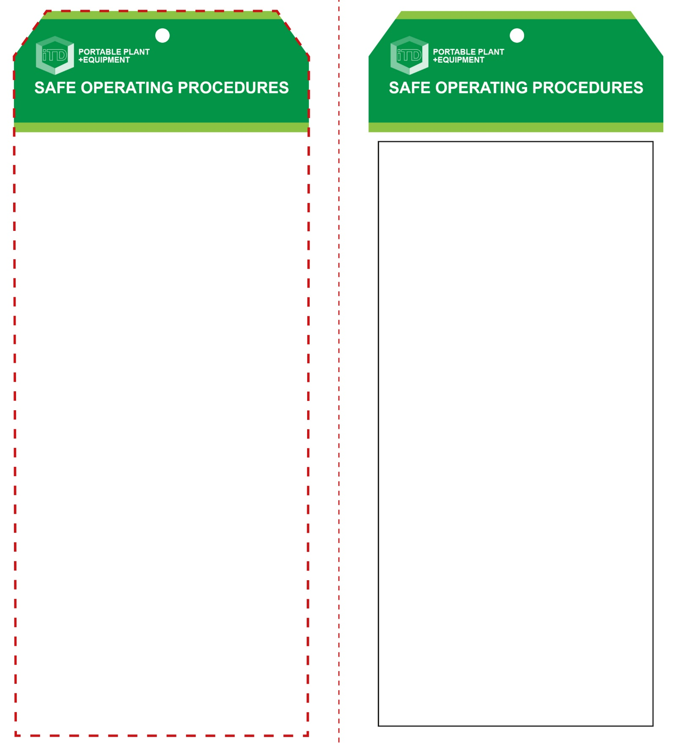

**Students must read this important information before using the equipment**

|  |  |
| --- | --- |
| Has your teacher given you instruction on the safe use and operation of this equipment? | |
|  | |
| Has your teacher given permission  for you to use this equipment? | |
|  | Approved safety glasses *must* be worn at all times in all ITD workspaces. |
|  | Appropriate protective footwear with substantial uppers *must* be worn in all ITD workspaces. |
|  | Rings and jewellery must not be worn when using this portable power tool. |
| **PRE-OPERATIONAL SAFETY CHECKS**   1. Ensure this power tool has a suitable safe work area. 2. Select the correct size drill bit to suit the dowel pins to be used. 3. Ensure all safety guards are serviceable and in place. 4. Make all machine adjustments with the power lead disconnected from the AC isolating switch. 5. Ensure adequate dust ventilation or extraction. | |

**OPERATIONAL SAFETY CHECK**

|  |
| --- |
| **Never operate a faulty electrical power tool. Report it to your teacher.** |
| 1. Use a vice or clamp to securely hold the work piece and support any overhanging portion. 2. Do not hold your work piece by hand. 3. Set fence heights and all stops to assure the correct, accurate position and depth for drilling. 4. Keep both hands on the dowelling machine while drilling. 5. Keep the sole plate pressed firmly on the work piece. 6. Do not apply excessive force – this could cause the drill bit to burn the work piece. 7. Before cleaning away waste material and inspecting the results of the drilling process, always bring the machine to a complete stop and keep hands away from the drill. 8. If any unforeseen problems arise while drilling, stop immediately, switch off and report it to your teacher. 9. Turn off immediately after use. Do not place the machine down until the drill has stopped rotating. |
| **Adjust fences and depth gauges accurately** |
| **HOUSEKEEPING**   1. Return this tool to the appropriate storage cupboard. 2. Leave the work area in a safe, clean and tidy condition.   **POTENTIAL HAZARDS AND RISKS**  ■ Moving, rotating and sharp parts  ■ Eye injuries ■ Electricity ■ Noise ■ Excessive dust |

**Dowelling Machine**

**Dowelling Machine**

**Front Reverse**

**Assembly instructions:**

1. Carefully fold this page in half vertically down the centre line
2. This should align ‘front’ and ‘reverse’ sides, then glue the halves back to back
3. Cut out the ‘tag’ shape along the RED dotted outlines indicated on the ‘front’ side
4. Laminate and trim to size with a clear 2mm border
5. Securely fasten an 8mm (ID) brass eyelet and washer where indicated.