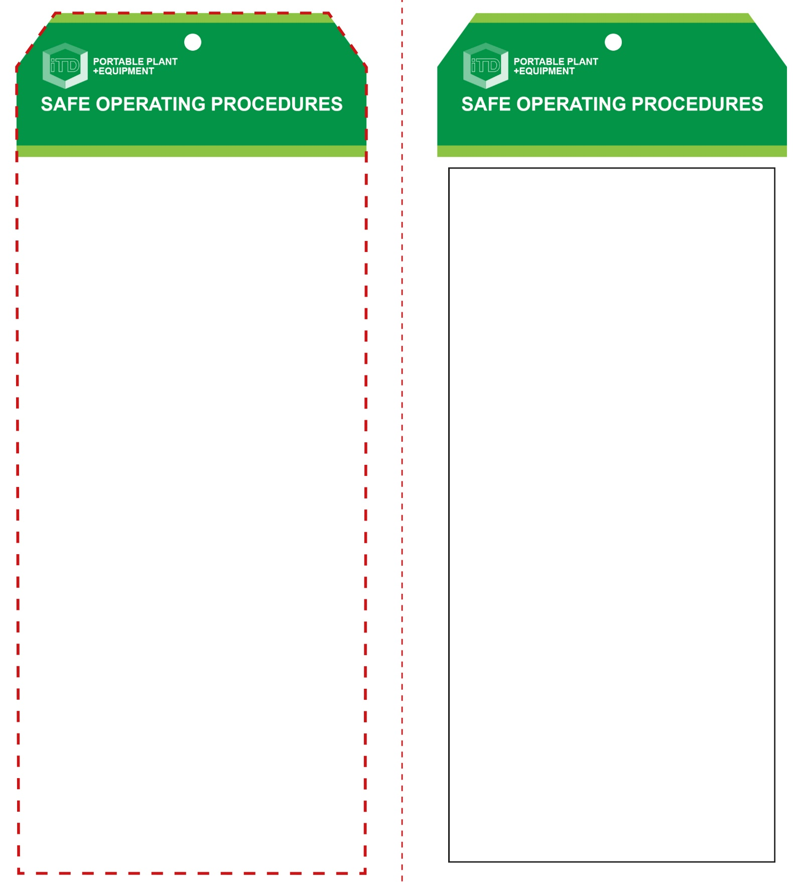

**Students must read this important information before using the equipment**

|  |  |
| --- | --- |
| Has your teacher given you instruction on the safe use and operation of this equipment? | |
|  | |
| Has your teacher given permission  for you to use this equipment? | |
|  | Approved safety glasses *must* be worn at all times in all ITD workspaces. |
|  | Appropriate protective footwear with substantial uppers *must* be worn in all ITD workspaces. |
|  | A mask *must* be worn when excessive airborne dust is created. |
|  | Hearing protection *must* be worn when noise levels are identified as excessive. |
|  | Protective clothing or a suitable workshop apron is encouraged. |
|  | Contain or restrain long and loose hair and remove exposed rings or jewellery. |
| **PRE-OPERATIONAL SAFETY CHECKS**   1. Ensure this power tool has a suitable safe work area. 2. Examine the power lead and plug for obvious damage. 3. Do not use dull or damaged drill bits. 4. Check the selected drill bit is correctly fitted. | |

**OPERATIONAL SAFETY CHECK**

|  |
| --- |
| **Never operate a faulty electrical power tool. Report it to your teacher.** |
| 1. Do not connect to power source until all adjustments have been made. 2. Check that the power lead does not create a trip hazard and that it is well clear of the workpiece. 3. Examine the material to be drilled for splits, loose knots and nails, etc. 4. Select the correct sized drill bit. Tighten securely in the chuck. 5. Ensure the workpiece is secure and well supported in a convenient position for drilling. 6. The power drill must be held firmly with both hands to control operational accuracy and the rotational torque. 7. Keep hands and fingers well clear of moving parts. Avoid blocking and covering the motor ventilation slots with your hands. 8. Allow the drill to reach operating speed, then apply load gradually. Do not apply excessive force. 9. Back the drill bit out to clear away all waste. 10. Avoid prolonged use as this could overheat the motor. Turn off after backing out the drill bit. Do not place the drill down until the bit has stopped rotating. |
| **Look before you drill – inspect for live wires** |
| **HOUSEKEEPING**   1. Remove the drill bit and return this tool to the appropriate storage cupboard. 2. Leave the work area in a safe, clean and tidy condition.   **POTENTIAL HAZARDS AND RISKS**  ■ Moving, rotating and sharp parts  ■ Eye injuries ■ Electricity ■ Noise ■ Excessive dust  ■ Burns (friction) |

**Hand Drill**

**Hand Drill**

**Front Reverse**

**Assembly Instructions:**

1. Carefully fold this page in half vertically down the centre line
2. This should align “Front” & “Reverse” sides, then glue the halves back to back
3. Cut out the “Tag” shape along the RED dotted outlines indicated on the “Front” side
4. Laminate & trim to size with a clear 2 mm border
5. Securely fasten an 8mm (ID) brass eyelet and washer where indicated.

*Website link to this SOP document:* <http://education.qld.gov.au/health/safety/hazards/equip-resources.html>