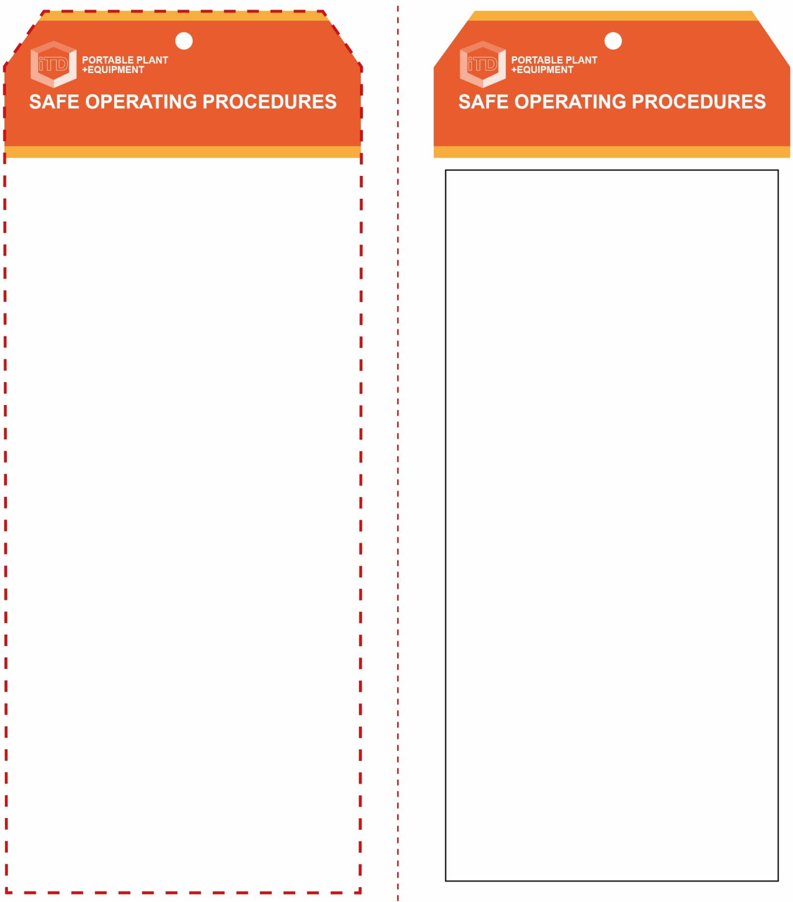

**OPERATIONAL SAFETY CHECK**

|  |
| --- |
| **Never operate a faulty electrical power tool. Report it to your teacher.** |
| 1. This hot air gun can be used for the following purposes:  * hot air welding (PVC), softening and moulding plastics * curing epoxy resins * heat shrink tubing * removing decals and stickers * to accelerate evaporation, etc.  1. Do not use a hot air gun when in the proximity of any flammable materials, gases or vapours. 2. Keep in mind the presence and direction of the heat produced. 3. Never direct, or point, the hot air flow (200-500°C) towards the body or towards other people. Hot air is invisible and can extend 40-50mm from the tip. 4. Never touch the hot metal nozzle with clothing or skin. 5. Avoid prolonged use. This could overheat the heating element causing it to fail or oxidise. 6. Never leave the hot air gun unattended when still switched ON or when switched OFF but still hot. 7. Turn off and wait until both the nozzle and heating element have completely cooled before storing the machine away correctly. |
| **Never touch the hot metal nozzle** |
| **HOUSEKEEPING**   1. Switch off, unplug and allow to cool down before storing. 2. Leave the work area in a safe, clean and tidy condition.   **POTENTIAL HAZARDS AND RISKS**  ■ Hot element, surfaces and air flow (200-500°C)  ■ Burns ■ Electricity ■ Eye injuries ■ Toxic fumes ■ Trip and slip ■ Fire |

**Students must read this important information before using the equipment**

|  |  |
| --- | --- |
| Has your teacher given you instruction on the safe use and operation of this equipment? | |
|  | |
| Has your teacher given permission  for you to use this equipment? | |
|  | Approved safety glasses *must* be worn at all times in addition to a welding helmet. |
|  | Appropriate protective footwear with substantial uppers *must* be worn in all ITD workspaces. |
|  | A suitable P2 or P3 filter mask *must* be worn whenever potentially toxic smoke and fumes are created. |
|  | A suitable protective workshop apron and leather gloves are advisable. |
| **PRE-OPERATIONAL SAFETY CHECKS**   1. Examine the power lead and machine for obvious damage. 2. Ensure that the cord does not create a slip/trip hazard. 3. Ensure the workspace is well ventilated. 4. Avoid overheating and burning of acrylics, painted and pigmented surfaces or toxic timbers such as Western Red Cedar. These fumes are VERY toxic. 5. Children often show curiosity towards a hot, burning type apparatus. Never leave the machine unattended when turned on or still hot. Leave unplugged when not in use. 6. Check for and remove all nearby flammable materials. | |

**Hot Air Welder**

**Hot Air Welder**

**Front Reverse**

**Assembly instructions:**

1. Carefully fold this page in half vertically down the centre line
2. This should align ‘front’ and ‘reverse’ sides, then glue the halves back to back
3. Cut out the ‘tag’ shape along the RED dotted outlines indicated on the ‘front’ side
4. Laminate and trim to size with a clear 2mm border
5. Securely fasten an 8mm (ID) brass eyelet and washer where indicated.