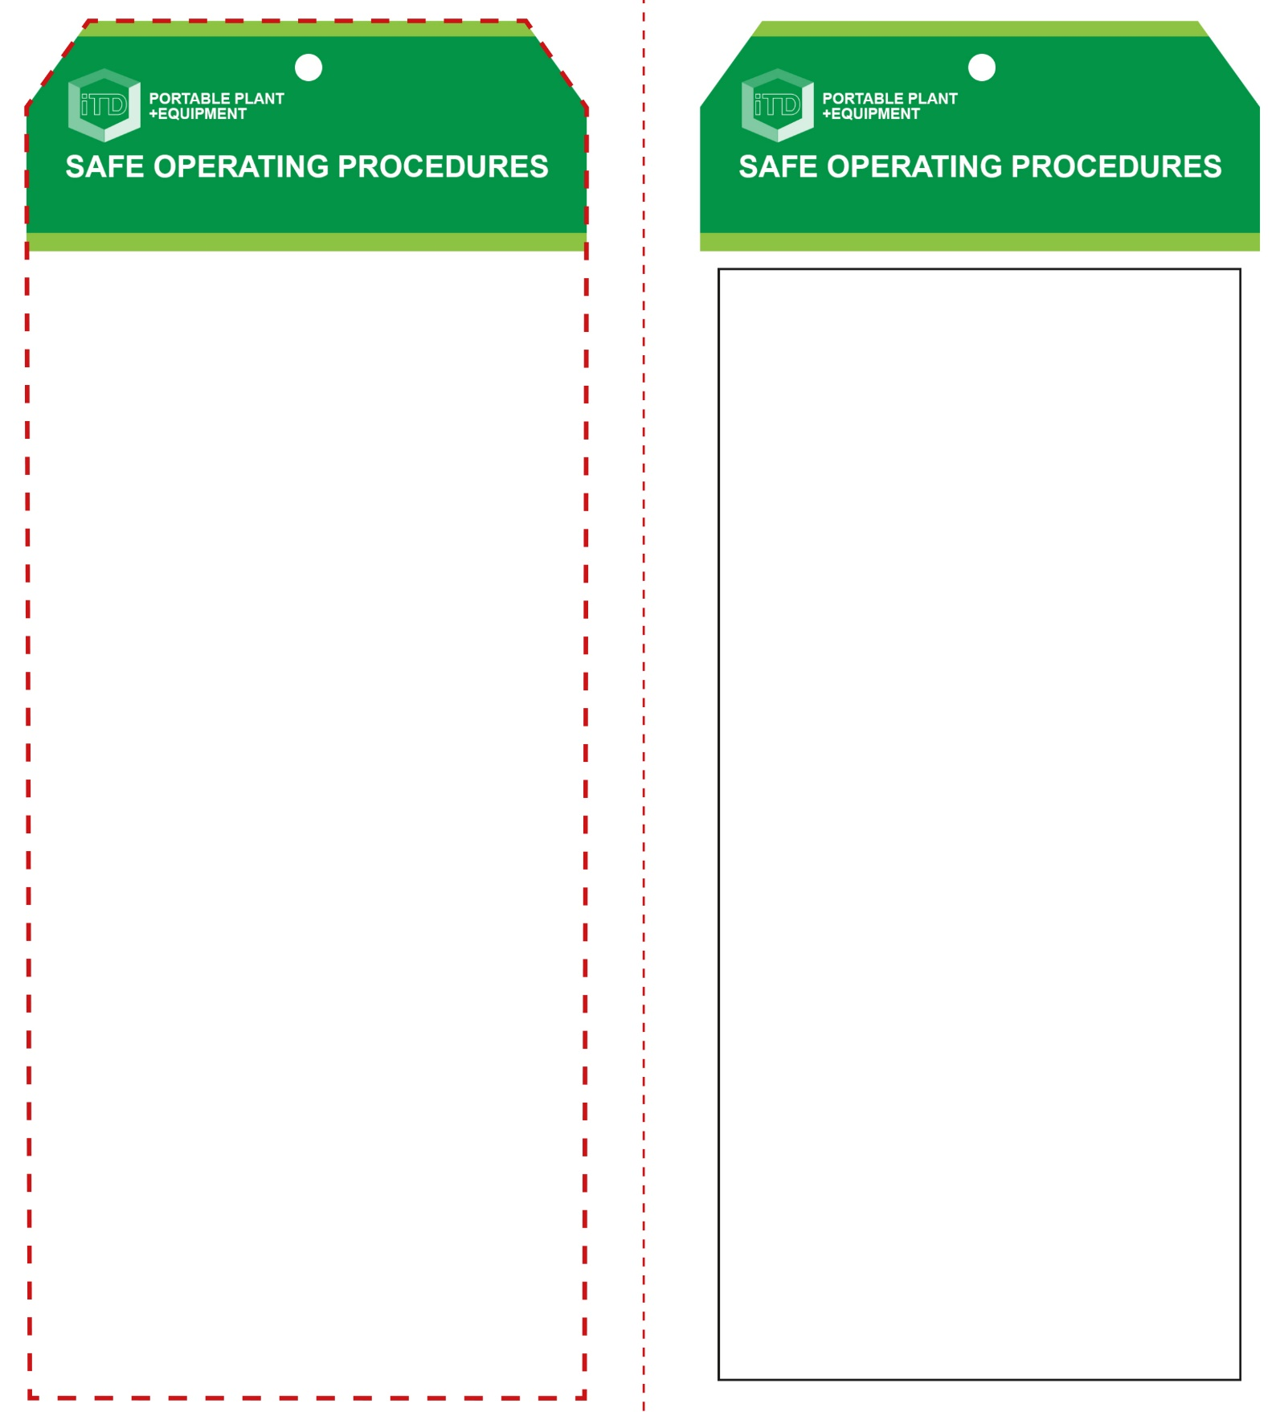

**Students must read this important information before using the equipment**

|  |  |
| --- | --- |
| Has your teacher given you instruction on the safe use and operation of this equipment? | |
|  | |
| Has your teacher given permission  for you to use this equipment? | |
|  | Approved safety glasses *must* be worn at all times in all ITD workspaces. |
|  | Appropriate protective footwear with substantial uppers *must* be worn in all ITD workspaces. |
|  | A suitable P2 or P3 filter mask *should* be worn whenever potentially toxic fumes are created. |
|  | Protective leather gloves *should* be worn when using this equipment. |
|  | A suitable workshop apron is advisable. |
| **PRE-OPERATIONAL SAFETY CHECKS**   1. Examine the power lead and tool for obvious damage. 2. Check there is a supply of suitable HMA glue sticks. 3. Ensure that the cord does not create a slip/trip hazard. 4. Ensure the workspace is well ventilated. 5. Children often show curiosity towards hot-melt glue guns. Never leave the tool unattended when turned on or still hot. Leave unplugged when not in use. | |

**OPERATIONAL SAFETY CHECK**

|  |
| --- |
| **Never operate a faulty electrical power tool. Report it to your teacher.** |
| 1. Turn on and pre-heat the melting element tip  5-10mins prior to using the glue gun. 2. Keep fingers clear of the extremely hot tip and molten glue. 3. Always wear safety glasses and leather gloves that are resistant to hot temperatures to protect against burns. 4. During use, keep the gun in a position where it will have no contact with objects that easily catch fire. It is best placed on a support stand with the nozzle facing down. 5. When placed on the support stand, place a material such as cardboard below the tip to help catch any molten glue that drips from the tip. The gun should never be placed on its side as the hot tip or molten HMA glue can cause a fire. 6. Avoid prolonged use. This could overheat the tip element causing it to fail. 7. If the element tip does not heat up efficiently, turn the glue gun off and report the fault to your teacher. 8. Never leave the glue gun tool unattended when still switched ON or when switched OFF but still HOT. 9. Turn off and wait until the tip element has completely cooled before storing the glue gun away correctly. |
| **CAUTION: HMA glues melt at 130°C - 220°C** |
| **HOUSEKEEPING**   1. Switch off, unplug and allow to cool down  before storing. 2. Leave the work area in a safe, clean and tidy condition.   **POTENTIAL HAZARDS AND RISKS**  ■ Hot surfaces and molten HMA glue ■ Electricity ■ Burns ■ Eye injuries ■ Toxic fumes ■ Fire |

**Hot Melt Glue Gun**

**Hot Melt Glue Gun**

**Front Reverse**

**Assembly instructions:**

1. Carefully fold this page in half vertically down the centre line
2. This should align ‘front’ and ‘reverse’ sides, then glue the halves back to back
3. Cut out the ‘tag’ shape along the RED dotted outlines indicated on the ‘front’ side
4. Laminate and trim to size with a clear 2mm border
5. Securely fasten an 8mm (ID) brass eyelet and washer where indicated.