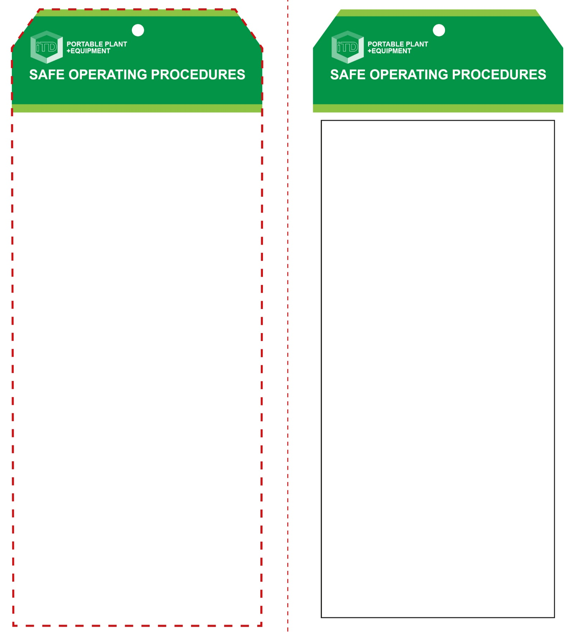

**Students must read this important information before using the equipment**

|  |  |
| --- | --- |
| Has your teacher given you instruction on the safe use and operation of this equipment? | |
|  | |
| Has your teacher given permission  for you to use this equipment? | |
|  | Approved safety glasses *must* be worn at all times in all ITD workspaces. |
|  | Appropriate protective footwear with substantial uppers *must* be worn in all ITD workspaces. |
|  | A suitable P2 or P3 filter mask *must* be worn whenever potentially toxic smoke and fumes are created. |
|  | Protective clothing or a suitable workshop apron is encouraged. |
| **PRE-OPERATIONAL SAFETY CHECKS**   1. Examine the power lead and machine for obvious damage. 2. Check condition of the burning tip. Replace if damaged. 3. Ensure that the cord does not create a slip/trip hazard. 4. Ensure the workspace is well ventilated. 5. Avoid burning on acrylics, painted and pigmented surfaces, or toxic timbers such as Western Red Cedar. 6. Never burn on MDF. These fumes are VERY toxic. 7. Children often show curiosity towards a hot, burning type apparatus. Never leave the machine unattended when turned on or still hot. Leave unplugged when not in use. | |

**OPERATIONAL SAFETY CHECK**

|  |
| --- |
| **Never operate a faulty electrical power tool. Report it to your teacher.** |
| 1. Do not plug in and turn on until the tip element has been checked, or replaced and tightened. 2. Keep fingers clear of the hot tip element. 3. Always wear safety glasses. Smoke and hot embers can occur. 4. Many species of exotic timbers create fumes that can be toxic when burnt – always wear a suitable dust mask (minimum standard P2 – for dusts, smoke and fumes). 5. Avoid prolonged use. This could overheat the tip element causing it to fail or oxidise. 6. Do not apply excess pressure to the tip. 7. For the ‘hot wire’ type machines, always maintain the correct shape to the tip element. Bent or distorted wire tips are often the cause of inefficient operation. 8. If the element tip does not heat up efficiently, turn the machine off, repair the fault or report it to your teacher. 9. Never leave the machine unattended when still switched ON or when switched OFF but still hot. 10. Turn off and wait until the tip element has completely cooled before storing the machine away correctly. |
| **Plastics and MDF smoke fumes can be toxic** |
| **HOUSEKEEPING**   1. Switch off, unplug and allow to cool down before storing. 2. Leave the work area in a safe, clean and tidy condition.   **POTENTIAL HAZARDS AND RISKS**  ■ Hot element and surfaces ■ Burns  ■ Eye injuries ■ Electricity ■ Toxic fumes ■ Trip and slip |

**Hot Wire Poker (pyrograph)**

**Hot Wire Poker (pyrograph)**

**Front Reverse**

**Assembly instructions:**

1. Carefully fold this page in half vertically down the centre line.
2. This should align ‘front’ and ‘reverse’ sides, then glue the halves back to back.
3. Cut out the ‘tag’ shape along the RED dotted outlines indicated on the ‘front’ side.
4. Laminate and trim to size with a clear 2mm border.
5. Securely fasten an 8mm (ID) brass eyelet and washer where indicated.