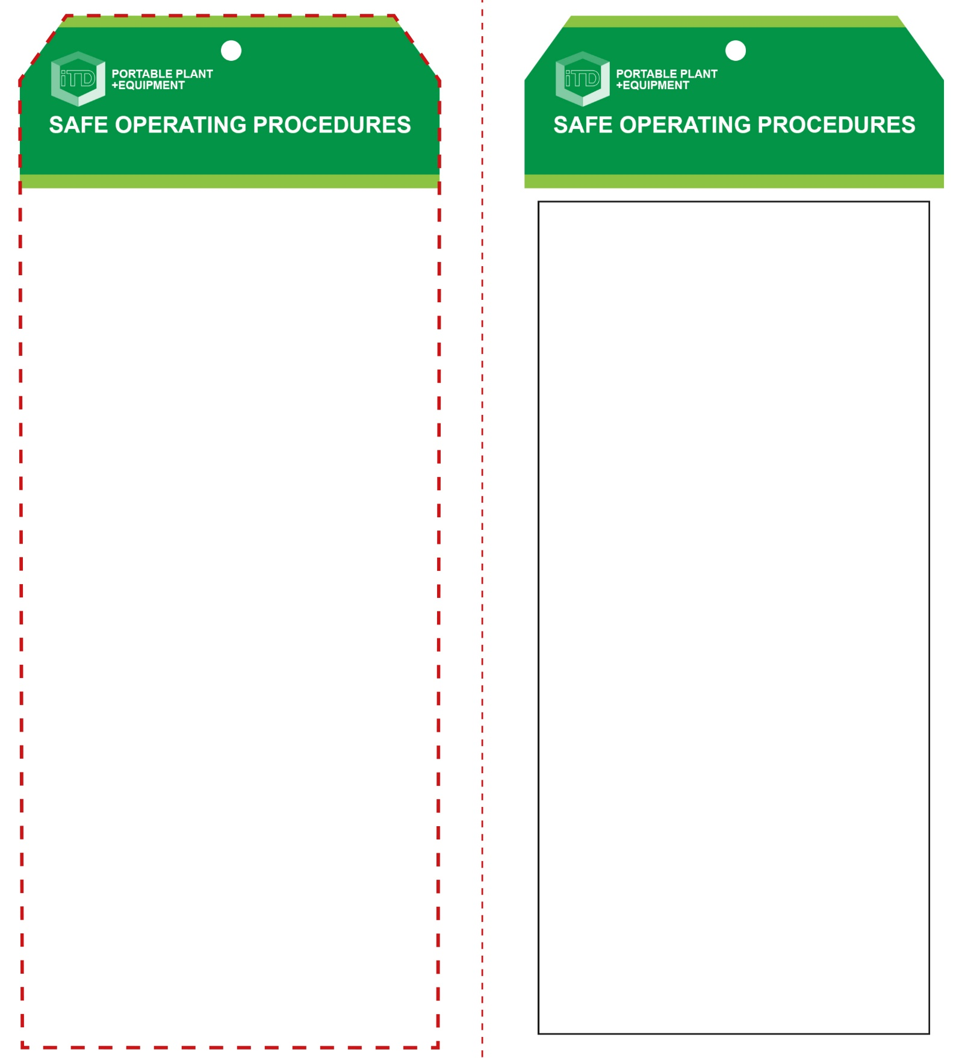

**Students must read this important information before using the equipment**

|  |  |
| --- | --- |
| Has your teacher given you instruction on the safe use and operation of this equipment? | |
|  | |
| Has your teacher given permission  for you to use this equipment? | |
|  | Approved safety glasses *must* be worn at all times in all ITD workspaces. |
|  | Appropriate protective footwear with substantial uppers *must* be worn in all ITD workspaces. |
|  | Hearing protection *must* be worn at all times when using this power tool. |
|  | Contain or restrain long and loose hair when necessary. |
|  | Wear close fitting protective clothing, overalls or a suitable workshop apron. |
|  | Rings and jewellery *must not* be worn when using this portable power tool. |
| **PRE-OPERATIONAL SAFETY CHECKS**   1. Ensure you have a suitable safe work area. 2. Check the router and bit for obvious signs of damage. 3. Examine the battery and charger for obvious damage. 4. Plan a routing procedure and the direction of travel. | |

**OPERATIONAL SAFETY CHECK**

|  |
| --- |
| **Never operate a faulty electrical power tool. Report it to your teacher.** |
| 1. Check the workpiece for faults and defects. 2. Fit the correct router bit (size and profile) and ensure it conforms to recommended specifications. 3. Make all adjustments for depth of cut before connecting to the battery. 4. Ensure your workpiece is firmly secured and supported. 5. Always consider the direction of rotation. This will determine the direction the router is to travel. 6. Allow the router to reach operating speed, then apply load gradually. Maintain a constant pace to avoid uneven finishes. 7. The router will not operate if the battery is too low. 8. Keep the sole plate pressed firmly on the workpiece. 9. Do not apply excessive force – this could cause the cutter bit to burn the workpiece. 10. If any unforeseen problems arise while routing, stop immediately, switch off and report it to your teacher. 11. Turn off immediately after use. Do not place the router down until the cutter has stopped rotating. |
| **Be extremely cautious of this high speed tool** |
| **HOUSEKEEPING**   1. After use, return the battery for recharging. 2. Leave the work area in a safe, clean and tidy condition.   **POTENTIAL HAZARDS AND RISKS**  ■ Rotating, sharp parts ■ Electricity  ■ Kickback ■ Ejected material  ■ Eye injuries ■ Dust  ■ Noise |

**Palm Router (cordless)**

**Palm Router (cordless)**

**Front Reverse**

**Assembly instructions:**

1. Carefully fold this page in half vertically down the centre line
2. This should align ‘front’ and ‘reverse’ sides, then glue the halves back to back
3. Cut out the ‘tag’ shape along the RED dotted outlines indicated on the ‘front’ side
4. Laminate and trim to size with a clear 2mm border
5. Securely fasten an 8mm (ID) brass eyelet and washer where indicated.