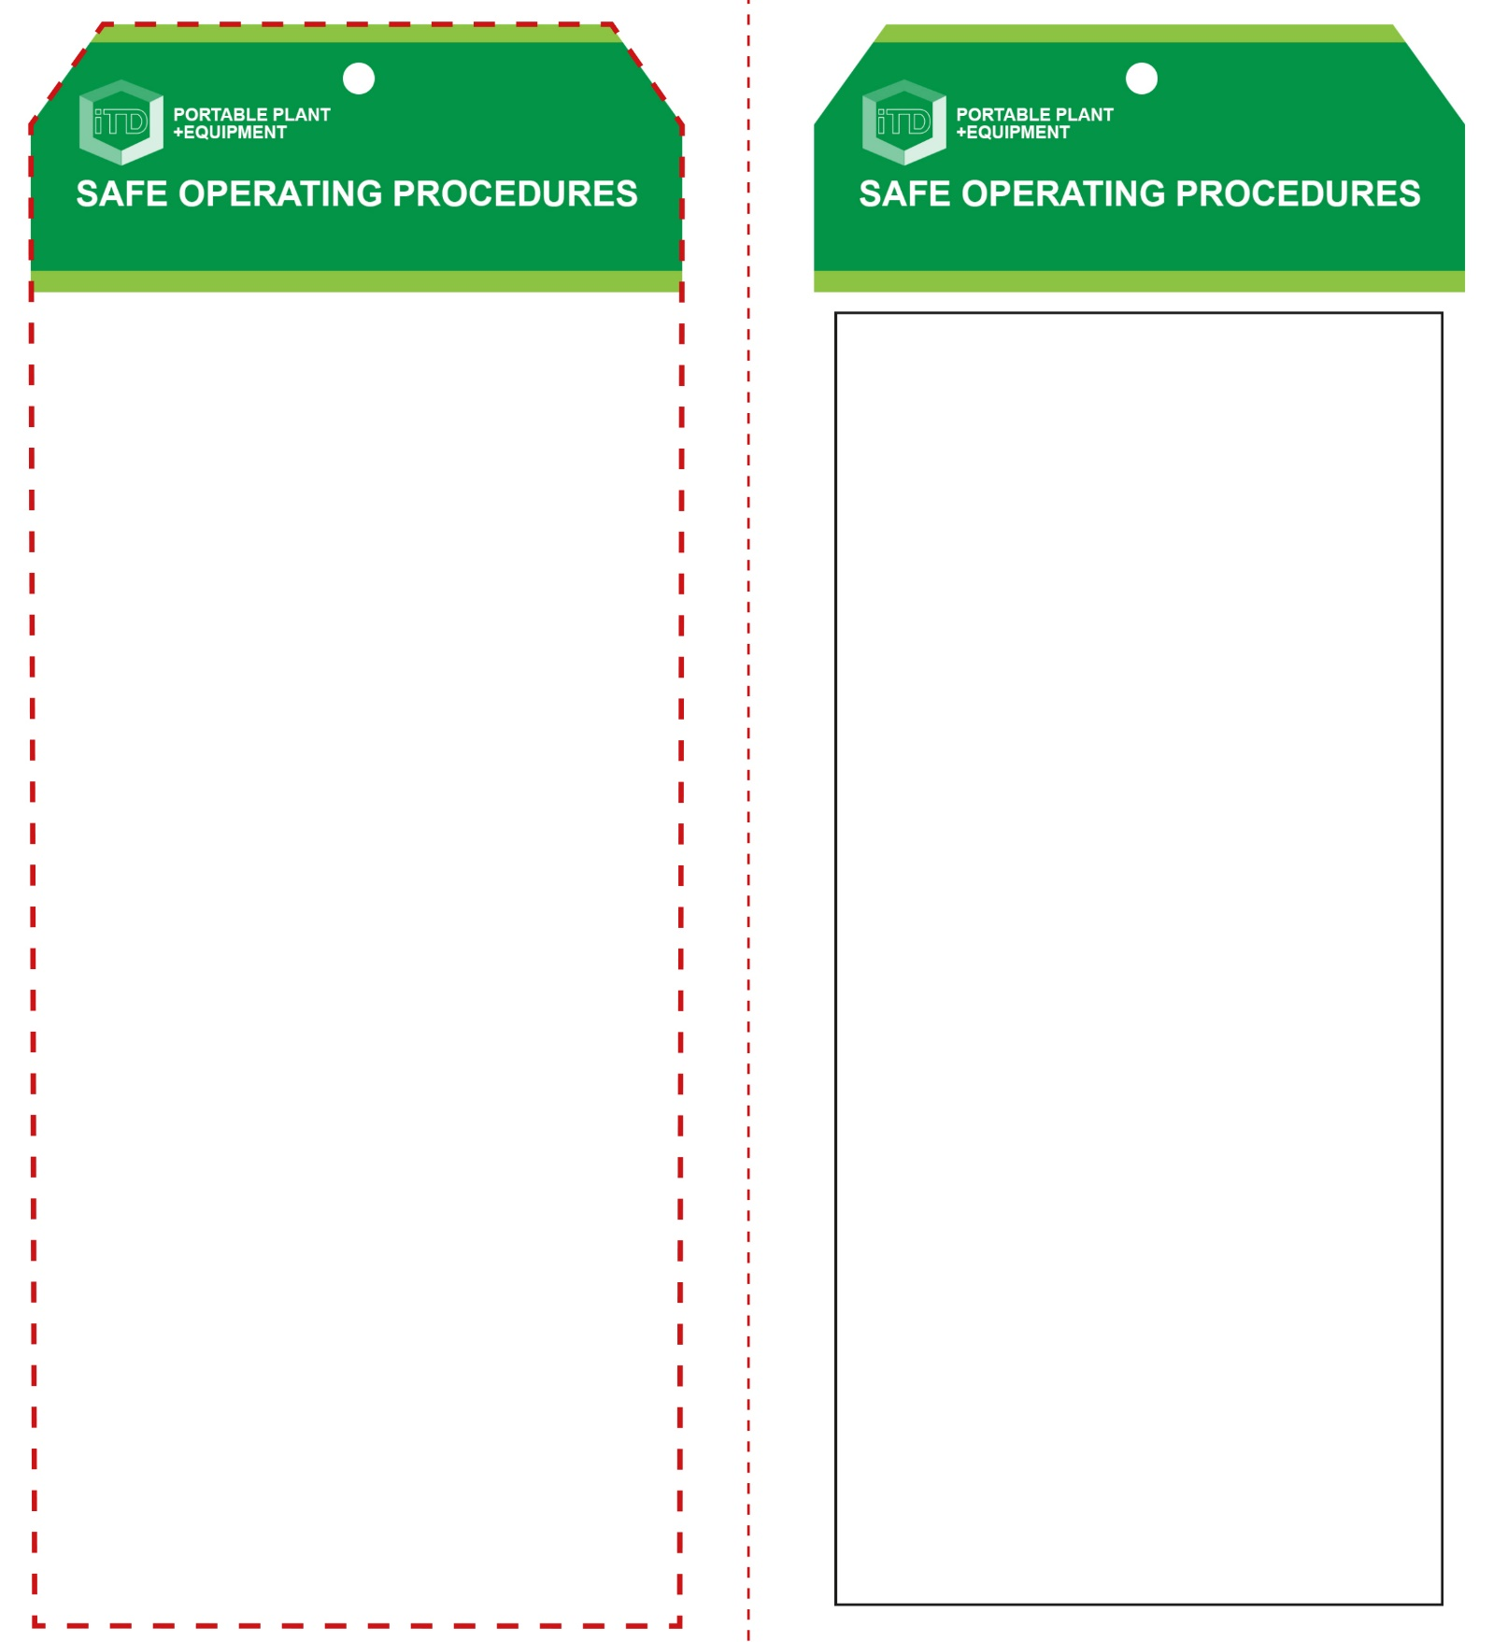

**Students must read this important information before using the equipment**

|  |  |
| --- | --- |
| Has your teacher given you instruction on the safe use and operation of this equipment? | |
|  | |
| Has your teacher given permission  for you to use this equipment? | |
|  | Approved safety glasses *must* be worn at all times in all ITD workspaces. |
|  | Appropriate protective footwear with substantial uppers *must* be worn in all ITD workspaces. |
|  | Hearing protection *should* be worn when noise levels are excessive. |
|  | Protective leather welding gloves *must* be worn when using this equipment. |
|  | Contain or restrain long and loose hair and remove exposed rings or jewellery. |
|  | Wear close fitting protective clothing, overalls or a suitable workshop apron. |
| **PRE-OPERATIONAL SAFETY CHECKS**   1. Ensure this power tool has a suitable safe work area. 2. Ensure the blade is intact and suits the material to be cut. 3. Ensure all required blade guarding is in place. 4. Examine the power lead and plug for obvious damage. | |

**OPERATIONAL SAFETY CHECK**

|  |
| --- |
| **Never operate a faulty electrical power tool. Report it to your teacher.** |
| 1. Check that the reciprocating cutting blade runs ‘true’. Listen for noisy or worn gearing problems. 2. Ensure the sheet metal is secure and supported. 3. Do not plug in until all adjustments have been made. 4. Ensure the power cord is well clear of the cutter blade. 5. Check the underside of the cut to ensure that the blade will not cause any damage or be obstructed. 6. Allow the nibbler to reach full speed before cutting. 7. Always cut at a moderate rate. Do not apply excessive force to the sheet material being cut. 8. Keep hands well away from the cutting operation. Off-cut material will usually be very sharp. Always wear leather gloves to protect your hands. 9. Take particular care when handling any sheet metal. 10. Take care when cutting tighter curves or corrugated metals to ensure that the blade does not bind. 11. If the blade binds, release the switch immediately – free the cutter blade and inspect for any damage. 12. On completion, wait for the reciprocating cutter blade to stop moving before resting the nibbler on its side. |
| **Ensure the blade runs ‘true’ and doesn’t wobble** |
| **HOUSEKEEPING**   1. Return this tool to the appropriate storage cupboard. 2. Leave the work area in a safe, clean and tidy condition.   **POTENTIAL HAZARDS AND RISKS**  ■ Moving, rotating and sharp parts  ■ Eye injuries ■ Electricity ■ Dust ■ Ejected waste  ■ Burns |

**Metal Nibbler**

**Metal Nibbler**

**Front Reverse**

**Assembly instructions:**

1. Carefully fold this page in half vertically down the centre line
2. This should align ‘front’ and ‘reverse’ sides, then glue the halves back to back
3. Cut out the ‘tag’ shape along the RED dotted outlines indicated on the ‘front’ side
4. Laminate and trim to size with a clear 2mm border
5. Securely fasten an 8mm (ID) brass eyelet and washer where indicated.