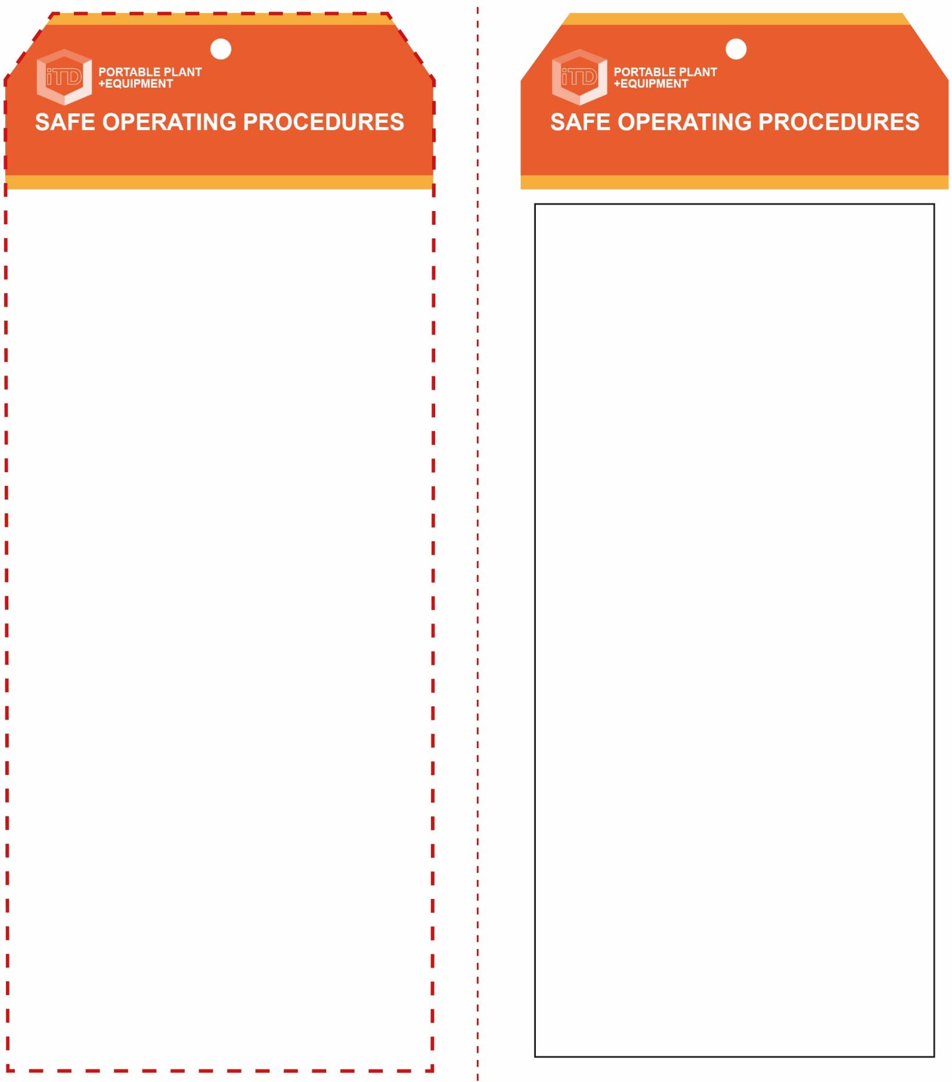

**OPERATIONAL SAFETY CHECK**

|  |
| --- |
| **Never operate a faulty electrical power tool. Report it to your teacher.** |
| 1. Ensure the MMAW machine is correctly set up. 2. Keep the welding leads coiled and as short as possible to minimise inductance. 3. Ensure the welding current is correctly set according to the project size and the electrode selection. 4. Ensure the welding return cable (earth) makes firm contact to provide a good electrical strike contact. 5. Ensure the workpiece has been prepared to be free of any paint, oxides or other surface finishes ensuring a good electrical strike contact. 6. Ensure that other workers in this locality are protected from any UV and IR radiation flash. Always close the UV curtain to the welding bay or erect a UV screen. 7. Never leave the welder running unattended. 8. When welding is finished or interrupted, remove any remaining electrode stub from the holder, turn off at the power source and secure the handpiece safely. |
| **Work area must be dry to avoid electric shock** |
| **HOUSEKEEPING**   1. Ensure the welder and fume extraction are switched off. 2. Hang up the electrode holder and all welding leads. 3. Leave the work area and welding bench in a safe, clean and tidy condition.   **POTENTIAL HAZARDS AND RISKS**  ■ Electricity and electric shock  ■ Burns due to hot, molten materials  ■ UV radiation to skin and eyes  ■ Cuts and lacerations  ■ Flying sparks  ■ Toxic fumes  ■ Fire and explosion |

**Students must read this important information before using the equipment**

|  |  |
| --- | --- |
| Has your teacher given you instruction on the safe use and operation of this equipment? | |
|  | |
| Has your teacher given permission  for you to use this equipment? | |
|  | |
|  | Approved safety glasses *must* be worn at all times in addition to a welding helmet. |
|  | Appropriate protective footwear with substantial uppers *must* be worn in all ITD workspaces. |
|  | Protective welding helmet with the correct grade UV lens *must* be worn. |
|  | Protective leather gloves *must* be worn when using this equipment. |
|  | Close fitting protective clothing or overalls, a leather apron and spats *must* be worn. |
|  | Rings and jewellery *must not* be worn when using any welding equipment. |
| **PRE-OPERATIONAL SAFETY CHECKS**   1. Ensure the MMA welder has a suitable safe work area. 2. Keep the area clean and free of grease, oils and flammables. 3. Ensure electrode holder and welding leads are inspected. 4. Ensure the area is well ventilated with fume extraction. | |

**MMA Welder**

**MMA Welder**

**Front Reverse**

**Assembly Instructions:**

1. Carefully fold this page in half vertically down the centre line
2. This should align “Front” & “Reverse” sides, then glue the halves back to back
3. Cut out the “Tag” shape along the RED dotted outlines indicated on the “Front” side
4. Laminate & trim to size with a clear 2 mm border
5. Securely fasten an 8mm (ID) brass eyelet and washer where indicated.

*Website link to this SOP document:* <http://education.qld.gov.au/health/safety/hazards/equip-resources.html>