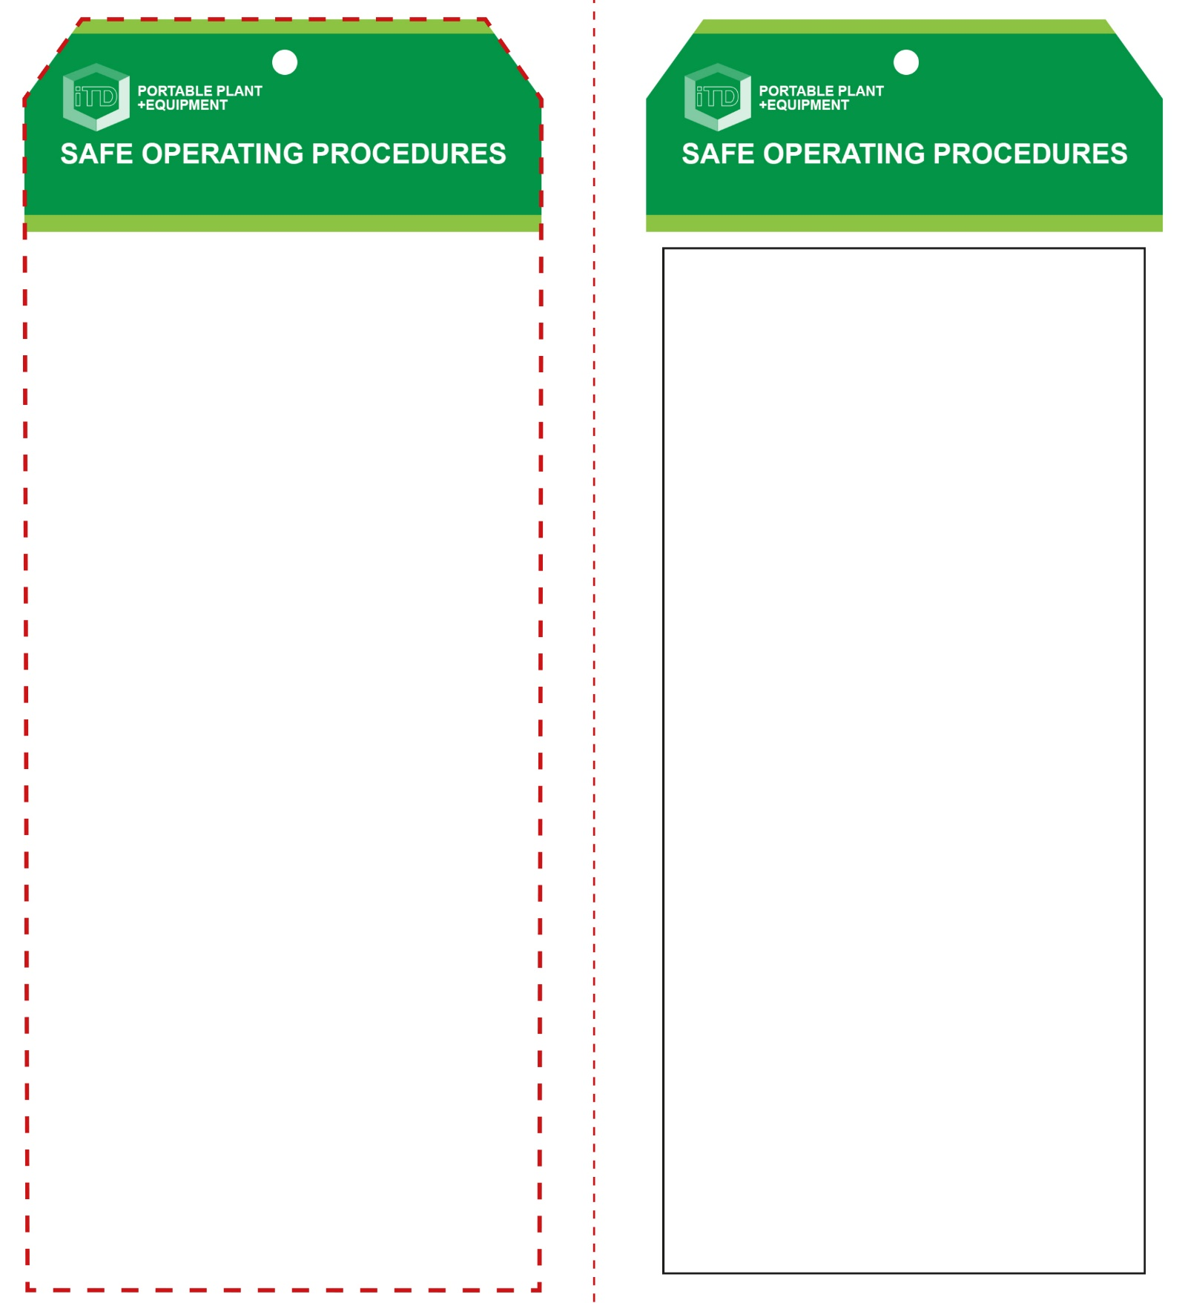

**Students must read this important information before using the equipment**

|  |  |
| --- | --- |
| Has your teacher given you instruction on the safe use and operation of this equipment? | |
|  | |
| Has your teacher given permission  for you to use this equipment? | |
|  | Approved safety glasses *must* be worn at all times in all ITD workspaces. |
|  | Appropriate protective footwear with substantial uppers *must* be worn in all ITD workspaces. |
|  | A suitable P2 or P3 filter mask *should* be worn whenever potentially toxic fumes are created. |
|  | Contain or restrain long and loose hair and remove exposed rings or jewellery. |
|  | A suitable workshop apron or close fitting protective clothing must be worn. |
| **PRE-OPERATIONAL SAFETY CHECKS**   1. Establish an appropriate exclusion zone when nailing. 2. Ensure the actuation muzzle is serviceable and in place. 3. Be aware of all departmental safety alerts for this equipment 4. Be aware (and very familiar with) the type of nail gun you are using, and how it is powered. | |

**OPERATIONAL SAFETY CHECK**

|  |
| --- |
| **Never operate a faulty electrical power tool. Report it to your teacher.** |
| 1. Never attempt to operate this power tool if you are an inexperienced worker, without proper training. 2. The nail gun user and everyone working within the vicinity should be wearing safety glasses, protective footwear, and hearing protection. 3. Be aware of others that may be working nearby. 4. Keep your finger off the trigger when not firing nails. The centre of gravity at the trigger makes it easy to accidentally fire the nail gun. 5. *Never* use a nail gun with a missing push lever and muzzle safety spring (or safety yoke). 6. Be careful to always keep your hands and feet away from the muzzle of the nail gun. 7. Never use any part of your body to support the wood you are nailing. 8. Never rest the nail gun against any body part, or try to climb a ladder with the nail gun cradled against your body. Never point a nail gun at anyone. 9. Never use bottled gas to power air-powered nail guns. 10. Always disconnect the nail gun from its air or electrical power source before transporting, reloading or trying to free a jammed nail. 11. Never leave the nail gun unattended. |
| **Students should never use a bump-fire nail gun** |
| **HOUSEKEEPING**   1. Return this tool to the appropriate storage cupboard. 2. Leave the work area in safe, clean and tidy 3. Maintain correct operation of the actuation mechanism.   **POTENTIAL HAZARDS AND RISKS**  ■ Moving, sharp projectiles ■ Pinch and squash  ■ Noise ■ Compressed gases ■ Eye injuries |

**Nail Gun (cordless)**

**Nail Gun (cordless)**

**Front Reverse**

**Assembly instructions:**

1. Carefully fold this page in half vertically down the centre line
2. This should align ‘front’ and ‘reverse’ sides, then glue the halves back to back
3. Cut out the ‘tag’ shape along the RED dotted outlines indicated on the ‘front’ side
4. Laminate and trim to size with a clear 2mm border
5. Securely fasten an 8mm (ID) brass eyelet and washer where indicated.