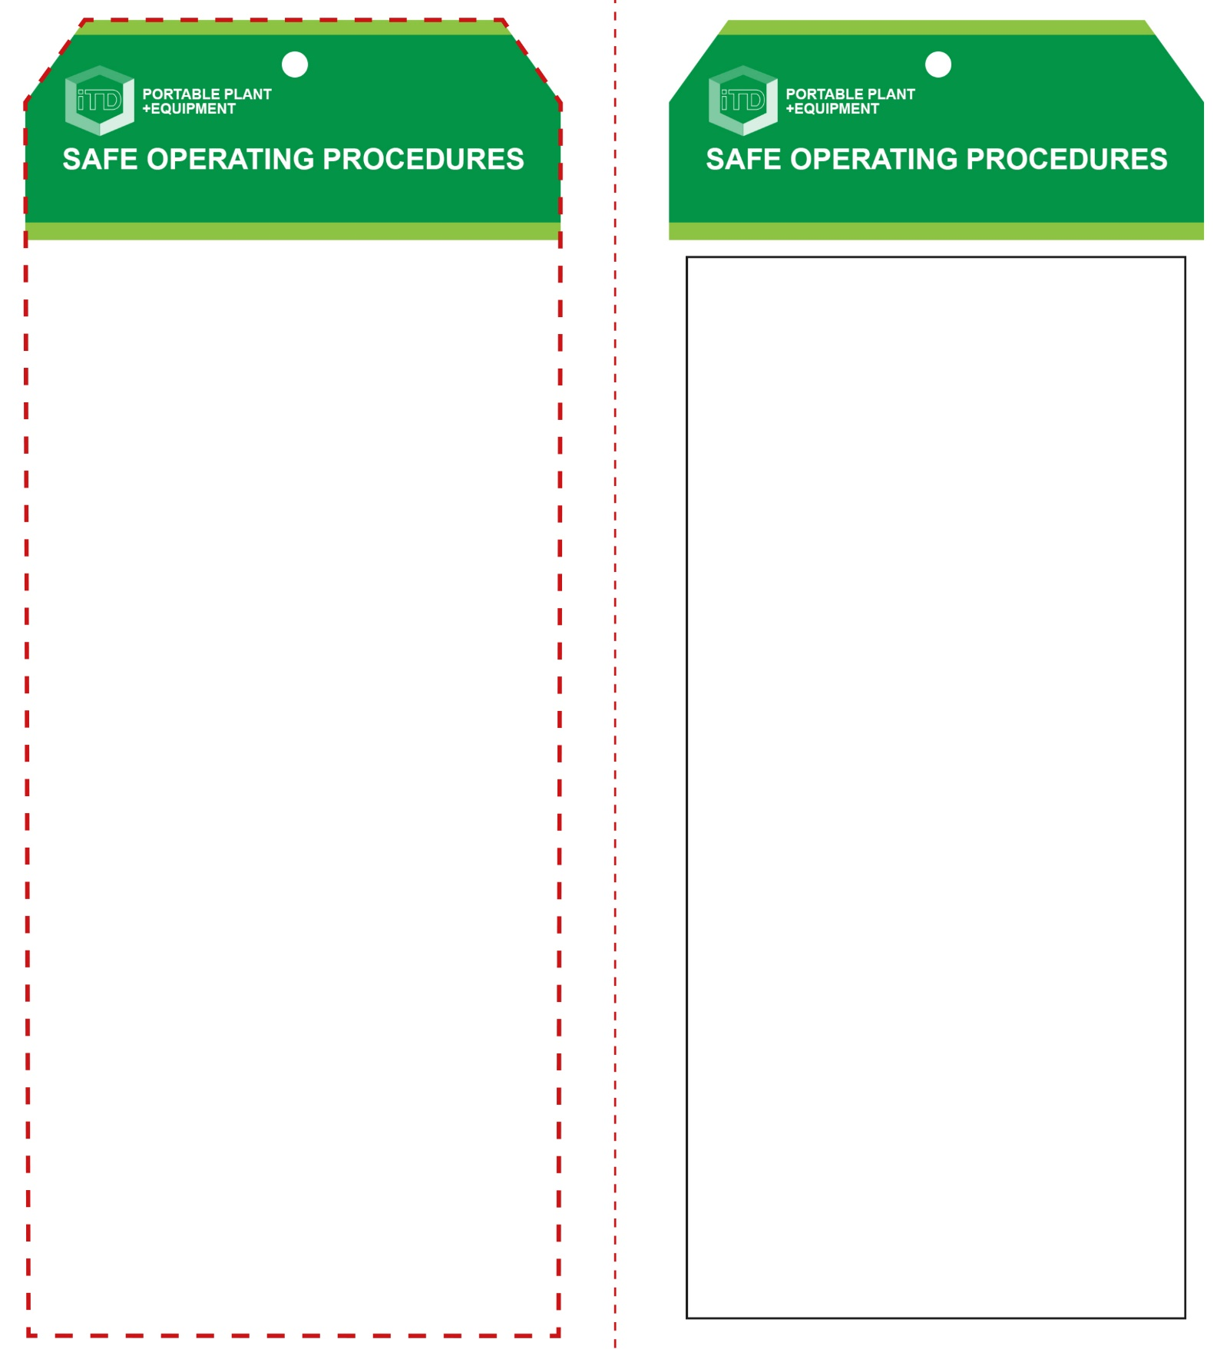

**OPERATIONAL SAFETY CHECK**

|  |
| --- |
| **Never operate a faulty electrical power tool. Report it to your teacher.** |
| 1. Place the oven on a bench at a suitable work height. 2. Connect to a suitable 240v AC power source. Turn the oven on and pre-heat for at least 10-15 minutes prior to use. Set dial to the required temperature (160°C for acrylic). 3. If the heating element does not heat up efficiently, turn the oven off and report the fault to your teacher. 4. Always wear approved safety glasses and cotton gloves that are resistant to high temperatures. 5. Before heating, bending or forming any thermoplastic material, always remove all protective paper from both sides. 6. Accurately mark the desired position for any bends or folds with a felt marker or china-graph pencil so that marks can be removed. 7. Carefully place the work piece on the desired shelf. 8. After the required period of heating, remove carefully. Always wearing cotton gloves. 9. Children often show curiosity towards the operations of the plastics oven. Never leave this equipment unattended when still switched ON or when OFF but still hot. |
| **Never overheat plastics material** |
| **HOUSEKEEPING**   1. Switch off, unplug and allow the oven to cool down. 2. Leave the work area in safe, clean and tidy   **POTENTIAL HAZARDS AND RISKS**  ■ Hot element and surfaces ■ Electricity  ■ Slip and trip ■ Burns  ■ Eye injuries ■ Fire  ■ Toxic fumes |

**Students must read this important information before using the equipment**

|  |  |
| --- | --- |
| Has your teacher given you instruction on the safe use and operation of this equipment? | |
|  | |
| Has your teacher given permission  for you to use this equipment? | |
|  | Approved safety glasses *must* be worn at all times in all ITD workspaces. |
|  | Appropriate protective footwear with substantial uppers *must* be worn in all ITD workspaces. |
|  | Protective cotton gloves *must* be worn when using this equipment. |
|  | A protective workshop apron is advisable. |
| **PRE-OPERATIONAL SAFETY CHECKS**   1. Examine the power lead and oven for obvious damage. 2. Check there is no foreign matter on the heating element. 3. Ensure that the cord does not create a slip/trip hazard. 4. Check that the correct oven temperature is dialled. 5. Check that the adjustable oven shelving racks are correctly spaced to provide the desired heating zone. 6. Ensure that smaller items cannot fall through the shelving racks and possibly contact the heating element. | |

**Plastics Oven**

**Plastics Oven**

**Front Reverse**

**Assembly instructions:**

1. Carefully fold this page in half vertically down the centre line
2. This should align ‘front’ and ‘reverse’ sides, then glue the halves back to back
3. Cut out the ‘tag’ shape along the RED dotted outlines indicated on the ‘front’ side
4. Laminate and trim to size with a clear 2mm border
5. Securely fasten an 8mm (ID) brass eyelet and washer where indicated.