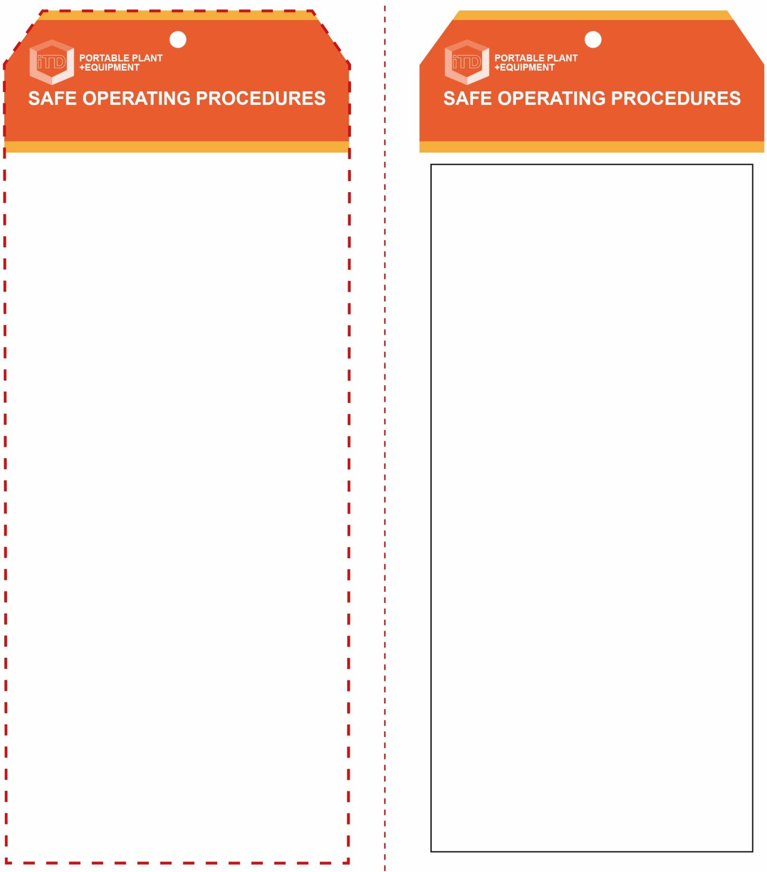

**OPERATIONAL SAFETY CHECK**

|  |
| --- |
| **Never operate a faulty electrical power tool. Report it to your teacher.** |
| 1. When setting up, check that the oxygen and acetylene regulator adjusting knobs are closed (OFF), and are loose. 2. Check that both handpiece blowpipe valves are closed. 3. Slowly open the cylinder valves on each gas cylinder by half a turn (180°) only – for a faster emergency shutdown. 4. Screw in the regulator adjusting knobs slowly until the delivery pressure gauges are both correct. 5. Purge the oxygen gas line and check for constant gas flow. Re-adjust delivery pressure if necessary. 6. Open the acetylene blowpipe (handpiece) valve until a neutral flame is produced. 7. Always be very aware of the dangers of a naked flame. 8. Note: when shutting down, always close the acetylene blowpipe valve first. |
| **Never ignite acetylene with matches or lighter** |
| **HOUSEKEEPING**   1. Ensure both gas bottles are off the welder secured. 2. Leave the work area in a safe, clean and tidy condition.   **POTENTIAL HAZARDS AND RISKS**  ■ Infrared radiation to skin and eyes  ■ Burns due to hot, molten materials  ■ Blowpipe flashback  ■ Flying sparks  ■ Toxic fumes  ■ Explosive and volatile welding gases |

**Students must read this important information before using the equipment**

|  |  |
| --- | --- |
| Has your teacher given you instruction on the safe use and operation of this equipment? | |
|  | |
| Has your teacher given permission  for you to use this equipment? | |
|  | Approved welding goggles *must* be worn at all times in oxy welding areas. |
|  | Appropriate protective footwear with substantial uppers *must* be worn in all ITD workspaces. |
|  | Close fitting protective clothing or overalls covering the arms and legs *must* be worn. |
|  | Protective leather gloves *must* be worn when using this equipment. |
|  | Protective leather apron and spats *must* be worn when using this equipment. |
|  | Rings and jewellery *must not* be worn when using any welding equipment. |
| **PRE-OPERATIONAL SAFETY CHECKS**   1. Ensure the oxy welder has a suitable safe work area. 2. Keep the area clean and free of grease, oils and flammables. 3. Hoses and regulators to be inspected and in good condition. 4. Ensure the area is well ventilated with fume extraction. | |

**Oxy Welder**

**Oxy Welder**

**Front Reverse**

**Assembly Instructions:**

1. Carefully fold this page in half vertically down the centre line
2. This should align “Front” & “Reverse” sides, then glue the halves back to back
3. Cut out the “Tag” shape along the RED dotted outlines indicated on the “Front” side
4. Laminate & trim to size with a clear 2 mm border
5. Securely fasten an 8mm (ID) brass eyelet and washer where indicated.

*Website link to this SOP document:* <http://education.qld.gov.au/health/safety/hazards/equip-resources.html>